Towards a non-disabling New Zealand
The annual report from the Minister for Disability Issues to the House of Representatives on implementation of the New Zealand Disability Strategy

December 2019

Author
Office for Disability Issues, Ministry of Social Development
Acknowledgements
This report was presented in December 2019 to the House of Representatives by the Minister for Disability Issues under Section 8 of the New Zealand Public Health and Disability Act 2000.
Published
This report is available online at: www.odi.govt.nz
ISSN: 2537-7701

Contents
Contents 3
Minister’s foreword 4
Introduction 6
Section one: Key achievements contributing to disabled people’s wellbeing in 2019 9
Launch of the Disability Action Plan 2019-2023 10
Development of the Accessibility Charter and the Accessibility Guide 12
Accessibility work programme developments 13
The Waikato demonstration of the Enabling Good Lives approach 15
System Transformation prototype: Continuation of the new disability support system prototype in MidCentral 17
Comprehensive reform programme in education 20
New Zealand Sign Language 29
I.Lead Symposium 31
Wellbeing Budget 2019: New disability focused funding 33
The Government’s report to the United Nations Committee on the Rights of Persons with Disabilities 34
Fulfilment of New Zealand’s international obligations 35
Section two: Looking forward to 2020 and beyond 39
Implementing the Disability Action Plan 2019-2023 work programmes by agencies, including the monitoring and reporting mechanisms 39
Developing measures for the New Zealand Disability Strategy 2016-2026 Outcomes Framework indicators 40
Improving accessibility in New Zealand 41
Campaigning for Robert Martin’s re-election to the UN Committee 42
Appendix one: Relationship between the UNCRPD, the New Zealand Disability Strategy, and the Disability Action Plan 43
Appendix two: Disability Action Plan 2019-2023 44

Minister’s foreword
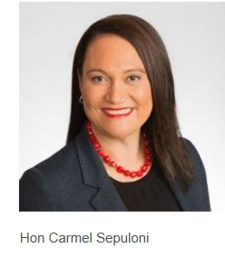
As the Minister for Disability Issues, I am committed to building a more inclusive and accessible society and ensuring disabled people have the same opportunities as other New Zealanders. That’s why I am pleased to release this annual report on implementation of the New Zealand Disability Strategy 2016-2026.
I recently launched the Disability Action Plan 2019-2023. This Action Plan is comprised of 25 comprehensive work programmes aligned with the eight outcomes in the Disability Strategy. These work programmes extend across all sectors: education, health, employment, housing, transport etc. It goes without saying that the 15 individual agencies (and their partners) delivering the work programmes can’t bring about change in isolation. Rather, agencies working together can bring about a fundamental shift in outcomes for disabled people.
I appreciate how officials have engaged with the Disabled People’s Organisations Coalition throughout the process of considering work programme for inclusion in the Action Plan. I am confident that if the work programmes are implemented with integrity and diligence by agencies, and disabled people are engaged with effectively throughout the process, we will see positive change in disabled people’s everyday lives.
Over the last year we have had other notable achievements which will contribute to the wellbeing of disabled people, including: the development of the Accessibility Charter and the Accessibility Guide, the embedding of the new disability support system prototype in MidCentral, the comprehensive reform programme in education, and increased disability focused funding in the Wellbeing Budget 2019.
I would particularly like to mention the I-Lead Symposium which I hosted at Parliament in September. It was inspiring to see so many enthusiastic young disabled people gathered together to discuss their key concerns, including: embedding universal design in the education system, creating more supported employment opportunities, achieving better representation of disabled people in the mainstream media, and developing universally accessible public transport. These articulate young disabled people made it very clear that they have dreams and goals which are no different from those of their non-disabled peers.
As we look to the future, monitoring and reporting progress on implementation of the work programmes in the Disability Action Plan will be important. I am also excited about our steps next year in improving accessibility, with a recommended policy for accelerating accessibility through legislation, coupled with awareness raising and education. We know that inaccessibility to the built environment, transport, information, public events and services leads to social isolation and exclusion.

I look forward to continuing to engage with disabled people, to listen to their concerns, and to celebrate the progress we achieve in enabling them to live the lives of their choice.

Hon Carmel Sepuloni
Minister for Disability Issues

Introduction
In New Zealand, there are several frameworks to address the barriers disabled people experience in living the best quality of life they can. These are:
- United Nations Convention on the Rights of Persons with Disabilities (UNCRPD). This is a United Nations treaty that the Government ratified in 2008. The UNCRPD is the most comprehensive global tool that outlines the human rights of disabled people.
- New Zealand Disability Strategy 2016-2026 (Disability Strategy). The revised Disability Strategy was launched in November 2016. The Disability Strategy represents New Zealand’s approach for the progressive realisation of the UNCRPD in the New Zealand context. There are eight broad domains for targeted action in the Disability Strategy: education, employment and economic security, health and wellbeing, rights protection and justice, accessibility, attitudes, choice and control, and leadership.
- Disability Action Plan 2019-2023. The new Disability Action Plan 2019-2023 (Disability Action Plan), launched in November 2019, will be the primary vehicle for implementing the Disability Strategy over the next four years. The Disability Action Plan is comprised of 25 comprehensive work programmes aligned with the eight outcomes in the Disability Strategy. Work programmes include those falling within the responsibility of a single government agency as well as those involving cross-agency collaboration.
- These frameworks are supported by several governance, monitoring and coordination mechanisms, including:
- Cabinet Social Wellbeing Committee
- Ministerial Leadership Group on Disability Issues
- Chief Executives’ Group on Disability Issues
- Disabled People’s Organisations Coalition (DPO Coalition)
- Independent Monitoring Mechanism.
Every year, the Minister for Disability Issues reports to Parliament. The purpose of the Minister’s annual report is to comment on progress with implementing the Disability Strategy. This report comments on activities and work programmes underway or completed in 2019, contributing to improving disabled New Zealanders’ wellbeing and the progressive realisation of their human rights.
There are two broad sections in the report:
- key achievements contributing to disabled people’s improved wellbeing in 2019
- looking forward to activities and work programmes in 2020 and beyond that will continue to improve disabled people’s wellbeing and quality of life.
It is important to understand that addressing the barriers impeding disabled people from fully participating in our society extends beyond the government activities and work programmes outlined in this report. Bringing about meaningful, long-lasting improvements in the daily lives of disabled New Zealanders is equally dependent on the attitudes, commitments and actions of all New Zealanders.

Section one: Key achievements contributing to disabled people’s wellbeing in 2019
Several initiatives in 2019 have continued work towards improving the identification and removal of barriers that disabled people experience, and ensuring they have the same opportunities and life-outcomes as other New Zealanders. These include:
- launch of the Disability Action Plan 2019-2023
- development of the Accessibility Charter and the Accessibility Guide
- accessibility work programme developments
- system transformation prototype – continuation of the new disability support system prototype in MidCentral
- Waikato demonstration of the Enabling Good Lives approach
- comprehensive reform programme in education
- New Zealand Sign Language
- I.Lead Symposium
- Budget 2019: New disability focused funding
- the Government’s report to the United Nations Committee on the Rights of Persons with Disabilities
- Fulfilment of New Zealand’s international obligations
- Minister for Disability Issues’ attendance at the Conference of States Parties
- Pacific Disability Forum
- Robert Martin’s re-election to the United Nations Committee on the Rights of Persons with Disabilities
- This section outlines what has happened with each of these initiatives and what has been achieved in 2019.

Launch of the Disability Action Plan 2019-2023
In November 2019, the Disability Action Plan 2019-2023 was launched. This new Disability Action Plan aims to improve the wellbeing of disabled people through the delivery of the eight interconnected outcomes in the Disability Strategy: education, employment and economic security, health and wellbeing, rights protection and justice, accessibility, attitudes, choice and control, and leadership.

Work programmes
The Disability Action Plan is not a conventional action plan in that it does not consist of a series of work areas followed by lists of actions. Instead, it is a package of 25 cross-government work programmes that are underway or being planned. Various work programmes in the Disability Action Plan can be aligned with more than one of the Disability Strategy’s outcomes, given that the outcomes are closely linked.
These work programmes are not business-as-usual disability programmes; they are intended to create a significant shift in outcomes for disabled people. The work programmes will be delivered by 15 government agencies and their partners.
The work programmes in the Disability Action Plan align with the twin-track approach of the Disability Strategy. This approach is about making mainstream services and supports inclusive of disabled people, alongside services and supports that are specific to disabled people.
Consistent with Article 4.3 of the UNCRPD (which enshrines the obligation of States Parties to “closely consult with and actively involve persons with disabilities”), disabled peoples’ voices have shaped the Disability Action Plan through a public consultation process. In addition, the feedback from consultation informed many important conversations (eg, in workshops) between the DPO Coalition and government agencies.
Many of the work programmes are substantial and long-term and are expected to continue beyond the life of this current Disability Action Plan.
As the work programmes are developed and implemented, they will be responsive to the needs and potential of all disabled people, including:
- Māori
- Pacific peoples
- children and youth
- older people
- women and girls
- disabled people with complex needs
- whānau.
New programmes of work may be included over the next four years as new priorities and opportunities are identified.
Most work programmes in the Disability Action Plan will be resourced from agencies’ existing funding. A few may be dependent on new or additional funding.

Cross-cutting issues
In addition to the 25 work programmes in the Disability Action Plan, government agencies have been asked to commit to two cross-cutting issues.
- The first issue is that each government agency is expected (in line with Article 4.3 of the UNCRPD) to engage effectively with disabled people when planning for and implementing their work programmes.
- The second issue is the disaggregation of data by disability in the development and implementation of agencies’ work programmes. This will be crucial to inform robust policy formulation and well-planned and effective service delivery, leading to positive outcomes for disabled people. For example, all agencies are expected to promote the use of the Washington Group sets of questions on disability in government surveys.

Development of the Accessibility Charter and the Accessibility Guide
The public sector is taking a leadership role in recognising accessibility as an enabler of inclusion. In February 2018, the Accessibility Charter was launched. The Charter was developed in consultation with Disabled People’s Organisations: Deaf Aotearoa, People First, Association of Blind Citizens and Kāpō Māori. The Charter sets expectations for government agencies to make information technology and communications accessible. Thirty-eight agencies, to date, have signed the Charter document.
Signed-up agencies will be expected to develop action plans. Regular six-monthly reports will be submitted to the Minister for Disability Issues outlining each agency’s progress. Examples of good practice from the reports have been shared with all agencies.
The Accessibility Guide (developed in conjunction with Deaf Aotearoa, People First and Association of Blind Citizens), which was launched in December 2018 by the Minister for Disability Issues, has been updated. The Guide outlines:
- why we should make information accessible
- the frameworks within which it sits (UNCRPD, the Disability Strategy)
- accessibility website standards
- best practice universal design
- alternate formats.
- A training programme has been delivered to support the Accessibility Guide. In 2019, the Ministry of Social Development facilitated the training for groups of 15 people to attend each monthly session.

Accessibility work programme developments
- The Ministry of Social Development has been working in partnership with the Access Alliance to design and progress the work programme on accessibility. Earlier this year discussions were held with a range of stakeholders to listen to their perspectives on achieving full accessibility. Stakeholders included disabled people, businesses, seniors, carers, central and local government, and key community groupings.
- Stakeholders provided feedback on how we should frame the way we think about and measure accessibility. While there was no common understanding of “full accessibility” there was universal support for change, taking into account the extent of the barriers and challenges people are experiencing, and the significant cost of not acting. Stakeholders support government involvement being a combination of legislation, awareness raising, and educational action.
- In June 2019, the Minister for Disability Issues provided an interim update to Cabinet about progress of the accessibility work programme. This noted that the approach to policy work over the next six months would include:
- examining overseas approaches to legislation that mandate accessibility
- identifying the range of possible options for legislative levers that could be applied
- examining the performance of existing regulatory mechanisms to determine what shortfalls exist and need to be resolved
- clarifying feasible options for a policy approach that combines legislation with other measures (awareness raising, education and support for organisations and businesses).

The Waikato demonstration of the Enabling Good Lives approach
The demonstration in the Waikato successfully completed its fourth year, with an extension made until June 2020. Demand remains high with the waiting list consistently being above 130 people. The Enabling Good Lives (EGL) principles remain central in guiding the work of the demonstration and decision- making.
There are currently 404 disabled people, families and whānau engaged in the demonstration. Of note, 32 percent of those participating are Māori, 25 percent are aged under 10 years, and another 26 percent are aged 10-19 years. 47 percent of people live in the many towns and rural areas of the Greater Waikato, including: Tokoroa, Putaruru, Taumarunui, Huntly, Ngaruawahia, Te Kuiti, Te Awamutu, Thames and Paeroa.
There are, currently, 376 people and whānau receiving a personal budget that they can use flexibly to purchase the support, items and services that will assist them to build a good life. Approximately 85 percent of people are receiving and managing this budget directly.
In February 2019, the third phase of the Waikato developmental evaluation was completed. Phase Three aimed to understand how, and to what extent, disabled people, families and whānau participating in EGL Waikato achieved anticipated outcomes. Fifty-five people were interviewed as part of this phase, with a particular focus being on the experiences of Māori and Pacific peoples.
The key finding was that people participating are clearly experiencing success and achieving their outcomes through EGL. The demonstration was described as generally well delivered, but with some opportunities for further refinement and improvement.
The main findings of the Phase Three evaluation included:
- 71 percent of people had achieved all or most of their own outcomes
- 20 percent achieved about half of their outcomes
- 90 percent of participants had experienced each of the EGL outcomes.
Tāngata Whaikaha (Māori disabled) identified that they felt safe and supported, particularly in comparison with previous systems. They valued having Māori tūhono, and had experienced mātauranga-informed practice that responded to them as Tāngata Whaikaha and as whānau
Tagata Pasifika experienced EGL as family focused and valued their positive relationships with tūhono/connectors. They felt EGL had created real opportunities, choice and freedom. The majority of Tagata Pasifika achieved most of what they set out to do.
Overall, 89 percent of participants thought the demonstration made a lot of difference to them and their whānau, with another seven percent stating some difference was made to them.
The four key pathways in EGL that people identified as leading to self-determination, choice and control were:
- flexibility and freedom to direct your own life
- individualised supports - what, when and how
- self-managed personal budgets
- tūhono/connector relationships.
The word cloud below is from the Evaluation Report (Phase Three). It shows how respondents described EGL Waikato:
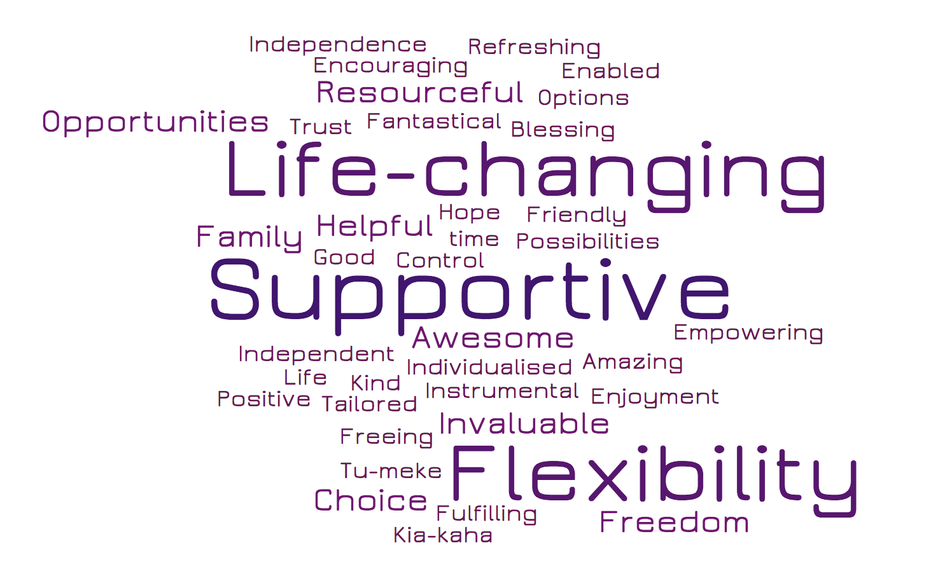

System Transformation prototype: Continuation of the new disability support system prototype in MidCentral
The prototype of the transformed disability support system, Mana Whaikaha, has been in place in the MidCentral DHB region since 1 October 2018. Mana Whaikaha builds on the findings from the EGL demonstrations in the Waikato and Christchurch.

Mana Whaikaha
Mana Whaikaha is a Ministry of Health initiative which had its genesis in Action 4A (to support changes to the disability support system) in the Disability Action Plan 2014-2018, and the EGL approach to the delivery of disability support services.
The new system, now known as Mana Whaikaha, aims to:
- give disabled people, families and whānau greater decision- making authority over their lives and supports
- provide disabled people, families and whānau with more flexible support options
- ensure all disabled people, families and whānau are able to take up the opportunities for change if they want to, including those who need support for decision making and have only paid people in their lives
- improve outcomes for disabled people, families and whānau.
This year has seen high levels of engagement with Mana Whaikaha. Since 1 October 2018, over 800 disabled people have worked with a connector. The role of the connector is to walk alongside the disabled person while they think about what a good life might look like for them, and what supports they would need to live that good life.
Increasing numbers of people are taking up the more flexible budget options available under Mana Whaikaha. In the year that the prototype has been operating over 400 people have accessed personal budgets through Mana Whaikaha.
Mana Whaikaha is seeing increasing engagement from people previously unknown to the disability support system, and from those under 15 years of age. These people are not necessarily accessing funded supports under Mana Whaikaha, but are working with the transformed system to think about and explore what a good life might look like for them in the future.
The first phase of the developmental evaluation is currently underway. This has focused on:
- what was implemented compared to the high level and detailed design
- how this has been implemented,
- how well this has worked.
The findings from this first phase of the evaluation will inform decisions on how the prototype can be adjusted to improve the outcomes and experiences of disabled people.

Workforce
In January 2018, a workforce working group made up of disabled people, unions, providers and officials was established. This group supports a work programme that aims to:
- support the development of the disability sector workforce; safeguard workforce rights, terms and conditions; provide employment information, advice and support for disabled people as employers; and monitor and evaluate impacts for the workforce and make recommendations for change
- improve flexibility and remove contract restrictions for providers so they can provide tailored individualised support that meets the needs of disabled people and their families and whānau in MidCentral.
- In 2019, the workforce working group has worked on the creation of a workforce specific objective for the transformed disability support system, ensuring that workers and providers have:
- representation in the first phase of the evaluation
- information sessions for care and support workers in MidCentral
- a clause and supporting guidance for the funding agreement that ensures disabled people are aware of their obligations as an employer, if they are directly engaging their care and support staff.
- In 2019, Flexible Disability Support contracts have been offered to all providers in MidCentral. These contracts remove restrictions on providers, meaning that they can offer more flexible, individualised supports for disabled people. In October 2019, workshops around how these contracts work were run.

Comprehensive reform programme in education
The Ministry of Education has a continued focus on equity and excellence for all students, including a focus on students with disabilities and those with learning support needs. A comprehensive reform programme will progress opportunities for ākonga (learners with disabilities). The Associate Minister of Education has delegations for progressing the learning support elements of this reform programme.
The Ministry of Education has engaged with disabled people and their whānau to inform items included in the Education Work Programme. This has involved working with the DPO Coalition to brief them on:
- how the results of engagement are flowing through into the Ministry’s advice
- to test that advice, including on proposals for legislative change and a toolkit the Ministry has developed for engaging with disabled people and their whānau.
The Ministry of Education commits to continuing to consult and engage with disability rights groups on how the changes in the Education Work Programme will be achieved in practice.

More funding for Learning Support
Budget 2019 provided further increases for Learning Support of $336 million over four years, including additional funding of $29.6 million to respond to population and demand growth for Learning Support, and funding of $217 million for a tranche of Learning Support Coordinators.

Learning Support Action Plan
In July 2019, the Learning Support Action Plan was finalised and published. This Action Plan builds on the Learning Support Delivery Model, which will strengthen how learning support is provided. The Learning Support Action Plan will enable all children and young people to get the right support in the right place at the right time.
The Action Plan sets out the Ministry of Education’s intention to:
- implement Learning Support Coordinators in schools and kura
- strengthen early identification of learning needs
- strengthen early intervention
- improve flexible supports and services for neuro-diverse children and young people
- meet the learning needs of gifted children and young people
- improve education for children and young people at risk of disengaging.
Under the Action Plan, 623 new Learning Support Co-ordinators (LSCs) have been allocated to school clusters. LSCs are a new in-school role that will work to ensure all learners, including those who are disabled, neuro-diverse, have behavioural needs, and those who are gifted, get the help they need. LSCs will be registered teachers and kaiako, employed by Boards of Trustees. Recruiting for these LSCs is underway, with LSCs to start working in schools from January 2020. Around 300,000 ākonga will be in schools that have LSCs. LSCs will work alongside classroom teachers and others to:
- build the capability of kaiako (teachers)
- identify and plan for the learning support needs of all children and young people in the school or kura, including those with moderate needs
- be available to support learners, and their parents and whānau.
LSCs will also work with school and kura leadership to set up or improve existing systems to support children and young people with learning support needs to move smoothly between early learning services, schools and kura, and into further education, training or work.

Tomorrow’s Schools Review
After more than 200 meetings with people interested in education, an Independent Taskforce provided its initial report to the Minister of Education in November 2018. The report, Our Schooling Futures, Stronger Together l Whiria Ngā Kura Tūātinitini, was released for public consultation on 7 December 2018.
From December 2018 to April 2019, the Taskforce undertook more than 100 public and targeted meetings with stakeholders and received more than 5,000 submissions on the initial report. The Taskforce heard from many educators, children and young people with disabilities and learning support needs and their whānau, along with board members and disability rights groups. The feedback was that our education system needed to do much more to be inclusive of students with disabilities and learning support needs.
In July 2019, the Taskforce’s final report was submitted to the Minister of Education. On 12 November 2019, the Government released its response.
For ākonga (learners with disabilities and/or other learning support needs), all schools should be great places to learn. The Ministry is resetting the system that governs, manages, administers and supports schools so that all learners get the same chance to succeed.
Key changes of relevance to disabled people include:
- a new independent process to resolve serious complaints through dispute resolution panels. This will facilitate the resolution of serious disputes not resolved with schools, including matters relating to learning support and the right to attend schooling
- more responsive, accessible and integrated local support to schools and early learning services through a new Education Services Agency (as part of the redesigned Ministry of Education)
- support for greater engagement with learners with additional needs and their whānau. The Ministry of Education will work in consultation with Disabled People’s Organisations and other disability rights groups on how this will be achieved in practice.

Statement of National Education and Learning Priorities
The Government is taking an integrated approach to set the direction for the education system. The Statement of National Education and Learning Priorities (NELP) expresses priorities to help those who govern schools, kura, early learning services and ngā kōhanga reo to focus their day-to-day work on things that have a significant positive impact for children and young people.
The draft NELP priorities have been informed by input from groups of learners and their whānau who are often underrepresented in traditional engagement processes. This has included disabled people and their whānau. The priorities build on the themes heard in the Kōrero Matauranga over the past 18 months, including a focus on:
- wellbeing
- inclusion
- eliminating racism, discrimination and bullying
- having high expectations that every learner can succeed.
Learners have shared with the Ministry of Education the importance of getting basic needs met at school, including:
- adequate, appropriate toilet facilities
- having their identity, culture and language (including New Zealand Sign Language) recognised and valued
- feeling welcome and included, whatever their learning needs
- their preferred way of learning provided for.
The draft NELP priorities are currently being consulted on, with the final priorities expected to be made available in early 2020.

Curriculum, Progress and Achievement
Both the Curriculum, Progress and Achievement Ministerial Advisory Group (MAG) and the Curriculum, Progress and Achievement Reference Group (Reference Group) include representation from the disability and learning support sector, along with two special schools, the Van Asch Deaf Education Centre and the Blind and Low Vision Education Network.
The MAG and the Reference Group have led engagement to gather feedback on the MAG’s emerging ideas for strengthening the focus on curriculum, progress and achievement. This has involved engagement aimed at specifically reaching those with disability and learning support perspectives including, for example, meetings with the Education for All inclusive education group, the New Zealand Sign Language Advisory Board, and the Special Education Principals Association of New Zealand (SEPANZ).
The feedback to MAG and the Reference Group recognised that, despite the education system’s long-held aspirations for inclusive education, there are experiences of a deficit approach that fail to value diversity, and to recognise or realise the potential of young people with disabilities or other differences that impact on learning and wellbeing. The feedback also highlighted that approaches to measuring progress are often not relevant to the individual learning pathway for many ākonga with disabilities or differences and, hence, their achievement and progress are invisible.
The MAG has finalised and published a report setting out its recommended approaches to strengthening curriculum, progress and achievement which incorporates this feedback. In response to the advice, the Minister of Education has asked the Ministry of Education to work in collaboration over the coming months to:
- develop a process for updating the national curriculum
- develop resources that map progress across the national curriculum
- develop a common approach to holistic records of learning
- create a trusted environment for using information.

Early Learning Strategic Plan
The analysis of an online survey of early learning found that children who need support to learn was a commonly identified improvement area. Respondents suggested better funding was needed to facilitate this, with specific reference to the need for timely early intervention.
Goal Two of the draft Early Learning Strategic Plan is to ensure every child is empowered through timely access to the resources they need to thrive. The Early Learning Strategic Plan will be finalised and published by the end of 2019.

Review of the National Certificates of Educational Achievement (NCEA)
During the engagement phase of the NCEA review in 2018, the Ministry of Education heard that some learners with disabilities were not getting the support they need to succeed in assessment. For example, some standards are difficult for students with a physical disability to compete. Others felt that access to Special Assessment Conditions (SAC) is often inequitable and unnecessarily difficult.
A strong theme in the feedback was the need for an inclusive mind-set, using Universal Design for Learning principles when designing assessments. The question was asked why assessment needs to be modified to accommodate the needs of learners with disabilities rather than simply being accessible by design.
Key changes have been announced to make NCEA more accessible to students with disabilities and learning support needs by:
- ending NCEA fees
- designing achievement standards and associated resources to be accessible and inclusive so that students with disabilities and learning support needs have an equal opportunity to achieve
- making existing SAC accessible to everyone, where possible
- simplifying the application and evaluation processes for SAC.
In addition to the changes outlined in the NCEA Change Package, the Ministry of Education is also working towards removing barriers to NCEA by strengthening and promoting inclusive assessment tasks in schools and kura as part of the Review of Achievement Standards. This will ensure that the end users of NCEA are able to fully access the significant learning contained in NCEA achievement standards, no matter their circumstances, disability or the school they attend.

Tertiary Education Strategy
A new Tertiary Education Strategy (TES) is being developed to specify the priorities and actions that give effect to the Government’s overarching education outcomes and strategic objectives. The new TES will drive the system changes needed to build on established strengths, address current issues, and realise the opportunities tertiary education offers for all learners.
To inform the drafting of the new TES, the Ministry of Education wanted to hear from a sample of those who are often underserved by the tertiary system. From January to July 2019, the Ministry held over 50 engagements on the TES with representative groups and peak bodies, including: ākonga (learners) and staff, TEO senior leadership, Māori, Pacific peoples, disability groups, and government agencies around New Zealand.
On issues relating to accessibility, ākonga (learners) reflected that universal design of tertiary education would be more appropriate than initiatives developed on an ad hoc basis. In general, they felt that tertiary education environments needed to be better resourced to sustainably cater to accessibility and other support needs.
Consultation on the draft TES has now closed. All feedback will be carefully considered, and the new TES will take effect in 2020.

Education Workforce Strategy
The Ministry is developing an Education Workforce Strategy in partnership with the education sector. The Workforce Strategy will be comprehensive, including the workforce across early learning services, primary and secondary education, the learning support workforce, both Māori-medium and English-medium, and with a focus on Māori language learning in all settings.
It will identify the mix of professionals and paraprofessionals (including teacher aides) needed to support children and young people with disabilities and those with learning support needs. It will also identify the ongoing learning and development that these professionals and paraprofessionals need. And it will consider the leadership, administrative, and technology support that will be required.

New Zealand Sign Language

Background
Census 2018 results show that 22,986 people can use New Zealand Sign Language (NZSL), that is, 0.5 percent of the New Zealand population. This means that NZSL, one of New Zealand’s official languages, remains a threatened language.

New NZSL Board members
The NZSL Board (the Board) membership has changed significantly since April 2019, with five new appointments and a new Board Chair. Recommendations for two new Māori Deaf members have also been provided.
The Board is focused on continuing to engage with Māori Deaf leaders as part of its commitment to ongoing engagement and development with the Māori Deaf community. For example, the Board commissioned a project, Hono kit e Hapōri Turi, to engage with leaders to identify Māori Deaf priority areas for the maintenance and promotion of NZSL. In October 2019, the Board further cemented this partnership relationship by allocating NZSL funds to maintain engagement with Māori Deaf leaders, and support Māori leadership succession planning by investing in rangitahi (Māori youth), building experience in a government context.

Investment of the NZSL Fund in local initiatives
Local grassroots initiatives that maintain and promote NZSL were considered in the fifth funding round early in the financial year. Round Six opened in August 2019, inviting projects that align with the NZSL Strategy 2018-2023 (NZSL Strategy) priorities.
The Board considered 17 applications and have recommended 12 grants for the 2019-2020 financial year totalling $291,321.
Of note is that the proportion of NZSL funds distributed between community grants and strategic projects has shifted over the past five years. Initially, most of the funding was allocated via the contestable community grants process. This year’s grants represent the lowest proportion awarded via the contestable process. This shift in the allocation of funding aligns with the Board’s approach to also progress strategic programmes required to progress the NZSL Strategy and support the vitality of NZSL.

Investment of the NZSL Fund in strategic projects
The NZSL Fund was increased from $1,250,000 to $1,645,000 in the Wellbeing Budget 2019. This increase has enabled the ongoing funding of core activities that support the vitality of NZSL, including:
- investing in NZSL week, which aligns with “attitude”, a strategic priority in the NZSL Strategy
- maintaining the NZSL online dictionary which documents the language for users.
These two activities total $395,000 annually and are contracted for the next three years.
In addition, a range of strategic investments were agreed to in October 2019 focusing on NZSL sector development. These are:
- contracting the NZSL Teachers Association (NZSLTA) to develop and deliver a range of professional development opportunities to NZSL teachers nationally, and develop a five-year strategic plan
- establishing an adult assessment service using the Sign Language Proficiency Interview (SLPI) tool to measure the fluency of adult NZSL users
- organising a NZSL Sector Development workshop to promote collaboration between NZSL professions, namely, Sign Language Interpreters, NZSL teachers and the adult NZSL assessment service
- creating a NZSL Online hub page that will provide NZSL users with a central place to find links to all relevant information about NZSL
- developing NZSL Interpreter Standards, post-graduation, which will be progressed alongside a Language Assistance Service (LAS) multiagency project led by the Ministry of Business, Innovation and Enterprise. This approach will ensure that the access needs of Deaf clients are viewed alongside all other languages by government agencies.

I.Lead Symposium
On the 3 and 4 of September 2019, the I.Lead Symposium was held at Parliament. This was a forum event where 60 young disabled people ranging in age from 18 to 28 years gathered together to have their voices heard by government agencies and policy makers. This event was put together by an organising committee of nine young disabled people, facilitated by Yes Disability Resource Centre and supported by the Office for Disability Issues and other agencies such as the Ministry of Education, Ministry of Social Development, Ministry of Health and the Ministry of Youth Development.
The event was very successful and provided a valuable opportunity for growing youth disability leadership and empowering young disabled people to be heard and participate in civil engagement and influence. It was valuable to hear from disabled youth and see the world from their perspective. At the end of the symposium, the participants presented their collated recommendations to key government and public sector officials.
The recommendations were grouped in seven key areas:
- education and training
- employment
- health
- housing
- media
- sport and recreation
- transport.
The young disabled people collated the recommendations into a draft report with the support of Yes Disability. They continue to work with the Office for Disability Issues on these. The Office for Disability Issues has also been working with key government officials who are equally eager to see the ideas from the conference addressed and/or implemented.

Wellbeing Budget 2019: New disability focused funding
Overall, the Wellbeing Budget 2019 is investing $548.702 million in initiatives that directly affect disabled people, to ensure:
- children with disabilities and learning support needs benefit from a more inclusive education system that better supports their needs (eg, new Learning Support Coordinators from 2020)
- support workers benefit from a regularised workforce and fair compensation of travel costs
- the disabled community benefits from the largest ever increase in disability support services, as well as additional funding for community participation services.
The across government increased demand for disability advice and guidance from the Office for Disability Issues has also been recognised in Budget 2019 through an additional $870,000 per annum for the Office for Disability Issues. This additional funding will:
- resource additional positions in the Office for Disability Issues
- increase support for the Nominations Data Base
- enable progress in implementation of the New Zealand Disability Strategy and the Disability Action Plan.
An additional $305,000 has been allocated to the DPO Coalition from Budget 2019, alongside the $80,000 currently allocated within the Office for Disability Issues’ budget. This new annual budget recognises the increased demand for DPO Coalition engagement with government agencies to progress the UNCRPD via the Disability Strategy and the Disability Action Plan.

The Government’s report to the United Nations Committee on the Rights of Persons with Disabilities
The Government has written a report to answer 100 questions posed by the United Nations Committee on the Rights of Persons with Disabilities (UN Committee). This report was sent to the UN Committee on 9 March 2019.
During the preparation of the report, the Government engaged with the DPO Coalition, disability sector organisations, the Independent Monitoring Mechanism and the public.
The report provides information on what the Government has done over the past four years to put the UNCRPD into action. It includes information on education, employment, health, justice, transport, housing, data, accessibility and many other areas.
The report provides a snapshot of where things are at currently. While good progress has been made, there are still areas for improvement.
The Government will be invited to Geneva to appear before the UN Committee. The Committee will then give the Government recommendations (called “Concluding Observations”) on what the Government can do to better implement the UNCRPD.

Fulfilment of New Zealand’s international obligations
Article 32 of the UNCRPD states that: “States Parties recognise the importance of international cooperation and its promotion, in support of national efforts for the realisation of the purpose and objectives of the present Convention, and will undertake appropriate and effective measures in this regard…”. New Zealand has a well-established international reputation in the promotion and protection of the rights of disabled people dating backing to New Zealand’s leadership during the negotiation of the UNCRPD.

Minister for Disability Issues’ attendance at the Conference of States Parties
The twelfth Conference of States Parties to the UNCRPD took place from 11 to 13 June 2019 in New York. This year’s conference theme was: Ensuring inclusion of persons with disabilities in a changing world through the implementation of the CRPD.
New Zealand’s delegation was headed by the Minister for Disability Issues. The members of the delegation included the Director of the Office for Disability Issues, Brian Coffey. Officials from the New Zealand Human Rights Commission and representatives from New Zealand’s civil society were also in attendance.
During the General Debate at the Conference, the Minister for Disability Issues delivered New Zealand’s National Statement. Key issues covered included:
- opportunities that technology presents to enhance inclusion and participation for disabled people in society
- progressive realisation of the UNCRPD in New Zealand through implementation of the Disability Strategy and the Disability Action Plan
- New Zealand’s commitment to supporting the implementation of the UNCRPD in the Pacific region.
The Minister for Disability Issues also co-chaired a meeting of the Group of Friends of Persons with Disabilities, and delivered the Joint Statement on the Group’s behalf supporting:
- the new United Nations Disability Inclusion Strategy
- the President of the General Assembly’s creation of the Steering Committee on Accessibility.
Other meetings that the Minister participated in included a quadrilateral meeting with Canada, Australia and the United Kingdom, and bilateral meetings with both Singapore and the UN Special Rapporteur on the Rights of Persons with Disabilities.

Pacific Disability Forum
In accordance with the Government’s Pacific Reset commitments, the Minister for Disability Issues announced that New Zealand will provide NZ$183,310 to the Pacific Disability Forum to support their work towards an inclusive Pacific 2030. The funding will support aspects of the Pacific Disability Forum’s 2019-2020 Work Plan, including (but not limited to):
- a regional workshop on intellectual disability
- in-country data analysis and capacity building to Disabled People’s Organisations to enhance understanding of and advocacy for the Washington Group Short Set of questions on disability in censuses
- work in Nauru, Republic of the Marshall Islands, Kiribati, Palau and Vanuatu with Disabled People’s Organisations in preparation for national elections to ensure they are inclusive and accessible.
Following this one-year funding contribution, New Zealand will explore establishing a long-term partnership with the Pacific Disability Forum to support their new Strategic Plan 2021-2025.

Robert Martin’s re-election to the United Nations Committee on the Rights of Persons with Disabilities
In June 2016, Robert Martin was elected to the United Nations Committee on the Rights of Persons with Disabilities (UN Committee). The UN Committee is a body of 18 independent experts which monitors implementation of the UNCRPD. The members of the UN Committee serve in their individual capacity, not as government representatives.
As the first person with a learning disability to serve on the UN Committee, Robert has brought a valuable perspective to the role. He has been an advocate for the rights of people with a learning disability worldwide, particularly around issues such as independent living and supported decision-making. He has also represented People First New Zealand for a number of years.
the Minister for Disability Issues announced at the Conference of States Parties that New Zealand is nominating Robert Martin for re-election to the UN Committee for the 2021-2024 term. If re-elected, Robert will build on the valuable work he has already undertaken in this role. The election to the UN Committee will take place in June 2020.

Section two: Looking forward to 2020 and beyond
What is important looking forward to 2020 and beyond is prioritising those strategic opportunities that will promote positive change for disabled New Zealanders and contribute to their wellbeing. These strategic opportunities include:
- implementing the Disability Action Plan 2019-2023 work programmes by agencies, including the monitoring and reporting mechanisms
- developing measures for the New Zealand Disability Strategy 2016-2026 Outcomes Framework indicators
- improving accessibility in New Zealand
- campaigning for Robert Martin’s re-election to the UN Committee.

Implementing the Disability Action Plan 2019-2023 work programmes by agencies, including the monitoring and reporting mechanisms
It will be important to monitor and report on progress in implementation of the 25 work programmes in the Disability Action Plan over the next four years. The Disability Action Plan includes several mechanisms to monitor implementation, including:
- Agencies will submit six-monthly status reports to the Office for Disability Issues on progress in implementation of their respective work programmes. As was done for the Disability Action Plan 2014-2018, summaries of a sample of the status reports will be made publicly available on the Office for Disability Issues’ website.
- The Ministerial Leadership Group on Disability Issues will meet bi-annually to monitor progress in implementation of agencies’ work programmes relating to the Independent Monitoring Mechanism’s six key issues (education, employment, seclusion and restraint, access to information and communication, housing, and data).
- The DPO Coalition will have the opportunity to raise any concerns about implementation of the Disability Action Plan and its work programmes in the bi-annual meetings with the Minister for Disability Issues.
- The DPO Coalition will have the option of requesting meetings with the government agencies (including Ministers, Chief Executives and officials) responsible for work programmes in the Disability Action Plan, whenever issues/concerns arise for them.
- The Minister for Disability Issues’ annual report to Parliament will report on progress with implementation of the Disability Strategy’s eight outcomes through monitoring of the Disability Action Plan’s work programmes.

Developing measures for the New Zealand Disability Strategy 2016-2026 Outcomes Framework indicators
The Office for Disability Issues carried out extensive consultation and worked directly with the New Zealand Disability Strategy Revision Reference Group (NZSRRG) to arrive at a set of indicators for the Disability Strategy Outcomes Framework. Twenty-eight indicators have been identified across the Disability Strategy’s eight outcome domains.
In collaboration with the Office for Disability Issues, Stats NZ has proposed some measures for the 28 indicators. These measures were based on the best understanding available at the time of what was intended by the Office for Disability Issues and the NZSRRG for each indicator. Currently, there are 58 proposed measures in total.
Further work on possible measures for the indicators and sources of data will continue in 2020. This will be complemented by agencies disaggregating the data they collect by disability.

Improving accessibility in New Zealand
In April 2020, the Minister for Disability Issues will report back to Cabinet with a recommended policy for accelerating accessibility through legislation, coupled with awareness raising and education. This report will indicate the direction of future work.
Consistent with Article 9 of the UNCRPD, accessibility legislation would allow us to meet our national and international obligations and align our legal approach with that of similar jurisdictions. It would also align with key government priorities, such as improving the wellbeing of New Zealanders, and ensuring everyone who can is earning, learning, caring or volunteering. Accessibility legislation offers a real opportunity to achieve change faster and improve socio-economic outcomes for disabled people.

Campaigning for Robert Martin’s re-election to the UN Committee
The campaign for Robert Martin’s re-election to the UN Committee will be led by the Ministry of Foreign Affairs and Trade and the Office for Disability Issues, alongside Robert Martin and People First New Zealand. This campaign will require planning and sustained effort.
Underlying objectives for the campaign will include (but not limited to):
- The rights of disabled people are one of New Zealand’s primary human rights priorities internationally. New Zealand remains committed to the promotion and protection of these rights and this campaign will highlight our commitment to furthering these rights.
- Advocacy by disabled people with diverse disabilities, including learning/intellectual disabilities, is important.
- Robert Martin is passionate about key issues important to the successful implementation of the UNCRPD, such as ensuring disabled people can make their own decisions.

Appendix one: Relationship between the UNCRPD, the New Zealand Disability Strategy, and the Disability Action Plan

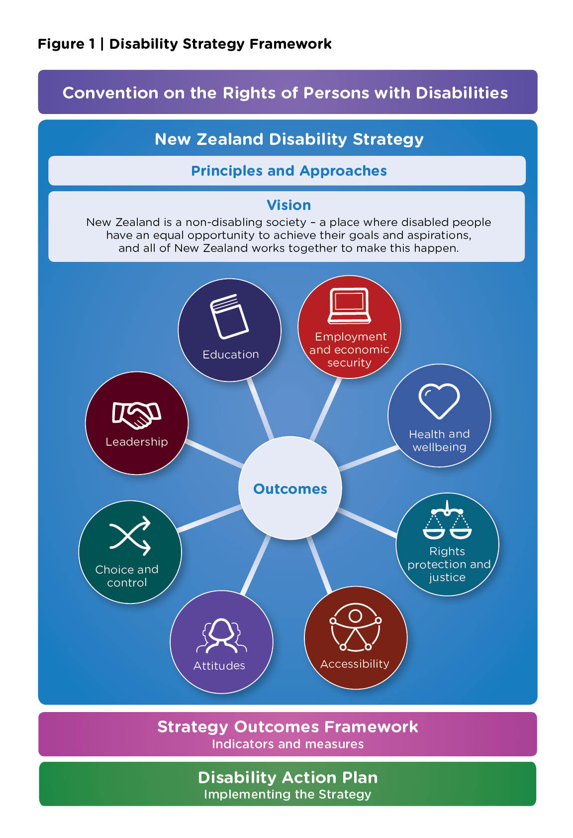

Appendix two: Disability Action Plan 2019-2023
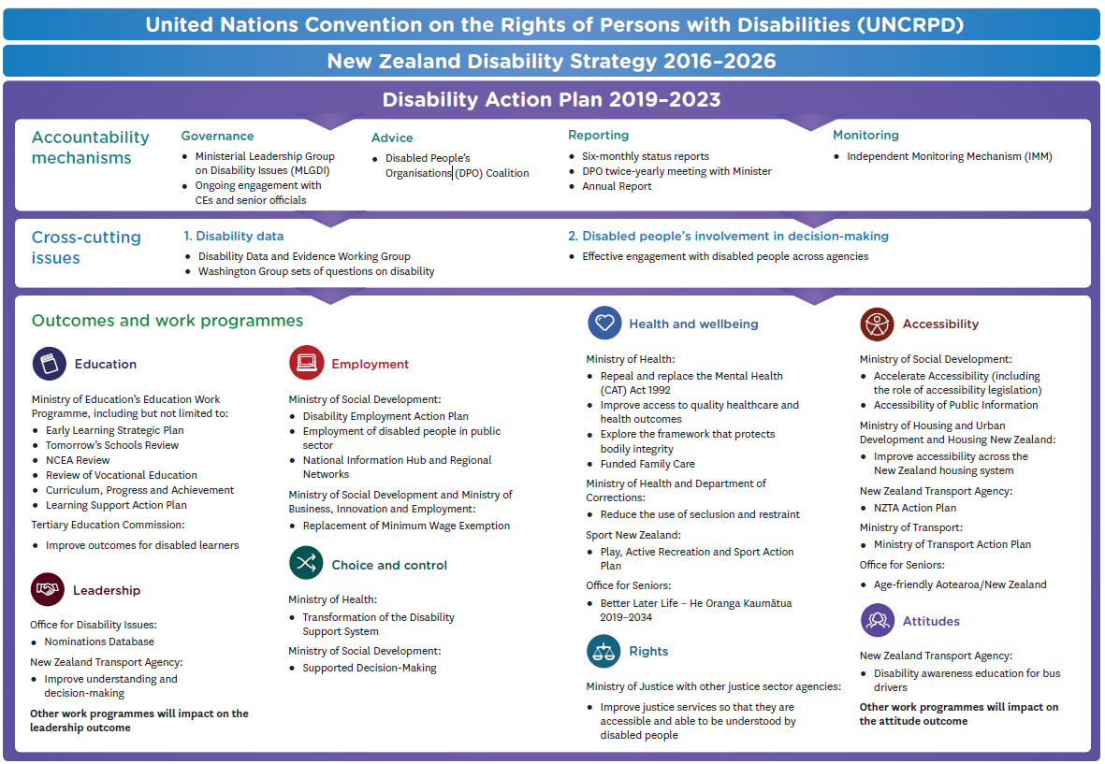

The New Zealand Disability Strategy 2016-2026 is available on the Office for Disability Issues website at: https://www.odi.govt.nz/nz-disability-strategy/about-the-strategy/new-zealand-disability-strategy-2016-2026/.
The relationship between the UNCRPD, the Disability Strategy and the Disability Action Plan is illustrated in Appendix one.
The DPO Coalition is a collection of seven Disabled People’s Organisations. Members include: Disabled Persons Assembly (New Zealand) Incorporated, People First New Zealand Incorporated, Kāpō Māori Aorearoa/New Zealand Incorporated, Association of Blind Citizens of New Zealand Incorporated, Deaf Aotearoa New Zealand Incorporated, Balance Aotearoa and Muscular Dystrophy Association of New Zealand.
The Independent Monitoring Mechanism (IMM) is a three-way partnership between the Human Rights Commission, the Office of the Ombudsman and the DPO Coalition. The IMM is designated by Cabinet to provide independent monitoring of New Zealand’s implementation of the CRPD.
Given that the Disability Action Plan 2019-2023 has only recently been launched, this report will not be commenting on progress in implementation of the work programmes comprising the current Plan.
The Disability Action Plan is attached as Appendix two.
The Access Alliance is a group of representatives from Disabled People’s Organisations, disability service providers, and community and disability advocacy organisations campaigning for accessibility legislation.
http://www.enablinggoodlives.co.nz/current-demonstrations/enabling-good-lives-waikato/waikato-evaluations/
It is important to note that the $275,000 per annum for Disabled People Led Monitoring research remains available.
The Government’s response to the UN Committee is available in various formats at: https://www.odi.govt.nz/whats-happening/read-the-governments-report-to-the-un-disability-committee/

