October 2017
Review of Be. Accessible Funding
Final Report

Further details about Allen + Clarke
Allen and Clarke Policy and Regulatory Specialists Limited (Allen + Clarke) is an established consultancy firm based in Wellington, New Zealand. We specialise in research, evaluation, policy and programme development and implementation, and secretariat services. A key component of our work is designing and undertaking research and evaluation projects to assess and inform strategy and programme accountability, development and improvement. Founded in 2001, the company is owned and managed by five of its senior staff and has a team of approximately 32 other research, evaluation and policy practitioners, analysts and support staff. Our company works extensively for a range of government agencies in New Zealand, and international clients and non-government organisations in Australia, the Pacific and Asia. More information about our work can be found on our website www.allenandclarke.co.nz.
This report has been prepared by:
Grant McLean, Joshua Williams, Ned Hardie-Boys
Allen + Clarke
Pam MacNeill
Disability Responsiveness New Zealand.

Suggested citation:
Allen and Clarke. (2017). Review of Be. Accessible Funding. Wellington, New Zealand: Ministry of Social Development.
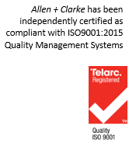
Document status: | Final Report
Version and date: | V5; 31 October 2017
Author(s): | Grant McLean, Joshua Williams, Ned Hardie-Boys
Filing Location: | MSD/Office for Disability Issues/Be. Accessible
Peer / technical review: | To be sent for further peer review from Pam MacNeill
Verification that QA changes made: | Grant McLean
Proof read: | Alasdair MacLeod, Anna Scanlen
Formatting: | Jo Evans
Final QA check and approved for release: | Ned Hardie-Boys

Contents
Contents 3
Key Messages 4
Executive Summary 6
1. Introduction 14
1.1. Be. Accessible 14
1.2. Purpose of this Review 15
1.3. Key Review Questions 15
1.4. Report Structure 16
2. Methodology 17
2.1. Data Collection Methods 17
2.2. Strengths and Limitations 20
3. Review Findings 21
3.1. Effectiveness 21
3.2. Efficiency 58
3.3. Relevance 65
3.4. Sustainability 70
4. Improving How Be. Accessible Funding Delivers Outcomes for Disabled People 74
Appendix 1: Be. Accessible business collaboration case studies 79

Key Messages
The following are the main messages of this review and represent the key lessons that decision makers can take on the funding and delivery of Be. Accessible programmes. The overall message is that the Be. Accessible programmes and approach have considerable merit, and are achieving valuable results. The full impact of the programmes and approach will take time to become evident, but given sufficient time, resources and strengthened partnerships, Be. Accessible is well-positioned to deliver on its potential:
- The review found that while overall Be. Accessible has exceeded its mostly quantitative contracted outcomes, and that there is some evidence of impact, the full effectiveness of the programmes will take some time to become visible. This could be assisted by future Outcome Agreements specifying more qualitative outcomes reporting and the further development of the evaluation framework.
- Be. Leadership alumni report very positive outcomes from the Be. Leadership programme, and the ‘accessibility journey’ under Be. Welcome resonates well with businesses and has helped to improve understanding of access needs and access to information and services. However, the Be. Welcome ratings need to be more clearly articulated to all those with access needs, particularly those with disabilities. Many businesses demonstrated a degree of enthusiasm for accessibility improvements and their relationship with Be. Accessible, and this is encouraging. However, the type of social change that Be. Accessible is trying to achieve takes time and there is more work to do.
- While Be. Accessible has internal strategies and plans, the ongoing implementation of Be. Accessible would be enhanced by the development and communication of a multi-year strategy. The strategy (supported by an evaluation framework), should set out Be. Accessible’s role and place in the accessibility system, its vision, and its short, medium and long-term outcomes (i.e., the strategy’s intervention logic). The strategy should communicate the social change journey that Be. Accessible is on and how this connects with government and other players in the accessibility system.
- More work is needed to support the engagement of disability sector organisations with Be. Accessible; this is vital to enhancing the success of Be. Accessible ’s programmes and its approach which is built on relationships and partnerships.
- While there are strong elements of the Be. Campaign including its ability to leverage significant national and local media coverage for accessibility, overall the campaign has not been well-understood by stakeholders and would benefit from more coherent messaging about what Be. Accessible is trying to change and how.
- The Be. Institute is a very agile organisation and emphasises learning and testing new ideas. This is positive. However, it is important that it does not lose sight of its existing programmes and that it does maintain focus, including on what is achievable. It cannot be everything to everyone. Therefore, when taking on new initiatives, the practical implications and impacts on existing programmes within the Be. Institute, need to be taken into account, so the quality of those programmes is not adversely affected.
- Be. Accessible is currently highly reliant on government funding (although it does also generate considerable revenue from consulting fees and attract significant in-kind support). The Be. Welcome programme is not yet sufficiently embedded within the business community to be financially sustainable, although the ability to generate fee-for-service income does indicate a willingness to pay for services. There needs to be more attention given to programme ‘exit strategies’, particularly given the ongoing cost of simply maintaining current levels of programming, compared to the costs of continuing to grow services (e.g., recruiting more businesses and emerging leaders in the programmes), or the cost of scaling up the Be. Welcome programme.

Executive Summary

Background
Be. Accessible has been developed and implemented over 2011–2017. It was initially developed with the intent of leveraging off the Rugby World Cup 2011 to support the development of accessible tourism. Its three foundation programmes which are the subject of this review – Be. Welcome, Be. Leadership and Be. Campaign – have adapted and evolved over the six years and new programmes have also been developed and tested. The government has provided $1,000,000 per annum to support the delivery of the foundation programmes.

Purpose and methods of the review
After five years of funding Be. Accessible, the MSD of Social Development (MSD) considered it timely to reflect on what the funding has achieved. Allen + Clarke was commissioned to conduct an independent review of Be. Accessible. The focus was to assess the effectiveness, efficiency, relevance and sustainability of funding used to deliver the three Be. Accessible programmes. The findings of the review are to inform decision-making on the future direction of the funding and development of Be. Accessible.
The review employed a mixed-methods approach drawing on a document review and two stakeholder engagement approaches (interviews and surveys).
The document review involved 30 documents relating to the Be. Accessible programmes. These documents included MSD funding contracts, Be. Accessible’s quarterly and annual reports, Be. Accessible research and evaluation documents, the Be. Accessible website, and the New Zealand Disability Strategy 2016 – 2026.
The stakeholder engagement involved interviews (individual, twin and small group), and two online surveys: one of businesses and the other of ‘access citizens’ (people with access needs).
The interviews were semi-structured and covered the full range of review questions but were tailored to specific interviewees. Thirty-eight interviews were conducted involving 60 people.
The survey of businesses was distributed to 150 businesses. Thirty-two businesses responded to the survey (a 21 percent response rate). Tourism and hospitality sector businesses, and council facilities, were the predominant respondents. Most respondents were highly rated Be. Welcome businesses (silver and gold).
The survey of access customers was developed in consultation with a number of disability sector organisations including People First NZ, Deaf Aotearoa, CCS Disability Action, and Association of Blind Citizens of NZ Inc.
The qualitative data from the interviews was analysed using NVivo software to code the data to key themes. This data was then corroborated with data collected in the surveys and information from the document review. The information was analysed across the focus areas of effectiveness, efficiency, relevance and sustainability.
A results workshop was held with the Office for Disability Issues and Be. Accessible to share emerging findings and to help interpret meaning, which further refined and focused the findings and analysis.

Findings and conclusions
The following table sets out our conclusions against each of the key review questions. The four focus areas and our findings are then discussed in more detail in the Review Findings section.
Focus | Key review questions and conclusions
Effectiveness | KRQ1: How effective has Be. Accessible been in achieving the agreed outcomes as specified in MSD contracts?
Be. Accessible
- Overall Be. Accessible has exceeded its (mostly quantitative) contracted outcomes
- While there is some evidence of impact, the full effectiveness of the programmes will take time to become visible (which can be assisted by moving to more qualitative outcomes reporting)
- Be. Accessible could make further gains by engaging and collaborating more directly with the disability sector
Be. Leadership
- Be. Leadership is having a positive impact on participants and broader impacts
Be. Welcome
- The Be. Welcome philosophy connects with businesses
- The Be. Welcome ratings system is comprehensive; although disability sector organisations have concerns about the consistency and comparability of ratings
Be. Campaign
- The focus and purpose of Be. Campaign is unclear; while the Fab 50 and ability to leverage media is a strength
 | KRQ2: To what extent has the social innovation approach been effective at delivering to the agreed outcomes?
- Be. Accessible’s social innovation approach is having a positive effect, providing a new lens and language
- Be. Accessible’s role and approach is not well understood by some stakeholders, particularly in the disability sector
- Given the nature of social change, it will take time to see the full results of change

Efficiency | KRQ3: How efficiently has Be. Accessible achieved the agreed outcomes?
- Be. Accessible overall achieves the agreed outcomes, and more, in an efficient manner
- The style of reporting is not conducive to assessing the efficiency of each programme on an individual basis
- Overall, the monitoring and review arrangements are adequate
- The primarily output (numerical) based nature of reporting does not support fostering continuous learning and improvements

Relevance | KRQ4: How relevant are Be. Accessible’s initiatives to government priorities in the New Zealand Disability Strategy 2016-2026?
 | - The three Be. Accessible programmes are directly aligned to priority areas in the Disability Strategy of accessibility (Outcome 5), attitudes (Outcome 6) and leadership (Outcome 8)
 | KRQ5: Are the current activities of Be. Accessible having benefits outside of the outcomes and services as specified in MSD contracts?
- Be. Accessible’s activities have benefits beyond the contractual outcomes and services (e.g., employment, language change, and professionalism)
- The social change model targets those who can deliver and influence change with a more inclusive language
- The approach looks beyond the disability strategy to facilitate change for a wider population

Sustainability | KRQ6: How sustainable are Be. Accessible’s current activities and outcomes beyond the current contract funding?
- Be. Accessible’s programmes are reliant on government funding, and this is likely to continue for the short to medium-term
- Be. Accessible is growing self-generated revenue and in time it could become financially sustainable
- Greater resources would enable Be. Accessible to achieve greater programme scale further enhancing sustainability
- There is a balance to strike between continued innovation and maintaining direction of foundation programmes

Effectiveness
Overall, Be. Accessible has exceeded the contract outcomes, which are mostly output- based (quantitative). While there is some evidence of impact, the full effectiveness of the programmes will take time to become visible (which can be assisted by moving to more qualitative outcomes reporting). There is also a high level of evaluative activity starting to occur, which needs to be comprehensively reported on as the results are finalised. Further, more direct feedback on the quality and impact of the Be. Accessible programmes needs to be gathered from ‘access customers’ themselves.
The overall effectiveness of Be. Accessible’s programmes will also take time to become evident given the nature of social change initiatives. We consider that the combined difference made by the programmes will take time to see, given the broad focus is on fundamental social change, and attribution will be difficult to measure. The development and refinement of the Evaluation Framework should help capture a more comprehensive picture of the combined impact of the programmes.
Be. Accessible is clear about its core role as a social change agent and social innovator and the approach is having some positive impacts. However, Be. Accessible’s role and approach is not well understood by some stakeholders, particularly in the disability sector.
Be. Leadership is impacting positively on participants and there are indications of broader impacts. A number of stakeholders reported potential improvements from establishing a formal alumni programme.
The Be. Welcome philosophy of taking businesses on a journey connects with businesses. The Be. Welcome ratings system and tool is comprehensive, although there were concerns expressed by disability sector stakeholders about the consistency and comparability of the ratings.
Be. Accessible’s ability to collaborate with business is a real strength and niche for the organisation, which can be extended to collaboration in other sectors (and to more customer-facing businesses and also to ‘back offices’) which could also benefit from accessibility assessments and dialogue.
While Be. Accessible meet its collaboration outcomes with disability organisations in the Outcomes Agreement, a number of disability organisations reported a lack of collaboration.
The overall purpose, focus and reach of the Be. Campaign is unclear. The Be. Campaign programme elements have varied over the years of the programme. In earlier years there was a detailed three-year Campaign plan, and a range of initiatives implemented and reported on. The Fab 50 initiative is noted as a positive strategic innovation, and that Be. Accessible has been successful in leveraging media to spread their accessibility message.
There are models and lessons that can be learned from more mature social change programmes in terms of evaluating and monitoring impacts using different types of quantitative and qualitative metrics. Two New Zealand examples that could be drawn on are the Like Minds, Like Mine campaign and the It’s Not OK! campaigns, which have been monitored and evaluated for a range of social, attitudinal, behavioural and community impacts over more than ten years.

Efficiency
Overall, Be. Accessible achieves, and exceeds, the outcomes agreed with MSD – and implements and manage its programmes in an efficient manner. In the year to June 2017, for almost every service MSD had provided funding for, Be. Accessible exceeded the contract outcomes. It is also clear, from the quarterly reports, that Be. Accessible delivers services and undertakes other activities over and above those in the Outcome Agreement.
However, it is not clear how much each of the four services in the Outcome Agreement individually cost to deliver. The style of reporting is not conducive to assessing the efficiency of each programme on an individual basis.
Overall, the monitoring and review arrangements are adequate. However, because they are primarily output-based rather than outcome-based, the performance only identifies compliance with the required (numerical) outputs but do not identify the deeper impact. Therefore, the current monitoring arrangements do not support fostering continuous learning and improvements. The development and communication of a clear multi-year strategy and intervention logic would assist in identifying appropriate short-medium and long-term measures of impact. Combining those measures with the research and evaluation work undertaken, could assist understanding of the impact of Be. Accessible’s activities, and identify lessons and improvements.
Several factors enabled efficient operating arrangements, including:
- ongoing funding of $1,000,000 per year;
- passionate and committed staff;
- a leadership team with experience running organisations and Social Enterprises;
- the support of partner businesses which provide services/expertise on a voluntary basis; and
- Board members with experience running organisations.
Factors which have constrained efficiency include:
- variable engagement from a contract management perspective and diffuse contract management functions;
- inefficient transition of MSD contract managers;
- a lack of coordination in government purchasing/funding of services and activities in the sector; and
- the absence of a clear strategy with intermediate measures of success.

Relevance
The three Be. Accessible programmes are directly aligned to priority areas in the current New Zealand Disability Strategy 2016-2026, namely accessibility (Outcome 5), attitudes (Outcome 6) and leadership (Outcome 8).
The benefits of the Be. Accessible programmes are more widely relevant. For example, the programmes have had positive impacts on employment of disabled people, language change, and there are benefits from other disability organisations becoming more professional as a result of Be. Accessible’s approach.
The social change model is relevant as it focuses on what is possible, and aims to target those who can deliver and influence change by using a more inclusive language of accessibility rather than disability. The approach is designed to look beyond the boundaries of the disability strategy to try and facilitate holistic change for a broader vision of accessibility, to improve the lives of a much larger proportion of the population. The accessibility language brings something different and makes it easier to engage businesses given it is framed in social and economic benefits.

Sustainability
The Be. Accessible programmes are reliant on government funding, and are likely to continue to be so at least in the short to medium-term. While Be. Accessible’s revenue is increasing so are its expenses.
The Be. Institute’s single main source of funding is provided by government. However, Be. Accessible also generates significant revenue through consultancy and services, and grants and donations – which are growing. If the growth in generated revenue can be maintained, Be. Accessible might be on a path to becoming financially sustainable in the medium-term. Further, in time, it is possible Be. Accessible’s funding could become largely self-generated.
Greater resources would enable Be. Accessible to achieve greater scale in its programmes and activities – and thereby increase its sustainability through reaching a wider audience and being able to better embed changes in people, organisations, and sectors.
There is a balance for Be. Accessible to strike between retaining the ability to innovate and evolve, and maintaining direction of sufficient (and perhaps growing) resources to the foundation programmes. We consider such balance is particularly likely if Be. Accessible can continue to generate revenue and attract pro bono support. The growth of Be. Accessible into other areas – both in terms of programmes and locations – will improve the sustainability of the organisation.

Recommendations
Section 4 of this report sets out our conclusions and recommendations for MSD and Be. Accessible. These recommendations are as follows:
- Develop and clearly communicate a multi-year strategy for Be. Accessible that:
  - Describes the overall goal and approach and sets out where Be. Accessible fits within the accessibility system;
  - Identifies short, medium and long-term outcomes;
  - Describes the programmes and tactics for achieving these outcomes; and
  - Incorporates a monitoring and evaluation framework to measure progress against the strategy and to support reporting, learning and improvement (that includes gathering more direct information on the quality and impact of Be. Accessible’s programmes for those with access needs, particularly those with disabilities).
- Strengthen partnering and collaboration opportunities with disability sector organisations:
  - As an initial step, this may involve a greater focus on acknowledging shared outcomes across the sector, and Be. Accessible sharing its strategy and understanding of its social change approach.
- Further develop approaches, such as partnering, that enable Be. Accessible to continue to operate and evolve as a hub of innovation without jeopardising the delivery of its foundation programmes
- Continue to make improvements to foundation programmes, including:
  - Be. Welcome: consider expanding reach into ‘back office’ type businesses and health facilities, and ensure consistency of assessments and ratings;
  - Be. Leadership: consider developing a more formalised alumni programme; and
  - Be. Campaign: reset the programme in line with developing an overall strategy (see recommendation 1).
- MSD and Be. Accessible give greater focus to ensuring the sustainability of current programmes and benefits, as well as consideration for the potential scaling up of activities, including through:
  - Continuing to generate commercial revenue through engagement with business partners;
  - Continuing to explore alternative sources of funding; and
  - Exploring options to, over time, transition responsibility for funding of programmes, or components of programmes from government to alternative sources (e.g., through co-funding arrangements or exiting government funding at certain points in delivery).
- Improve contracting and reporting arrangements by:
  - Reporting on the costs of delivering each service individually in monitoring reports against the Outcome Agreement;
  - Reporting more qualitative information about the impact of the activities and programmes, including greater critical self-reflection by identifying lessons and areas for improvement;
  - Improving the ability to track information and issues across reports.
  - Integrating outcome measures into contracts and reporting, aligned to the strategy (see recommendation 1);
  - Considering opportunities to consolidate MSD contract management functions for all Be. Accessible programmes. At the very least, this should include integrating contract reporting across the programmes (i.e., into a single report); and
  - Improving hand-over processes associated with any future transition in contract management responsibilities within MSD.

- Introduction
  - Be. Accessible
Be. Accessible is managed by the Be. Institute, which identifies as a social enterprise that aims to work across all sectors and communities throughout New Zealand. The expressed belief is that every person has their part to play in the creation of accessibility regardless of how big or small the change. Be. Accessible is described as a social change initiative and a holistic framework for accessibility with a mission to create a truly accessible country for all New Zealanders.
Be. Accessible was originally developed with the intent of leveraging off the 2011 Rugby World Cup to support the development of access tourism in New Zealand. Access tourism focuses on the economic benefits of attracting domestic and overseas tourists by making communities and businesses accessible for disabled people, their friends, and families. Research from the United Kingdom has found that people with impairments or those travelling with people with impairments tend to stay longer at locations and spend more. Access tourism is also underpinned by the spill-over benefits for local people with disabilities and access needs from increased accessibility of public facilities.
In 2011, the Minister for Disability Issues announced baseline funding of $1 million per year from Vote: Social Development for Be. Accessible, starting from July 2011. Initially, the funding for Be. Accessible was contracted as part of the Think Differently campaign promoting positive attitudes and behaviours and overseen by the Ministry of Social Development’s (MSD) Social Change Team. MSD contracted the Be. Institute to deliver accessible tourism through service outcome deliverables focused on three programmes:
- Be. Welcome (accessibility assessment and support for businesses) – which aims to increase the accessibility of the entire customer experience provided by businesses/organisations by promoting and delivering: an assessment programme, training coaches, referral of clients to specialist providers, and promoting the programme to larger organisations;
- Be. Leadership (opportunities for disabled people to engage in leadership development) – which supports the participation of between 15 and 20 people per year in a leadership programme aimed at increasing their involvement in vocational leadership roles, and community and civic leadership; and
- Be. Campaign (a change campaign to raise the awareness of accessibility and the possibilities for all New Zealanders through a number of communication methods) – which aims to promote accessibility and improve the attitudes of businesses and New Zealanders towards accessibility.
The contract also included an allocation of funding for Be. Accessible to undertake research and evaluation to understand the effectiveness of the programme and to inform its future development.
More recently MSD has contracted the Be. Institute to deliver a fourth programme, Be. Employed. While outside the scope of this review, Be. Employed is a programme that aims to address accessibility and employment issues, and works with employers to enhance innovative possibilities in employment.
  - Purpose of this Review
After five years of funding Be. Accessible, the Office for Disability Issues, which sits within MSD, considered it was timely to reflect on what the funding for Be. Accessible has achieved and whether any changes are desirable to improve how the funding improves outcomes for disabled people.
The Office for Disability Issues commissioned Allen + Clarke to conduct an independent review of Be. Accessible. The focus was to assess the effectiveness, efficiency, relevance and sustainability of funding used to deliver the three Be. Accessible programmes: Be. Welcome, Be. Leadership, and Be. Campaign.
The review focuses on the contractual agreements, and Be. Accessible’s underpinning logic as the programme has evolved, particularly its approach of social change and social innovation. The review maintains a forward-looking focus in assessing the impact and role of Be. Accessible.
The findings are intended to contribute to decision-making on the future direction of the funding and development of Be. Accessible.
  - Key Review Questions
The review is framed around the following key review questions (KRQs):
Focus | Key review questions
Effectiveness | KRQ1: How effective has Be. Accessible been in achieving the agreed outcomes as specified in MSD contracts?
 | KRQ2: To what extent has the social innovation approach been effective at delivering to the agreed outcomes?
Efficiency | KRQ3: How efficiently has Be. Accessible achieved the agreed outcomes?
Relevance | KRQ4: How relevant are Be. Accessible’s initiatives to government priorities in the New Zealand Disability Strategy 2016-2026?
 | KRQ5: Are the current activities of Be. Accessible having benefits outside of the outcomes and services as specified in MSD contracts?
Sustainability | KRQ6: How sustainable are Be. Accessible’s current activities and outcomes beyond the current contract funding?

The review also investigates three questions associated with contractual processes:
- What were the monitoring and review arrangements for the MSD contracts?
- How well did these arrangements support continuous learning and improvements for Be. Accessible?
- What factors enabled or constrained efficient operating arrangements?
  - Report Structure
The remainder of this report is structured as follows:
- Section 2 sets out the evaluation methodology, including the overall design, the evaluation objectives and questions, and specific methods.
- Section 3 sets out the main review findings organised under the four overarching review focus areas (effectiveness, efficiency, relevance, and sustainability), and as related to the specific key review questions (and sub-questions).
- Section 4 draws together the review findings and analysis as conclusions and provides our recommendations to the MSD of Social Development.

- Methodology
This section sets out our approach to the review; summarises the information sources, methods and analyses; and identifies the key strengths and limitations of the review design.
The review methodology was set out in a work plan at the beginning of the project, and was agreed with the Office for Disability Issues with input from Be. Accessible.
  - Data Collection Methods
The review employed a mixed-methods approach drawing on a document review and two stakeholder engagement approaches (interviews and surveys).

Document review
A review of key documents and data related to the Be. Accessible programme was completed. This included reviewing contracts and internal review, monitoring and reporting documents for the programme, Be. Accessible’s quarterly and annual reports, Be. Accessible research and evaluation documents, administrative data (e.g., social media monitoring data), the Be. Accessible website, and the New Zealand Disability Strategy 2016 – 2026.
In total 30 documents were included within the document review.
The document review helped the project team to gain insight into the intent and context of the Be. Accessible programmes. The document review also informed stakeholder engagement for the Be. Accessible funding review.

Stakeholder engagement
Four overarching stakeholder groups were identified in consultation with the Office for Disability Issues and Be. Accessible:
- Group 1 – Direct involvement: stakeholders with direct interest in the Be. Accessible programmes (Office for Disability Issues/Ministry of Social Development; Be. Accessible management and staff; trustees, coaches; Fab 50).
- Group 2 – Be. Welcome businesses (direct service recipients/businesses): directly engaged with the Be. Welcome programme (e.g., have been assessed and rated).
- Group 3 – Tourism, business supporters, and pan-sector/government agencies: with an interest in accessibility (e.g., AUT Centre for Person Centred Research, Ministry of Health, Ministry of Business, Innovation and Employment).
- Group 4 – ‘Access citizens’: (e.g., Be. Leadership alumni; national organisations that represent the disability community [both Disabled Peoples Organisations (DPOs) and disability provider organisations]; and people with access needs themselves (reached through representative/membership organisations).
The project involved two main types of stakeholder engagement; stakeholder interviews (individual, twin and small group – the majority face to face and some by phone), and two online surveys (one of businesses and the other of people with access needs: the ‘access customers’ survey). The interviews were semi-structured and covered the full range of review questions but were tailored to specific interviewees. In total 38 interviews were conducted involving 60 people. Members of the project team travelled to Auckland for a site visit with Be. Accessible and to interview a number of stakeholders across the city. Several interviews were held in Wellington with disability sector organisations (particularly the DPOs) and government agencies.
The surveys were developed in SurveyMonkey. The survey of businesses focused on recently engaged businesses. The survey was distributed to 150 businesses. Thirty-two businesses responded to the survey (a 21 percent response rate). Tourism and hospitality and council facilities were the predominant respondents, and a selection of ‘other’ businesses. Most respondents are highly rated businesses (silver and gold) under the Be. Welcome programme.
The survey of ‘access customers’ was developed in consultation with a number of disability sector organisations including People First NZ, Deaf Aotearoa, CCS Disability Action, and the Association of Blind Citizens of NZ Inc. These organisations distributed the survey. The survey was translated into New Zealand Sign Language by Seeflow, allowing respondents to read and respond to the survey in sign language. 203 responses were received. 76 percent of respondents stated that they had at some time experienced an access barrier. 70 percent of respondents reported having a temporary or permanent impairment (whether vision, hearing, physical, learning or psychological functioning). 22 percent had regular outings with young children with strollers. 13 percent had an age-related impairment.
Note for when reading the findings of both surveys: not everyone responded to each question, so the data presented refer to those who responded to a particular question.
For analysis, the stakeholder groups were further broken down into seven sub-groups (see Table 1 over the page). To provide for the anonymity of individuals and organisations, the participants are referred to throughout this document by reference to their stakeholder group. This provides the reader with information about what broad stakeholder group they belong to (e.g., Government, Be. Governance and Management and Be. Coaches).

Table 1: Key informant interviews and survey respondents by stakeholder group/organisations
Stakeholder group | Number  of Interviews | Number  of survey  respondents
Group 1: Government | 6
Group 2: Be. Governance & Management, Be. Coaches | 5
Group 3: Disability sector organisations (including DPOs) and other | 8
Group 4: Be. Welcome businesses and tourism organisations | 9 | 32
Group 5: Be. Leadership alumni | 5
Group 6: Fab 50 and partners | 5
Group 7: Access customers |  | 203
Total | 38 | 235

Analysis
The qualitative data from the interviews was analysed using NVivo software to code the data to key themes. The information was analysed under each of the key review questions across the focus areas of effectiveness, efficiency, relevance and sustainability.
Analysis focused on synthesising qualitative information from the stakeholder interviews and the document review, and corroborating the quantitative data from the surveys. We continually revisited our findings to check whether and how the supporting and relevant evidence fitted with the emerging findings.
A results workshop was held with the Office for Disability Issues and Be. Accessible to share emerging findings and to help interpret meaning, which further refined and focused the findings and analysis.
We distinguished between primary data (stakeholder interviews and survey data) and secondary data (document review) throughout the analysis. We considered data or evidence to be more valid, and therefore gave it more importance, when we were able to validate it with data collected from other sources (e.g., from multiple stakeholders) and/or by other methods. We were also cognisant of the importance of context and the risks of generalising. This required us to look for areas of convergence (i.e., does it fit the story?) but also for areas of divergence, and then to assess whether this could be explained by different contexts.
  - Strengths and Limitations

Strengths
The breadth and quality of the stakeholder engagement in terms of the number of stakeholders willing to participate and share their perspectives and experiences of Be. Accessible is a strength of the study. The access customer survey in particular helped provide a direct link to the ‘voice’ of people with a variety of access needs and disabilities.
The volume of quarterly reports and other documentation reviewed as part of the study helped provide important contextual information and insights on the development and progress of Be. Accessible since its inception in 2011.

Limitations
The project team believe that there may be a positive bias in the business survey sample, as the survey was distributed to more recently engaged businesses and the majority of the respondents were highly rated businesses. This could mean that respondents are likely to have a more positive perspective of their experiences with Be. Welcome.
The access customer survey was distributed via a small number of organisations that support or advocate for disabled people, so it is not a representative sample of all people with disabilities and access needs more generally.
We were unable to directly reach some organisations that support and represent people with access needs, through the stakeholder engagement, for example the older people perspective. Similarly, some tourism sector organisations approached were not available for interview.

- Review Findings
This section presents the findings of the review according to the key review questions, and related sub-questions.
In reporting findings, reference will be made primarily to the specific programmes (Be. Welcome, Be. Leadership and Be. Campaign) and at times to Be. Accessible more generally, when referring to the broader underpinning social innovation and social change logic and approach behind the programmes.
  - Effectiveness
This section firstly reports on the overall findings in relation to Be. Accessible’s effectiveness in delivering on the contracted outcomes (3.1.1., against KRQ1) then focuses on the effectiveness of the individual programmes (see 3.1.2 on page 35), and concludes by reporting on the effectiveness findings in relation to KRQ2 (see 3.1.3 on page 55).
    - Effectiveness of Be. Accessible
Focus | Key review questions and conclusions
Effectiveness | KRQ1: How effective has Be. Accessible been in achieving the agreed outcomes as specified in MSD contracts?
- Overall Be. Accessible has exceeded its (mostly quantitative) contracted outcomes
- While there is some evidence of impact, the full effectiveness of the programmes will take time to become visible (which can be assisted by moving to more qualitative outcomes reporting)
- Be. Accessible could make further gains by engaging and collaborating more directly with the disability sector

Overall Be. Accessible has exceeded its contracted outcomes
Overall, Be. Accessible has exceeded the contract outcomes, which are mostly output- based (quantitative). While there is some evidence of impact, the full effectiveness of the programmes will take time to become visible (which can be assisted by moving to more qualitative outcomes reporting). There is a high level of evaluative activity starting to occur, which needs to be comprehensively reported on as the results are finalised.
The Be. Institute has been submitting reports to MSD since first being contracted in 2011-2012. The content and comprehensiveness of the reports has evolved over that time, both in terms of the reporting requirements specified by different contract managers and the level of information provided by Be. Accessible. Different contract managers have also visited Be. Accessible over the years to work with the organisation on ways to improve reporting.
It was noted by contract managers that generally the reporting is good and is a mix of quantitative and narrative reporting. The key area where contract managers have wanted to see more detailed reporting is around ‘customer/end-user’ and alumni feedback. From relatively early on Be. Accessible worked hard on improving reporting, providing data, and tracking of progress across the programmes to meet the MSD’s needs. For example, in the 30 June 2014 report it was stated:
“As you will see in the following report, each of the three programmes now have a series of spreadsheets and graphs as well as supporting narrative, that describe and demonstrate the degree of impact we are having. This new reporting approach will form the basis of all future reporting and now provides a platform for us to build on.”
Over the six years of the delivery of the three core Be. Accessible programmes, the programmes have evolved with additional components being added during that time. Alongside this Be. Accessible was awarded a contract by MSD to deliver Be. Employed. In parallel, Be. Accessible has entered into a range of partnerships with commercial organisations (often on a pro bono basis), reflected in Diagram 1 below.
Diagram 1: Timeline of evolution of Be. Accessible funded and partnership (pro-bono) programmes (and key initiative development)
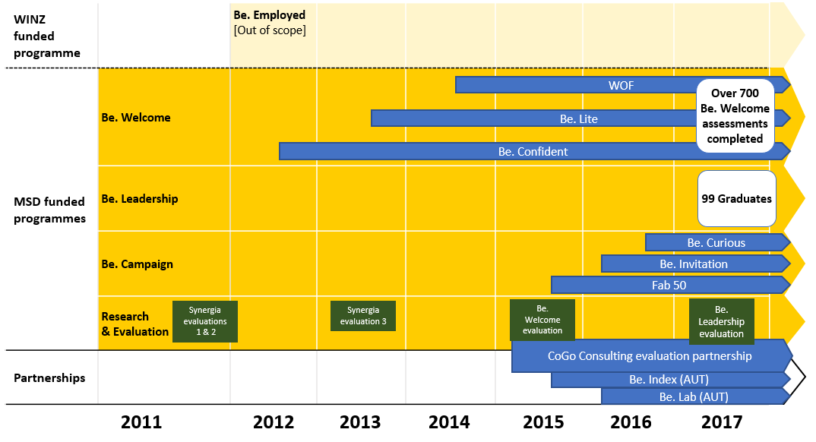

Overall reporting for the Outcomes Agreement is timely and detailed
The Outcome Agreements performance measures primarily specify reporting on outputs (volumes) across the three programmes (Be. Welcome, Be. Leadership and Be. Campaign). There is some requirement for more qualitative reporting through narrative reports (although again there is an emphasis on the number of reports required).
There is also a requirement that research is used to inform strategies and that evaluation is used to determine effectiveness and changes to the programme(s) as a result.
Table 2 (over the page) summarises the reporting against the contracted outcomes as at the end of June 2017. The results reflect that Be. Accessible had achieved or exceeded the quantity of service outputs, in some cases by a significant margin (e.g., number of new and existing organisations engaged with). It was observed that this pattern of achievement has occurred in previous years. The Be. Leadership programme was on track to meet its contract outcome for the past year until a participant withdrew from the course.”
An overall observation with the quarterly reporting is that there is a strong (and sometimes selective) emphasis on positive results. There is an opportunity for future reporting to be more reflective and self-critical of programme delivery (what worked well, what didn’t), to share lessons learned to help improve the development focus, and delivery of programmes and initiatives into the future.

Qualitative reporting on aspects of stakeholder engagement for Be. Welcome and for Be. Campaign is unclear
In the detailed service description for Be. Welcome there is a requirement to advance the programme through ongoing partnership and collaboration with disability service provider organisations, including gathering insights and impacts of the programme on them. While the organisations engaged with are listed in Be. Accessible’s quarterly reporting (seven – which is over the output target), it is not clear what the impacts of the programme are on these organisations, or the nature and quality of that engagement. It is also not clear what information was provided and what actions were agreed to, and the outcomes, through that engagement. One Disability Service Organisation listed for collaboration advised that they had not been engaged with the Be. Welcome programme.
There is also a requirement to provide narrative reporting on the extent to which the Invitation Campaign increases its reach across New Zealand resulting in access actions taken and shared. This does not appear to have been reported on. It is understood that this is partly due to an agreement with the contract manager to only provide generic reporting on Be. Campaign, rather than reporting on specific campaign activities (such as Be. Invitation).
Be. Accessible receives $1,000,000 per annum funding, which is allocated relatively evenly each year across the three programmes (Be. Leadership = $320,000; Be. Welcome = $330,000; Be. Campaign = $340,000, along with $10,000 for research and evaluation). (Table 2).
Table 2: 2016/17 Outcome Agreement – Performance Measures

Description of Service | Performance Measures | Quantity of Service | Results – Full Year (1 July 2016 to 30 June 2017)
Be. Leadership Programme  $320,000 | Number of participants on the Be. Leadership Programme | 15 - 20 | 14
Be. Welcome Assessment Programme  $330,000 | Number of new organisations engaged | 40 | 74
 | Number of existing organisations with deeper accessibility development | 60 | 95
 | Number of Be. Coaches/consultants engaged | Report actual | 16
 | Number of Disability Service Providers added to the Be. Welcome partnership | 3 | 7
 | Number of tourism focused partners providing information on the accessibility of each organisation | 2 | 5
 | Feedback from access citizens is positive | Report actual data in narrative reports | Final results yet to be reported
Be. Campaign  $340,000 | Promote accessibility and its relevance to all New Zealanders  Improve attitudes towards access customers among the business community  Us the Be. website and other communications and social media to increase knowledge and mobilise people to action  The Invitation Campaign increases its reach across New Zealand resulting in  ‘access actions’ taken and shared | 4 Narrative reports | 4 narrative reports completed which include some comment on the Be. Campaign  Data on website usage and social media reported  Reporting in Supplementary Report
Research and Evaluation  $10,000 | Use research to inform strategies and evaluation to determine the effectiveness and any changes to the programme as a result | 4 narrative reports | Evaluation Framework referred to. Evaluation commissioned. Summaries of all completed evaluation results not provided (some included, e.g., on Be. Leadership alumni).

There is a strong focus on capturing evaluative evidence within the development of an Evaluation Framework
Since the inception of Be. Accessible in 2011, there has been a contractual requirement to undertake research and evaluation. Five independent evaluation and research projects have been commissioned between 2011 and 2017 on Be. Accessible and its specific programmes and activities. Synergia conducted two evaluations in 2011 that informed the further development of the Be. Welcome programme. Synergia completed another evaluation in 2013 of Be. Accessible’s Social Change Programmes, which contributed to the development of the Fab 50. In 2015 Pink Striped Leopard assessed the effectiveness of the Be. Welcome website. Be. Accessible demonstrated its willingness to learn from these evaluations, for example by producing a formal response to the Pink Striped Leopard evaluation, outlining the approach Be. Accessible would take to address the findings.
In recent years Be. Accessible has proactively sought to build a stronger independent focus and culture of evaluation and research over and above the contract specifications. In 2016, Be. Accessible began developing an Evaluation Framework with CoGo Consulting. This is a positive step forward in adopting a more strategic evaluative approach (assessing progress towards identified goals).
The framework has the potential to generate quality evaluative feedback on the effectiveness of the programmes. The Framework lists several surveys and other evaluative activity that will capture information on the strategic goals.
The Be. Institute final report for 2016/17 includes a strong focus on evaluative activity and reports against the evaluation framework. A total of twelve different evaluation and research activities are listed in the report. However, it is difficult to draw clear conclusions as to the extent of the effectiveness/impacts of all the programmes because the reporting status varies, and/or is partial, and high level. Summary findings are provided in the report for the Be. Leadership survey (and a separate report has been submitted to the Office for Disability Issues) which indicates the programme is making a positive impact on the participants (see below). Additionally, there are a range of surveys which were commissioned and are referred to briefly in the report, however, the summary results for the completed surveys are not provided or appended. This creates a barrier if the reader wants to get more detailed information on these survey results.
The purpose and scope of Be. Accessible’s Access Citizens Survey and relationship to the Accessibility Survey is not clear
Currently, the overall purpose and scope of the Access Citizens Survey is not clear within the Evaluation Framework. Further, there seems to be some ambiguity about how the New Zealand Accessibility Survey and the Access Citizens Survey (also referred to as the New Zealand Census of Access Citizen’s Participation) interact, or whether they are the same thing.
While the Access citizens survey is described as seeking to determine ‘the state of access across New Zealand’ its focus seems to be narrower in assessing the ‘Access Travellers Journey’ and barriers to participation. The 2015 ‘Accessibility Survey’ was intended to provide the original baseline and benchmark of attitudes and experiences of New Zealanders in relation to accessibility, and was to be conducted annually, but this has not occurred. It was noted in the December 2016 – March 2017 quarterly report that the New Zealand Accessibility Survey is to be redesigned and presented in an annual report along the lines of the NZ Census of Women’s Participation, that will present the survey findings along with a range of other data (although it is not specified precisely how all the data will be collected/sourced). The April – June 2017 quarterly report states that a ‘revamp’ of the New Zealand Accessibility Survey is being scoped form 1 August 2017, but no deliverable date for this survey or the annual report is provided.
The 2017 Access Citizens Survey was distributed widely via a range of online channels, and 718 responses were received. The survey does not seem to have been translated into New Zealand Sign Language. The survey currently reports on public activities and events that ‘access citizens’ participate in, as well as what they would like to participate in if accessibility was improved.
There is an opportunity to either broaden the scope of the Access Citizens Survey, or the Accessibility Survey, to ensure either is comprehensive enough to become a baseline and benchmark to measure the overall shifts in social and community attitudes to accessibility in New Zealand (one of the five goals of Be’s programmes as stated in the Evaluation Framework).
There is a lack of direct feedback from the intended ‘end-users’ of Be. Accessible’s programmes (access citizens/customers)
In general, there is a lack of direct feedback from those who are the intended ‘end-users’ of Be. Accessible’s programmes, that is the people with access needs themselves and representative organisations for specific user groups (e.g., organisations representing disabled people, older people and so on). The 2015 evaluation of the Be. Welcome website by Pink Striped Leopard included some focus group feedback from a small selection of access users/non-users. The Access Citizens survey and related surveys capture high level information related to access customers interaction with the environment, services and facilities, but they do not ask direct questions about the quality and impact of the services delivered through the programmes on the end-users (those with access needs), e.g., the utilisation and quality of the Be. Welcome ratings programme (that is, do access customers find the ratings useful, accurate and so on), the quality of the website, and quality of the campaign activity.
This kind of information could either be captured through an expansion of the Access Citizens survey, through the development of the Be. Index (see page 47), or the development of a more specific satisfaction survey, and more direct consultation and engagement with representative organisations (such as disability sector organisations). This kind of evaluation could help capture more direct evidence of the impact on changes in accessibility (i.e., attribution). The kind of data that could be collected include: awareness, utilisation and quality of the Be. Accessible website (or related websites) for accessibility information; and awareness, utilisation and quality of the Be. Welcome ratings programme.

Access customers have experienced positive changes to accessibility
Fifty-nine percent of respondents to the access customers survey (conducted by Allen + Clarke for the review) had experienced noticeable positive changes in accessibility over the past five years. The three main changes identified are more physical spaces are accessible (70 percent; n=68), more information is provided in accessible formats (68 percent; n=66), and better customer service and understanding of access needs (65 percent; n=63).

It is not clear whether general public awareness of accessibility has improved
When it comes to greater awareness among the general public of accessibility issues, access customer survey respondents were fairly evenly split on this, with just over half (53 percent) stating there was greater public awareness.

There is a positive level of awareness of Be. Accessible
61 percent of access customer survey respondents had heard of Be. Accessible. Of those who were aware of Be. Accessible the majority referred to elements of the Be. Welcome and Be. Leadership programmes. When asked what they knew about Be. Accessible, 36 respondents mentioned Be. Leadership or training leaders with disabilities and 31 mentioned Be. Welcome/assessing accessibility.

Be. Accessible is making positive contributions to accessibility
Seventy percent of access customer survey respondents acknowledged that Be. Accessible is contributing to improving awareness and understanding of accessibility issues (n=128). 23 percent stating that Be. Accessible was contributing ‘quite a bit’ and 8 percent ‘a lot’ (Figure 1 – over the page).

Figure 1: To what extent is Be. Accessible contributing to improving accessibility?
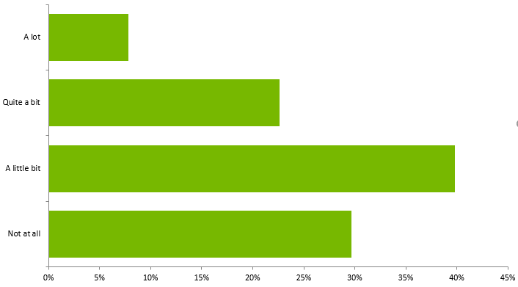

Survey respondents positively acknowledged Be. Accessible programmes but also offered a range of improvements
There were general positive statements about Be. Accessible (n=10), with respondent noting the impact on businesses:
“They're working proactively with businesses to support them to be accessible. This is really important because otherwise businesses wouldn't know what to do.”
The most common improvements were that there needed to be more focus on promotion of Be. Accessible (n=12), that Be. Accessible needs to work with other disability organisations (n=8), and that improvements are required to the programme (n=6). One respondent stated that:
“I believe there is a need for such a programme because accessibility in this country is lacking, but we’re yet to discover a programme that actually delivers the difference I think is possible.”
Another saw an opportunity to assist and connect more with disability organisations:
“They seem to provide a lot of positive attitude, but lack depth of disability understanding. The user-pays approach excludes a lot of organisations that might want to engage with them. They don't appear to engage much with grassroots disability organisations who could really benefit from being involved in discussions at the higher levels that Be. reaches.”

Be. Accessible is meeting its engagement targets
Based on the quantity of engagement above, Be. Accessible is meeting its agreed collaboration outcomes, and its ability to collaborate and partner with businesses and organisations is a real strength. However, collaboration between Be. Accessible and disability organisations has emerged in our stakeholder engagement as a key area for improvement. Of eight interviews with disability organisations (some involved twin and group interviews), seven stated there is an issue with inadequate collaboration between Be. Accessible and the sector. The lack of collaboration has been described in the following ways by disability organisations:
“Be. Accessible has missed opportunities to meet with the disability community. Unless Be. Accessible can engage with the community, the community will not get behind Be. Accessible.”
“[We] have not had much involvement with Be. Accessible…there is no relationship, which is not optimal but that is not to say there is a bad relationship.”
“[We] have found it difficult to develop a working relationship.”
“Be. Accessible has little time for other organisations in the sector.”

There is significant scope to improve the quality and extent of engagement with the disability sector
As noted earlier, the Outcome Agreement to June 2017 provided that Be. Accessible partner and collaborate with three Disability Service Providers to advance the Be. Welcome programme and engage with three Disability Service Providers to gather insights into the programme’s impact. The quarterly report to June 2017 notes that Be. Accessible has collaborated with the following seven disability service providers:
- The Blind Foundation;
- Independent Living Services;
- The Halberg Disability Sport Foundation;
- Paralympics;
- Touch Compass;
- Polo Driving School; and
- Disability, Spirituality Faith Network.
The three disability service providers Be. Accessible has engaged with to gain insights into the impacts of the Be. Welcome programme are:
- Blind Foundation (in progress);
- Deaf Aotearoa (in progress); and
- Artificial Limbs Service.

There is a willingness for more engagement between disability sector organisations and Be. Accessible
There is support for greater openness and collaboration to occur with Be. Accessible, as evidenced by the following statements from disability organisations:
“[We] want Be. Accessible to be successful, as want to see the disability sector grow”
“Be. Accessible can’t do this work on their own. All organisations in the disability sector have a vested interest in succeeding.”
“Like to think we are all in it for the same reason, so would appreciate closer collaboration with Be. Accessible.”
“The disability sector needs strong organisations, and the Be. Accessible leadership has connections – they just need to use them for the interests of the sector.”

The Office for Disability Issues may have a leadership role to foster increased engagement and partnering
Several individuals from across the stakeholder groups of government, alumni, and disability organisations observed there is a greater leadership role for the Office for Disability Issues to play. This role is to assist Be. Accessible and disability organisations to work together, to improve understanding, and influence funding processes which impact on the nature of collaboration and partnering.
Five stakeholders consider that funding is an issue in collaboration. One noted that:
“A competitive funding environment does not help collaboration. It would be useful if ODI could do some thinking about the competitive funding process and the ability to achieve social outcomes.”
A stakeholder from the alumni group considers:
“There is a problem with mistrust of new organisations… don’t know what it will take to change, but suspect government has a role to play in how they fund organisations.”
One government stakeholder observed that:
“The organisations can complement each other…and there is a role for ODI to focus organisations’ purpose and make the sector aware of a strategy for how Be. Accessible could help disability organisations.”

Improved engagement needs to start with better understanding of the respective roles of organisations within the sector, acknowledgement of their histories and what they can contribute into the future
It was suggested that before collaboration can happen, there needs to be an understanding reached about the role, strategy, and place of the different organisations in the sector, and efforts made – on all sides – to heal past frustration and put the potential for a future relationship on a sound and positive footing.
There also needs to be a building of trust and respect. One such stakeholder observed:
“The disability sector is fragmented as it is defined and siloed by impairment type. We need to get beyond that to link up and work together.”
“We need to develop a high-level of trust between organisations to push for change. This development has two elements:
- government trusting organisations by not being too prescriptive with funding requirements and providing freedom; and
- trust between disability sector organisations; perhaps achievable through working together on a mutual project to break-down organisational barriers and develop trust.”
This healing includes Be. Accessible acknowledging the ‘hard yards’ and extensive and challenging on the ground work many long-standing disability sector organisations have put in before Be. Accessible even existed.

Partnering with the disability sector could help Be. Accessible extends its reach and impact
There could be collaboration both in terms of sector-wide initiatives to improve understanding of accessibility issues, or to work on particular initiatives, where expertise could be shared for mutual benefit on complementary activities. One disability sector stakeholder stated:
“There is power in working together, and we can have a better effect if we stop to talk to each other.”
Be. Accessible’s strengths include marketing, networking, partnering, influencing, and persuading. These skills and competencies have helped the organisation develop useful partnerships across private, not-for-profit and increasingly public sector organisations. There is an opportunity to share this knowledge and business savvy to help disability sector organisations to improve their impact in achieving shared goals. One disability sector stakeholder commented:
“[We] would like to see Be. Accessible engage more with the sector…and support it with Be. Accessible’s social change know-how.”
Another stakeholder suggested a way of achieving this (working together) might be through secondments between these entities, and/or putting something in the Disability Action Plan about these entities working together intentionally.
Building stronger relationships in the disability sector may also provide an opportunity for Be. Accessible to leverage greater efficiency through utilising the strengths of partner organisations to achieve mutual goals and reach a wider audience. Be. Accessible also acknowledge that there is an opportunity to be more effective if they could work more closely with disability sector organisations (including the DPOs).

    - Effectiveness of individual programmes: Be. Leadership, Be. Welcome, Be. Campaign
Focus | Key review questions and conclusions
Effectiveness | KRQ1: How effective has Be. Accessible been in achieving the agreed outcomes as specified in MSD contracts?
Be. Leadership
- Be. Leadership is having a positive impact on participants and broader impacts

Be. Welcome
- The Be. Welcome philosophy connects with businesses
- The Be. Welcome ratings system is comprehensive; although disability sector organisations have concerns about the consistency and comparability of ratings

Be. Campaign
- The focus and purpose of Be. Campaign is unclear; while the Fab 50 and ability to leverage media is a strength

Be. Leadership programme

Be. Leadership is impacting positively on participants and there are indications it is having broader impacts
Be. Leadership was established because of a perceived paucity of tailored programmes to develop leadership among disabled people.
Be. Leadership has the strongest evaluative evidence base for impact. In addition to the positive impacts on the participants themselves, there are indications that the ‘transformative’ nature of the programme for individuals is spilling over into their respective communities. Graduates now understand leadership differently and are beginning to take up leadership opportunities and initiatives in their communities. The fact that there are now almost 100 graduates spread across the country helps add to the social change potential on accessibility over time.
An independent evaluation was conducted by online survey of leadership alumni who had taken part in the programme from its inception in 2011 to 2016 (sent to 89 alumni and 55 responded, a response rate of 62 percent). The survey canvassed the impacts of the programme on participants’ personal and professional lives, subsequent career choices, and the impact they are having on the communities in which they live and work. Key findings included:
- 85 percent ‘strongly agreed’ or ‘agreed’ that their leadership capability increased as a result of the programme;
- 82 percent reported taking action in their career in order to make the most of their strengths;
- Alumni are connected to a range of communities (44 percent);
- 87 percent said they were ‘very likely’ (71%) or ‘likely’ (16 percent) to recommend the programme to others; and
- 68 percent consider the alumni network valuable.
While the majority of participants returned to their current paid or voluntary employment, or studies after graduation, for many the programme resulted in a new direction. It was reported that 40 percent started a new project/initiative, 36 percent started a new programme/course of study, 15 percent began volunteer work, and two people began a board directorship.
While the evaluation provides useful information on the impacts on individuals and some broader impacts, there could be more exploration and reporting on the delivery of the programme by Be. Accessible and what specific actions could be taken to improve it.
The post-graduation experience of some of the alumni spoken to for this review indicates the potential broader impacts the programme can have. For example, a graduate noted that around one third of the class had made significant contributions regionally and nationally since being on the course. Another graduate had established an advocacy group, and another had established a self-help network.
Five alumni were interviewed as part of this review. The majority stated they had benefitted personally – as well as professionally – from their participation in the programme. During the interviews, they used terms such as ‘watershed year’ and ‘greatest experience of my life’.
The diversity of the participants was identified by a number of those spoken to as a strength of the programme, something that Be. Leadership deliberately sets out to foster within the programme. However, this wasn’t a universally held view. Some participants in the review felt that those with certain disabilities were not well catered for, particularly those with learning disabilities. More broadly, one participant commented that Be. Accessible was not a particularly diverse organisation: “it is made up of predominantly middle-class white people”, and that there wasn’t much diversity among Be. Leadership participants or the speakers invited to talk. It was also suggested that there might need to be some more work to help Māori and Pasifika populations see Be. Accessible as a relevant organisation for them.
According to Be. Accessible the programme is designed to be fairly advanced. There is a perception by some of those spoken to that the programme is too focused on those who are well-educated and already leaders, or are on the leadership pathway, and so the programme could be extended to those who are not yet on the pathway. It was acknowledged by Be. Accessible that it is a challenge to get the right mix of people.

There is a lack of a formal alumni programme as part of Be. Leadership
There was a common view that more could be done to strengthen and formalise the alumni programme. It was noted by some participants that there ‘isn’t so much going on’. Graduates want to remain connected and build a network and community. This is considered as particularly important to ensuring that the impacts of the programme can be sustained. Be. Accessible acknowledges these challenges, noting there are financial constraints for most of the alumni who are disabled around getting to the occasional (mostly social) events and graduations.
Stakeholder engagement suggested that Be. Leadership alumni activities are informal; that there is a Facebook page and occasional social events, but that essentially it is up to alumni themselves to collaborate and maintain their connections post-graduation.
Of the five Be. Leadership alumni we interviewed:
- One was not active in alumni activities;
- One was positive about the current level of alumni engagement;
- Three considered the activities were mainly social, and that it was left to alumni themselves to maintain contact (which means relying on a few key people). Therefore, there could be a place for Be. Accessible to help maintain connections.
One of the alumni stated that it would be beneficial for Be. Accessible to do something:
“around connecting people and helping them to maintain connections with each other, and with philanthropists, as disabled people need to link up and collaborate in order to change the environment.”
We consider the alumni would benefit from further support and a formal programme to maintain the investment made in them, and better ensure achievement of the programme’s purpose.
A few disability sector organisations commented that they were not clear on the status of the Be. Leadership programme and that they had thought it had ceased. While these organisations get the newsletters from Be. Accessible, there may also need to be more targeted and face to face communication about the status of the programme. Be. Accessible advise that every year, Be. Leadership writes letters to the Chief Executives of the DPOs and Disability Service Providers inviting them to put forward candidates for the leadership programme. This is in addition to newsletter content and social media.

Be. Welcome programme

The Be. Welcome holistic philosophy of taking businesses on a journey connects with businesses
The majority of businesses interviewed for the review that have engaged with the Be. Welcome assessment and ratings system are very positive about their experience, the holistic scope of the assessments, and the positive encouraging way coaches help take businesses on the journey towards accessibility. According to Be. Accessible, Be. Welcome is about building relationships and transformational change and not seeing Be. Accessible as ‘auditors’. It was noted that without the journey, Be. Welcome would just be another benchmarking assessment tool: “which people don’t take a shine too.” The philosophy is to focus on the entire customer experience.
Be. Accessible’s own survey of ‘most engaged’ businesses indicated that businesses are making some positive changes as a result of engaging with the Be. Welcome programme (the number of businesses surveyed was not specified). 83 percent of the businesses engaged to improve how they deliver customers service, 67 percent had achieved their desired outcome (although the outcome was not specified). 40 percent of business had made 1 to 5 changes, and a further 40 percent made 21 plus changes.
Feedback from a number of businesses interviewed reinforced this broader view. Be. Welcome had ‘opened their eyes’ to the wide range of people with accessibility issues, and changed their perspectives. Some businesses talked about engaging with Be. Welcome initially to tick a box, but changed their view to wanting to ‘do the right thing’ and make a broader cultural change.
Some brief case study examples of Be. Welcome business collaborations provided by Be. Accessible are included in Appendix 1.
It was also commented by the businesses that Be. Accessible’s approach is very patient and flexible, working around business operational needs, so as not to disrupt day to day business activity (e.g., working around opening hours). One business survey respondent stated:
“Fantastic movement full of passionate and helpful people. A great gateway to finding connections in the community, growing staff awareness and understanding of access challenges.”
“The willingness of Be. to customise their services to our needs has been one of the main reasons we have engaged with them”
“Be. Accessible engage people, businesses & communities - the programmes offer support, knowledge and a "moving forward" attitude. I am very proud to work alongside Be.”
Be. Welcome is trying to move beyond tourism and small businesses to other sectors, such as local government, which provides opportunities to broaden its impact and bring together multiple groups with an interest in accessibility. This is starting to occur in Auckland and particularly in Wellington (the Wellington Hub).
A fundamental element of Be. Welcome that seems to be having an impact is the Be. Confident workshops, which address the broader cultural change in organisations. Be. Accessible explain that Be. Confident takes businesses beyond minimum standards and to look through a different lens. Once people understand the ‘why’ they get the ‘what’ and the ‘how’. People realise accessibility is about them too as they get older, or injured, it’s not just ‘those people out there’. It was noted that larger businesses are approaching Be. Welcome to run the Be. Confident workshops, which has the potential to impact on more staff, and ultimately more customers.

There is high engagement by businesses in Be. Welcome
Among respondents to the business survey, engagement with Be. Welcome is high with a total of 75 percent indicating that they were reasonably to highly engaged (Figure 2 – over the page).
When asked about the reasons for the level of engagement, those that are reasonably to highly engaged reflected a strong focus on improving accessibility and having a strong relationship with Be. Accessible. One respondent commented:
“I work with Be. closely and have a great relationship with the Be. programme manager... I also engage our staff to participate in the programme - this year there were approximately 60 staff”
Those that were seldom or not engaged with Be. Welcome noted that they either needed to proactively contact Be. Accessible, or the programme doesn’t really assist their business.
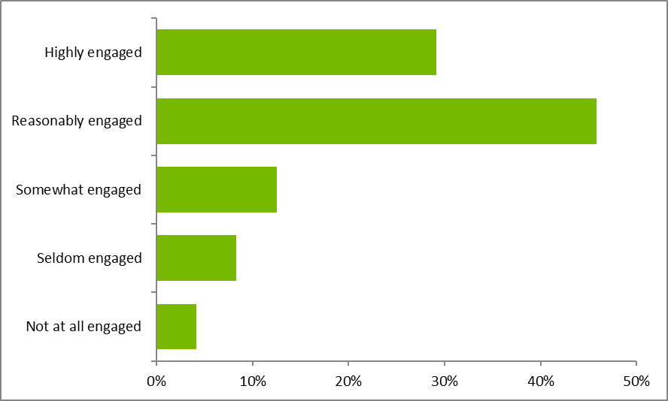
Figure 2: Level of engagement with Be. Welcome

Businesses rated the experience of working with Be. Welcome very positively
All businesses rated the experience of working with Be. Accessible as positive, with the majority (54 percent) responding excellent (Figure 3 – over the page).

Figure 3: Experience rating of working with Be. Welcome
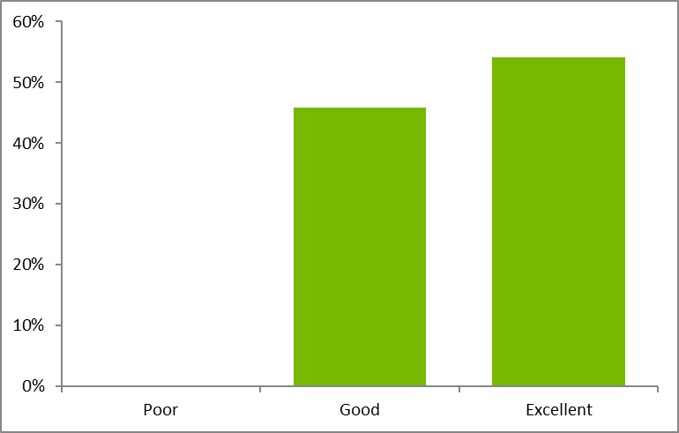

The ratings system is attracting more customers with access needs to businesses
A total of 58 percent of businesses believe more customers are attracted to their business because of the rating system (Figure 4).
Figure 4: Extent to which rating has attracted more customers
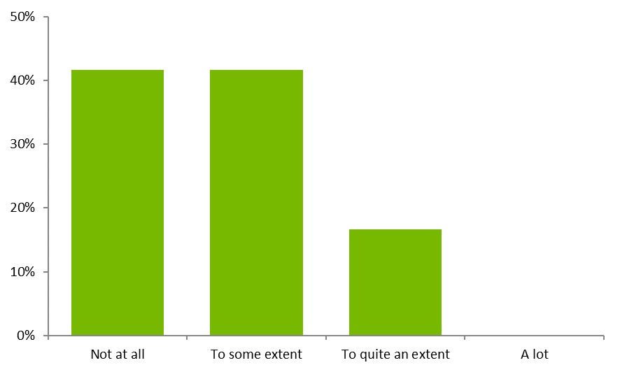
Respondents who noted that the accessibility rating system attracted more customers with accessibility needs to their business stated that:
- Being Be. rated had increased awareness for their business (n = 3);
- Their clients either need, or expect accessibility in businesses (n = 3); and
- They can now use the rating in marketing (n = 1).
One respondent said that they look for venues that are also partners to Be Accessible. Another respondent stated that most people weren’t aware of the meaning of the ratings.
The respondents who said that the Be. Accessible rating has not attracted extra customers with accessibility needs to their business, provided the following reasons for their answer:
- Difficulty finding the business on the Be. Accessible website (n = 1); and
- No feedback through surveying of visitors or feedback forms that visitors have chosen to come due to Be accessible rating (n = 1).

Businesses have made a range of changes to improve accessibility
Businesses have made a range of changes to improve accessibility as a result of engaging with Be. Welcome, including improved physical spaces and signage, and most notably improved customer service (Figure 5). The improvements in customer service reinforce the broader, holistic focus of the Be. Welcome programme.
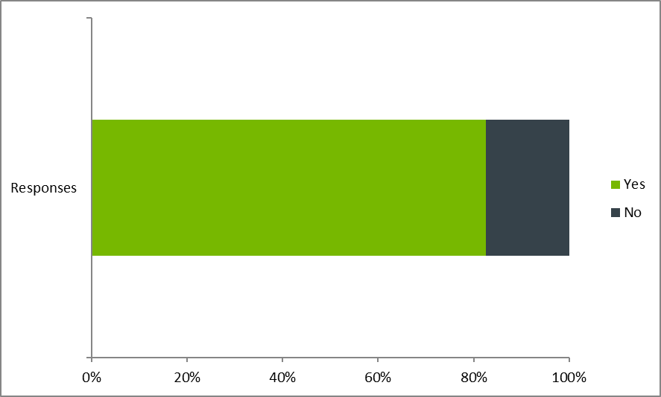
Figure 5: Changes made as a result of engaging with Be. Welcome

Businesses understand disability issues differently due to working with Be. Welcome
The majority of businesses who responded to the survey stated they understand accessibility issues differently as a result of working with Be. Welcome (Figure 6) and most have acted as a result (Figure 7 – over the page).
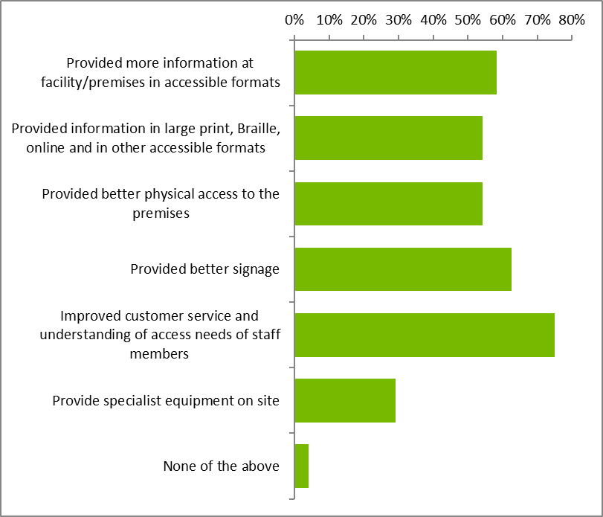
Figure 6: Has the business understood accessibility issues differently because of working with Be. Welcome?

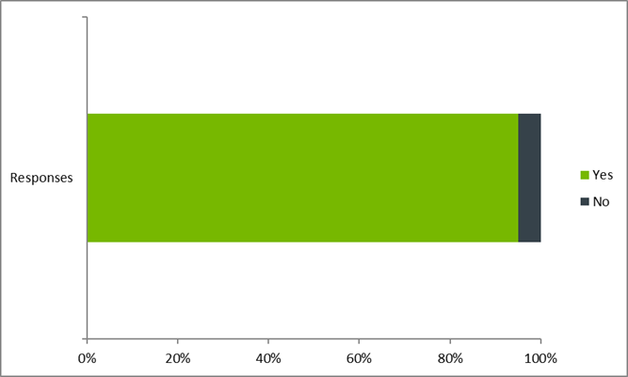
Figure 7: Has this understanding of accessibility led you to take action?

The most common examples of action taken by respondents following gaining an understanding of accessibility were:
- Modifications to buildings;
- Providing accessible information to customers;
- Choosing accessible businesses; and
- Increased training (staff).

Accessibility information is sourced from a mix of channels – with the internet and friends most common
When asked about where people get information about what services or facilities are accessible, there was a mix of information channels: a majority (54 percent) mentioned the internet, followed closely by friends (53 percent), then organisations (39 percent), and family (30 percent). (Figure 8 – over the page).

Figure 8: Where do you get information on accessible services and facilities?
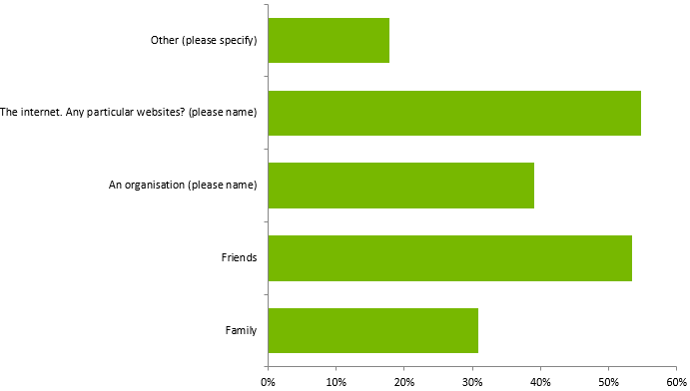
Looking more closely at which internet sites people identified as having accessibility information available, the top three sites mentioned (excluding other) were CCS (26 percent), the business directly (19 percent) and then Google (11 percent). The Be. Accessible website was mentioned by five percent of respondents. (Figure 9 – over the page).

Figure 9: Website or organisations where accessibility information is available
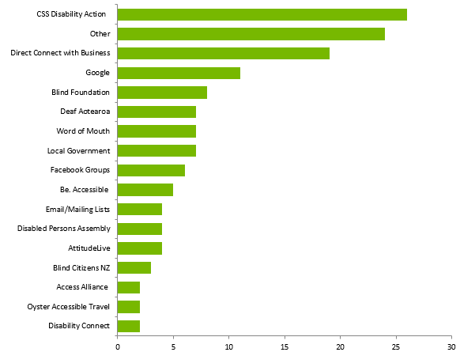

Awareness and usage of the Be. Accessible website is relatively low
When the Access customer survey respondents were asked whether they are aware of the Be. Accessible website (which provides information on accessible services), 40 percent said yes (n=150).
When asked whether they used the website (Figure 10 – over the page), 72 percent of respondents stated they did not use it (n=89), with the most common reason being that they thought the information was incorrect, or of no use to them (n=20). Of those who do use it, three stated they referred to it for updates on Be. Accessible programmes.
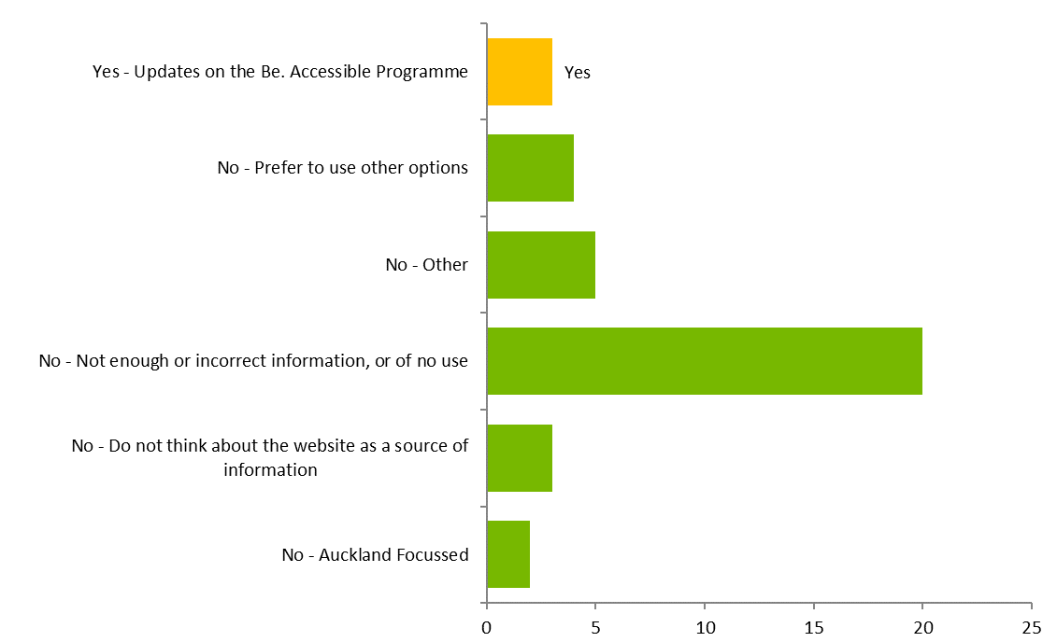
Figure 10: Reasons for using/not using the website

The Be. Welcome rating system is comprehensive, but there are concerns about the consistency and comparability of the ratings among the disability sector
The majority of the disability sector stakeholders interviewed, as well as a few businesses, had some concerns about the consistency and comparability of the ratings system. Seven disability sector stakeholders consider there are issues with the Be. Welcome ratings. Five raised a specific business as having received a Be. Welcome rating (gold), which they did not think resembled the reality of accessing that business. These concerns reflect a broader perception issue about the ratings system that needs to be addressed.
One disability sector stakeholder stated that the ratings compromise on accessibility requirements and water down standards meaning businesses and other organisations responses will be to reduce to the minimum, noting:
“a business is either accessible or it is not. If the way to access a business is via stairs, then it is not accessible – it does not matter how friendly the reception is if people cannot get to it.”
Another stakeholder commented:
“[the] ratings don’t seem to match reality… not sure of the basis for judgement.”
Another organisation commented that they are unsure how the audits of businesses are qualified, and that Barrier Free New Zealand (BFNZ) used to do this auditing work. There was a perception that BFNZ stopped doing audits as they were being confused with Be. Accessible’s. This organisation questioned why all organisations aren’t using standard 4121, and has the sense that Be. Accessible’s ratings are devaluing accessibility, and there is a lack of consistency. While Be. Accessible notes that Be. Welcome is built on standard 4121, there is clearly a perception issue that needs to be addressed in the disability sector.
The concern for some DPOs was an apparent lack of consultation, outreach and publicity on the development of Be. Welcome, two commenting:
“..there has been no discussion or consultation about what Be. Accessible’s standards mean.”
“We want organisations to get on the same page about access standards.”
A few organisations mentioned concerns about the how the ratings assist people with specific disabilities. Two examples being:
“Be. Welcome ratings are not equitable for blind people… [xx business] has a definite lack of braille, yet received a gold rating.”
“Learning/intellectual disabilities have been left out..”
Another stakeholder commented that while not aware how the ratings system was set up, there has been a positive benefit in terms of raising awareness among businesses of how they can make workplaces more accessible.

Awareness of accessibility ratings systems is low, although highest for Be. Welcome
According to the Access customers survey, 40 percent of respondents (n=56) indicated that they were aware of any accessibility ratings systems for services and facilities. Of those who could name a specific ratings system (Figure 11 – over the page), half named Be. Welcome (49 percent), followed by Barrier Free (15 percent), then LifeMark (9 percent).

Figure 11: Named accessibility ratings systems
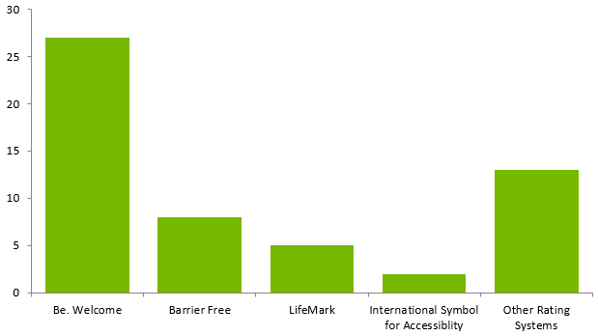
Thirty two percent (n=43) of those who responded aware of the Be. Welcome programme ratings (i.e., Platinum, Gold, Silver, Bronze).
Further, the majority of respondents (66 percent, n=89), don’t currently look for ratings systems when searching for a service or facility.

A minority of the respondents stated the Be. Welcome ratings influence whether or not they will use a service or facility
Twenty seven percent of those who responded to this question (n=35) stated that the Be. Welcome ratings system influences whether or not they would use a service/facility. Among those who do not use the system and stated a reason for their answer, the most common response was that they were not aware of the ratings system (n=33), the accessibility ratings were not accurate or suitable to access needs (n=19). 21 respondents stated that they use the ratings to influence their decision.

Be. Accessible has worked to evolve the ratings system since its inception
Be. Accessible has developed and invested in the Be. Welcome ratings system over six years. The review team was provided with a demonstration of the live extranet view of the assessment tool and observed the detail of the tool. The broad focus of the assessment tool beyond physical assessment to the customer service element has resulted in a comprehensive assessment tool covering more than 800 questions. Be. Accessible has done some work to try and explain the fundamental differences in the scope of its accessibility assessment construct. A paper was produced by Be. Accessible to compare their assessment to the narrower physical assessment provided by through Barrier Free New Zealand’s audit tool to help explain that the Be. Welcome assessment is fit for its (broader) purpose (see Diagram 2 over the page).
Diagram 2: Scope of Be. Welcome accessibility assessment compared to the Barrier Free New Zealand audit
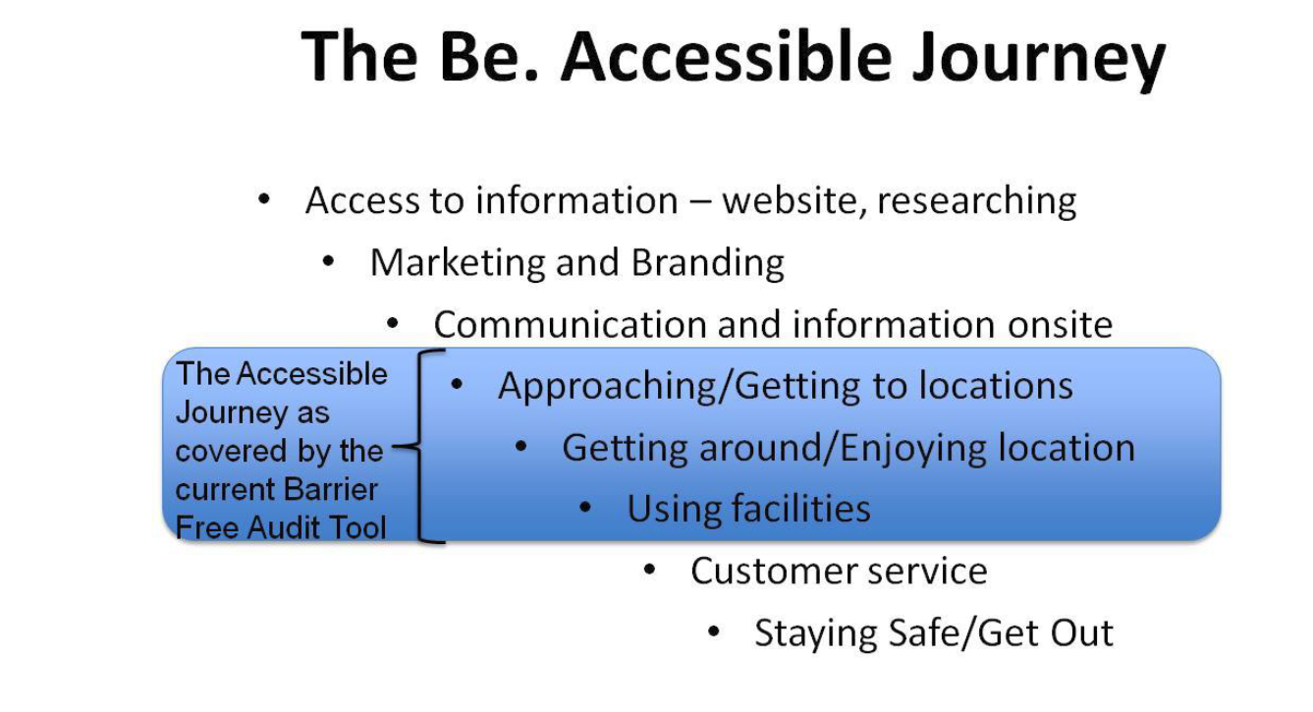
Be. Welcome Master Coaches who use the tool are also barrier free assessors and have a good knowledge of the building code requirements. Some of the businesses spoken too acknowledged that the assessment process is comprehensive, and they have detailed reports to refer too. Summary reports are also provided online on the Be. Accessible website. There are also a number of case studies provided across different types of businesses.

Be. Accessible’s ability to collaborate with business is a real strength and niche with significant potential
Be. Accessible is clearly a connector with private sector businesses, and this area could be considered the organisation’s niche. Be. Accessible deliberately started in access tourism and while this focus is still important, it is extending into other key areas such as local government and could go much broader.
Be. Accessible believes that after six years of development and testing, it has developed a method and framework that could be applied to any type of organisation.
An example of a current collaboration that reflects the space Be. Accessible is moving towards, is a collaboration with AUT. This collaboration offers mutual benefits for both Be. Accessible and AUT as the two organisations explore establishing an accessibility ‘centre of excellence’. Be. Accessible gains access to considerable research expertise and is also supporting AUT with its goal to become a fully accessible education institution. The two initiatives are:

Be. Access Index
This flagship project involves developing an index of accessibility based around the individual (rather than physical spaces or services). The aim is to measure the way New Zealand deals with access challenges. The index is intended to be international and measured across jurisdictions. The need for international benchmarks was mentioned by at least one Be. Welcome-rated tourism-focused business. This collaboration also helps strengthen the evidence base for Be. Accessible’s social innovation and social change approach by drawing on robust research capability.

Be. Lab
Be. Lab is an initiative that includes working with researchers at AUT who established a design lab at Auckland hospital. This provides access to designers and design students who are developing innovative solutions to accessibility issues. The broader Be. Lab concept reflects a maturing of its role to be a social enterprise that is principally an incubator of accessibility ideas, which partners with others (private sector, local government, health, and potentially disability sector organisations) on delivery.
While Be. Welcome is particularly strong on supporting organisations that are customer facing (e.g., tourism/hospitality, retail) there are businesses/organisations that aren’t public/customer facing – such as ‘back offices’, which could also benefit from accessibility assessments and dialogue.
There are also large sectors such as health (particularly hospitals) and social service agencies that are ‘customer’ facing, and where access issues are critical that could benefit from engagement with the Be. Welcome programme. One respondent stated that partnerships are needed with government (for support and alignment of programmes), the ‘traditional’ disability community (to leverage skills and thinking), and the education sector.
There could be an opportunity for Be. Accessible to use their private sector engagement expertise, networks and influence to broker engagement between business and other disability organisations to help support those organisations deliver to their respective stakeholders.

Be. Campaign

The overall purpose, focus and reach of the Be. Campaign is unclear
The purpose, focus and reach of Be. Campaign is currently somewhat unclear in the absence of an overarching communications plan that explains the goals, strategy and tactics.
There were mixed views from government stakeholders on the effectiveness of Be. Campaign, reflecting a lack of clarity about the purpose and focus of the campaign element. One government stakeholder considered that Be. Accessible’s online presence is minimal and stated they are unsure what Be. Accessible’s plan is regarding Be. Campaign. The same stakeholder also said that they would like to see Be. Accessible grow its campaign arm. A second government stakeholder advised they had not seen anything of Be. Campaign since the launch of Be. Accessible, and thinks it has ‘died away’. A third government stakeholder advised they are unsure how Be. Campaign works. While a fourth government stakeholder considered that “Be. Accessible is strongest at the campaign side of its work”, and thinks the Fab 50 is a good example of the campaign by getting high-profile people to be access champions. This government sector stakeholder also felt that Be. Accessible has achieved some of the most effective attitude and behaviour change in the disability sector and that the campaign side of their work is their strength.
One of the alumni observed that Be. Campaign seemed strong in the first two years, but considered it was not so well known now as other programmes have taken a lead. And one stakeholder associated with Be. Accessible considers the communications programme will take off again under a new Director.
Of the disability sector organisations spoken to in the review, only one could describe elements of Be. Campaign and what it is trying to achieve in terms of social change. Two other organisations stated they did not know what the Be. Campaign was about but they were aware that Be. Accessible has received funding to deliver a communication campaign. One commented that as far as they were aware Be. Accessible is the only (disability-focused) organisation in New Zealand with funding to do this kind of work. The project review team note that some other disability sector organisations do appear to receive some funding for campaign-initiatives.
Be. Accessible suggests that ‘Be. Campaign’ is probably not the right language for that arm of the programmes. The ‘campaign’ terminology possibly implies a traditional national mass media campaign, yet the programme was never funded to run such a campaign. The communications element of Be. Campaign is described as a ‘multi-channel’ approach, including Facebook, Twitter, direct mail (newsletters), alumni celebration, speaking engagements and events. The Be. Accessible website is also a campaign channel and resource.
The Be. Campaign programme elements have varied over the years of the programme. In earlier years there was a detailed three-year campaign plan, and a range of initiatives implemented and reported on. While campaigns have continued to be delivered it is not clear how they fit into an overall plan. The Invitation was included in the 2016/17 Outcomes Agreement to be reported on. Be. Accessible advised that the Outcomes Agreement has become more generic in recent years, so that detailed reporting on specific campaign elements has not been required. So, while it was not directly reported on in the June 2017 report to MSD, Be. Accessible provided a summary on The Invitation for this review, outlined over the page.

The Invitation
In late 2015 ‘The Invitation’ campaign was launched. The Invitation is a 40-minute documentary that was used as one of the many initiatives and tools that Be. Accessible has piloted and launched to New Zealanders aimed at raising awareness of accessibility. ‘To Be. Me’ documents the value of people with access needs, and invites people across New Zealand to work with Be. Accessible to create greater access across the country. The campaign was delivered in partnership with Fairfax Media and Neighbourly who promoted the campaign and hosted the video on the stuff.co.nz platform. Be. Accessible also promoted the campaign through its Facebook and Twitter channels.
By the end of July 2016 over 1,500 screenings had been held online and approximately 150 screenings were held in homes, community centres, schools, and in workplaces using the DVD pack. To date, the video has been viewed online 1,704 times. Be.’s social media channels performed well with Facebook likes growing by +21% between November 2015 and July 2016 and the number of Twitter impressions sat at 38,800. This film and take action toolkit became a valuable engagement tool for the Be. Team.
In terms of flow-on impacts, it was noted that there was a media impact with national media coverage generated of $111,000. A Be. Welcome coach in Wellington was able to leverage engagement with a number of organisations through the screenings.
Finally, the CEO of Brilliant Software attended a screening, which led him to connect with Be. Accessible to find out more about the organisation. Brilliant Software has committed approximately $200,000 in pro bono effort to redevelop the Be. Welcome assessment tool for Be. Coaches so that it could be more flexible and effective to allow Be. Accessible’s ratings of businesses across New Zealand to be shared with other tourism databases.
This campaign for a period of 18 months provided a platform for deeper engagement in accessibility across New Zealand. It increased the awareness of the social change movement and the reach of the campaign as evidenced by the media coverage and many actions of people across the country.

Be. Accessible has successfully leveraged media
Be. Accessible has been able to consistently leverage significant national and local print and on-line media coverage on its accessibility message and work since its inception in 2011, for relatively little financial investment. Be. Accessible note that they have managed to tap into a relatively high level of media coverage through the Chief Executive’s media profile. It was also noted that there have been spin-offs into the Be. Employed programme through the media connections, with Fairfax Media and BFM taking on interns within their organisations. Be. Accessible reported that for 2017:
“Be.’s PR company has recorded an equivalent PR dollar value of over $1,000,000 in PR presence – all of this on a small budget allocation of under $10,000 each year to PR”.
It was commented by government stakeholders that the Be. Accessible’s online presence is minimal. Be. Accessible reports on social media activity for its Facebook and Twitter accounts, and its newsletter distribution. The newsletter distribution has remained at the same level (4500) for several years, and the open rate has also not changed. The number of followers on the Facebook page (2700) is quite small for an organisation that has a dedicated social campaign programme, focus and deliverables. By comparison it is noted that some disability organisations have similar, or much higher followings. For example: CCS Disability Action (3000), Deaf Aotearoa (8500), Blind Foundation (8700).
Be. Accessible has also had a focus on delivering presentations as part of communicating its social change message through a wide range of fora (e.g., TEDX) and organisations over the past five years. Be. Accessible note that this includes presentations specifically to disability organisations, organisational teams, conferences, expos and collaborative communication events with other disability organisations (e.g., The Our Place event, in partnership with Inclusive NZ).

The Fab 50 is a positive strategic innovation
The Fab 50 is a new component of the Be. Campaign established in 2015, which was informed by an evaluation of the impact of Be. Accessible’s Social Change Programmes on influencers across New Zealand. It is a useful strategic approach to broadening the accessibility message and gain access to influential supporters and their networks, which is having some significant flow-on impacts. A Be. Accessible trustee noted that the network is an important part of Be. Accessible’s work, it both helps build a community of passionate advocates, but also provides access to skills and networks for the small team.
The Fab 50 has connected Be. Accessible to a wide range of influential New Zealanders in the private and public sectors. A number of the members are Chief Executives and their support has given Be. Accessible access to significant skills, expertise and organisations. These connections through the Fab 50 have led to partnerships and support from the likes of Yellow Pages Online, AUT, and the Wellington City Council. One Fab 50 member noted that Be. Accessible had recruited champions from across society.
    - Effectiveness of the social innovation approach
Focus | Key review questions and conclusions
Effectiveness | KRQ2: To what extent has the social innovation approach been effective at delivering to the agreed outcomes?
- Be. Accessible’s social innovation approach is having a positive effect, providing a new lens and language
- Be. Accessible’s role and approach is not well understood by some stakeholders, particularly in the disability sector
- Given the nature of social change, it will take time to see the results of change

Be. Accessible sees its role as a social change agent and social innovator and the approach is having impacts
Be. Accessible sees its role and focus as a social innovator and social change agent. Its fundamental approach is to reframe disability as accessibility and ultimately possibility – and achieve full accessibility in New Zealand.
The Be. Accessible philosophy is explained as beginning with the ‘Be. Lens – a new way of looking at the world’. It changes the emphasis from barriers and exclusion to ‘a sense of engagement and generosity from every member of society’. The Be. Accessible website characterises the language and approach as:
“The language that reflects this new lens is about "accessibility" rather than "disability", about possibility rather than limitation, about innovation rather than the status quo. We talk about access citizens, access customers, the access economy, and accessible people!”
Be. Accessible explain that for true accessibility the ‘three pillars of life’; physical (physical and information environment), social (inspiring people to think differently) and personal (creating individual and collective leadership capacity to facilitate transformative conversations and engagement) need to be addressed together.
The reframing of disability to accessibility includes identifying that all New Zealanders have access needs at some point in their lives – and so the aim is to encourage people to think deeply about accessibility and begin to value the contribution that disabled people make to New Zealand. Be. Accessible created a brand, identity, and a social movement which it hoped any organisation would be proud to be associated with. Be. Accessible recognises that for any social change to happen, the attitudes of everyday New Zealanders are critical, either as an ‘enabler’ or ‘disabler’. The challenge for Be. Accessible was to invite people into a different conversation about accessibility. That included focusing on ‘economic opportunity’, tourism, the ‘Yellow Dollar’ and shifting away from a ‘welfare conversation (Be. Welcome)’; leading change (Be. Leadership) and social movements (Be. Campaign).
Be. Accessible also acknowledge that the nature of social change is to be ‘disruptive’ to the status quo, and this can create tension.
Be. Accessible’s overall social change and innovation approaches reflect standard approaches to social change, innovation and stage of behaviour change theory. That is to primarily focus on:
- targeting the early adopters (those most ready to change, e.g., the most receptive businesses and individuals);
- work in parallel with those showing an interest; and
- not explicitly focusing on those who may not be ready to change at present.
Almost two thirds of stakeholders commented on Be. Accessible as a social change agent and its social innovation approach. Those working directly on the programmes had a strong understanding of the concepts and approach, and how Be. Accessible’s work has reflected social innovation and social change. Almost a quarter saw Be. Accessible as a leading social innovator and agent of social change, noting that Be. Accessible was remarkable in terms of its kaupapa and language – with its emphasis on all New Zealanders taking responsibility for making New Zealand accessible. One stakeholder commenting:
“Be. Accessible has grown to become one of the standout examples of social innovation in New Zealand.”
The approach of Be. Accessible is regarded by a number of stakeholders as fresh and engaging and pushing boundaries. The language is positive as is Be. Accessible’s approach. Many stakeholders talked of the passion, energy and commitment of Be. Accessible leadership and programme staff. It was also acknowledged that given the nature of social change it can be hard to ‘identify a tangible result’, as this kind of change can take time to happen. It was also commented by one stakeholder that Be. Accessible can’t achieve change in isolation, that collaboration is needed to push through change.
It was commented by one disability sector organisation that Be. Accessible’s approach had raised the bar with its professional and polished approach, which is a benefit to the whole sector.

Disability sector organisations also work in the area of social change and social innovation
There is a view among some of the disability organisations that they have been working in the space of social change and innovation themselves for many years. One stakeholder noted that the ‘universal design’ and ‘accessibility’ language is not new. Further that Be. Accessible has ‘re-packaged’, or ‘claimed’ as their own, what was already there with slick marketing and their access to the resources and thereby are able to gain a higher profile for accessibility. The disability organisations note they have not had the luxury of the same level of dedicated resource to focus on social change and innovation.
This view also touched on open and transparent communication. Before Be. Accessible ‘moves into’ an area that others are already working in, it was suggested that they reach out and a) inform organisations that they are looking at the area, and b) also consider opportunities to partner and consult, rather than establishing a separate (potentially competitive) initiative.

Be. Accessible’s role and approach is not well understood by all stakeholders
There was a view that the social innovation approach is not widely understood in the disability sector, and could be better articulated. It was also acknowledged, as identified by Be. Accessible above, that by its very nature the process of social change creates some tensions and disruption in challenging the current (and past) way of doing things.
Most of the disability sector organisations spoken with were not sure where Be. Accessible fits within the disability sector. Some note that Be. Accessible does sees itself differently, or separate from the disability sector, while others think they are part of it, although isolated.
From the establishment phase of Be. Accessible there was early engagement and collaboration with disability organisations, and endorsement from the Disabled Persons Assembly. This engagement has dropped off in more recent years, partly due to tensions between Be. Accessible and disability organisations. There has been some negativity and impact on relationships and collaboration in a small sector which is not well resourced, due to one organisation receiving one million dollars per year.
Be. Accessible considers it holds a different space from disability sector organisations; that it is a social change organisation first, that ‘happens to focus on accessibility’. It does, however, clearly have a strong stake within the disability sector; and the disability sector organisations and disabled people are a fundamental audience.
Be. Accessible could better articulate its role and communicate the meaning and applicability of its terminology to the disability sector. For some there is a question about the meaning of particular terminology such as ‘access citizen’, and whether it waters down a focus on the needs of disabled people, meaning that profoundly disabled people may miss out. There is also a perception that the Be. Accessible programmes cater to the highest functioning disabled people, and so picks ‘low hanging fruit’, while people with the greatest needs/barriers continue to be ignored.

The full effectiveness of Be. Accessible’s programmes will take time to become evident given the nature of social change initiatives
It is generally acknowledged in the literature that it is challenging to evaluate behaviour and social change initiatives due to both the long timeframes required to identify significant change, and the complexity of attributing and isolating impacts between interventions and results.
This challenge was acknowledged by Be. Accessible, who noted that while they think there is movement (towards accessibility in New Zealand) attribution can be difficult as it is hard to know how much is down to Be. Accessible and how much is down to ‘the world moving.’ Be. Accessible understands that they are a player among a lot of factors and conditions. Another stakeholder noted that in leading social change it can be difficult to identify any tangible results as change can take a while to occur.
The nature of social change and innovation also has an impact on how contracts are drafted. Government contracts generally are required to be fairly prescriptive, which does not necessarily align well with pursuing social change and innovation. As a social change and innovation agent, by definition, the entity needs to be nimble and evolve and go in different directions in reaction to opportunities in the environment. This can be difficult to capture and reflect in both government contracts and reports. This is something that was acknowledged as a challenge by contract managers.

  - Efficiency
Efficiency | KRQ3: How efficiently has Be. Accessible achieved the agreed outcomes?
- Be. Accessible overall exceeds the agreed outcomes, in an efficient manner
- The style of reporting is not conducive to assessing the efficiency of each programme on an individual basis
- Overall, the monitoring and review arrangements are adequate
- The primarily output (numerical) based nature of reporting does not support fostering continuous learning and improvements

As well as the overarching KRQ on efficiency, this section considers:
- What were the monitoring and review arrangements for the MSD contracts?
- How well did these arrangements support continuous learning and improvements for Be. Accessible?
- What factors enabled or constrained efficient operating arrangements?

Be. Accessible implements and manages its programmes, and achieves outcomes efficiently
In the last Outcome Agreement between MSD and the Be. Institute, from 1 July 2016 to 30 June 2017, $1,000,000 in funding was provided by MSD.
Payment for services is made in four instalments of $250,000, provided that a satisfactory report for the previous period is received.
As reported in Table 2, in the year to June 2017, for almost every service MSD has provided funding for, Be. Accessible has exceeded the contract outcomes (with the exception of Be. Leadership where the service outcome fell short of the contracted number of participants by just one place). In some instances, particularly on the Be. Welcome programme, the contracted outcomes have been well-exceeded. This is indicative of a degree of efficiency; Be. Accessible is delivering more than it is contracted to for the same price.
Our stakeholder engagement also suggests that Be. Accessible operates efficiently. Of 24 stakeholders who felt knowledgeable and held a view on how efficiently Be. Accessible had achieved its outcomes:
- 13 stakeholders considered Be. Accessible to have efficiently achieved the agreed outcomes;
- 6 stakeholders considered there has been mixed success in terms of efficiency; and
- 5 stakeholders considered Be. Accessible has not been efficient.
It is also clear, from the quarterly reports, that Be. Accessible delivers services and undertakes other activities over and above those in the Outcome Agreement.
That Be. Accessible has been able to deliver, on the whole, a substantially higher quantity of service for the funding provided by MSD, suggests Be. Accessible has used the funding efficiently, and has implemented and managed their programmes well.

The style of reporting is not conducive to assessing the efficiency of each programme on an individual basis
Because the financial statements (discussed in detail in the sustainability section, below) group all costs related to service delivery together we cannot see what each of the four services in the Outcome Agreement actually cost to deliver.
The current form of reporting means it is unclear how much of the allocated funding has been spent on each of the services on an individual basis.
If the monitoring reporting to MSD included information on the costs of delivering each service on an individual basis against the Outcome Agreement, that would enable parties to see how efficiently each specific programme is being implemented and managed.

Overall the monitoring and review arrangements are adequate, however are not linked to outcome-based performance measures
The Outcome Agreement to 30 June 2017 provides for monitoring and review arrangements in Appendixes 2 – 4. These arrangements include:
- four monitoring or support visits by MSD to Be. Accessible during the 2017 financial year;
- quarterly reports from Be. Accessible to MSD; and
- regular audits or accreditation reviews of Be. Accessible.
Of themselves, the monitoring and review arrangements are adequate. However, we consider there has been a lack of framing of clear outcome-based performance measures. The outcomes discussed in the sections above could perhaps better be characterised as ‘outputs’ rather than outcomes. As such, the monitoring and review arrangements can identify compliance with the required outputs, but they do not identify the impact of the outputs (outcomes). Therefore, the monitoring and review arrangements are not conducive to supporting continuous learning and improvements.
Be. Accessible produces annual internal business plans, business models, and strategic plans (for example the most recent Be. Institute Strategic Plan 2015/16) to help guide its direction and the development and focus of its programmes. However, an overarching strategic plan has not been published (including on the Be. Accessible website) or distributed to help communicate Be. Accessible’s strategic approach to stakeholders.
A stakeholder associated with Be. Accessible advised that:
“Be. Accessible has hit all the targets MSD has ever asked for in terms of its programmes, plus more by a long margin.”
A second stakeholder associated with Be. Accessible observed that reports to MSD are on the Be. Accessible website, and there is good, but anecdotal, evidence of the volume of connection and growth going on in the last five years. This stakeholder considers the anecdotal evidence for the effectiveness of Be. Accessible’s programmes is huge, and shows things are happening, and that Be. Accessible is working with AUT to create an ‘Access Index’ to measure accessibility.
A government stakeholder considers Be. Accessible delivers on its contract and goes broader, noting that “they are all over everything, including running workshops and seminars and targeting businesses in a region”. This stakeholder considers Be. Accessible is good at reporting on its activities, and notes the reports are very detailed, and that:
“..not many people provide that level of detail in the reporting that Be. Accessible does.”
However, this stakeholder is unsure what difference is being made and considers the primary gap is with the customer/end-user feedback, particularly around impact and attribution:
“..the contract with Be. Accessible is about quantity, and while Be. Accessible reports on quality, customer feedback is lacking.”
A third Be. Accessible stakeholder advised that the contract relationship originally sat with the Social Change Team at MSD, who were trying to do things differently. This stakeholder observed:
“[This] created a contract environment which was quite broad, and no-one really knew what the deliverables were going to look like because it was new. It was an atmosphere of trying things and working them out together – it felt quite collaborative.”
This stakeholder advised the contract relationship shifted within MSD, and more rigour was imposed, but that MSD also helped Be. Accessible rather than simply tell them what to do. This stakeholder considers Be. Accessible had:
“..struggled to tell its story, particularly with social change…knew getting deep change with businesses, but were asked to account for this with numbers, which didn’t do justice to what was going on.”
A government stakeholder noted that a requirement was put into Be. Accessible’s contract last year about working with disability service providers, due to a lack of collaboration. The stakeholder also considered Be. Accessible’s contracts should be consolidated, and that it would make sense for Be. Accessible to report on one contract.
We note that Be. Accessible’s reporting has evolved and improved to provide a more consistent reporting structure and content. However, on balance, we consider the reporting is light on qualitative information about the impact of the activities and outcomes, and further critical self-reflection by Be. Accessible about their programmes. As such, the reporting is not as useful as it might be for identifying lessons and areas which might be improved.
Further at times, it is difficult to track information and issues across reports. There is scope to ensure some activities have a ‘clear line of sight’ from one report to another. For example, in terms of the engagement with disability service providers, subsequent reports do not record what occurred with those organisations that were identified to engage with (i.e., the actions and outcomes).

MSD engagement to assist with reporting and strategy development has been mixed
An evolution in reporting was described by this Be. Accessible stakeholder, who noted that an analytical and evaluative perspective was taken, involving a contract manager coming to Auckland and spending days in the Be. Accessible office going through the programmes and asking questions, which helped Be. Accessible record the change they were observing and show this to MSD. This stakeholder considers the reports improved, and the reports:
“..immediately showed a completely different picture from what [Be. Accessible] had been providing.”
The Be. Accessible stakeholder observed that there had been no handover performed between contract managers or the provision of background documents, so new contract managers had to get up to speed while doing the job. The stakeholder also observed that Be. Accessible now evaluates Be. Welcome businesses, and surveys access citizens, and has now ‘built in’ the way to communicate their story to government in a meaningful way and got into a rhythm with this.
While long-term change and attribution is difficult, we consider there to have been a missed opportunity for MSD to work with Be. Accessible to develop a clearer strategy about what activities are being done and why. We consider development and wide communication of a clear strategy and intervention logic would assist in identifying some good short, intermediate and long-term measures of impact.

Increase in reporting on research and evaluation – Evaluation Framework
Be. Accessible has developed an evaluation framework, and a strong focus on evaluative activity is reported in 2016/17. Over the fourth quarter of the 2017 financial year, Be. Accessible carried out (or had carried out) the following research and evaluation activities:
- an independent evaluation of Be. Leadership;
- a survey of the most engaged Be. Welcome businesses; and
- an Access Citizen Survey, seeking to determine the state of access in New Zealand.
A number of other evaluation and research activities are being developed or scoped, including:
- an action to shift social/community attitudes to accessibility across New Zealand (as an enabler for ‘access citizens’ participation in public life);
- initiating the Be. Access Index (the framework is to be developed by the AUT Centre of Person Centred Research, with a detailed approach defined by September 2017);
- commissioning a digital aggregating tool which will pull feedback from all social digital forums to assess perception on access citizens’ participation (to support the creation of accessible experiences – physically and socially);
- gathering deep dive evaluative stories of outcomes (to build individual and collective leadership capacity amongst the access community and wider);
- estimates/modelling of economic impact of increasing labour market participation of disabled people (to enhance the economic potential of people with access needs); and
- economic modelling on estimated impact of products/designs that are in pipeline and that need investment (as part of access innovation, e.g., products or access solutions that unlock potential and create value).
We consider the research and evaluation work undertaken is valuable and is a sign of a sophisticated organisation. However, the research and evaluation work is not combined with the development and communication of a clear strategy and short, medium and long-term measures of impact, which means it is difficult for Be. Accessible and MSD to understand how Be. Accessible’s activities are progressing, or to identify lessons from, and improvements to, those activities.
As an example, to illustrate the above point, one of the contracted outcomes is for Be. Accessible to “run a Be. Leadership alumni programme that continues to foster a leadership community.” However, the Outcome Agreement does not provide either a quantity of service or other indicators to determine how well this outcome was implemented or what has been achieved by this outcome.

Several factors enabled or constrained efficient operating arrangements
We consider guaranteed funding (in out years) for Be. Accessible has been an important enabler of efficiency, as it has provided the ability for the organisation to plan over the medium term (five years), offer medium-term employment contracts, and avoided the necessity of having to frequently bid for funding to support its core programmes.
Other enablers of efficiency include – as reported during stakeholder engagement:
- Be. Accessible staff ‘work on/for passion rather than a salary’, and do more than they are paid to do;
- The senior leadership team is experienced at running organisations and Social Enterprises;
- Be. Accessible has been able to attract the support of “partner businesses” which have provided services/expertise on a voluntary basis (to a reported value of $1,000,000 in the last financial year);
- Be. Accessible ‘values time’ and appears to be running a ‘lean and mean’ operation; and
- the Be. Accessible Board consists of people who have previously/currently do run organisations, and they look closely at the funding and spending.
Factors that have constrained efficiency, again as reported through stakeholder engagement, include variable engagement from a contract management perspective. The transition of MSD contract managers, and the hand over performed between them, it times has been inefficient, as it was reported new contract managers have had to learn about what Be. Accessible is and does while doing the job.
It is possible that a lack of coordination in government purchasing/funding of services and activities has also constrained the efficient achievement of outcomes. One government stakeholder observed – and we agree – that:
“It would be good for government agencies to coordinate investments in order to achieve positive outcomes for individuals.”
We consider this comment is about the disability sector generally, and note there is a question that has been raised by stakeholders in the disability sector about the cohesiveness of what MSD is funding different organisations to do, and the clarity of the roles of different organisations tasked with undertaking activities. For example, it was reported that Be. Accessible and Barrier Free NZ had both received funding to undertake assessments of the accessibility of facilities. However, there seems to be some confusion in the sector as to whether these organisations are doing the same work, or if the assessments are different; or if the organisations focus on different aspects of the same work – such as the physical built environment, and attitudinal/human resources side of an organisation; or if the organisations do the same work but from different perspectives, such as a compliance-based approach, and a positive, encouraging approach.
We suggest the absence of a clear strategy with intermediate measures of success may also be a constraint on efficiency as efforts may not be as focused as they otherwise might be.
We consider a further constraint on efficiency is experienced through MSD’s diffuse contract management functions with Be. Accessible. We have heard – and can come up with – no good argument for why there should be separate contract management of Be. Employed but are encouraged to learn about potential efforts to integrate reporting under the two contracts.

  - Relevance
Relevance | KRQ4: How relevant are Be. Accessible’s initiatives to government priorities in the New Zealand Disability Strategy 2016-2026?
 | - The three Be. Accessible programmes are directly aligned to priority areas in the Disability Strategy of accessibility (Outcome 5), attitudes (Outcome 6) and leadership (Outcome 8)

The three Be. Accessible programmes are directly aligned to the New Zealand Disability Strategy
The programmes are aligned to three priority areas in the current New Zealand Disability Strategy 2016-2026, namely:
- Be. Welcome = Accessibility (Outcome 5);
- Be. Campaign = Attitudes (Outcome 6); and
- Be. Leadership = Leadership (Outcome 8).
While out of scope for this review, it is noted that Be. Employed aligns with the Outcome 2: Employment and economic development.
There was comment among two stakeholders interviewed that the programmes do not align well with Outcome 4 (rights protection and justice) and that Be. Accessible has gone too far away from a ‘rights’ perspective in a ‘business case’ direction. However, Be. Accessible was clear that its philosophy is to deliberately try and take businesses on a journey to accessibility, encouraging and supporting them to do the ‘right’ thing that ultimately will benefit everyone, rather than taking a rights-based perspective to accessibility.
Relevance | KRQ5: Are the current activities of Be. Accessible having benefits outside of the outcomes and services as specified in MSD contracts?
- Be. Accessible’s activities have benefits beyond the contractual outcomes and services (e.g., employment, language change, and professionalism)
- The social change model targets those who can deliver and influence change with a more inclusive language
- The approach looks beyond the disability strategy to facilitate change for a wider population

There are benefits beyond the outcomes and services specified in the MSD contracts
Sixteen stakeholders (across all of the stakeholder groups) considered Be. Accessible was having broader benefits beyond those specific to its contracted programmes. These outcomes included:
- Be. Accessible is having a positive impact on the employment of disabled people through flow-on effects of Be. Leadership (and Be. Employed, which is funded separately through MSD);
- Be. Accessible may have a positive impact on Health and Safety standards through the Be. Welcome programme improving access, which may also improve physical safety;
- Be. Leadership seems to result in personal as well as professional development and fosters networking/collaborating;
- business involvement in Be. Welcome has seen people with disabilities subsequently being employed, and staff learning sign language;
- language change has been noted in the sector; and
- other disability organisations have ‘lifted their game’ and become more professional because of Be. Accessible’s approach and savviness.
Be. Leadership and the 99 alumni are identified as starting to have broader impacts within communities and regions around the country, with the potential for the impact to be much greater over time. One stakeholder stating that the leadership graduates are:
“nodes of a different way of thinking’”
As mentioned in the Efficiency section, above, Be. Accessible is undertaking activities over and above those it receives government funding to do. For example, the delivery of Be. Confident workshops do not appear as an agreed service in the Outcome Agreement. However, these workshops are being delivered. The Be. Welcome businesses we interviewed, which have participated in them, report that the workshops have been of great benefit through increasing their staff understanding of disability/accessibility issues and improving their confidence in interacting with customers who have disabilities/access needs.
Further, the Be. Welcome Warrant of Fitness programme, which is also not specified in the Outcome Agreement, has the benefit of maintaining engagement with Be. Welcome businesses and reinforcing their commitment to becoming more accessible through regular reminding and tracking of the changes they have made to improve their accessibility rating.

There is no consensus on which government agency should administer funding for the Be. Accessible programmes
Given that the Be. Accessible programmes began in response to the Rugby World Cup, a major event with a tourism focus, some stakeholders queried whether the lead government agency should be MSD or MBIE.
Those involved in establishing Be. Accessible note that the tourism angle was an opportunity to start a different conversation and while accessible tourism has remained an important focus, the organisation quickly broadened its focus to other sectors and types of organisations (e.g., councils, large retailers).
MBIE does not currently see itself as leading in accessibility; that accessibility is just one focus area in business delivery. It believes it would have more of a supporting role and is engaged around the building compliance aspect.
For Be. Accessible, the accessibility issue is somewhat marginalised where it sits currently, within a disability paradigm, overseen by the Office for Disability Issues. Be. Accessible believes that accessibility sits across central government, rather than a ‘single box’ of disability, which is acknowledged as challenging with agencies sometimes looking at issues in isolation. Be. Accessible suggest it would be helpful to see a pan-government oversight. They would also like to see a Minister of Accessibility. It is noted by the review team that the government of Canada is currently considering new federal legislation to improve accessibility.

The social change model is relevant as it focuses on what is possible, and aims to target those who can deliver and influence change
The project team believe that the social change approach of Be. Accessible is designed to look beyond the boundaries of the New Zealand Disability Strategy to try and facilitate holistic change for a broader vision of accessibility, to improve the lives of a much larger proportion of the population. Be. Accessible explain that the focus is on pointing out that everyone has a role to play in accessibility, and everyone is likely to have access needs at some point (so it is about ‘us’ rather than ‘them’). They note that the ‘access needs language brought something different and made it easier to talk to businesses given it was framed in social and economic benefits. The economic side, possibilities and innovation are key to get social change. A business stakeholder stated that Be. Accessible’s relevance is their focus on the long-term, that transformative change is a longer-term change, in that sense it is essential that Be. Accessible are considered, and remain, relevant.
Be. Accessible is in a fairly unique and relevant position within the New Zealand Disability Strategy (and beyond) because few others have been funded to concentrate on this important component.
Be. Accessible advise that diversity has been purposefully supported in its staff in order to role model the social change Be. Accessible wants to see in the world. Be. Accessible consider they have strong diversity in terms of:
- impairment type;
- gender; and
- professional background (staff come from diverse sectors and perspectives, including corporate/private sector, community/voluntary sector, and the public sector).
One Be. Leadership alumni noted that the social innovation approach at the heart of Be. Accessible has likely helped the organisation remain relevant as it is flexible to adapt and respond to change and pursue innovative approaches.
Be. Accessible is also looking beyond New Zealand and trying to bring a more global perspective through the language and lens of accessibility. In this regard, they could be seeing the future, and considered to be ahead of the current policy context. One stakeholder commented that in Canada there is a Minister of Accessibility and that in time we will have that here in New Zealand too. Be. Accessible started out with accessible tourism and has gradually tried to connect with more sectors, areas of society, reflecting their broader perspective.

There is a need to articulate the social change story in ways that connect with government and the disability sector
Be. Accessible and its programmes need to be able to better capture and articulate the social change story in ways that connect with government funders and the disability sector. There has been an acknowledgment that this has been challenging. It is noted that Be. Accessible has been trying to do more narrative ‘story-telling’. Very few of the disability sector organisations spoken to could comment on the social change story Be. Accessible has developed. In addition to concerns about the language being used not connecting with their audiences. One stakeholder commented that Be. Accessible say they use a different lens but “they should come and talk to us and tells us what it means.” They also stated that Be. Accessible act like they invented the language of ‘accessibility, but we have used it for years.
Even within the business community Be. Accessible could concentrate more on how to ensure good reach into communities, as some have not heard of the Be. Accessible message outside of the Be. Welcome context.
To remain relevant to changing government priorities, it could be that the nuanced language needs to be adjusted for particular audiences. It was also suggested that Be. Accessible needs to ensure it moves beyond businesses and engages with a wider range of partners (particularly government) to find mutual opportunities.

There is a concern that Be. Accessible does not reach ‘access customers’ equally
While taking the broader more inclusive accessibility focus, Be. Accessible should not lose sight of the disability sector that it is also part of and has a responsibility to work alongside to ensure the needs of those with disabilities are improved.
Most of the disability sector organisations reported that they felt those with the highest levels of need were not a focus of the Be. Accessible programmes, whether Be. Welcome, Be. Leadership or Be. Campaign. While Be. Accessible activity tends to focus on the ‘enablers’ of accessibility, and accessibility change (e.g., businesses, leaders and influencers in different sectors) and cannot be expected to reach everyone given its own resource constraints, more could be done to communicate its vision to those with the full range of access needs, particularly those with disabilities.
Part of this issue is one of language and a number of disability sector organisations prefer to use language that retains disability at its core. The ‘access citizen’ or ‘access customer’ language does not always resonate with them, and may miss people out. However, this is not a universal view and others mentioned that Be. Accessible’s approach was connecting with disabled people who don’t want to focus on what is wrong, particularly young people. Others also mentioned that the language was changing in the disability sector.
There was some comment that the Be. Accessible programmes have been Auckland-focused, and attempts to get greater regional coverage have been mixed with activity ebbing and flowing at times (e.g., in Wellington and Christchurch). Most recently though, there is a much stronger presence and activity occurring in Wellington through the Wellington Hub.
In terms of particular groups not being reached, those with learning disabilities were mentioned, and more broadly there was a question about relevance to Māori and Pasifika. However, it was also noted though that the organisation is leading by example, in having people with access needs working directly for them.

  - Sustainability
Sustainability | KRQ6: How sustainable are Be. Accessible’s current activities and outcomes beyond the current contract funding?
- Be. Accessible’s programmes are reliant on government funding, and this is likely to continue for the short to medium-term
- Be. Accessible is growing self-generated revenue and in time it could become financially sustainable
- Greater resources would enable Be. Accessible to achieve greater programme scale further enhancing sustainability
- There is a balance to strike between continued innovation and maintaining direction of foundation programmes

The Be. Accessible programmes are reliant on government funding, and are likely to continue to be so in the short to medium-term
The Be. Institute’s single main source of funding is provided by government ($1,000,000 p.a. from MSD for the three programmes covered by the scope of this review). However, Be. Accessible also generates its own revenue through consultancy and services, and grants and donations.
The audited financial statements of the Be. Institute for the year ended June 2016 show that Be. Accessible generated total revenue, including government funding, of $1,570,615 (at the time of writing, audited financial statements for the year to June 2017 were unavailable). This generated revenue increased by more than $50,000 from the previous year’s total of $1,518,612. However, over the same period, Be. Accessible’s total expenses increased from $1,490,736 to 1,579,539, leaving a deficit for the 2016 financial year of $8,924.
As Be. Accessible grows by increasing the number of Be. Welcome businesses on its books (which require continued engagement and “warrant of fitness checks”), and as the number of Be. Leadership alumni increases with every year the programme runs (which may require more resource to organise and hold alumni events) additional resource may be necessary in order for Be. Accessible to maintain current levels of engagement and service provision.
Those close to the organisation believed that Be. Accessible runs a ‘lean’ operation and does a lot for the resource it has.
It was reported by Be. Accessible that, in the last year, it has attracted pro bono support from businesses providing services worth $1,000,000. If accurate, that achievement is testament to Be. Accessible’s strength and ability in:
- partnering and collaborating with businesses; and
- articulating their vision and role in a way which attracts support and commitment from others.
Be. Accessible also advise they have generated $700,000 from its consultancy and services in the 2016/17 financial year. This would be a significant increase from the $248,148 revenue generated from commercial activities reported in the financial statement in the year to June 2016. If a similar growth trajectory can be maintained, Be. Accessible might be on a path to becoming financially sustainable in the medium-term. Further, such achievements suggest that, in time, it is possible Be. Accessible’s funding could become largely self-generated.
Be. Accessible advised that they will be seeking more funds from both government and other sources, and that they have thought carefully about how to scale their activities. As a result, Be. Accessible has deliberately brought in additional expertise onto their Board with the appointment of two Trustees with strong backgrounds in banking and investment.
A stakeholder associated with Be. Accessible observed that:
“the funding contract with MSD has been on the same basis for the last 6 years; there has been no increase in funding from government. Therefore, Be. Accessible has innovated, come up with new ways of doing things, and looked for outside sources. And Be. Accessible has achieved everything [it has been] asked to.”
Be. Accessible is also assessing the feasibility of establishing an Innovation Fund with the objective of creating a sustainable economic base for people with access needs including: micro-finance to entrepreneurs, grants and Public Private Partnerships as part of their Innovation Goal.

Be. Accessible’s capacity and capability has grown, and the growth requires careful management to retain quality delivery
A number of stakeholders spoken to reflected that Be. Accessible has been very reliant on the Chief Executive in growing the organisation and getting the accessibility message out. It was identified that this has been a vulnerability for the organisation. However, most of these stakeholders also stated that they have observed the capability of Be. Accessible broadening with new staff coming on board, and that there are a number of capable people sharing the load. This was particularly evident when the Chief Executive was away for an extended period due to illness, and the organisation ‘didn’t fall over’.
While initially very Auckland-centric, the gradual growth of the organisation into other areas is seen as a move that will improve the sustainability of the organisation.
The Be. Leadership programme and alumni were identified as a catalyst for improving sustainability both within different regions and within more communities. Be. Accessible believe that the 100 people who have been on the programme provide a community of leadership in New Zealand. One alumni stated that Be. Accessible is upskilling people in the sector, and allowing them to make more connections with the leadership programme playing a role in this change. Others pointed to examples of alumni returning to their communities and addressing accessibility issues. One stakeholder concluding that the alumni are having a ‘big impact’ and changing the language and way of thinking about accessibility.
There were some stakeholders who cautioned against the Be. Accessible programmes broadening too much, and taking on new areas, as there was a risk of spreading the resources too thinly, and watering down programmes, and therefore their quality and impact.
We consider there is a balance for Be. Accessible to strike between retaining the ability to innovate and maintaining direction of sufficient (and perhaps growing) resources to the foundational programmes.

As Be. Accessible’s programmes grow, the current resourcing is put under pressure
As more businesses come on board, the Be. Welcome model requires ongoing and quality engagement to be maintained (including to perform Warrant of Fitness checks). Further, as the Be. Leadership alumni grows, the cost of proactively supporting this network (e.g., bringing people together, running events and so on) will increase. Outside of maintaining the current programme outputs, there is also an opportunity to expand the scale and reach of these programmes with more resources.
Be. Accessible has to balance its innovation and evolution – such as its stated desire to see Be. Lab being at the heart of Be. Accessible in future – with continued delivery of its foundational programmes. The ability to be agile and position the organisation for the future is positive. It is important that a focus be maintained on the current programmes and contract outcomes while also enabling Be. Accessible to scale its activities and to evolve into a hub of innovation and conduit for delivering activities to achieve social change.

To achieve transformative social change takes time and resource
As with any major social change, to achieve societal change takes time, which requires a sustained approach.
A number of stakeholders noted that Be. Accessible’s programmes need to be supported over the longer term to ensure significant change is achieved. Further, some stated that Be. Accessible is at the point where it needs to be resourced to ‘power up’ to get to ‘the next level’. These commentators felt that funding to the organisation and its programmes should not only be maintained but be significantly increased. Increased funding would enable Be. Accessible to scale its programmes and activities – and thereby increase its sustainability through reaching more people and businesses and being able to better embed the changes Be. Accessible is working to see in people, organisations, and sectors.
There is some evidence of culture change and accessibility becoming embedded in business bottom-lines and processes of some businesses. And while there are businesses and influencers who have clearly really taken the accessibility message and philosophy on board and are making sustainable changes within their businesses (i.e., through culture change), these businesses are still few. In order to sustain the benefits of the programmes, businesses need ongoing support and engagement from Be. Welcome. The Warrant of Fitness is a development that helps businesses work towards sustainable change.

Given the current reliance on government funding, political sustainability is a risk
Be. Accessible’s funding is still largely drawn from government, which means there is a vulnerability to political shifts which might impact on funding.
There is a question about whether the funding contract may better sit with another government department – for example, MBIE – rather than ODI, given Be. Accessible’s focus on businesses, tourism, and economic development, and its ethos of mainstreaming access issues rather than having them siloed in disability. We have no view on where the funding contract best sits within government.

Lack of clearly articulated strategy is a risk to sustainability
We consider Be. Accessible would benefit from the development of plans/strategies, and clear articulation of what they are doing and why. An idea for Be. Accessible’s campaign/communications plan is to publish a vignette about a disabled person’s life, showing where the person goes, and how they go about their day, in order to make the ‘access work’ personal and relevant.

Be. Accessible might need to consider identifying the next market/sector to focus on to improve sustainability
It was noted that Be. Accessible has focused on where people go (such as shopping centres, hotels, restaurants, and tourism attractions), but not where people work – which is where a lot of people’s time is spent. Be. Accessible also notes that in some areas they might be reaching saturation in terms of reach, for example tourist attractions.
Places of employment which perform more ‘back-office’ type functions, rather than being customer-facing, are largely not reached by Be. Welcome. It was also noted that the health sector is an area which would benefit from becoming more accessible.
It was also identified by a contract manager that a challenge for Be. Accessible is its capacity and that by further partnering and involving others in the disability sector, Be. Accessible could extends its reach and broaden its scale.

- Improving How Be. Accessible Funding Delivers Outcomes for Disabled People
This section presents our overall conclusions and recommendations. It is written with a view to guide future decision making.

Articulate Be. Accessible’s role and strategy, and place in the system
Be. Accessible is clear on its strategy and role as a social innovator and change agent. However, there is scope to develop and communicate a multi-year strategy (short, medium and long-term focus) to help stakeholders (government, local government, tourism and other businesses sectors and disability sector organisations) understand the goals, audiences, programmes, tactics and how this all fits together as a coherent whole. Be. Accessible increasingly sees itself as becoming an incubator of ideas to address accessibility, and partnering through others to deliver innovations and services. This will expand the need to partner with organisations across sectors. This vision and role needs to be reflected within the strategic approach. This will help provide a roadmap and identify where the synergies are with other government strategies, and where the opportunities lie to partner and collaborate with different actors. The strategy could also be used to support communication efforts directed at clearing confusion in the disability sector about what Be. Accessible is doing and why.

Evaluation Framework – developing measures of impact
The existing evaluation framework is focused on capturing and tracking the views of businesses, and ‘access citizens’ to the work and impact of the Be. Accessible programmes and changes in accessibility more generally. This is a good starting point. Underpinning and mirroring the development of a strategy, is a need to modify the existing evaluation framework by incorporating a clear intervention logic to assess the links between strategic goals, programme activities and impacts. The framework should identify a small set of specific outcomes and measures that the evaluative activity is seeking to assess (e.g., what level of shift in social/community attitudes is being sought, and what do quality accessible experiences look like?). A particular need is to gather more direct feedback on the quality and impact of the Be. Accessible programmes needs to be gathered from ‘access customers’ themselves.
We consider that the combined difference (impact on outcomes) made by the programmes will take time to see, given that the broad focus is on fundamental social change, and that attribution is difficult to measure. The development and refinement of the evaluation framework should help capture a more comprehensive picture of the combined impact of the programmes.
There are models and lessons that can be learned from more mature social change programmes in terms of evaluating and monitoring impacts using different types of quantitative and qualitative metrics. Two New Zealand examples that could be drawn on are the Like Minds, Like Mine campaign and the It’s Not OK! campaigns, which have been monitored and evaluated for a range of social, attitudinal, behavioural and community impacts over more than ten years.

Recommendation 1: Develop and clearly communicate a multi-year strategy for Be. Accessible that:
- Describes the overall goal and approach and sets out where Be. Accessible fits within the accessibility system;
- Identifies short, medium and long-term outcomes;
- Describes the programmes and tactics for achieving these outcomes; and
- Incorporates a monitoring and evaluation framework to measure progress against the strategy and to support reporting, learning and improvement (that includes gathering more direct information on the quality and impact of Be. Accessible’s for those with access needs, particularly those with disabilities).

Strengthen collaboration and partnering opportunities
One of Be. Accessible’s real strengths is its collaboration and partnering with businesses and other organisations like AUT. Be. Accessible should continue to play to this strength. However, there is also an opportunity to strengthen relationships and collaboration with disability sector organisations where the experience to date has been variable.
We make no judgement as to responsibility for the apparent lack of collaboration reported with organisations in the disability sector. It was acknowledged by disability organisations that the funding position of Be. Accessible compared with other organisations, and the way in which this situation came into being (with a reported lack of transparency or consistency from government), became a source of confusion and resentment. We consider this context contributed to the difficulty in the sector achieving collaborative relationships with Be. Accessible.
There are benefits to getting the DPOs involved more directly with Be. Accessible programmes, as this would give them a sense of ownership in Be. Accessible. Be. Accessible could further bolster its capacity and capability by increasingly involving and partnering with the disability sector Be. Accessible, thereby further extending its reach and broadening its scale. There is also an onus on DPOs to be active about trying to get involved with Be. Accessible – DPOs need to step up their game too.

Recommendation 2: Strengthen partnering and collaboration opportunities with disability sector organisations. As an initial step, this may involve a greater focus on acknowledging shared outcomes across the sector, and Be. Accessible sharing its strategy and understanding of its social change approach.

Retain agility but don’t lose focus on foundation programmes
While some stakeholders cautioned against the Be. Accessible programmes broadening too much and moving into new areas, with the risk that resources are spread too thinly, and the quality and impact of the programmes decrease, we consider Be. Accessible can – and should – balance its ability to innovate and evolve with maintaining a focus on delivery of its foundational programmes. We consider such balance is particularly likely if Be. Accessible can continue to generate revenue and attract pro bono support. The gradual growth of Be. Accessible into other areas – both in terms of programmes and locations – should continue, with careful management, as it will improve the sustainability of the organisation.

Recommendation 3: Further develop approaches, such as partnering, that enable Be. Accessible to continue to operate and evolve as a hub of innovation without jeopardising the delivery of its foundation programmes.

Continually improve foundation programmes
Be. Welcome and Be. Leadership show considerable potential and there is an opportunity to build on their achievements to date. The strategy for Be. Campaign needs to be re-set and this could be done as part of developing Be’s overall strategic direction (recommendation 1). There is a need to consider how these improvements can be funded and whether this will impact on the current quantity of programming (i.e., number of new businesses engaged in Be. Welcome and number of new participants in Be. Leadership).

Recommendation 4: Continue to make improvements to foundation programmes, including:
- Be. Welcome: consider expanding reach into ‘back office’ type businesses and health facilities, and ensure consistency of assessments and ratings;
- Be. Leadership: consider developing a more formalised alumni programme; and
- Be. Campaign: reset the programme in-line with developing an overall strategy (see recommendation 1).

Ensure sustainability of programmes and outcomes
The Be. Accessible programmes are reliant on government funding, and are likely to continue to be so at least in the short to medium-term. While Be. Accessible’s generated revenue is increasing, so are its expenses. Further, as Be. Accessible grows and has more customers and programmes on its books, additional resource may be necessary in order for Be. Accessible to maintain current levels of engagement and service provision. More attention is required to ensure current programming is sustainable and that the benefits of current programming continue. This is likely to include the development of strategies to exit government funding.

Recommendation 5: MSD and Be. Accessible give greater focus to ensuring the sustainability of current programmes and benefits, as well as consideration for the potential scaling up activities, including through:
- Continuing to generate commercial revenue through engagement with business partners;
- Continuing to explore alternative sources of funding; and
- Exploring options to, over time, transition responsibility for funding of programmes, or components of programmes from government to alternative sources (e.g., through co-funding arrangements or exiting government funding at certain points in delivery).

Improve monitoring and contracting arrangements
The review highlighted several areas where relatively small adjustments could result in increased efficiency associated with monitoring and contracting arrangements between MSD and Be. Accessible. Several of these improvements concern how information is reported to MSD.

Recommendation 6: Improve contracting and reporting arrangements by:
- Reporting on the costs of delivering each service individually in monitoring reports against the Outcome Agreement;
- Reporting more qualitative information about the impact of the activities and programmes, including greater critical self-reflection by identifying lessons and areas for improvement;
- Improving the ability to track information and issues across reports.
- Integrating outcome measures into contracts and reporting, aligned to the strategy (see recommendation 1);
- Considering opportunities to consolidate MSD contract management functions for all Be. Accessible programmes. At the very least, this should include integrating contract reporting across the programmes (i.e., into a single report); and
- Improving hand-over processes associated with any future transition in contract management responsibilities within MSD.

Appendix 1: Be. Accessible business collaboration case studies (provided by Be. Accessible)
Progressive Enterprises – Commitment to increased accessibility in all new builds
Following negative customer feedback, Progressive Enterprises approached Be. Accessible to assist with their store design and capital works programme.
The initial engagement began with a meeting attended by the Access Advisor at CCS Disability Action and the Accessibility Advisor at Be. Accessible. Initially Progressive Enterprises came from a stance of meeting the New Zealand Standards in access without really understanding the access community they were serving or indeed the commercial opportunity available by delivering a more engaging, accessible and safer environment. CCS Disability Action was able to hand over the ongoing engagement with Progressive Enterprises to the Be. Accessible team.
Be. Accessible’s approach has been to work with the three lead architectural teams commissioned by Progressive Enterprises to establish an optimal design approach in accessibility. Progressive Enterprises now has goals of optimal standards being met all the way from better designed car park layouts, better store access, attention to lighting, and contrast and specialty signage.
All of these changes are being built into Progressive Enterprises’ programme and will have immediate positive impacts for all.
The next steps are for Progressive Enterprises to engage their retail service team to go through the Be. Confident programmes.

Kapiti Aquatic Centre
Kapiti connects with its community with its fully accessible Aquatic Centre
Be. helped the Aquatic Centre to establish a partnership that has changed this facility from a poorly used space that struggled to get public support through to a thriving, fully utilised community space accessible for all.
This and the full engagement of staff culminated in the first ever Platinum award for a community pool.
Visitor numbers have increased with staff constantly receiving great feedback from the local community. In setting an example Be. now has a further three sporting complexes engaged, with more lining up to effect change.
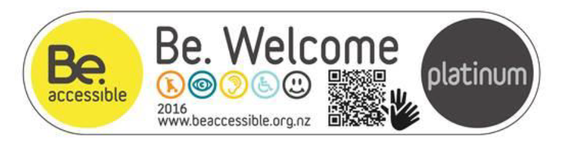

Parliamentary Service Tour, Wellington
Parliamentary Service Tour’s journey to a Be. Accessible gold rating began back in 2014. Achieving a gold rating means that people with hearing impairments can listen in on the tours with ease, people with vision impairments can navigate the premises, people pushing wheelchairs or buggies can rest, just to name a few.
Due to the media coverage received from local members of the Wellington disability community of the physical inaccessibility of the whole parliamentary buildings, the Precinct Services team decided to take on the recommendations of the Be. Welcome assessment and build them into a set of new designs for the entire Parliament buildings to remove all physical barriers to access. This work is ongoing and in consultation with the Be. Accessible team.
Be asked the Group Manager for Precinct Services a few questions about the experience of embarking on the accessibility journey for the team: “In mid-2014 a Government Administration Committee raised the issue of accessibility issues across the parliamentary precinct and challenged the Parliamentary Service to undertake a thorough review.
As a result of the Be. Welcome assessment process we now consider all aspects of accessibility whenever we are planning events, planning changes to procedures, or undertaking changes to our buildings. Among the staff there is now a wider understanding of accessibility issues, and a much greater willingness for staff to voluntarily ask people if they need help. The awareness and willingness to help has made a huge step change. Some of the improvements that we are really proud of are hearing induction loops for the deaf, high visibility markings on glass doors and bollards, resting pads beside bench seats in the grounds so anyone pushing a wheelchair can rest, changing the font on our printed material, and an awareness that assistance dogs need access to toilets too! The benefit in being accessible is in availing yourself to 100% of the community. Limiting engagement with the whole community is a lost opportunity, be that in a capacity as a visitor attraction or a business. There is a warm feel-good factor knowing our business is able to cater to almost all disabilities, something we are very proud of.”

Halberg Trust, Department of Conservation and Be. Accessible

Access mapping New Zealand’s top walks and cycleways
This unique partnership will see New Zealand’s top Heritage Walkways mapped and assessed with access citizens in mind. Starting with 15 walk, water and cycle ways in 5 catchments (75 in total) critical data and information on accessibility will be captured. This will then put access information in users’ hands prior to and during their journey. The trial across the 75 sites will utilise the “Sensibel” App developed by a Christchurch Social Entrepreneur to drop precise pins along the track that are tagged with positive and negative features of the track which will highlight potential obstacles or advantages.
Ultimately this App and capability will be put in the hands of access citizens to build on the initial track information and add critical seasonal information. Track assessments started in September 2017 and will be reviewed in November prior to a soft launch.
The detailed track information will be enriched by Be.’s assessment methodology thinking through the access citizens’ requirements from planning, pre-information, parking, amenities, track hazards, getting assistance and getting home safely. Be. are bringing together private partners to assist in managing and taking the information to Kiwi Access citizens and improving all New Zealanders connection with recreation opportunities.

People with access needs are referred to in this report interchangeably as ‘access citizens’ and ‘access citizens’, and more specifically at times as disabled people, depending on the context of the discussion.
This is an indicative summary of programme activities
This review primarily refers to the 2016/17 Outcome Agreement Between the Ministry of Social Development and Be. Institute Charitable Trust, as the most recent report capturing information on the performance measures (covering the period 1 July 2016 to 30 June 2017). However, our findings also take account of reviewing quarterly reports throughout the review period (2011 to 2017).
Synergia (2011) Be. Welcome Assessments: Evaluation Report; (2011) Be. Key Informant Interview Research: Report to the Be. Institute.
Synergia (2013). Executive Summary: Evaluating Be. Accessible’s Social Change Programmes.
Pink Striped Leopard (2015). Be. Accessible Qualitative Findings January 2015.
Be. Accessible. Be. Accessible (2015). Response to Evaluation Report. February 2015.
CoGo (2017). Be. Accessible Evaluation Framework 2017.
Be. Accessible. Be. Accessible Ministry of Social Development Quarterly Report. April – June 2017.
Be. Accessible. Be. Accessible Ministry of Social Development Quarterly Report: April – June 2017
Be. Accessible. Be. Accessible Ministry of Social Development Quarterly Report: December 2016 - March 2017
Pink Striped Leopard (2015). Be. Accessible Qualitative Findings January 2015.
Summary findings reported in the Be. Accessible Quarterly Report (April – June 2017) to the Ministry of Social Development.
Be. Accessible. Be. Accessible Ministry of Social Development Quarterly Report: April – June 2017
The Wellington Hub is an initiative being led by Wellington City Council to make visitor attractions more accessible, as part of a goal to make Wellington the most accessible city.
Synergia (2013). Executive Summary: Evaluating Be. Accessible’s Social Change Programmes.
Be. Accessible website: www.be.accessible.org.nz/the-movement/about-be.accessible (retrieved 15 September 2017).
Be. Accessible 30 June 2014 End of Year Report to the Ministry of Social Development.
Transtheoretical Model of Behaviour Change (Prochaska et al) and Diffusion of Innovations (Everett Rogers).
Be. Accessible received new funding outside of a contestable process.
Jepson. R, Harris. F, Pratt, S and Tannahill. C. (2010). The effectiveness of interventions to change six health behaviours: a review of reviews. BMC Public Health, 2010: 538.
Be. Institute – Strategic Plan: 2015/16. The review team also cited some examples of business plans and business models for 2012.
https://news.ontario.ca/profiles/en/tracy-maccharles. Such a role which recently has been established in the province of Ontario in Canada, the Minister oversees the Accessibility for Ontarians with Disabilities Act (AODA) 2005. This landmark legislation calls for an accessible Ontario by 2025.
https://www.canada.ca/en/employment-social-development/programs/planned-accessibility-legislation/reports/consultations-what-we-learned.html#h2.1

