Enabling Good Lives Waikato

Phase two evaluation

summary report

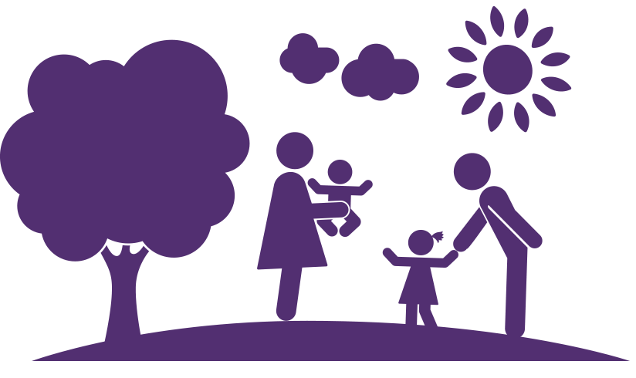

February 2017

Contacts

Prepared by Louise Were for the Joint Agency Group and the Enabling Good Lives Waikato Leadership Group

Client | Local Evaluator
Joint Agency Group and the Enabling Good Lives  Waikato Leadership Group  C/- Chris Potts  E: christine.potts005@msd.govt.nz | Louise Were  Hikitia Consultants  Member of Tuakana Teina Evaluation Collective  E: louisewere@gmail.com

Acknowledgements

Louise would like to sincerely thank the participants, families and whānau engaged with Enabling Good Lives Waikato, the Waikato Leadership Group, EGL Waikato staff, and providers of disability services who have shared their whakāro and their journeys so openly.

Tēnēi te mihi atu ki a koutou. Many thanks to you all.

Accessible and easy-to-read versions

Accessible and easy-to-read versions are currently in development with Enabling Good Lives Waikato.

Disclaimer

The information in this report is presented in good faith using the information available at the time of preparation. It is provided on the basis that the author of the report is not liable to any person or organisation for any damage or loss that may occur in relation to taking or not taking action in respect of any information or advice within this report.

Table of contents
Executive summary 5
Key findings from the phase 2 evaluation 5
Recommendations for future implementation 9
Summary of what EGL means to participants and their aspirations 13
Evaluation purpose and EGL background 16
Purpose of the evaluation 16
What is the Enabling Good Lives approach and why change? 16
Evaluation methodology 21
This is phase 2 of a multi phase evaluation 21
Key evaluation questions for phase 2 22
Evaluation design included use of developmental evaluation and mixed method approaches in phase 2 23
Evaluation analysis for phase 2 26
Evaluation limitations 28
Findings from the evaluation cover six themes 30
Theme 1: Participation and pathways into the Demonstration 31
Participants and pathways 31
Referral pathways 33
Theme 2: Non-active participants 34
Description of non-active participants 34
Reasons non-active participants did not continue 36
Non-active participants may still have benefited from EGL 37
Theme 3: The role of Tūhono/Connector 39
Intent of the Tūhono/Connector role 39
Key functions of the Tūhono/Connector 40
Ideal qualities of the Tūhono/Connector 41
Participant experiences of working with their Tūhono/Connector 43
Enabling factors for Tūhono/Connector success 43
Barriers to Tūhono/Connector success 44
Tūhono/Connector role: potential solutions – what does the role need to be successful? 45
Theme 4: Personal budgets 46
How personal budgets are set 46
Participant experiences of personal budgets 47
Participant’s perspectives on managing personal budgets 48
Engaging supports 50
Potential supports 50
Natural supports 51
Community connection and participation 52

Theme 5: Achievement of goals and outcomes 54
Experiences prior to EGL 54
Deciding factors to join EGL Waikato 55
Achievements are because of EGL Waikato 55
Outcomes participants are aiming for 55
Barriers to participant success 58
Theme 6: Providers’ actions and adaptions 59
Providers’ reflections on the EGL approach 60
How providers are adapting their practice 61
Barriers to providers adapting their practice 61
How providers work in an EGL way 62
How providers are creating value for EGL participants 62
Providers’ reflections on supporting adaption 63
Theme 7: Success factors 64
The difference the Demonstration makes 64
Success factors of the Demonstration 65
Theme 8: Learnings about system change and transformation 66
Appendix 1 73

Executive summary

This report details the findings from the second in a series of evaluations of the Enabling Good Lives (EGL) Waikato Demonstration. EGL is a principles-based approach to supporting people with disabilities to live their vision of a good life. Following its development, EGL has now been trialled in two Demonstration sites – Christchurch and Waikato.

The phase 2 evaluation focuses on a formative period of the EGL Waikato Demonstration, that is, the first year of implementation (July 2015 to June 2016). The evaluation will inform advice on the future direction of disability supports.

Key findings from the phase 2 evaluation
The phase 2 evaluation found that the EGL Waikato Demonstration is providing an option for disabled people, families and whānau that is person centred and offers greater choice and control over their supports and lives.

Disabled people, families and whānau
The EGL Waikato Demonstration is creating a difference for participants by offering an approach that:
- is person centered and strengths based
- provides skilled Tūhono/Connectors, who model the EGL principles to work with disabled people, families and whānau
- takes a whole-of-life, holistic approach to investing through personal budgets
- creates options to see people self-manage or work with a host provider.
While the Demonstration has only just completed its first year of implementation, clear learnings are emerging. The Demonstration is:
- creating opportunities for people that were not always possible in the previous system (disabled people living an everyday life and achieving their aspirations and goals, for example, living in the community supported in a way they have chosen and undertaking activities they have chosen – refer to Theme 5)
- fostering relationships across the sector to ensure there is a continuum of support for participants. Some participants have been actively connected with others to provide ongoing facilitation, coaching or intensive supports, particularly where people or families are living with high and complex social and health needs
- enabling and recognising the evolution of relationships – for example, parents and grandparents don’t have to be solely caregivers; young people can ‘do ordinary things’.
Disabled people, families and whānau interviewed for the evaluation openly shared their experiences of the Demonstration. Of the 32 participants interviewed:
- 32 (100%) felt, prior to joining the Demonstration, that participating in EGL Waikato would be positive; they would have more choice and control and the flexibility to determine what was possible
- 31 (97%) felt that their achievements would not have been possible without EGL Waikato
- 30 (94%) have experienced a positive working relationship with their Tūhono/Connector
- 30 (94%) felt that the Demonstration is making a difference and they are experiencing positive change across the outcome domains
- 26 (81%) felt the planning process was positive.
Of the people eligible for participation in the Demonstration, 79 are currently non-active, that is, no longer undertaking or completing any of the key steps towards receiving a personal budget via the Demonstration. There were no clear trends in the types of people that are non-active or the reasons they disengaged with the Demonstration. Interestingly, of the 27 non-active participants who consented to be involved in the evaluation, many of them still derived some benefit from their brief engagement with EGL. The main benefit noted was connection with information, equipment, training or employment options, or other people or services. Further work is needed to understand why people disengage.

Providers
This evaluation interviewed six providers to discuss their reflections about the Demonstration. To provide a holistic, whole-of-system perspective on the Demonstration, the providers interviewed had all worked with the participants interviewed.
Three providers of disability services reported that they see EGL as a fresh, new approach that is putting power into disabled people’s hands. The provider representatives interviewed reported that they are finding ways to learn about and reflect the EGL principles.

Two providers reported they have already been working in an EGL way for many years. Five providers and EGL staff noted that they are building effective relationships to ensure open dialogue and collaboration so participants have choice and are connected and well supported.

Two providers interviewed acknowledged that there are some challenges with having two systems operating for supporting disabled people and their families and whānau. Providers still have their existing contracts with Ministries and this creates some challenges because their contractual obligations may not encourage them to work in an EGL way.

Providers and Demonstration staff interviewed reported that they valued working together to help participants put their plans into action. For participants living in very complex situations, the need for a collaborative approach is even more critical. Five providers interviewed identified that they are working positively with participants in ways that reflect the EGL approach. Some of the emerging examples of flexible ways that providers are working with participants are:
- supporting people to shift their thinking and expectations from the current services and supports being offered, to knowing that there are options
- encouraging participants to think about wider community options and identifying natural supports.
While three of the providers interviewed recognised that more must be done to ensure the EGL principles are adopted sector-wide, the EGL Community of Practice was identified as a valued mechanism to share and build principles-based practice across the sector.

Issues with delivery of the Demonstration
Beyond the challenges identified in the provider interviews, there have been some challenges with the delivery of the Demonstration. This is to be expected given that the Demonstration was within the first year of implementation of an innovative approach to systems change.

Striking the right balance between achieving Demonstration targets and meeting and working with people where they are at is challenging. While some participants felt their connection with their Tūhono/Connector was improving, it was felt that a few Tūhono/Connectors started engagement with participants too early and without the necessary knowledge of local or community options and EGL systems. A few participants also experienced limited contact with their Tūhono/Connectors, which was causing some participants to have misgivings about the Demonstration.

This is then compounded when participants sometimes experience EGL systems as unresponsive. This unresponsiveness has been attributed to the timing and the level of detailed information required. For example, participant information is not held in an integrated database, and the time from the preparation of a personal budget to formal acceptance and having a contract in place can be longer than expected.

External barriers are also impacting participant outcomes. For example, some agencies are not as flexible as required or are unable to work in an individualised way. This results in limited options for people and lessens responsive, person-centred options. Working in an individualised, fee-for-service way requires systems and cost structures that a few providers have not yet developed. Another example is improving communication and sharing information between agencies, which would help participants transition more smoothly from the current system to the Demonstration.

Some of the delivery issues described in this evaluation have already been identified by the Demonstration and work has commenced to remedy them. These include ensuring participant three-monthly reviews take place in a timely manner; providing opportunities for regular contact; taking a team approach to supporting some participants to ensure more consistent connection with EGL; and improving communication with providers when they are working alongside participants.

A period of consolidation for the Demonstration would be valuable in the future.
“A key characteristic of complex systems is that they are constantly changing and evolving … as individuals interact, and as the context responds to the opportunities and challenges, changes in the system affect the initiative and the initiative affects the system.”

Taking time to consolidate the learnings from the past 12 months, to affirm the Demonstration’s ability to create and add value to the lives of disabled people, families, whānau and the disability system as a whole, is an important step in the change process.

Recommendations for future implementation
The recommendations in this section are a synthesis of the findings and learnings from both the phase 1 and phase 2 evaluations. They reflect considerations for successful future implementation and delivery of an EGL approach. Some recommendations reflect success factors of the current Waikato Demonstration that should be maintained for ongoing success. Other recommendations are based on gaps in the Waikato Demonstration that require some development for continued success of the approach. While some of these recommendations relate directly to findings in the evaluations, other recommendations speak to overall learnings and findings rather than specific aspects of the evaluation.

EGL implementation and delivery
To ensure the implementation and delivery of EGL approaches are successful it is recommended that the following characteristics are present:

Leadership by disabled people
Leadership by disabled people must be present, prominent, visible and invested in at all levels of the Demonstration. Disabled leadership is a key factor that contributed to the early success of the Demonstration, as identified in the phase 1 evaluation.

Co-design and effective partnerships
The commitment to co-design, where all voices are important and everyone works together to co-create change and map improved outcomes, is foundational to an EGL approach. Through co-design, EGL partnerships are built on transparency, trust and open communication. The phase 1 evaluation highlighted co-design as another contributor to early success.

Investment in families and whānau
The practice of investing in families and whānau centeredness is adopted. The need to strengthen families and whānau through direct investment was identified during the national design of the EGL approach (Enabling Good Lives, 2016). Disabled people, families and whānau interviewed for the phase 2 evaluation highlighted that ensuring families and whānau have opportunities to come together and can also access brief support and connections means that, as a whole, everyone is flourishing. Natural supports, such as parents and other siblings, are a vital part of support networks for disabled people. Investment in their wellbeing will go some way to ensuring people live well and stay well closer to home.
Participants and providers interviewed identified that an important issue is addressing the ability for people, especially those who are rurally isolated or dealing with high and complex needs, to choose who they employ, including family who come to live with them.

Level and intensity of support
It was found through interviews with active and non-active participants and EGL staff in phase 2 that the level and intensity of support that participants need varies along a continuum. To be responsive, the EGL team must be able to determine the level and intensity of support provided to participants. While there are parameters in place, Tūhono/Connectors are encouraged to walk alongside people, respond in times of greatest need, and ensure participants are well resourced to lead their own solutions, at their own pace.

Capability building
A capability-building approach to enhance the knowledge and skills of disabled people, families and whānau supports sustainable change and assists people to understand and take up opportunities to have more choice and control.
Opportunities for participants to connect are a vital mechanism to create networks and share ideas about what is possible and what works. Some participants commented how important it is to learn from each other.

Building community awareness and capability
EGL partners, in particular government agencies and providers of disability supports, must actively support the efforts of Demonstration sites to respond to and build community awareness and capability. Some participants highlighted that a co-ordinated effort is required, with one provider emphasising that this is particularly needed in rural areas.
Communities that are more welcoming and accessible and recognise the contribution that disabled people make are more likely to become people’s first choice. This is the EGL approach in action. Disabled people, families and whānau across both phases of the evaluation see this as vital to their long-term success.

EGL principles in practice
The EGL principles enhance services for the benefit of disabled people, families and whānau. Through the focus group with the provider Community of Practice in phase 1 and provider interviews in phase 2, it was highlighted that opportunities must be continually created for EGL partners, in particular providers of disability services, to reflect on how their values align with the principles. A Community of Practice approach is valued, where providers and practitioners can share learnings and insights and model the EGL principles.
Two providers also see that there is potential to encourage and support changes to service provision by aligning all facets of provider service commissioning, delivery, development and accountability with the vision and principles of EGL. If the EGL principles were reflected in government contracts, evaluative monitoring and self-assessment tools, this would help set expectations and determine what quality looks like.

Local host options
EGL staff and three providers identified that developing local host options is another opportunity to add value to an EGL system, particularly in rural communities. Where hosts are able to offer and provide a range of services, from recruitment and management of staff to payroll, training and connections with others in the wider community, this has high value for participants.
However, the success of the host is determined by the relationship they foster with participants and vice versa. Across all groups interviewed in phase 2, ongoing relationships between the Demonstration and hosts were seen as important to ensuring participants have options for the services and supports they need and pay for.

EGL systems and processes
To ensure the EGL systems and processes support the ongoing and future success of the EGL approach, a range of ideas and solutions has been identified. All groups interviewed as part of phase 1 and 2 recommended:
- attracting and retaining people who are highly skilled and model and mirror the EGL principles in all places (e.g. EGL staff and leadership group members); this is a critical success factor
- continuing to use existing infrastructure and systems that are available, easily accessible and cost effective
- using systems that are integrated and draw on what works, such as a data management system to ensure all participant information is accessible in one central database
- clarifying roles and responsibilities when other agencies or organisations are working with EGL staff and participants
- ensuring processes are as easy to use as possible. Ongoing guidance is required to build participants confidence and support them to manage the responsibilities of budget holding and becoming an employer
- continuing to ensure all documentation and processes are accessible – easy to read and easy to access.

Tūhono/Connector role
To ensure the ongoing and future success of the Tūhono/Connector role, EGL staff recommended:
- ensuring Tūhono/Connectors reflect the unique qualities identified through the Demonstration and the literature (refer to Theme 3)
- deploying an intentional Tūhono/Connector recruitment strategy. EGL staff endorsed this recommendation, to ensure that the diversity of the disability community is reflected across the team, with a commitment made to recruit Māori staff, as well as seeking creative thinkers from inside and outside the disability sector
- putting in place a clear job description, deliverables and role boundaries reflect the EGL principles and align with the other unique qualities of Tūhono/Connectors. The combination of these factors is valued by Tūhono/Connectors
- providing purposeful, active management and support of the Tūhono/Connector role, as this is critical to the individual and collective success of EGL staff. While each Tūhono/Connector will bring a range of values, attributes, skills and knowledge, the role is new to the sector. Deliberate capacity and leadership development is valued by EGL staff and is recognised in practice by participants and other partners
- encouraging and investing in the use of self-reflection, peer supervision and other professional development options. The phase 2 interviews showed that Tūhono/Connectors value these. The Tūhono/Connector role has a range of intensive functions that require continual review and training to help make the role successful. Collective, reflective time together to translate learnings into practice and support adaptive, responsive practice is valued and adds value to the role and overall outcomes
- allowing Tūhono/Connectors to determine the level and intensity of support provided to participants. Continual review and refining of practices are needed so that EGL supports people to action their vision of their good life and stay engaged and present but is not the centre of participant success.
- continuing the separation of Tūhono/Connectors from funding allocation processes. EGL staff consider, however, that it is important the Tūhono/Connectors have a clear understanding of the personal budget processes so they can actively and accurately support participants to effectively manage and control their budget and supports, as highlighted through participant interviews
- ensuring that if the role is located away from a central hub locally based leadership is co-located so the role always has easily accessible and responsive support.

Summary of what EGL means to participants and their aspirations

The following diagram outlines a selection of participant views on what EGL Waikato is for them. The views were shared during the interview process with 32 active participants.

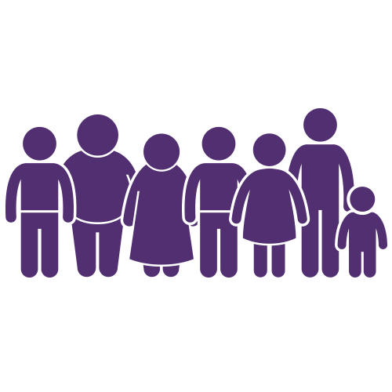
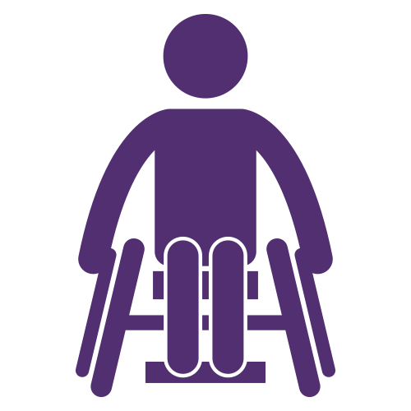
For active participants, EGL Waikato is …

Freedom

Independence

Exciting

One cool programme

Less frustrating

A life changer

Learning

Opportunity

Community

Fantastic

Awesome

Person centred

A journey

A process

A better future

Choice

Challenging

Connections
Trial and error
Flexible
Enabling
Easy
Loving it
Empowering
A good life
A godsend
Hope
The following diagram outlines a selection of participant views shared during the interview process with 32 active participants, including a final question asking participants if there was anything in closing they would like to share about their experience of EGL Waikato.

Participant aspirations for EGL

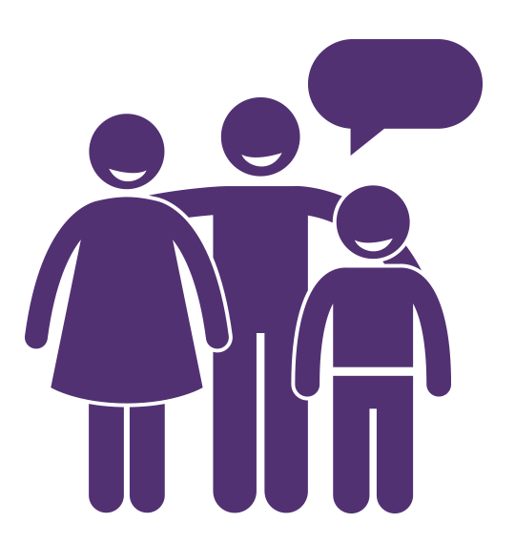
This has given us the opportunity to be independent.

Keep this funding going – first positive experience.

They should roll it out across the country.

Without services like this, families like ours would fall. down.
Glad they’ve got this out there … Don’t stop it, keep it going.

It would be nice if all agencies worked under the same philosophy.
Don’t stop it. It’s making a difference.

One cool programme. Wish it would never end.

It would be crazy to stop it. It’s made everyone’s lives better, including extended family.

Please consider opening for longer to give other people the opportunities.

If it was increased, it would change the nation.

Would highly recommend it and it should be available for everyone.

Evaluation purpose and EGL background

Purpose of the evaluation
This report details the findings from a second evaluation of the Enabling Good Lives (EGL) Waikato Demonstration. EGL is a principles-based approach to supporting people with disabilities to live their vision of a good life. The Demonstration, developed to test this approach, is a partnership between representatives of disabled people, families, providers and government agencies. EGL has now been trialled in two places, Christchurch and Waikato, which are called Demonstration sites.

The phase 2 evaluation focused on a formative period of the EGL Waikato Demonstration, that is, the first year of implementation (July 2015 to June 2016). The evaluation will inform advice on the future direction of disability supports. The Ministries of Education, Health and Social Development, along with EGL Waikato, wanted to understand how the Demonstration works to support disabled people to have a good life, and under what circumstances and how well this occurs.

What is the Enabling Good Lives approach and why change?
The Enabling Good Lives (EGL) approach is a partnership between the disability sector, that is, disabled people, families, whānau, providers of disability support and government agencies, that aims to improve outcomes for disabled people by giving them more choice and control.

The emergence of the EGL approach is an attempt to address long-standing concerns with the existing disability support system. The existing system of support for disabled people has often made it difficult for an individual to live an everyday life of their choice in their community.

On 12 September 2012 the Ministerial Committee on Disability Issues endorsed eight principles for a long-term direction for change to the cross-government disability support system, based on the EGL approach, to give disabled people greater choice and control over their supports and their lives. This includes self-determining how resources are used and making use of more natural and universally available supports so that people can have the lives they want.

The EGL approach is not a prescriptive approach, but has eight principles that guide all decisions and actions, from the system level to the individual. The EGL principles are:
- Self-determination: Disabled people are in control of their lives
- Person centred: Disabled people have supports that are tailored to their individual needs and goals, and take a whole-of-life approach rather than being split across programmes
- Mana enhancing: The abilities and contributions of disabled people and their families are recognised and respected
- Beginning early: Early investment in families and whānau supports them to be aspirational for their disabled child; builds community and natural supports; and supports disabled children to become independent, rather than waiting for a crisis before support is available
- Easy to use: Disabled people have supports that are simple to use and flexible
- Relationship building: Supports build and strengthen relationships between disabled people, their whānau and community
- Ordinary life outcomes: Disabled people are supported to live an everyday life in everyday places; they are regarded as citizens with opportunities for learning, employment, having a home and family, and social participation – like others at similar stages of life
- Mainstream first: Disabled people are supported to access mainstream services before specialist disability services.

Key components of the EGL approach in EGL Waikato
Key components of the EGL approach in the Waikato and Christchurch Demonstrations include co-design, facilitation and planning functions, access to pooled funding that can be used flexibly, a community development function and provider development.

The EGL approach is different from existing systems in that it aims to provide a single, principles-based system that can be flexible in the way it is implemented as long as the principles are adhered to. Current systems that disabled people, families and whānau can access are typically more defined and span three different Ministries. The current Ministry of Health system is usually accessed through the local Needs Assessment Service Co-ordination (NASC) organisation. The NASC assesses and allocates funding that includes all disability support services such as residential care, home and community support, supported living, respite care and carer support. This funding may be used to purchase support from contracted providers, or can be accessed through an individualised funding arrangement. Some disabled people, families and whānau may also access Participation and Inclusion funding, which covers specialist employment and community participation services and very high needs funding from the Ministry of Social Development. Children and young people living with a disability may access Ministry of Education Ongoing Resourcing Scheme (ORS) funding and Transition funding.

The key components of the EGL Waikato Demonstration are:
- Co-design: The first year of the Demonstration in the Waikato brought together the EGL Waikato partners to co-design and build community awareness of the Demonstration in preparation for delivering the components outlined below.
- Tūhono/Connector engagement: EGL Waikato staff assist participants to think about where they’re at, make links and connections in the community, make their plan, understand their budget, and link with the information and support that they choose to work towards their vision of a good life.
- Building community connections: The Tūhono/Connector and the EGL Demonstration team help disabled people, families and whānau to build or extend their connections with the community.
- Supported self-assessment (SSA) and planning: These processes help participants, family and whānau, and their Tūhono/Connector to understand what resources are required to support participants to plan for and live the lives they want, as reflected in their personal plans. Participants can complete the SSA by themselves or receive support from their Tūhono/Connector to think about what is needed to live their good life.
- Pooled personal budget: A person-centred funding allocation is linked to a participant’s plan and supported self-assessment, and each person controls how this is spent to create a good life for themselves. Participants can either self-manage their personal budget or engage with a host to manage the budget. EGL brings together funding from government agencies – the Ministries of Health, Education and Social Development – in a pooled funding package that can be used in different ways to see disabled people, families and whānau plan for the lives they want.
Figure 1 below provides an overview of the pathway participants move along when they engage with EGL Waikato. Following the design and community-building phase the Demonstration, with the above components in place, was launched on 1 July 2015. The Demonstration will run until June 2017.

Focus of the EGL Waikato Demonstration
The Waikato Demonstration comprises four action areas:
- Individual choice (building on the Ministry of Health’s Choices in Community Living approach)
- Māori disabled and their whānau
- Disabled children and young people
- Disabled people seeking employment(Office of the Minister for Disability Issues, 2014).

Figure 1. EGL pathway
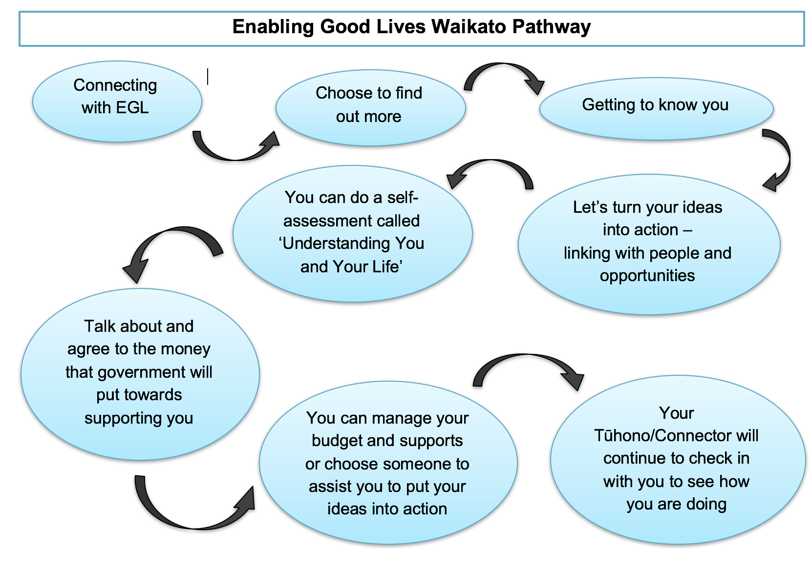

Evaluation methodology

This is phase 2 of a multi-phase evaluation

Phase 1 evaluation of EGL Waikato
This was the first of four evaluation phases/learning cycles that focused on implementation in the first six months of EGL Waikato (July to December 2015). This evaluation focused on participants’ first engagement with the Demonstration and early implementation to identify what was working well, where there were any gaps and what participants’ experiences were of the Demonstration.
The key learnings from this evaluation were that, although the implementation had gone well and participants were typically having positive experiences of EGL, a consolidation phase was needed. In the second six months of implementation, the Demonstration needed to stay participant focused, and strengthen communication and engagement to ensure things didn’t get too complex. One of the changes made as a result of the first evaluation was that participants were given the option of a host organisation to help them manage their budgets.

Phase 2 evaluation of EGL Waikato
This report presents the findings of the phase 2 evaluation/learning cycle, which focuses on the second six months of implementation and also reflects on the whole first year of the Demonstration (July 2015 to June 2016). The main focus of this evaluation is similar to the first in that it is formative rather than outcomes based.
The primary objective of the phase 2 evaluation is to understand how and how well the EGL Waikato Demonstration is working and leads to change for disabled people, families and whānau. While the phase 2 evaluation was framed to learn about and provide feedback to improve the Demonstration, it also focused on providing clear and useful information to government agencies responsible for the future transformation of disability systems.
Phase 2 builds on the information collected in phase 1 by looking at the core components of the Demonstration, participant experiences over a longer period of time, provider experiences, how well the Demonstration processes have been consolidated, and learnings for systems transformation.

Future evaluation phases of EGL Waikato
The intent of future phases is to continue to reflect on what is happening in the Demonstration, with a focus on outcomes for disabled people, their families and whānau. Outcomes will be framed against the outcome success criteria as well as looking for emergent and unexpected outcomes. Typically, because the Demonstration has only been in operation for two years, the evaluation will focus on immediate outcomes that are emerging and exist for participants rather than long-term outcomes.

Key evaluation questions for phase 2
Key evaluation questions provide a guiding framework for ongoing evaluation during the three years of the Demonstration. Please refer to Appendix 1 for overarching questions for the Demonstration evaluation.
The Demonstration is flexible and ever-evolving in nature. Each phase of the evaluation has revised questions to incorporate other identified sub-questions to ensure useful and usable evaluation information is available to feed into decision-making processes. In this evaluation phase/learning cycle, new questions were identified by reflecting on the overarching evaluation questions and feedback received from the Joint Agency Group General Managers.
The evaluation questions for the phase 2 evaluation are:
- Who is participating in the Demonstration? What are the pathways into the Demonstration?
- Who is not participating? Why? What are they using instead?
- What makes a good Tūhono/Connector? What support does this role need to be successful?
- How are personal budgets being managed and utilised to support outcomes for disabled people and families?
- Are disabled people, families and whānau achieving their goals and outcomes as planned?
- How are providers working with disabled people, families and whānau as part of the Demonstration? How are providers adapting to support this?
- What makes the difference? What are the success factors?
- What are the learnings from the EGL Waikato Demonstration for system change and transformation?
In this report the specific evaluation questions are reflected in the focus areas of the themes.

Evaluation design included use of developmental evaluation and mixed method approaches in phase 2

A developmental evaluation approach was used
This evaluation used a developmental evaluation approach because EGL is an emergent and innovative approach and therefore requires a flexible and adaptive evaluation methodology. The aspects of innovation, change and complexity present in the EGL Waikato Demonstration are recognised in the evaluation approach by applying and reflecting on developmental evaluation principles throughout the evaluation, particularly in this formative stage.
Developmental evaluation brings an evaluative approach to an innovation, often where vision and values drive processes, and it pays attention to the influences of relationships and systems, looking for what emerges while still monitoring intended outcomes and pre-determined goals. “Developmental evaluation provides evaluative information and feedback to social innovators, and their funders and supporters, to inform adaptive development of change initiatives in complex dynamic environments” (Patton et al., 2016). This developmental focus provides greater understanding of the dynamic systems involved and how they are producing the outcomes that are being achieved; what is required for good programmes to succeed; and what the innovative and successful components of programmes are (Patton, 2011; Patton et al., 2016).
This evaluation and the evaluation team also recognised that they are operating within multiple cultural contexts – Disability, Māori, Pasifika, rural, urban, for example. As such, the evaluation drew from two fields of theory and practice – Culturally Responsive Methodologies and Kaupapa Māori – with members of the interview team representing Disabled and Māori communities.
One of the key aspects of any developmental evaluation is the use of learning cycles of evaluation with reflection and feedback loops that inform each new phase of the innovation. This is the approach used in this evaluation. Each phase of the evaluation is loosely framed around each stage of the Demonstration to allow feedback from each stage to inform the next stage, such as that reflected in the example in Figure 2 below.

Figure 2. Adaptive reflection and action cycle
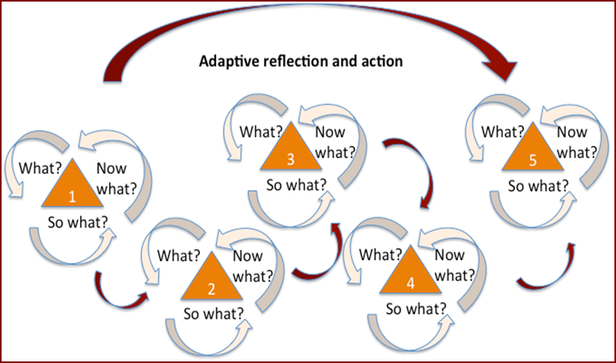

The EGL developmental evaluation was designed to take place over two years and include four phases or learning cycles, an approach endorsed by the Waikato Leadership Group and the Joint Agency Group.

Evaluation also adopted a mixed method design for phase 2
A mixed method design was used to complement the Developmental Evaluation approach. The advantage of mixed methods is that it enables the analysis to compare and contrast the findings across several types of data. Combining methods can also offset limitations inherent within individual methods and allow the evaluator to draw on the strengths of each method when synthesising data and making evaluative judgements. Therefore, a mixed methods approach can provide a more complete picture of the Demonstration than would be possible using a single method in the timeframe and with the resources available.
In this case the mix of methods included semi structured interviews (representatives of 32 active demonstration participants, 5 non active participants and 6 provider representatives); focus groups (Tūhono/Connectors and EGL staff) as well as document analysis of administration data. These were chosen because of their capacity to answer the key evaluation questions and their ability to be adaptive and responsive to our participant groups. The methods were applied concurrently but separately across the evaluation, with some data sources being used to answer multiple questions.

Interviews with disabled people, families and whānau
A sample of participants was selected and invited to participate from the group of Demonstration participants who are ‘active’; these are participants who are currently actively engaging with Tūhono/Connectors, are participating in key steps in the EGL Waikato pathway, and have had a personal budget allocated prior to April 2016. Participants were also sampled by action area, location, age and ethnicity, resulting in 30 interviews being undertaken, representing 32 participants and nearly one-third of potential respondents.
The interviews explored participants’ experiences of the Demonstration, with attention given to each component. The aim was to understand what participants want to achieve, the difference the Demonstration has made and what hasn’t worked so well.
A sample of non-active participants was also recruited for the evaluation, with 27 consenting to participate. The Demonstration staff collected data about engagement for these non-active participants. Interviews were sought from 10 people but only completed with 3 people, representing the experiences of 5 non-active participants.
The interviews with non-active participants focused on their perceptions of the Demonstration, their experience, and the reasons why they didn’t continue. The interviews also sought to understand whether value was created through their brief engagement, and what supports they currently have in place. Finally, they were asked what changes or improvements they thought were needed.

Interviews with selected providers
The six providers interviewed for this evaluation were among those that had worked with the participants interviewed. All providers that were asked to participate in the evaluation agreed to be involved. Three types of providers, covering the range of those that operate within the Demonstration, were interviewed for the evaluation. The types of providers interviewed were those that:
- work alongside participants and Tūhono/Connectors, to ensure they have the right supports in place
- are ‘hosts’ or organisations that are engaged by participants to provide them with financial management and/or human resource support
- are contracted by the Demonstration to walk alongside participants in the EGL pathway. That means working in a way that reflects the role of Tūhono/Connector and/or a host.
For each provider, the key contact for the Demonstration was interviewed. The provider interviews focused on their experiences of working with the Demonstration and Demonstration participants, how they may be working in an EGL way, what’s working well, and what could be improved.

Focus groups with EGL staff
Focus groups were undertaken with Tūhono/Connectors and EGL staff. The focus groups explored the Tūhono/Connector role and personal budget process.

Administrative data analysis
Document analysis of administration data, that is information collected through EGL process such as the supported self-assessment was completed. The analysis focused on participant demographic information and what participants had planned to achieved through EGL.

Evaluation analysis for phase 2
The approach to analysis was not as one single analysis process, but a combination of synthesis, analysis and sense-making processes.
The qualitative data was analysed using a Qualitative Data Analysis Tool based on identifying and discussing four aspects of the data:
- generalisations and exceptions (usually … but …)
- contradiction (on the one hand … on the other hand …)
- surprise (I’d expected … but….; I didn’t expect … but ….)
- Puzzle (why…?)
These questions were addressed in an analysis workshop with those who undertook the evaluation and as part of the writing process.
To understand the counterfactual, that is, the situations, conditions or outcomes that hypothetically may occur or prevail for participants or partners of the EGL Waikato Demonstration if this innovative approach did not exist, required us to make comparisons. Given the constraints of the evaluation (time and resources), where we wanted to understand if participants would have achieved the same outcomes if there was no Demonstration, we referred to their experiences and arrangements that were in place prior to joining the Demonstration. There was no baseline data.

Evaluative rubric used in analysis
To help develop a shared understanding of how well something has been done and define the aspects that are important to success, an evaluative rubric was designed in phase 1 (refer to Appendix 1). This tool is a way of being explicit about judgements. For example, it helps determine what are the important or essential aspects for the success of a policy, approach or programme, how well a policy or approach has been implemented, or if outcomes, intended and unexpected, have been realised.
The EGL principles provide both the guiding framework for the Waikato Demonstration and the high-level framework for the success criteria. This ensures that the principles provide the initial measure of quality. It is also important to show the synergy between the EGL Christchurch quality of life domains and how they link to the EGL Waikato approach to understanding the implementation and, over the life of the evaluation, the expression of quality of life.
The success criteria for the Demonstration are reflected in the theme areas explored in this report. Throughout the analysis, the success criteria for the implementation were used to frame the key findings and considerations for future iterations of the Demonstration.
For the phase 2 evaluation it is acknowledged that since some EGL Waikato participants are only in the early stages of engagement we are not able to make a judgement on emergent or early participant outcomes at this stage. It is not possible to draw firm conclusions about longer-term impacts on participants and their families.

Evaluation limitations
There are possible limitations to any evaluation. Potential risks and the mitigation strategies for the Waikato Demonstration evaluation are outlined below.
Possible limitations | Mitigation
- Potential for bias in the respondents | - As with any interviewing process where a sample of participants is used, there is the possibility of introduced bias. To mitigate this source of bias in this evaluation we have done our best to ensure a variety of participants was interviewed. However, it is also important to acknowledge that the lives of disabled people, families and whānau are often complex and so participants’ experiences are likely to be varied. Where possible, findings and learnings from participants reflect the variety of experiences that were identified in the interviews, providing a wide perspective of experiences and therefore limiting bias where possible.
- Sometimes perspectives on the experiences of the disabled person may be based on the perspective of the family/whānau members rather than the disabled person themselves | - To mitigate this limitation, wherever possible the disabled person themselves was asked to reflect on and discuss their experiences. Therefore, typically the perspectives included in the evaluation findings relate directly to the disabled person. However, it is important to note that this evaluation looks at experiences and perspectives of the disabled person, families and whānau and therefore reporting on the perspectives of family and whānau is a valid and reliable source of data for this evaluation.
- Not all desired Demonstration outcomes may be fully achieved within the timeframe of the evaluation | - Across the two-year Demonstration, outcomes will be mapped at multiple time points for subgroups of identified Demonstration partners. It is acknowledged that outcomes may not be fully realised within the Waikato Demonstration period.
- Assessing impact is problematic (such as no random assignment, voluntary participation) | - A range of evaluative methods and tools will be applied and the data overlaid to reflect on the impact created within the Demonstration timeframe.
- Not all evaluation questions may be fully answered within the time available to complete the evaluation | - Every effort will be made to leverage networks and processes to ensure the vital information is collected and analysed to provide useful, usable information to inform decision-making.
- Participants interviewed may not reflect the wider population of those eligible for EGL | Participation in EGL Waikato is voluntary. Participants interviewed may not reflect the wider population of those eligible for EGL. Effort was made to interview people who did not continue with the Demonstration. However, this phase of the evaluation did not interview people who had no contact with the Demonstration.

Findings from the evaluation cover six themes

The report covers six themes which will provide the Joint Agency Group and the Enabling Good Lives Waikato Leadership Group with insights into how the participants were experiencing the process in the time period of Phase 1 and 2 from July 2015 to June 2016.
The intention is that each theme presents a balanced approach to topics that cover, for example, the pathways experienced by participants; the role of the Tūhono/Connector; how budgets were managed; status of goals set; adaptions and barriers experienced by providers.

Theme 1: Participation and pathways into the Demonstration
This theme area presents evaluation findings about who is participating in the Demonstration and what pathways exist for entry into the Demonstration.

Participants and pathways

Analysis of EGL administrative data revealed that as at 30 June 2016:
- most of those who contacted the EGL Waikato Demonstration met the eligibility criteria. Of the 193 disabled people, families and whānau who had contacted or connected with the EGL Waikato Demonstration, 11 did not meet the Demonstration eligibility criteria; 29 people were also on a waiting list
- of the 182 people eligible to be part of the Demonstration, 103 were actively engaging with Tūhono/Connectors and participating in key steps in the EGL Waikato pathway. Participants on this pathway are working with Tūhono/Connectors, being connected into their community, planning their life and proceeding towards receiving and managing a personal budget via the Demonstration; 99 active participants consented to participate in the evaluation
- 79 of the 182 disabled people, families and whānau eligible to be part of the Demonstration were considered not active, that is, no longer undertaking or completing any of the key steps identified above; 27 non-active participants consented to participate in the evaluation.
For the purposes of this evaluation, participant data for the ‘active’ and ‘non-active’ groups will be presented separately. 30 interviews representing 32 active participants and three interviews representing five non-active participants were undertaken.
Active participants (n = 99)
 | Individual choice remains the action area with the highest degree of uptake. |  |  | 86 (nearly 87%) participants have progressed through to budget, with nearly 67 (68%) participants progressing through to contract.
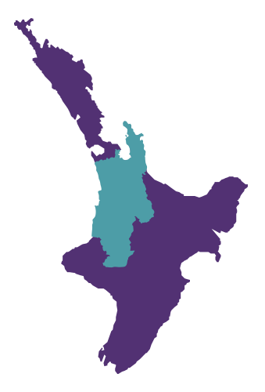 | Demonstration participants are located across the greater Waikato region; 45 (45%) Demonstration participants are living in Hamilton, followed by 18 in the Waipa and 16 in Waikato Districts. |  |  | There are slightly more male participants than female, continuing the trend from phase 1.
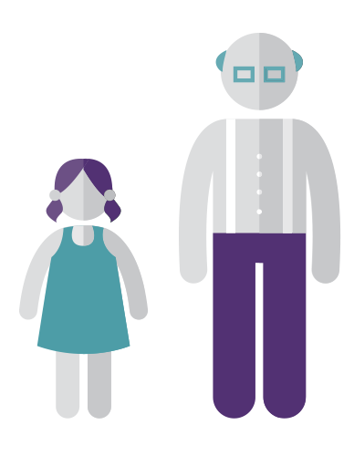 | The Demonstration is reaching people aged between 3 and 64 years. Those aged between 20 and 29 years represent 43%, continuing the trend from phase 1. | 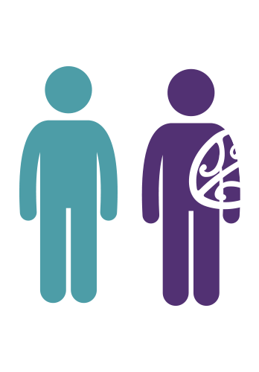 |  | 65 (54%) participants were from the European ethnic group, at least twice the number of participants recorded in phase 1. While the number of Māori has risen by 11 (n=37), overall the percentage of Māori has plateaued. However, it is still double the Waikato Māori population percentage.

Referral pathways
While the workshops or forums funded or facilitated by EGL Waikato were the primary source of initial referrals in the phase 1 evaluation, participants in the phase 2 evaluation have connected with EGL Waikato through a range of pathways.
However, based on analysis of EGL administrative data, most disabled people, families and whānau connected with EGL through self-referrals (33) or through workshops funded or facilitated by EGL Waikato (21).
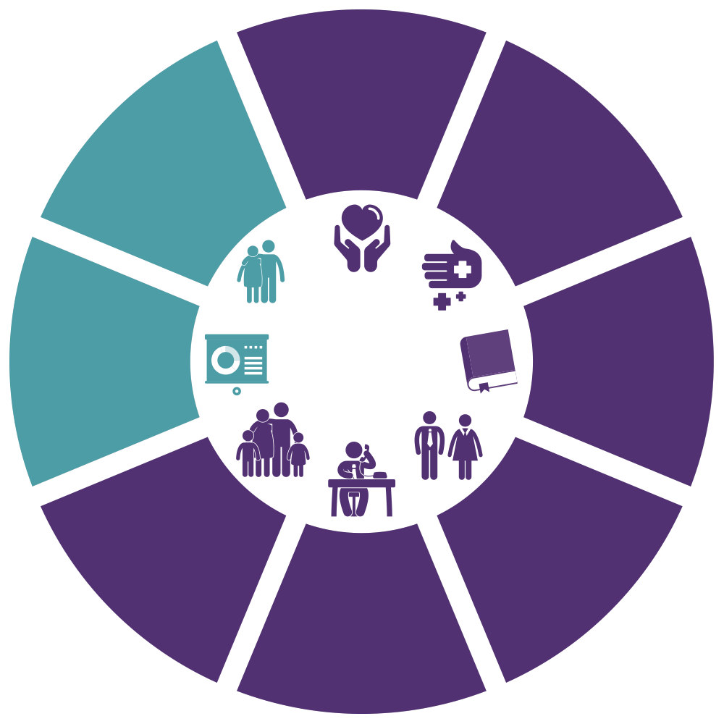
1
Ministry of Social Development
Work and Income; Child, Youth and Family; Other MSD staff

2
Health
Funders and providers of health services such as the Ministry of Health, Needs Assessment Service Co-ordination services, Māori health providers, Whānau Ora providers, and General Practitioners

33
Self / Family

21
Workshops
Funded or facilitated by EGL Waikato

2
Education
Organisations that deliver early childhood education, primary, secondary to tertiary

14
Disability Support Services
Organisations that are disability focused

5
Other Individuals such as friends

12
Other Agencies

Theme 2: Non-active participants
This theme looks at who is not participating in the Demonstration, their reasons for stopping engagement, and what they are using instead.

Description of non-active participants
Analysis of EGL administrative data revealed that as at 30 June 2016, 79 disabled people, families and whānau were considered not active, that is, no longer undertaking or completing any of the key steps towards receiving a personal budget via the Demonstration.
There are recognised limitations to this analysis because of incomplete data for this group. Earlier in the Demonstration consent was not sought to participate in the evaluation, but this has now been remedied.
A review of the 27 participants who consented to participate in the evaluation has been undertaken to determine if participants were able to derive any benefit from their brief engagement with EGL Waikato through Tūhono/Connector facilitation and/or access to other systems or supports.
Phone interviews were attempted with 10 people who had engaged with EGL Waikato but did not continue. Feedback was received from three people, representing five individuals. Additional data collected by Demonstration staff was also reviewed.

Of participants who connected with EGL Waikato but did not continue (n=27):
- all were aged from 2 to 64 years, with 14 (52%) aged between 20 and 39 years
- 17 (63%) were male
- 14 (52%) identified as European or Pakeha
- 14 (52%) were located in Hamilton City.

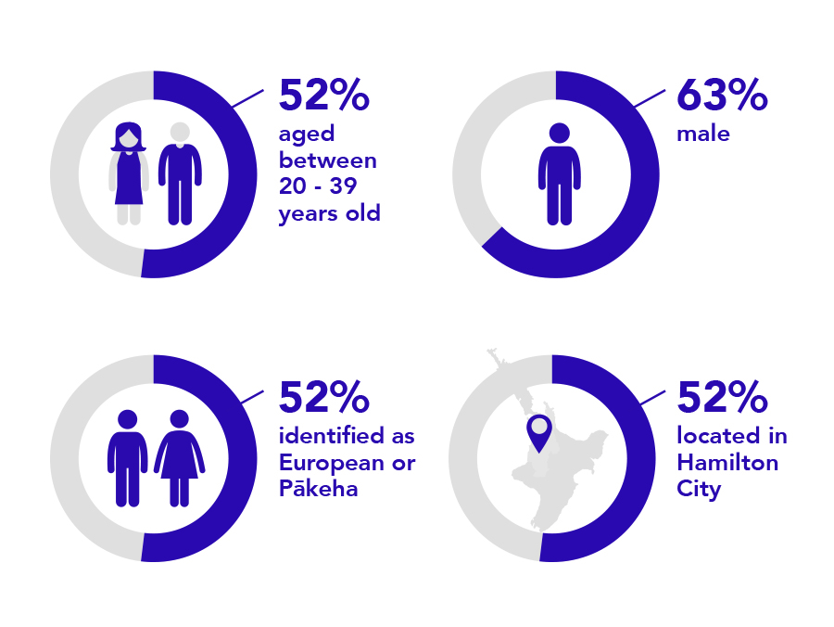

Reasons non-active participants did not continue

Non-active participants gave a range of reasons for not continuing:

people were connected with information or supports or had organised other arrangements outside of DSS services, such as returning to live with family.

people have either had a subsequent increase in their package from the NASC or decided to stay with their current provider or package. One participant also commented that they did not have the energy to change and transition out of Manawanui^{A} at the time.

9
10
people were no longer in contact with EGL, had asked to put
their engagement on hold or, as one person described, were “[waiting to] see where EGL adds value”.

8

- Manawanui is a company specializing in facilitating Individualised Funding and other self-directed services (see http://www.incharge.org.nz/interested-in-using-individualised-funding/what-we-do/ )

Non-active participants may still have benefited from EGL
Data provided by Demonstration staff about the 27 non-active participants who consented to be involved in the evaluation, identified the extent to which non-active participants derived benefits from their brief engagement with EGL. Of the 27 non-active participants, there were at least 10 people who received tangible benefits from their brief engagement with EGL Waikato.

Non-active participants were connected to:
Other people or services
Training or employment options
Equipment
Information
Following this brief engagement with EGL Waikato, a third of non-active participants involved in the evaluation (n=9) decided that they would remain with DSS services such as Individualised Funding and Residential care, with one person making the choice not to use any services.

Feedback received from three people, representing five individuals, highlighted the very different experiences people may go through when connecting with EGL Waikato. Even though families engaged in various ways, the interviews identified that:
- people saw the potential in EGL and how it could work for them
- one person benefited from receiving information and having the Tūhono as a ‘check-in’ point. They even considered themselves to still be part of the Demonstration despite not going through to budget
- two families chose to not continue with EGL despite thinking, Wow, this sounds really good … there are options … EGL sounded like that’s what we were looking for. The deciding factor was that their brief engagement with EGL was making things more stressful or more complicated, and what was being proposed didn’t make sense to the families.

A determining factor, identified by families and EGL staff, for how families engage and connect with EGL Waikato is the person’s or family’s ‘starting point’ or current situation. It is important to understand the immediate needs or current position the person or family is in. One participant reflected that [EGL staff] must recognise what families are about and what they need. It is also vital to identify who else is working with people so a collaborative approach can be fostered. One EGL staff member reflected that, we have to be person centred – connect at the level they are at.

Theme 3: The role of Tūhono/Connector

This section explores the evaluation findings in relation to what makes a good Tūhono/Connector and what support the role needs to be successful.

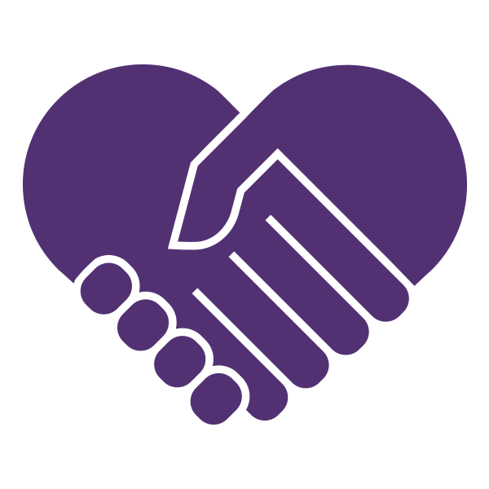

Intent of the Tūhono/Connector role

The intent of the Tūhono/Connector role is to offer meaningful support, information and connections that assist disabled people and their families and whānau to plan for, and have, their good life. The Tūhono/Connector role works in alignment with the EGL principles of:
- relationship building: developing authentic, genuine connection with participants and wider community networks
- person centred: meeting people where they are at, working alongside people to ensure they are well resourced to lead their own solutions
- self-determination: supporting participants to pursue their aspirations and have control over their lives.

Key functions of the Tūhono/Connector

The functions of the Tūhono/Connector role were developed as part of the Demonstration co-design process. The evaluation concluded that the functions are similar to those identified in Lord and Hutchison’s 2003 review of 10 ‘promising’ individualised funding initiatives across the globe.

Lord & Hutchison – Functions of facilitators  - Build relationships with disabled people, families, networks and local communities  - Provide information about networks, support options, community resources and direct funding  - Help people and families build social support networks  - Assist people and families to plan what they want, using a strengths-based approach, often facilitating planning meetings  - Help people and families to develop detailed support plans and budgets for submission to the funder  - Facilitate community connections  - Assist people to find, purchase or create supports |  | EGL Waikato – Key roles  - Get to know you – establishing respectful, ongoing relationships  - Turn ideas into action – creating and linking people and opportunities together  - Plan the life you want – assisting people with the assessment and planning processes  - Provide budget assistance – assisting people to understand their budget, developing appropriate systems to self-manage or connecting them with others who can host their individual budget

Ideal qualities of the Tūhono/Connector

Evaluation participants identified the qualities they valued in the Tūhono/Connectors, as evidenced by the following quotes:
Work alongside people to ensure they are well resourced to lead their own solutions.
It’s about building relationships.
She was very open and honest, gave us good ideas and gave us real confidence in the way they EGL worked.
Free to answer questions, she is there on hand.
I said I can’t do this, and she helped me.
The enthusiasm of [our Tūhono] was infectious and helped us consider various options.

The qualities identified are summarised below:

Values  Reflects, models and mirrors the EGL principles:  - Self-determination  - Person centred  - Beginning early  - Mana enhancing  - Ordinary life outcomes  - Easy to use  - Mainstream first  - Relationship building |  | Attributes  - Spark, energy  - Fresh ideas  - Willingness to listen  - Empathy  - Encouragement  - Responsiveness  - Presence  - Flexibility  - Optimism  - Future focus  - Innovation  - Creativity  - Willingness to walk alongside  - Commitment to deliver – do what they say they will do  - Willingness to help  - Consistency  - Trustworthiness |  | Skills and knowledge  - Ability to build effective relationships  - Sound facilitation skills  - Ability to network and connect into new spaces  - Awareness of possibilities  - Focus on creating opportunities  - Flexibility  - Cultural responsiveness  - Excellent communication skills  - Sound knowledge base – of the sector, community, EGL systems (planning, budget management)

Participant experiences of working with their Tūhono/Connector
Overall, participant interviews identified that:
- 30 (94%) of active participants interviewed have experienced a positive working relationship with their Tūhono/Connector
- 5 (17%) of this group had issues that impacted on their engagement with their Tūhono/Connector, such as limited information about EGL processes or community options
- 2 (6%) of active participants, while still progressing with EGL Waikato, had an experience that resulted in less than positive outcomes.
The following sections explore what is needed to ensure Tūhono/Connectors are successful, issues or barriers to their success, and potential solutions.

Enabling factors for Tūhono/Connector success
This section draws on observations from and interviews with participants and EGL staff to understand what is needed to maximise Tūhono/Connector success. A whole-of-system focus has been taken incorporating both the practice of the Tūhono/Connector and Demonstration practices and processes.

- Tūhono/Connectors are demonstrating the qualities expected of their role, as evidenced by the following quotes from disabled people and families:
Brought to the table a perspective that we didn’t have.
Really good at finding community opportunities that connect to goals.
Well connected.
- Tūhono/Connectors are able to be flexible and adjust the level of support they provide to the participant’s needs and current situation – balancing expectations with knowing what is required as evidenced by the following quote:
[The Tūhono] asked what would be helpful.
- Disabled leadership is present, prominent and visible at all levels of the Demonstration. This supports Tūhono/Connectors to be disability-centred in their role modelling, and reinforces their practice.
- Tūhono/Connectors report that they know what to do, in part because they have a clear job description, deliverables and role boundaries that reflect the EGL principles and align with the other desired qualities of the role.
- Tūhono/Connector capacity and leadership development has occurred, with input from the Senior Tūhono/Connector, Programme Advisor, Management and the Local Leadership Group as evidenced by the following quote:
[We’re] growing leadership intentionally, giving them the chance to do and explore how it went … mana-enhancing [by] exploring growth areas of staff.
- Individual and team reflection and supervision have been used to inform practice and collectively support each other with ideas and strategies, as evidenced by the following quote:
We talk about things are a team … it’s good to be able to bring issues back to the table and share.

Barriers to Tūhono/Connector success
Participants, providers and EGL staff interviewed identified a mix of factors that limited the effectiveness of Tūhono/Connectors, for example:
- Tūhono/Connectors not always working from the place where people and families are at as evidenced by the following quote:
The connector was keen to have him use the bus. It was difficult to deal with… [the Tūhono/Connector] would come up with ideas that weren’t available in their area.
- Tūhono/Connectors, in a few cases, having limited networks, noticeable gaps in their knowledge, or lack of understanding of the sector or community they are working in
- Tūhono/Connectors, in a few cases, having a limited working knowledge of EGL systems and processes, or failure to provide clear information about them
She arrived and had not completed all her training … she also wasn’t well connected and was new to the area.
It was a little murky, I can’t explain it but it seemed like her knowledge was lacking.
- unresponsiveness of EGL systems because of timing and the detail of information required, for example participant information not being held in an integrated database, the length of time between preparation of budget to formal acceptance and contract in place
- limited availability and knowledge of local community options
- lack of flexibility of some agencies, or their inability to work in an individualised way.

Tūhono/Connector role: potential solutions – what does the role need to be successful?

The participants, providers and EGL staff interviewed suggested possible solutions to the barriers hindering the success of the Tūhono/Connector role. Some of these ideas are already being used in the Demonstration, but others could be improved on or further enhanced in the current Demonstration, including:
- finding a balance between working from where disabled people, families and whānau are at and being aspirational. Tūhono/Connectors need to understand that being aspirational may be a gradual process for some. The key, as highlighted by some participants, is to have the flexibility to be able to determine the level and intensity of support that meets the needs of participants at that point, recognising that this will change over time. Where intensive facilitation is needed long term, participants can be connected with those who can provide this
- providing ongoing training to ensure Tūhono/Connectors have the right mix of local and systems knowledge
- undertaking ongoing review and refinement of processes and documentation to ensure they are easy to use
- providing clearer, more regular communication and contact between the EGL Waikato team and participants, so participants are clear about what is possible
- clarifying roles and responsibilities when other agencies or organisations are working with EGL staff and participants.

Theme 4: Personal budgets

This section explores evaluation findings in relation to how personal budgets are being set, managed and used to support outcomes for disabled people, families and whānau.

How personal budgets are set
Personal budgets are set using a whole-of-life holistic approach that has been developed and refined to reflect the EGL principles and fit the needs of the Waikato Demonstration.
Information is gathered from multiple sources (outlined in the diagram below) and is presented by the Senior Tūhono/Connector to the Funding Committee to set a personal budget for each Demonstration participant.

Supported self-assessment (SSA)
Participant plan

Funding estimate calculated from the SSA

Participant story
(current situation)

Once presented, the Funding Committee then reflects on the information and decides on a personal budget based on five criteria:
- Equity: Taking into account that people don’t all start at the same place; some people will need a greater investment at the start
- Good life outcomes: What does this individual need to enable them to have their good life?
- EGL approach: Is what the person wants in line with EGL principles?
- Community: Will what the person wants strengthen their links to others and increase their participation in their community?
- Looking across allocations: Is there a match between the SSA and the previous allocation – are there any discrepancies?

Funding allocation process
The evaluation found the funding allocation process used in the Waikato Demonstration is based on the following principles. The evaluation found the allocation process:
- is designed and structured to invest; that is, it is usually future focused and is based on investing resources over time that will help see disabled people, families and whānau live their good lives, rather than just providing resources for basic needs
- usually draws on collective decision-making based on transparent criteria (outlined above). The Funding Committee consists of three senior EGL staff who are responsible for determining personal budgets for all participants
- usually takes into consideration the family’s story and where they currently are at
- usually ensures the initial budget allocation is discussed with the participant
- usually provides advice and guidance to ensure the participants have the right financial supports in place
- usually has three-monthly funding reviews built into the EGL pathway.

Participant experiences of personal budgets
Overall, 26 (81%) participants felt the planning process was positive as the following quotes indicate:
It’s about my life.
Could express what I wanted.
Focused on opportunities.
Holistic; inclusive.
Perfect amount of support from Tūhono/Connector.
Easy; good process.
However, 6 (19%) participants interviewed reported that their experiences of the supported self-assessment and/or wider planning processes were unhelpful as the following quotes indicate:
It was rocky.
Left feeling like they didn’t get all the information or guidance needed.
Not reflective of what was required to manage complex health needs.
Left feeling ‘unsure’ or ’unclear’ about the outcome.

Participant’s perspectives on managing personal budgets
Of the 32 people interviewed:
20
9

Self-Managing
Supported by a Host provider

1
2
Supported by ‘Host’ provider as well as managed a portion of their budget
Unsure of arrangements

Interviewees who were self-managing reported it is:
- enhancing their confidence
- creating greater self-governance and control
- creating greater transparency of spend. For example, one interviewee reported that
We see where every cent of support budget goes. We can discuss that as a family … important having transparency … we had no idea where we were with the [previous organisation].
- making the funding go further
- creating greater flexibility
- developing important skills: financial management, human resource skills.

The evaluation found that for interviewees working with a host:
- a few reported having a host available to support them was a deciding factor for their involvement in EGL. For example, combining an already demanding life with the responsibility of managing wage payments, and the time and skills needed, saw three families opt not to self-manage as evidenced by the following quote:
We have [a host]. We get so tired so at this stage we have them. It has been good.
- A few people are receiving a range of supports from their host, not just financial but also support worker recruitment and management, and training as evidenced by the following quote:
[I] manage a tiny portion of the budget which I quite like because it gives me flexibility with things … but then I don’t have the stress of the staff. I don’t want to worry about all that kind of stuff … [my host] does all of that. The good thing about that is having another set of people that I can run ideas past.
- there is varying success with hosts. For some interviewees, things were working well. However other interviewees were experiencing problems with their host provider (e.g. not receiving statements; funds being pooled for people living together). For one family, the issues they were experiencing was having a significant impact on how they can work together with their young person to plan for and live their lives.
One possible solution for improving satisfaction with host providers could be to have better communication between the participant, the host and the Demonstration to ensure expectations are clear.

Engaging supports

The evaluation found that four clear types of supports are being purchased:
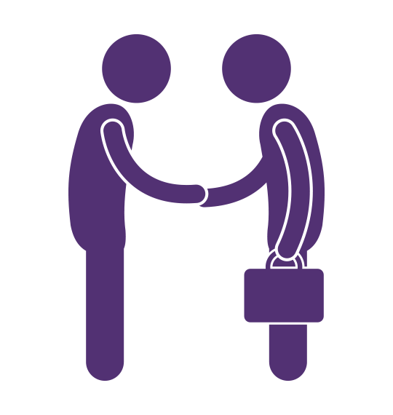
Activities
Equipment
Specialist support and training
People who provide assistance and support

While a few participants are maintaining connection with supports and services from the previous model alongside new supports and services, others had no services previously.

Potential supports

Participants commented that there is still scope to expand the range of supports people can access via their personal budget, for example:
- technology to support learning and communication
- other equipment to support access to their community
- specialised, one-on-one training.

Natural supports
Overall, natural supports are the same as those used previously. However, some people are now able to call on their natural supports in a more affirming way because of EGL Waikato.
Some interviewees reported that they can now access other supports and lessen the burden and pressure on those who provide natural supports. For example, one family interviewed reported:
My family have always done lots and continue to do lots, but it’s nice to be able to kind of reimburse people for things as well. When someone’s got really high needs you can’t expect family and friends to do things, because they need equipment, they need a van, they need to be able to lift them, and it becomes too much. So, it’s nice for me to not to have to rely on and exhaust my family.
There is evidence that family relationships are evolving as a result of the disabled person receiving better support – parents and grandparents now don’t have to be solely caregivers, and young people can ‘do ordinary things’.
Some interviewees reported relationships are improving between family members, for example, husbands and wives, parents and children, other siblings; and some families are now happier. For example, one family interviewed reported:
Without this integral part [EGL Waikato] we would be very stuck in a rut – 18 months ago, we were neither getting a break or time out. Our son wasn’t able to go to the pools or parks, because [my daughter] couldn’t go, so [my son] doesn’t get some everyday life things. Just 10 minutes with him [now able to collect him from school] means everything. [EGL Waikato] is helping us get along better as a family … even my son who is six says EGL helps him.
A few participants interviewed reported they are beginning to grow and develop confidence and are connecting with people, such as neighbours, in new and different ways. Several interviewees reported they feel enabled to self-manage and know that things are possible, while a few reported that Tūhono/Connectors are also encouraging them to do different things.

Community connection and participation

Participants interviewed commonly reported that they have increasing confidence to connect with and participate in communities following engagement in the Demonstration. For example, participants interviewed reported they are now:
- volunteering and sharing skills
- attending social and family events
[Our son] gets out to the movies more often now that he is able … it’s opened up his work a little bit more.
- reconnecting with their spirituality
- participating in community-based activities and courses
[Our son] is now attending university with a view to starting a degree next year.
- building their own business
[Our daughter is] able to be part of a business venture that creates lunches for school students.
- attending university
- training and competing in sporting events
Goes to Special Olympics … is more involved doing athletics, swimming and bowls.
- connecting with new people and neighbours.
He has blossomed … he has made friends.

How the Demonstration is making the difference
Several participants interviewed reported they are engaging more in their community. Although there may be other contributing factors, participants identified that EGL Waikato contributed to their increased engagement by:
- providing the flexibility and autonomy to plan for and access communities in ways that work for them as evidenced by the following quote:
I know where we are, but I also know where we are going, there’s a plan for it. It’s nice as it makes the transition out of school not so daunting because I do know that there are things that he can still access.
- assisting them to get supports that enable access, such as transport
- assisting them to get a support worker who is adaptable and flexible and can facilitate access
Under EGL, I can employ who I want to work with, when I want to work with them, how I want to work with them … and my team like working with me
- partnering them with a Tūhono/Connector to develop ideas, relationships and connections as evidenced by the following quote:
[My Tūhono/Connector] tells me things I should know, but I’m still thinking inside the box of it has to be this [particular] way … everything was [in the previous system] restricted, rigid, whereas in EGL I’m like okay, if I need something I ask [my Tūhono/Connector] and we put this in a proposal together.

Theme 5: Achievement of goals and outcomes

This section explores evaluation findings in relation to disabled people, families and whānau achieving their goals and outcomes as planned.

Experiences prior to EGL

Most participants (n = 25, 78%) interviewed reported that their experiences of previous services and support were not always positive. The following quotes from participants are examples of this point.

It was a disaster.
[EGL is] a lot more flexible than [NASC] ever was, and I wasn’t really utilising the hours.
I wasn’t going out much … I was basically a prisoner before.

Some participants (n=7, 22%) interviewed had good experiences of their previous system; however, under EGL Waikato they were looking for connections and support that would enable them to do or experience other things. Of note, two participants were only supported by their school – no disability supports were in place prior to the Demonstration.

Deciding factors to join EGL Waikato

All of the participants (n=32) interviewed felt that participating in the Demonstration would be positive; they would have more choice and control and the flexibility to determine what was possible with EGL Waikato. The following quotes from participants are examples of this.
The freedom to do things for ourselves. The power is with us.
Before, deficit based, but EGL is aspirational.
Flexibility is an absolute imperative to get the aid and help we need.

Achievements are because of EGL Waikato

Almost all of the participants interviewed (n=31, 97%) felt what they have achieved would not have been possible without EGL Waikato. The following quotes from participants are examples of this.
No guarantee.
Too much red tape.
Didn’t work.
Harder.
Impossible.
No not at all. It wouldn’t even come close.

One participant felt that what they are doing now would be possible without the Demonstration, and they are not experiencing any real difference.

Outcomes participants are aiming for

Participants interviewed identified a diverse range of goals and outcomes
Ultimately, disabled people and their families and whānau reported they were aiming to live an everyday life to achieve their aspirations by being able to:
- be in control of their lives and what happens to them as evidenced by the following quote:
Happy I’m living in a flat … able to flat not living as a boarder.
- say what they want and carry out their choices and decisions. One participant stated
I can take control of my life, and Mum doesn’t feel like I’m missing out.
- access information, support and funding at the right time
- choose and access supports that are simple to use, flexible and work for them, when and how they want them
- be supported to live an everyday life in everyday places, like others at similar stages of life as evidenced by the following quote:
Through EGL, I can now meet every Wednesday with my circle of friends.
- contribute to the lives of others and their community.

Participants described living an everyday life to achieve their aspirations as:
- having autonomy, self-governance and self-management as evidenced by the following quotes:
The best thing is that every day can look different.
In residential you don’t make your own goals, they make them for you.
- having choices available – sometimes ones they had not considered – and being able to create their own options/activities as evidenced by the following quote:
I wanted to try something different, and hope that when he gets a little older he gets a different life than residential care.
- having hope. For example, participants stated:
My outlook is a bit better now. Makes me keep healthy, looking forward to the day. I look a bit higher, further out at what’s around.
It [the equipment] has made a huge difference because he is now safe at night … so it’s given us peace of mind, and we can relax about it now.
I can have a life; we weren’t having a life at all.
- ‘starting early’ as evidenced by the following quote:
It’s made it a lot easier knowing we’ve got funding to use for what [she] needs. Especially things she wants to do … [she] is getting older, there will be more opportunities opening up to her. We see EGL funds will support this.
- being able to learn to connect, and reconnect, with others and make friends. For example, some participants stated:
I have a lot to contend with so just having the freedom to see my friends; I really look forward to that. Without EGL playing that important role, I wouldn’t have that time. I’ve felt like I’ve been entombed in my house for three years. People take seeing their friends for granted. It means the world to me.
If I didn’t have this funding I would be in my room 20 hours a day.
- being able to focus on the future and what is possible, as opposed to the here and now. For example, some participants stated:
I kind of liked creating the plan. I think having another person’s perspective was good as well. I also think it kind of gave me the opportunity to think quite big ... and to be aspirational with the things that you wanted in the plan.
It was a broad plan, included getting set up, getting staff involved, training and up-skilling to be more independent and get [my] drivers licence back.
- giving them the freedom to do their best
- removing red tape
- helping to change negative behaviours as evidenced by the following quotes:
Being able to control what you do. Like having a shower when I want.
Freedom gained has been life-giving. It’s been liberating.
- reducing the pressure, lessening the stress
- reconnecting families
- reconnecting them with their culture as evidenced by the following quote:
Has made everyone’s lives better including extended family members. Others outside our family looking in see that there’s a difference.

Barriers to participant success

Some participants are still experiencing a range of barriers to achieving their outcomes
These barriers are outlined in the figure below. The barriers reflected below were shared by participants during the interview process. Some participants are impacted by multiple barriers; therefore, the numbers reflected do not reflect different individual participants. The length of time and the degree to which the barriers are impacting participants are also not yet clear.

Figure 3. Barriers to participant success
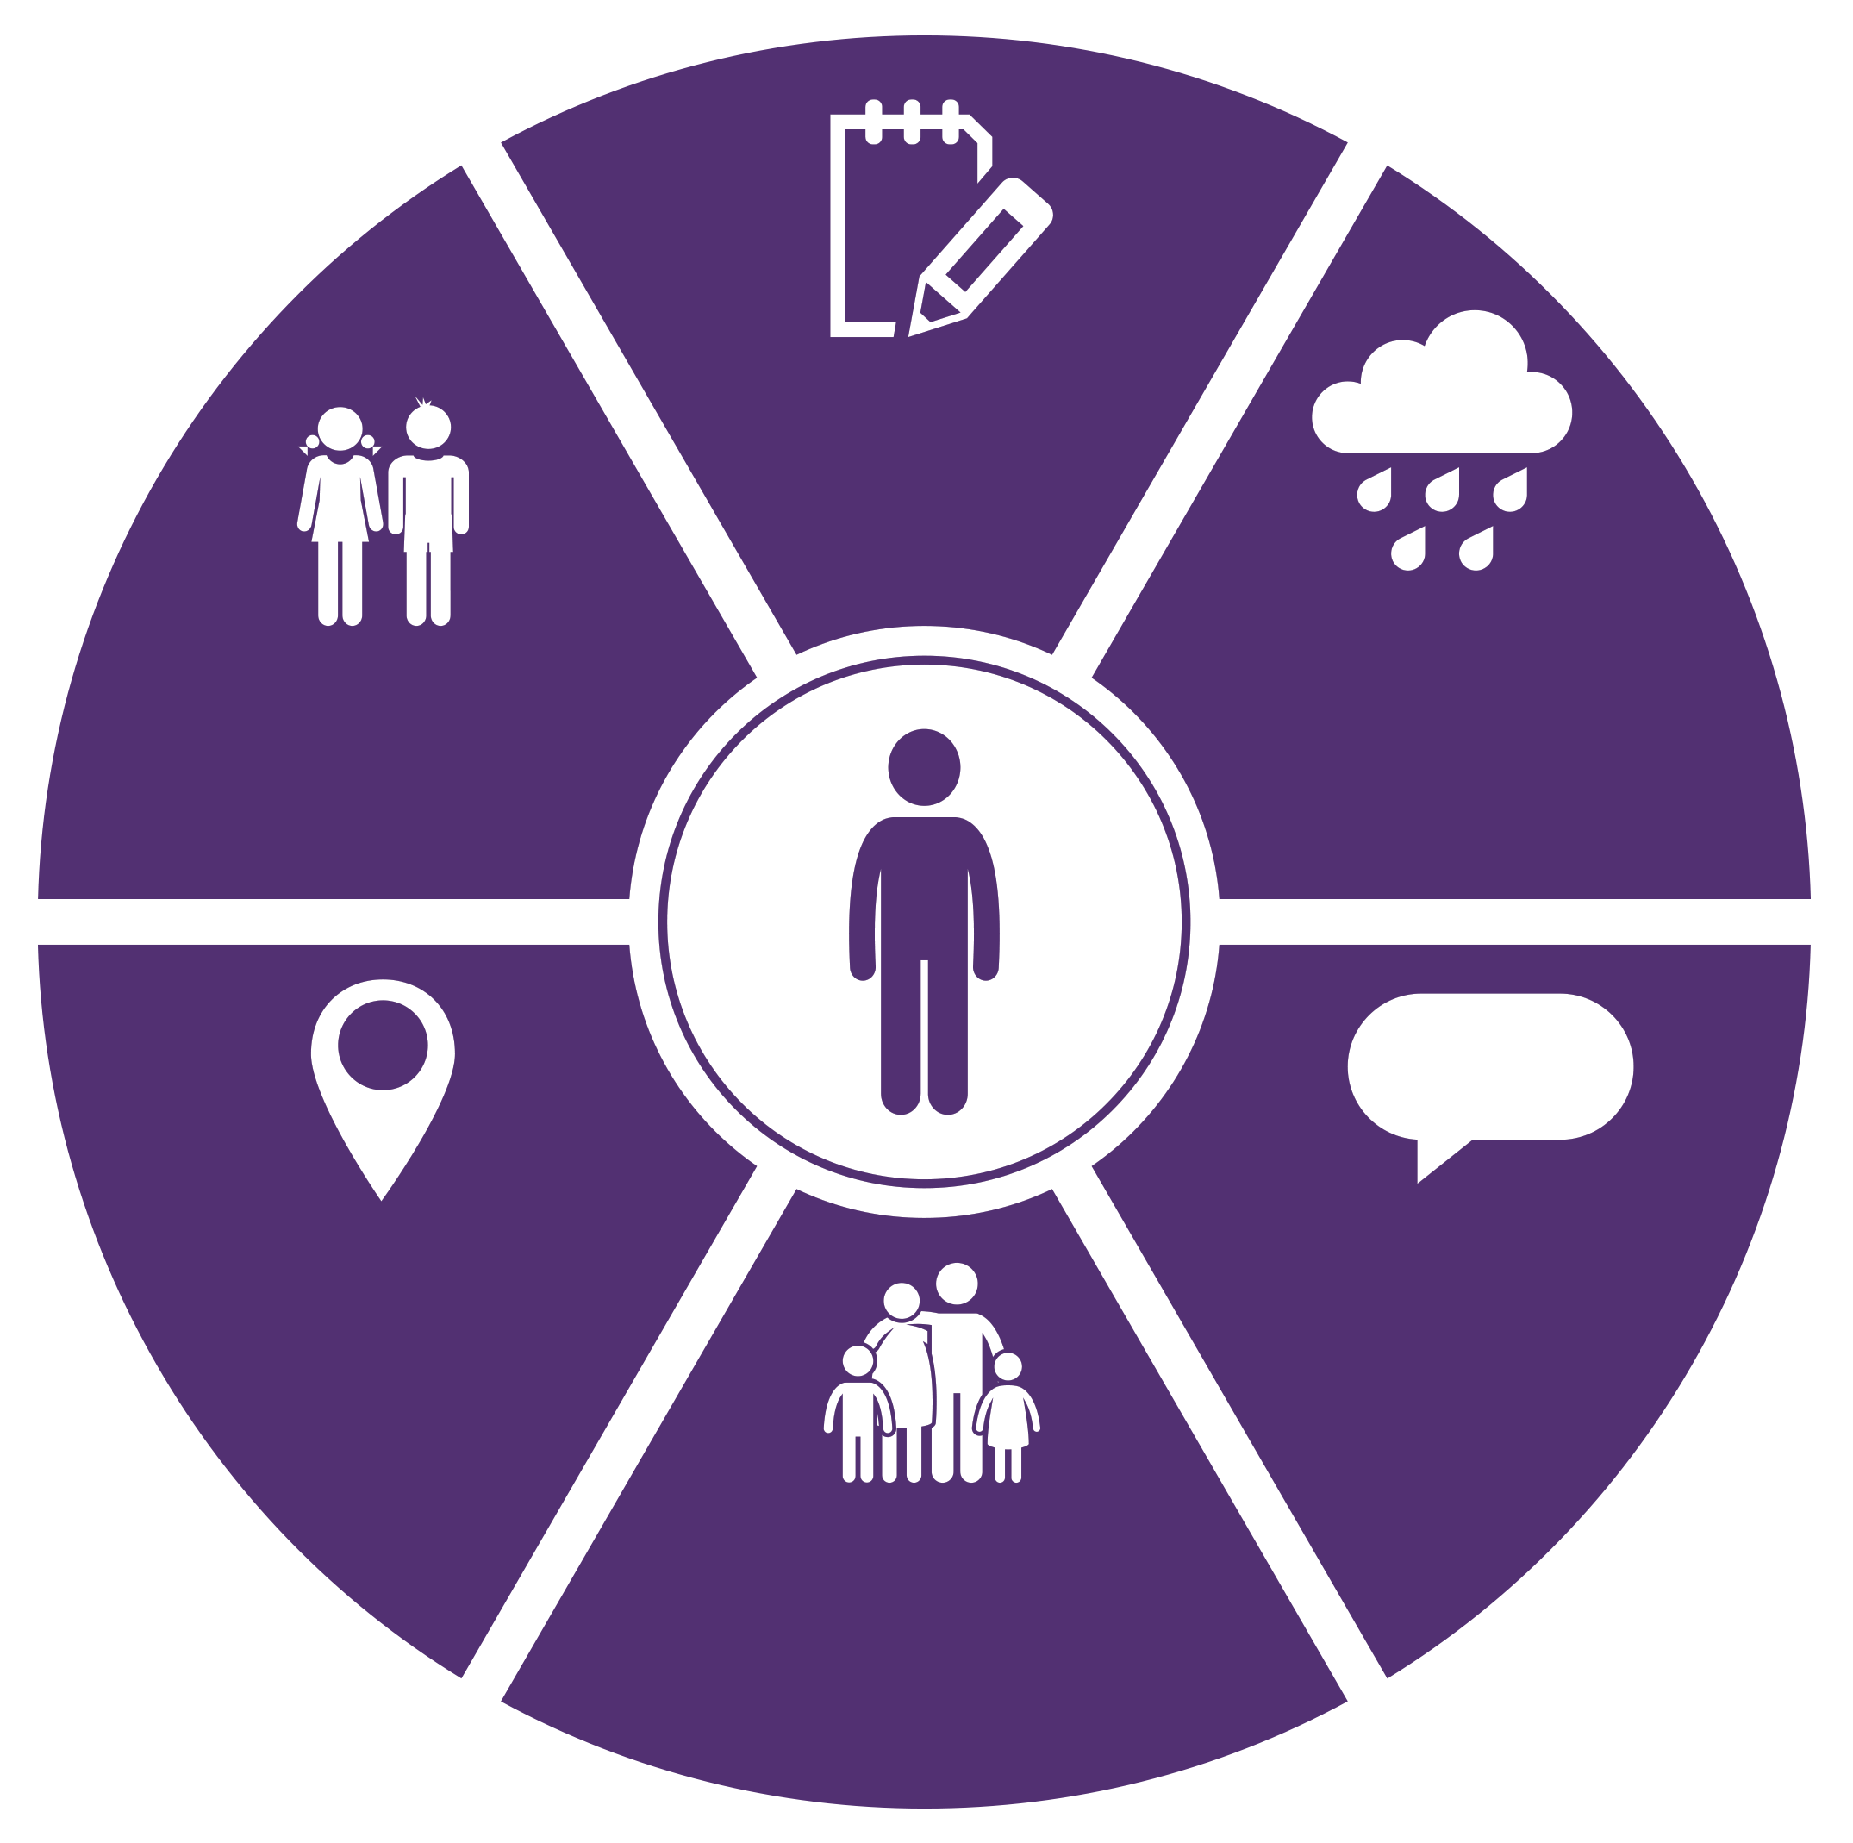

n=6

n=4

Plan not fully implemented, or don’t have all the information

Environmental barriers like the weather, distance and limited family availability to support

n=6

Rural location and impact of distance from bigger centers

Options for youth not always present in small, rural communities

People and families are still developing their confidence to self-manage and self-advocate

Some participants still cannot find support workers that ‘fit’

n=6
n=3

n=2

Theme 6: Providers’ actions and adaptions

This section discusses evaluation findings about how providers are working with disabled people, families and whānau as part of the Demonstration. It also discusses how providers are adapting to support this.

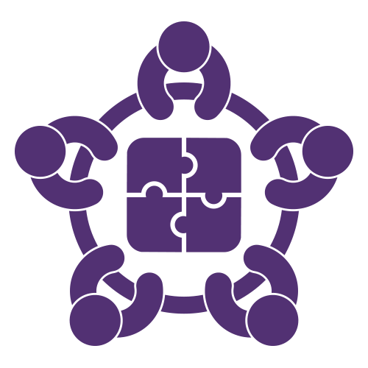

There is a range of provider partners who are working with the Demonstration and participants. Providers of disability services are involved with the Demonstration in several different ways, such as:
- working alongside participants and Tūhono/Connectors, to ensure they have the right supports in place
- being ‘hosts’ or organisations engaged by participants to provide financial management and/or human resource support to participants
- being contracted by the Demonstration to walk alongside participants in the EGL pathway. That means working in a way that reflects the role of Tūhono/Connector role and/or host.

Six providers were interviewed during the course of this evaluation to provide their perspective on the first year of the Demonstration and the EGL approach.

Providers’ reflections on the EGL approach

EGL is seen as a fresh new approach that is putting power into people’s hands
Four providers interviewed reflected that they are dedicated to the EGL principles, and believe their organisations align. They are also passionate about disabled people and their families and whānau leading the way. Two of these providers reported they have been working in an individualised way and practising the principles for many years.
For example, one provider shared:
There are very limited choices in [rural towns]; EGL has had a huge impact and there is potential for EGL to make a significant difference. Delivering EGL collaboratively in rural communities supports connections with community and between participants. Participants are beginning to experience the benefit of these connections.

Five providers interviewed reported they are finding ways to reflect the EGL principles, by:
- building relationships to ensure participants have choice and control to live the lives they want
- building trusted, respectful relationships to ensure open dialogue and collaboration with the Demonstration
- contributing as a member of the Waikato Leadership Group.
One provider asked:
What can we do to help the EGL Demonstration?
What could our place be to help EGL participants and Tūhono/Connectors?

There have also been some challenges
The evaluation found:
- Where providers are contracted to work with participants, it was identified by providers, EGL staff and participants that in some cases there has been a lack of clarity of roles. However, work is underway to minimise the impact on participants.
- There were instances when providers believed they should have been involved earlier and included in the planning and budget-setting process.
- For three providers, it took some time to connect with the Demonstration. This has improved and things are working well.
- Improving communication and sharing of information between agencies would help participants transition more smoothly from one system to another, according to providers and EGL staff interviewed.

How providers are adapting their practice
The evaluation found:
- Four providers recognised that they must do things differently to reflect the EGL principles. For one provider, this is just for EGL participants, while for three others these differences are being applied service wide
- Two providers are developing and delivering a range of in-service training activities on the EGL principles. One provider is also reflecting the principles in the scope of their roles and in their reporting systems
- Two providers are connecting with and sharing their ways of working with others
- The EGL Community of Practice is recognised as an important mechanism to network and share learnings about practising in an EGL way.

Barriers to providers adapting their practice
A few providers interviewed:
- acknowledged that to work in an EGL way takes time and this is having an impact on their ability to be responsive in a timely manner. In turn, this is negatively affecting a few participants
- recognised that while the EGL principles have been in place for some time it does not mean that they are actioned by all
- reported that there is a limited sector-wide approach to embedding the EGL principles
- reported that some tools, such as the organisational self-review tool, are not being well utilised by providers.

How providers work in an EGL way
Three providers interviewed reported they recognise that:
- there is a need to work collaboratively to support and help participants put their plans into action
- some participants are living in very complex situations and need a multidisciplinary approach to ensure effective supports are in place to enable them to have a good life.
One provider interviewed suggested that it just took one person “to jump on board with EGL and give it a go”. This showed others what was possible.

How providers are creating value for EGL participants

Five providers are:
- supporting people to shift their thinking and expectations
- prompting participants to think about wider community options
- supporting people to identify natural supports.
One provided stated:
People have always a known number of days or hours, or staying in the current thinking of what is delivered.
For a few participants interviewed, the journey to get started with the Demonstration required substantial shifts in expectations and language. The transition from the current system to the Demonstration means moving beyond the current thinking about what can be delivered and what is possible.
The power of giving someone the opportunity to know there are options is great.
One provider is facilitating several workshops with participants and the wider disability community on topics such as power of attorney and employment law. They also plan to run workshops where people can network and learn from each other.

Providers’ reflections on supporting adaption
In summary, providers interviewed reported that:
- the EGL principles enhance services for the benefit of disabled people, their families and whānau. Organisations need to reflect on how their values align with the principles
- the EGL principles reflected in contracts could help set expectations from government and determine what quality looks like
- working in an individualised, fee-for-service way requires systems and cost structures that some may not have or may need to develop
- fostering a Community of Practice approach so providers and practitioners can share learnings and insights would be beneficial
- designing and delivering in-service training to support the workforce to model the EGL principles would be beneficial.

Provider reflection on the value of EGL
Four providers shared their views on the potential value of EGL, with one provider reporting:

People are now making decisions for themselves, now can be creative and decide how to spend their budget; as there is no or limited respite or carer support options, they are employing whānau members to provide vital supports that is working really well.

Theme 7: Success factors

This section discusses evaluation findings about aspects of the Demonstration that make the difference for disabled people, families and whānau. It also elaborates on success factors for the Demonstration that were identified in the evaluation.

The difference the Demonstration makes
Almost all participants interviewed (n = 30, 94%) felt that the Demonstration is making a difference and they are experiencing positive change as evidenced by the following quotes:
We wouldn’t be able to do this without EGL. It benefits our child getting out in the community.
EGL provides a lot of opportunities for parents. Parents are really vulnerable.
Two participants felt that they were not experiencing any real difference, but felt it could help them in the future or help them experience things they haven’t before as evidenced by the following quotes:
You have to do your best. When it’s just you, my situation is harder simply because I don’t have any other family. If I had somebody, just one person, I believe it would make a lot of difference, but I don’t, and I just happen to have two children with special needs. So, it’s incredibly hard, sometimes when you work hard, long hours, you’re stressed and tired, not sleeping at night, for years, never sleeping for years. It is silly to expect people to be motivated. Sometimes I see other parents more motivated than me, going to meetings, parent groups, and I feel like I can’t do it.
I need someone to look after me, so I can look after my children.

Success factors of the Demonstration
Factors contributing to the success of the Demonstration include:
- being person centred, strengths-based
- having skilled Tūhono/Connectors who model the EGL principles
- taking a whole-of-life, holistic approach to funding allocation as evidenced by this quote:
We believe in a living wage and the carers we received from health care organisations were great but were on minimum wage. As a result of paying a living wage we have amazing carers. They are part of the family.
- providing options to self-manage or work with a host provider as evidenced by these quotes:
Because of EGL we are able to thrive; before we were struggling. I share when I go out that EGL has enabled me to do this.
It was a good process. The team are good partners in doing something differently. It was a good feeling experience.
- allowing autonomy, flexibility and freedom to determine what, when and how to do things as evidenced by these quotes:
Happy, I’m living in a flat.
We are Individualised now, not part of an agency … [best thing has been] getting him out of the system, he’s an individual.
- providing access to more flexible and reliable supports, particularly support workers
- providing access to equipment to ensure the health, safety and wellbeing of disabled people, families and whānau
- helping develop the confidence to think ahead and know that things are possible as evidenced by these quotes:
EGL helped me with my outlook for the future; others say I’m not so down all the time.
It’s about my life.

Theme 8: Learnings about system change and transformation

This section is synthesis of the findings from the phase 1 and 2 evaluations, using the EGL principles as our high-level framework for success, and highlights key learnings for systems change and transformation. Quotes from evaluation participants have been incorporated to enhance the learnings for each area of success.

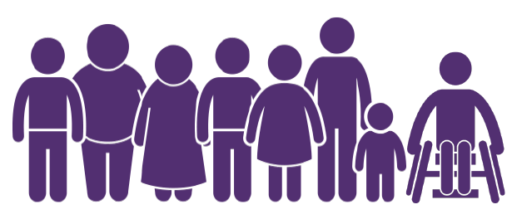
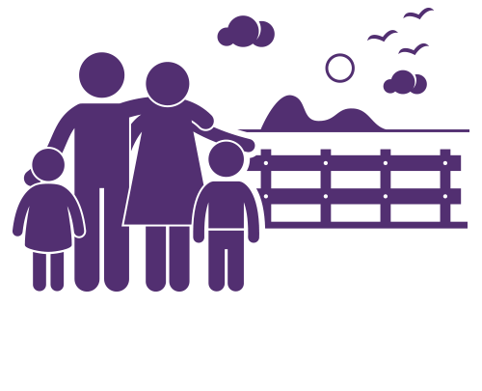 | Self-determination: EGL increases, and supports disabled people and their families and whānau to have control of their lives
- Taking a capability-building approach to enhance the knowledge and skills of disabled people and their families and whānau so they understand and take up opportunities to have more choice and control
We [as a host] are seeing some people gaining the skills and confidence to ultimately achieve their goals, with some progressing through to becoming self-managing.
- Ensuring disabled leadership is present, prominent and visible at all levels of the Demonstration
- Continuing to attract and retain people – staff and leadership group members – who are highly skilled, and model and mirror the EGL principles in all respects
- Finding a balance between working from where disabled people, families and whānau are at and being aspirational; and understanding that being aspirational may be a gradual process
- Enabling people, especially those who are rurally isolated or dealing with high and complex needs, to choose who they employ, including family who come to live with them.

 | Person centred: Disabled people and their families and whānau have increased choice and control over supports. Supports take a whole-of-life approach and are tailored
- Investing in families and whānau to best support their disabled family member to have a good life and help them develop a vision and aspiration for what can be achieved
Funding people with profound disabilities needs to be looked at, because their needs are so unique and it’s 24-hour care.
- Readying families for role or relationship changes particularly at significant transition points, such as leaving school.

 | Beginning early: EGL ensures its core systems are accessible, flexible and easy to navigate and to use
- Ensuring Tūhono/Connectors reflect the values, attributes, knowledge and skills identified through the Demonstration and the literature (refer to Theme 3)
- Constantly using reflective practice to enhance practice and performance
- Continuing the separation of Tūhono/Connectors from funding allocation processes, while ensuring they actively support participants to effectively manage and control their budget and supports
- Ensuring systems draw on what works and are integrated, for example using a client management system to ensure all participant information is accessible from one central database.
 | Mana enhancing: EGL creates opportunities for the abilities of disabled people, and values the abilities and contributions of disabled people and their families and whānau
- Committing to being disabled-person led, meaning everything is accessible
- Acknowledging that the level and intensity of support participants need vary along a continuum. Tūhono/Connectors are encouraged to walk alongside people to ensure they are well resourced to lead their own solutions
- Adopting a practice of family or whānau centeredness; and ensuring that families and whānau can also access brief support and connections so that, as a whole, everyone is flourishing. Natural supports, such as parents and other siblings, are a vital part of support networks for disabled people. Investment in their wellbeing will go some way to ensuring people live well and stay well closer to home.

 | Ordinary life outcomes: EGL supports equity and citizenship for disabled people and their families and whānau
- Providing opportunities to connect participants, to create networks and share ideas about what is possible and what works
Just get more people in [residential services] out in the community.
- Ensuring processes are as easy to use as possible. Additional, ongoing guidance to support participants to build confidence and ease into the responsibilities of budget holding and becoming an employer is required.

Mainstream first: Disabled people and their families and whānau are supported to access community options, connections and services before specialist disability services
- Continuing to foster and grow community awareness so that communities are more welcoming and accessible, recognise the contribution that disabled people make, and become people’s first choice – the EGL approach in action.
[We need] help to raise community awareness and develop collective community options not just individual … recognise that this takes time, but want to explore this together with others.

Relationship building: EGL builds and strengthens relationships between EGL partners – that is, disabled people, families and whānau, community, providers of disability services and government
- Ensuring continued adoption and use of the EGL principles by all EGL partners – disabled people, families, whānau, community, providers of disability support and government agencies
It would be nice if all agencies worked under the same philosophy or principles [as EGL] and were flexible instead of keeping in their silos.
- Continuing to foster a community of practice approach to support the use of the EGL principles in action
- Encouraging and supporting changes to service provision by aligning all facets of provider service commissioning, delivery, development and accountability with the vision and principles of EGL
- Promoting transparency, trust and communication between all EGL partners
- Recognising that ongoing relationships between the Demonstration and hosts are important to ensure participants are receiving the services and supports they need and pay for
- Ensuring clarity of roles and responsibilities when other agencies or organisations are working with EGL staff and participants.

The following quotes are a selection of participant views shared during the interview process with 32 active participants, including a final question asking participants if there was anything in closing they would like to share about their experience of EGL Waikato.

Keep it real

EGL provides a lot of opportunities for parents. Parents are very vulnerable

Out and shining. Keep on with EGL

It works! Flexibility is a very good thing
With EGL you have more control

Absolutely loving it. Without EGL, I wouldn’t be doing anything right now

EGL takes the burden off

We can solve our own problems

EGL – have it your way

My son is making the world a better place

Pleased we’ve done it

They should roll it out across the country. People are entitled to decent care. Carers are entitled to a living wage

References

Anderson, D., Ferguson, B., & Janes, R. (2014). Enabling Good Lives Christchurch Demonstration: Phase 1 evaluation report. Wellington, New Zealand: Ministry of Social Development, Ministry of Health and Ministry of Education.
Berryman, M., SooHoo, S., & Nevin, A. (2013). Culturally responsive methodologies. Bingley, UK: Emerald.
Cram, F. (2009). Maintaining indigenous voices. In D. Mertens & P. Ginsberg (Eds.), The handbook of social research ethics (pp. 308-322). Thousand Oaks, CA: Sage.
Enabling Good Lives. (2016). Enabling Good Lives – Key characteristics. Retrieved from http://www.enablinggoodlives.co.nz/about-egl/egl-approach/key-characteristics/
Hood, S., Frierson, H., & Hopson, R. (Eds.). (2005). The role of culture and cultural context in evaluation: A mandate for inclusion, the discovery of truth and understanding. Greenwich, CT: Information Age Publisher.
Jacobson, M., Azzam, T., & Baez, J. (2012). The nature and frequency of inclusion of people with disabilities in program evaluation. American Journal of Evaluation, 34(1), 23-44.
Lord, J., & Hutchison, P. (2003). Individualised support and funding: Building blocks for capacity building and inclusion. Disability & Society, 18(1), 71-86.
Mikkelson & Cosgriff (2016). Internal team reflections – Enabling Good Lives Waikato. Unpublished.
Office of the Minister for Disability Issues (2014). Demonstrations of the Enabling Good Lives approach in Christchurch and the Waikato – paper to the Cabinet Social Policy Committee. Retrieved from http://www.enablinggoodlives.co.nz/about-egl/enabling-good-lives-context/christchurch-waikato-paper/
Patton, M. (2011). Developmental evaluation: Applying complexity concepts to enhance innovation and use. New York, NY: The Guilford Press.
Patton, M., McKegg, K., & Wehipeihana, N. (Eds.) (2016). Developmental evaluation exemplars: Principles in practice. New York, NY: Guilford Press.
Preskill, H., Gopal, S., Mack, K., & Cook, J. (2014). Evaluating complexity: Propositions for improving practice. FSG. Retrieved from http://www.fsg.org/publications/evaluating-complexity
Schalock, R., Verdugo, M., Jenaro, C., Wang, M., Wehmeyer, M., Xu, J., & Lachapelle, Y. (2005). Cross-cultural study of quality of life indicators. American Journal on Mental Retardation, 110(4), 298–311.
Smith, L. (1999). Decolonizing methodologies: Research and indigenous peoples. London: Zed Books.
Smith, L. (2005). On tricky ground: Researching the native in the age of uncertainty. In N. K. Denzin & Y. S. Lincoln (Eds.), The Sage handbook of qualitative research (3rd ed., pp. 85-107). Thousand Oaks, CA: Sage.

Appendix 1

Overarching evaluation questions
The overarching questions for the Demonstration evaluation are:
- How and how well is EGL Waikato being delivered to and experienced by participants?
- What are the outcomes that matter to participants? How and how well have participants achieved their outcomes? What contribution has the EGL Waikato Demonstration made to those outcomes?
- How and how well have disabled Māori and their whānau been effectively engaged in and utilised EGL Waikato?
- How and how well have disabled Pasifika and their families been effectively engaged in and utilised EGL Waikato?
- How has EGL Waikato influenced or changed the systems that support disabled people and their families and whānau?
- How well is EGL Waikato delivering the Demonstration? What has supported and what has hindered delivery?
The evaluation questions for phase 2 outlined earlier are a subset of these questions.

Evaluation analysis for phase 2
The approach to analysis was not as one single analysis process, but a combination of synthesis, analysis and sense-making processes.
The opportunity was also taken to use a set of qualitative data analysis questions to allow for deeper consideration and analysis by individual interview team members. Individual analysis was then jointly completed as part of group analysis sessions.
To understand the counterfactual, that is, the situations, conditions or outcomes that hypothetically may occur or prevail for participants or partners of the EGL Waikato Demonstration if this innovative approach did not exist, required us to make comparisons. Given the constraints of the evaluation (time and resources), where we wanted to understand if participants would have achieved the same outcomes if there was no Demonstration, we referred to their experiences and arrangements that were in place prior to joining the Demonstration.

Evaluative rubric used in analysis

EGL Principles | EGL Waikato Demonstration  Implementation Criteria | EGL Waikato Outcomes Criteria |  | EGL Christchurch  Quality of Life Domains
 |  | Disabled People | Families and Whānau
Self- Determination | The EGL Waikato Demonstration increases and supports disabled people, and their families and whānau to have control of their lives. | I am in control of my life and what happens to me.  I can say what I want and carry out my choices and decisions. | Family and whānau are empowered to express their goals and aspirations and those they care for. | Self-Determination  - Autonomy/personal control  - Goals and personal values (desires, expectations)  - Choices (opportunities, options, preferences)
Person-centred | Disabled people, and their families and whānau have increased choice and control over supports. These supports take a whole-of-life approach over time and are tailored to their needs, goals, and aspirations. | I control and direct my life, including my disability supports.  I can choose who can assist me with my on-going support.  Supports work for me when and how I want them.  I can do things that are important to me. | Supports work for families and whānau when and how they want these.

EGL Principles | EGL Waikato Demonstration  Implementation Criteria | EGL Waikato Outcomes Criteria |  | EGL Christchurch  Quality of Life Domains
 |  | Disabled People | Families and Whānau
Beginning early | The EGL Waikato Demonstration ensures that their core systems (Tūhono/Connectors, community connections, supported self-assessment and planning, and personal budgets) are accessible, flexible and easy to navigate. | I have aspirations and can plan for them.  I am in control of my life and what happens to me.  I have the supports I need, when I need them. | Families and whānau are aspirational for their child’s life and future.  We have access to support and funding that contributes to our family and whānau living the life we want.  We are known and connected in our community. | Emotional Well-Being  - Contentment (satisfaction, moods, enjoyment)  - Self-concept (identity, self-worth, self-esteem)  - Lack of stress (predictability and control)  - Safety and security  - Spirituality/ culture  Physical Well-Being  - Health and wellness (functioning, symptoms, fitness, nutrition)  - Activities of daily living (self-care, mobility)  Physical activities including recreation  Material Well-Being  - Financial status  - Employment status; job-related skills and behaviours  - Housing status  Having possessions  Personal Development  - Education (achievements, education status)  - Performance (success, achievement, productivity)  - Personal competence (cognitive, social, practical skills)
Mana enhancing | EGL Waikato demonstration creates opportunities for the abilities of disabled people; values the abilities and contribution of disabled people and their families and whānau. | The contribution I can make is recognised and respected.  I can contribute to the lives of others and to my community.  EGL Waikato is culturally respectful of me. | The abilities and contributions of families and whānau are recognised and respected.  EGL Waikato is culturally respectful of our family and whānau.
Ordinary Life Outcomes | The EGL Waikato Demonstration supports equity and citizenship for disabled people, families and whānau. | I am supported to live an everyday life in everyday places, like others at similar stages of life.  I have citizenship rights, including opportunities for learning and contribution, having a home and family, friends and connections and employment. | Families and whānau are supported to live an everyday life in everyday places.

EGL Principles | EGL Waikato Demonstration  Implementation Criteria |  | EGL Waikato Outcomes Criteria |  | EGL Christchurch  Quality of Life Domains
 |  |  | Disabled People | Families and Whānau
Easy to use | The EGL Waikato Demonstration ensures that their core systems (Tūhono/Connectors, community connections, supported self-assessment and planning, and personal budgets) are accessible, flexible and easy to navigate. | I find the EGL system easy to use and flexible.  I have supports that are simple to use and flexible.  I know how to and can access information, support and funding at the time I need it.  I have one plan and one amount of funding. |  | We find the EGL system easy to use and flexible.  We know how to and can access all the information our family and whānau needs.  We have one plan and one amount of funding. | Rights  - Human (respect, dignity, equality)  - - Legal (citizenship, access, fair treatment)
Mainstream First | Disabled people, families and whānau are supported to access community options, connections and services before specialist disability services. | I am known and connected in my community.  I know how to and can access all the information at the time I need it.  Community options, connections and services that are for everyone can be used before disability services. |  | We know how to, and can access all the information our family and whānau needs.  We are known and connected in our community.  Community options, connections and services that are for everyone can be used before disability services.

EGL Principles | EGL Waikato Demonstration  Implementation Criteria | EGL Waikato Outcomes Criteria |  | EGL Christchurch  Quality of Life Domains
 |  | Disabled People | Families and Whānau
Relationship Building | EGL Waikato builds and strengthens relationships between EGL Waikato Partners – disabled people, families and whānau, community and government. | I can build strong relationships that are important to me.  I can contribute to the lives of others and to my community. | We are known and connected in our community.  We know how to, and can access all the information our family and whānau needs. | Interpersonal Relations  - Interactions (social networks, social contacts)  - Relationships (family, friends, peers)  - Supports (emotional, physical, financial)  - Social activities
Social Inclusion
- Community integration and participation
- Community roles (contributor, volunteer)
- Social supports (support networks, services

Refer to the Evaluative rubric (Appendix 1) for more information about the outcome domains.
The EGL Community of Practice is a forum developed during the EGL co-design phase; it offers a supportive environment for providers of disability services to network and share how the EGL principles are being put into practice and explore what the principles mean to the workforce.
Preskill et al. (2014).
The Christchurch Demonstration, which began in July 2013 and focused on school leavers in Christchurch, provided a reference point for the Waikato Demonstration. While the Christchurch Demonstration has ended, EGL, including independent facilitation, is still available to Christchurch school leavers.
Mikkelson & Cosgriff, 2016
‘Natural supports’ often refers to the resources inherent in community environments including personal associations and relationships that enhance the quality, and security, of life for people. Natural supports usually involve family members, friends, co-workers, neighbours and acquaintances. People may need help in developing these connections, but, over time, these connections can help an individual build a strong community network and support system that enhances their quality, and security, of life.
Enabling Good Lives (2016). Enabling Good Lives – Principles. Retrieved from http://www.enablinggoodlives.co.nz/about-egl/egl-approach/principles/
For more information about the EGL approach see http://www.enablinggoodlives.co.nz/ and the phase 1 evaluation https://www.parliament.nz/resource/en-nz/51SCHE_EVI_00DBSCH_EST_69136_1_A518056/189a1cc919fac269857fba33efa50f0e79c83c6b
Further detailed information is provided in the themed sections of this report.
“While there is not an agreed definition of co-design internationally, it usually involves collaborative relationships between public service professionals and citizens or users of the design process. [Some authors] believe these relationships need to demonstrate equality and reciprocity. There is also a focus on delivery of outcomes rather than just the service” (Anderson et al., 2014).
‘Tūhono/Connector’ is the unique Waikato name given to the Independent Facilitator. Refer to Theme 3 for more information.
Definition accessed from http://www.enablinggoodlives.co.nz/about-egl/egl-teams/waikato-team-2/
Choice in Community Living was an element of Disability Support Services’ New Model within the Ministry of Health. Please refer to http://www.health.govt.nz/your-health/services-and-support/disability-services/types-disability-support/new-model-supporting-disabled-people/choice-community-living for more information.
This action area has not been implemented fully because the phase 1 evaluation identified that it was complex and required more discussion and deliberation.
Refer to Appendix 1.
Berryman et al. (2013) and Hood et al. (2005).
Cram (2009), Smith (1999) and Smith (2005).
Sourced from The Kinnect Group, personal communication. The Kinnect Group are a New Zealand research and evaluation company ( http://www.kinnect.co.nz/)
We wish to acknowledge the use of Bob Williams’ ideas about data analysis, in particular the Qualitative Data Analysis Tool as contained on his website http://www.bobwilliams.co.nz/Tools.html and http://www.bobwilliams.co.nz/Tools_files/analysis2.pdf
A rubric sets out clearly criteria and standards for assessing different levels of performance. See http://betterevaluation.org/en/evaluation-options/rubrics
Partners in the EGL Waikato Demonstration are disabled people, families and whānau, provider networks and government Ministries.
Three interviews incorporated multiple participants. Two active participant interviews included two siblings and a mother and child. One non-active participant interview included a family of three.
As participants can identify with multiple ethnicities, the total number does not equal the total number of participants.
It is important to note that there are some inconsistencies with the ethnicity data, namely the ethnicity categories with which participants can self-identify. Use of the Census ethnicity definitions to enable consistent data collection will be recommended to the Demonstration team.
Lord & Hutchison (2003).
Additional analysis of the scale, numbers and extent of participant outcomes is currently being undertaken. This report was completed at the end of November 2016.
The EGL principles provide the basis for understanding how and how well the Demonstration is implemented. Please refer to Appendix 1 for more detail.
We wish to acknowledge the use of Bob Williams’ ideas about data analysis, in particular the Qualitative Data Analysis Tool as contained on his website http://www.bobwilliams.co.nz/Tools.html

