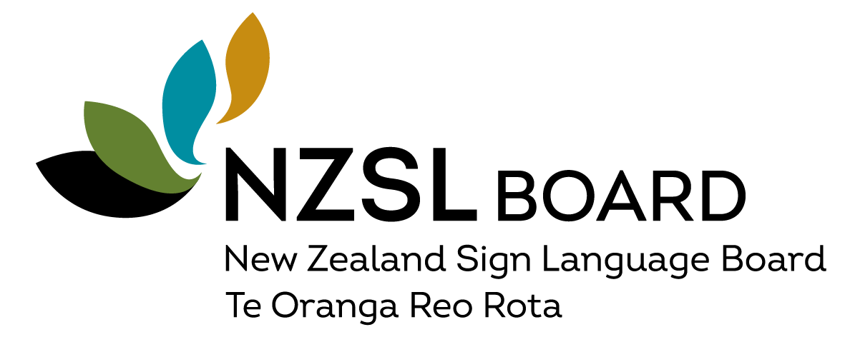

Nomination form
- Nominations should be submitted using this form and the Cabinet Committee Curriculum Vitae CAB 50/01 form in writing, sent to the NZSL Office.
- Nominations should be received by 5pm Friday 6 October, 2023.
- The Office will acknowledge receipt of nominations.
- Nominees will be informed about the Minister’s decisions.

Nominated by:
(name, and name of nominating organisation if applicable )
Nominee has been notifed of, and agrees to, nomination |  | Yes/No
Person being nominated
Name:
Email / phone:
Address:

Role the nomination is for: | Board Member
 | Board Chair
Deaf or hearing?
Fluent in New Zealand Sign Language?
Ethnicity identified with?

Contact details of two people who can act as a referee:
Contact One
Name:

Their relationship to nominee:

Contact details (telephone and email):

Contact Two
Name:

Their relationship to nominee:

Contact details (telephone and email):

Send the completed nomination forms:

- Email as a Word document to, nzsl@whaikaha.govt.nz

