# 

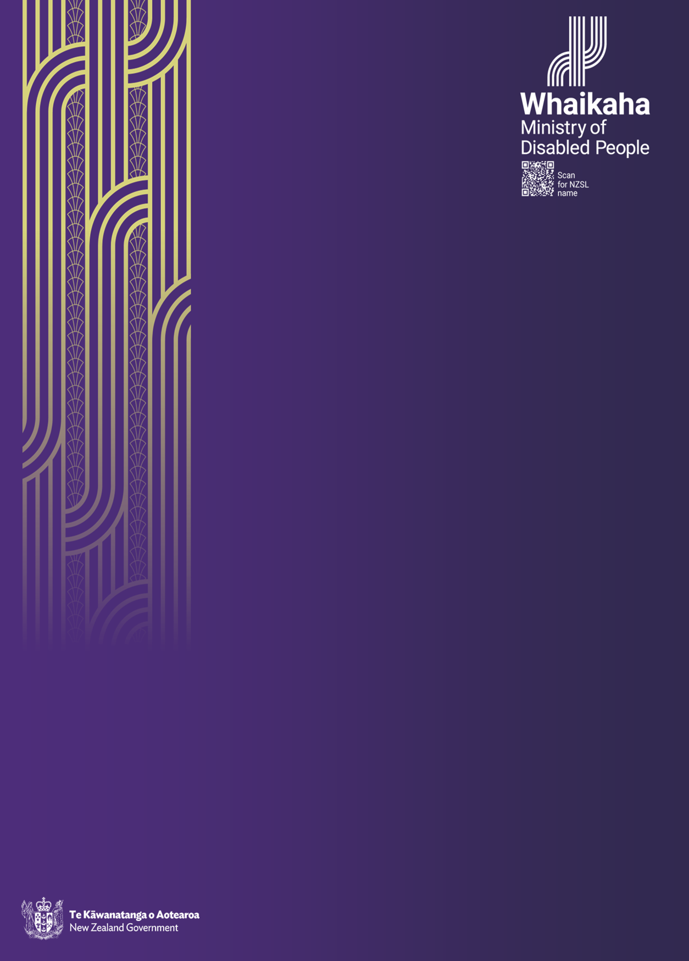

**Pacific Community Talanoa Feedback Report**

**September 2024**

Tēnā koutou kātoa, Noa’ia, Mālō ni, Kia orāna, Mauri, Fakaalofa lahi atu, Ni sa bula vinaka, Talofa lava, Halo oloketa, Mālō e lelei, and Pacific greetings.

**“**Fakamalolo ke he tau amaamankiaga, ke mafola ai e tau matakainga - strengthen all endeavours and the community will benefit” (Niuean Proverb)



The leaves of a coconut tree depict shelter, protection and provision to the social interactions that bring harmony to the person and their surroundings.

## **Contents**

Introduction 4

Background 5

Purpose & Approach 6

What the community told us 7

Themes 7

Priorities for the Action Plan 9

Discussions 9

Regional Feedback 14

Next Step 23

Reflections: Opportunities for Improvement 23

Appendix One: Background to the Action Plan 25

Appendix Two: Whaikaha establishment 26

Appendix Four: Talanoa engagement questions 29

Appendix Five: Pacific disability dashboard 30

**Acknowledgement**

Whaikaha - Ministry of Disabled People recognises the dedication and passion shared by the community throughout the talanoa series and we want to thank you for sharing your stories of strength, challenges, resilience, and success. The gift of your voices has brought this report to life and now we need to ensure the Action Plan we develop reflects the thoughts of our people.

**Meitaki Maata, Fa’afetai lava, Fakaaue, Vinaka, Fakafetai lasi, Malo ’Aupito, Fakafetai lahi lele, Tanaka, Ngā mihi**



**Mua Ō!**

Is a traditional call used in Samoan culture to gather people together for a special event or presentation.

## **Introduction**

Pacific disabled people are an important area of focus for the Ministry of Disabled People – Whaikaha (Whaikaha).

Whaikaha is developing a National Pacific Disability Action Plan (the Action Plan). Progressing this Action Plan is a priority for Whaikaha. It demonstrates our on-going commitment to improving disability services, information, and cultural responsiveness to the needs of our communities.

The advice from our Pacific disabled community is to ensure Whaikaha co-design and co-develop this Action Plan with and for Pacific disabled people.

Our community have told us they want an Action Plan that boldly re-shapes the design of disability supports around the needs and aspirations of Pacific disabled people and their Aiga in Aotearoa, New Zealand for the next five years.

The Action Plan is being co-developed with the guidance and support of many Pacific disabled people representing Pacific young people and their parents, service providers, and support groups such as, Blind/Low vision Pacific group and Parents of children with autism groups.

From February to April 2024 a series of 20 talanoa (conversations) were held throughout Aotearoa, New Zealand for all Pacific disabled people and their aiga, carers to share their experiences with us.

The talanoa series was attended by over 1000 Pacific disabled people with their Aiga, carers, community leaders, Pacific non-government organisations, providers, extended family members and others interested in conversations regarding disability.

This report brings together feedback and information from this talanoa series. It aims to offer a comprehensive perspective and voice of how we can all contribute to the collective success of Pacific disabled people.

**Mua ia ina Mua Ō! *–*** This is our moment.

## **Background**

The previous Pacific Action Plan, the Faiva Ora National Pasifika Disability Plan (2016-2021) expired in June 2021(Appendix One)before Whaikaha was established.

In June 2021, the Ministry of Health (Appendix Two), through the Disability Directorate, conducted a thorough review of the Faiva Ora Action Plan 2016 – 2021[1].

The review recommended the development of a new Action Plan grounded by four recommendations, which we consider instrumental in shaping future initiatives and achieving the objectives for the newly recommended Action Plan.

1. Achieving more equitable wellbeing outcomes for Pacific disabled people
2. Exploring disability system transformation from a Pacific lens
3. Empowering system levers
4. Fostering Pacific disability community empowerment

Whaikaha was established in July 2022. In July 2023, the then Minister for Disability Issues endorsed the development of the first Whaikaha National Pacific Disability Action Plan.

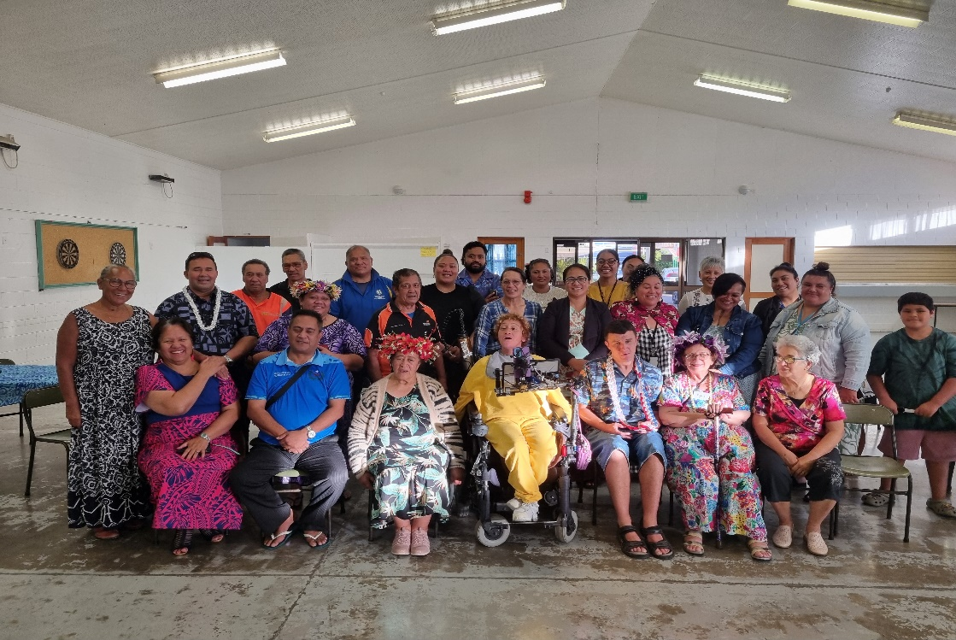

## **Purpose & Approach**

Critical to the success of the development of the Action Plan, was the need to talanoa with Pacific disabled people from the outset of the process.

A series of community talanoa were held to capture the voices of Pacific disabled people, their Aiga, family carers, Pacific and non-pacific providers, support networks, and Villages[2].

Pacific talanoa were established across the four main centers and in smaller regions. Regional leadership of Pacific disability was utilised to lead and facilitate these regional talanoa. We also sought mandates from regions and respective Island groups as a mechanism for providing Island group by Island group voice.

In addition to working with various groups, we also broadened our engagement mechanisms to include:

* an online survey to collect feedback from a wider range of people, those who couldn’t otherwise attend any of the face-to-face talanoa to better inform Pacific disability wellbeing outcomes. (Appendix three)
* online-zoom talanoa, were hosted to ensure those who could not attend in person talanoa could have their say to inform the final plan, virtually.
* Blind/low vision focus group facilitated by Blind/Low Vision New Zealand
* Pacific disabled people in residential care focus group

## **Kapasa – Pacific Policy Analysis Tool**

The Ministry for Pacific Peoples’, Pacific Policy Analysis Tool – **Kapasa**, has been included to add value to the public policy development process. It encourages a strengths-based approach to policy development that draws upon the strengths and values of Pacific families and communities.

Effective engagement with Pacific people and/or service providers is an important element throughout all the phases of the talanoa process using the **Yavu** tool of engagement.

## **What the community told us**

Pacific disabled people and their families have highlighted the importance of a Pacific-led and community-centered approach to developing the Action Plan.

They have emphasised the critical involvement of Pacific disabled people, their families and community stakeholders in both shaping and implementing the action plan.

**“Now you’ve explained who they are, wow! A Ministry that is ours, that is for us. That’s a very big deal. We can be a priority and not as an afterthought… this Pacific Disability Action Plan, with Whaikaha can be built from the bottom up, with us, and by us, and for us”** (Youth & Autism Talanoa)

The Pacific community wants Whaikaha to let them play a much stronger role and give voice in informing what's best for them, their families, their Carers, and their wider community - who are closer in knowing and understanding their needs and aspirations.

**“I want Whaikaha to be the champion in the government space to help us continue to be the champions that we are, motivating and enriching lives.”** (Youth & Autism Talanoa)

### **Themes**

The themes below summarise insights gathered from the talanoa, detailing the strengths and challenges of living with a disability, as well as the perspectives of individuals with lived experiences and the supportive roles of families.

It was important for many who participated, that all environments and settings are considered in supporting disabled people of all groups.

For Pacific the theme of increasing awareness has been consistently heard across the country and seeks to empower our Pacific community by increasing their knowledge of disability and nurturing positive attitudes towards our disability community. Despite considerable advancements for the disability sector, there remains room for progress. By educating people about disabilities, we promote respect and recognition, while also equipping them with the skills to perform jobs, identify services, and navigate systems. This approach also acknowledges the diversity of disabilities and the uniqueness of each person that allows for further acceptance and respect.

The community feedback has been themed into three categories: major themes, minor themes and other themes. While many other important issues were also shared, the majority align and contribute into these three categories.

#### **Major themes were:**

* Empowering Pacific disability communities through increased awareness.
* Developing a culturally aware workforce to enhance capacity and capability in the disability sector and Pacific disability workforce.
* Effective leadership, ‘grow our own’ from youth to family members who can advocate for our Pacific disabled person.
* Stakeholder collaboration involved local community groups to participate and share information.
* Family-centered approach: The value of the role families play in navigating the system for their disabled family member(s).
* Health focused response in addressing access and resource barriers (delayed access to child development services, diagnosis, speech therapists, counsellors and hearing aids).
* Youth focused initiatives.
* Language barriers – Pacific languages and NZSL.
* Access to services in rural and semi-rural areas (increasing cost for essential services that significantly disrupts families who heavily rely on accessible and affordable options).

#### **Minor themes were:**

* Advocacy, representation, and inclusive decision making
* Support for family carers
* Social connections in communities
* Social determinants of Health (Transport, Housing, Employment, and Education)
* Safeguarding in disability

#### **Other themes:**

* Involvement of Pacific Churches and Organisations in promotion, understanding and acceptance of disability
* Enhancing Pacific data insights
* Creating opportunities for disability community groups to develop and promote community-driven initiatives with customised solutions.

## **Priorities for the Action Plan**

We have carefully considered the insights shared to us by the community during the talanoa, which have informed us of the needs, aspirations and potential implications for collective action.

In considering all the themes presented in this report, we have identified eight key priority areas for the National Pacific Disability Action Plan.

### **Priorities for consideration**

1. Disability awareness within Pacific communities
2. Leadership in Pacific disability
3. Workforce capability and capacity
4. Accessibility
5. Strengthening support to empower families
6. Stakeholder collaboration
7. Strengthening ethnicity specific data collection
8. Enabling Good Lives and its principles

### **Discussions**

The community recognised other important issues that they felt were crucial to raise and discuss. These topics were considered essential for further consideration amongst our community members that would ultimately shape the future for Pacific disabled people and their families.

#### **Whaikaha Stewardship role**

Central to improving tangible outcomes for all disabled people is the stewardship role that Whaikaha holds. This role enables Whaikaha to collaborate with other agencies to integrate disability perspectives into their policies and services, build capacity and capability within the public sector, and share responsibilities in a consistent and unified manner that helps remove barriers that prevent disabled people from fully participating in society.

**“I think if I could just share a story... Whaikaha is now the essence of disability support. I believe it's about asking what more they can do for us, bridging the gaps that have been left unfilled”** (Youth & Autism Talanoa)

Based on feedback from the community, we have heard several key challenges affecting Pacific disabled people and their families in their daily lives. The high cost of living was a recurring theme throughout the talanoa process across all villages 2. The impacts of rising cost of services, transport, school fees, affordable housing, and medical expenses have become increasingly burdensome. These rising costs not only strain financial resources but also force difficult decision-making processes, as families must continually re-evaluate their priorities and allocate their limited resources to meet both immediate and long-term needs of the family member with a disability.

Pacific disabled people living in semi-rural villages expressed the compounded challenges they face. Particularly, in accessing specialised services that are more readily available in large urban centers. Achieving tangible outcomes for Pacific disabled people, their families, and the wider community would see collaborative efforts from various government agencies that ensure meaningful change and a more equitable society for all.

#### **Pacific perspectives on Enabling Good Lives**

Following our community consultations, we observed that many Pacific disabled people, their aiga and carers, were unfamiliar with EGL (Enabling Good Lives) and its principles. This lack of awareness was particularly noticeable among families in villages[3] where EGL and its principles were not present. However, in the villages where EGL initiatives were present, families have shared accounts of its benefits and how the approach has positively impacted their lives, prompting others in their community to join in and benefit from it as well.

**“EGL aligned with my family members goal and was able to find leisure activities that allow our family to participate.”** (Horowhenua Talanoa)

Some families have brought up notable points about how the approach may be able to accommodate Pacific cultural values, and practices. One significant perspective they shared is that, while the principles prioritise individual strengths, from a Pacific context, there may be room to further acknowledge the role of the broader family unit. This is particularly crucial in the Pacific context, where the family holds immense value and importance. Prioritising the collective well-being of the family is a fundamental aspect of maintaining communal harmony. This value not only shapes our societal norms but also is central to the Pacific way of life.

The community emphasised that families serve as the foundation upon which their communities thrive. This familial support too often leads to families, or even the extended family to care for their own disabled person, which may partly explain the underutilisation of mainstream services, especially where these services are unavailable or culturally inappropriate. Despite these shortcomings in the broader system, families will often take the role of caregivers and provide support when the broader system fails.

#### **Young Pacific disabled people & Autism: A whole of life approach**

During the talanoa, our young people have expressed a desire for a lifelong, intergenerational approach in the Action Plan that supports them across all stages of their lives, ensuring continuity rather than focusing solely on specific phases. They aspire for equal opportunities in education, employment, housing, and the chance to fully participate in and contribute to society.

**“The plan needs to be intergenerational minded and looks after each life stage, for youth, especially in the transitional years”** (Youth & Autism talanoa)

They aspire to the same life outcomes as their non-disabled peers. Throughout the engagements, we heard that educational institutions, including schools and universities, are often inadequately equipped to support disabled students and their needs. They fail to provide the necessary accommodations and personalised support plans, hindering academic success but also limiting other opportunities for them. There is also a lack of focus on the transition period after they leave school, which leaves many disabled students without the essential resources and support needed to navigate the shift, to post educational life.

**"I was at a boarding school for 2 years, after that I had no support for 3 years. I had family but no external support. It has been a struggle, and I have only had volunteer work."** (Youth & Autism Talanoa)

Their families have also shared the challenges they face in finding employment opportunities that accommodate the disabilities of their loved ones. Too often they see barriers put in place by workplaces that prevent inclusivity and hinder the full utilisation of their talents and abilities.

Parents have expressed feeling unprepared and isolated when determining the right time to seek medical advice for their children's and their symptoms. They describe receiving fragmented information and learning about available services only later. They stress the importance of timely communication regarding these services and emphasise the significant value of early intervention that is affordable and easily accessible for their child or family member.

In regions where services are insufficient to meet the needs of Pacific disabled people, numerous support groups have emerged. These groups appear to compensate for the shortcomings in supports provided by government agencies. They offer essential information for navigating systems, provide crucial support during times of crisis, and create a safe space for emotional support, addressing the significant challenges and stresses faced by both disabled persons and their families.

#### **Defining who we are: Our Community’s Pathway forward**

We are currently using the term 'Pacific disabled people' in our documentation. However, in our various Pacific languages, there is no commonly used wording that describes disability in a way that is mana enhancing and is positive. Using positive and affirming language is crucial as it allows for greater receptivity and acceptance within communities, enabling them to understand but also embrace disability within their own families and wider communities.

**“In our culture, the word carries very negative energy and connotations: not being whole, lacking any quality of life, and depending on others for support and assistance”.** (Timaru Talanoa)

Specific terms for disabilities like Autism, Intellectual disability, etc., do not exist in our Pacific cultures and languages. We have heard from parents and family members that they are reluctant to use the current terminology in their respective languages to refer to their disabled child or family member. This issue could pose an ongoing barrier for families striving to create an environment conducive for acceptance and understanding of disabilities. It may also limit efforts to raise broader awareness about the challenges and realities faced by disabled people.

Another key point raised, was the importance of employing a specific term to refer to Pacific disabled people. This suggestion emphasises the benefits of ensuring greater consistency and standardisation across agencies to strengthen policy development and implementation within a Pacific space.

Various perspectives were shared regarding how Pacific disabled people prefer to be described, and the challenges in reaching consensus on a unified term, given the diversity of Pacific cultures. It was recognised that naming rights are deeply significant and sacred to each Pacific Island group, making consensus difficult to achieve.

However, some community members have expressed diverse preferences regarding the terminology. There is preference for the term “Pacific disabled people/person” among some, while others favour “Pacific person with disability”. Others have emphasised the importance of using the name chosen for their child at birth. Despite this, all can agree that ensuring easy access to essential services and adequate funding to support their daily needs was of critical importance.

With no consensus during the talanoa, we will maintain the use of “Pacific disabled person” in our documents aligning with the social model of disability and the language adopted for the New Zealand Disability Strategy.

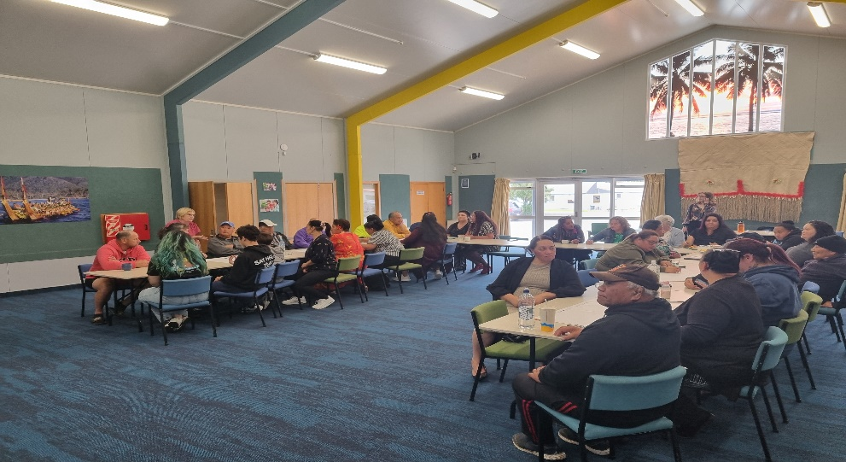

Defining the word disability/disabled person by various Pacific Island groups during the talanoa:

* **Cook Island:** Pakipaki ta’i
* **Fijian:** Taukoto
* **Niue:** Tagata ai katoatoa e malolo tino
* **Samoan:** Tagata e iai a’afiaga tumau o le soifua, Tagata Sailimalo, Tagata e iai mana’oga faapitoa, Tagata e le atoaatoa le malosi.
* **Tongan**: Faingata’a‘ia fakaesino
* **Tokelau:** Tagata e he katoatoa te malohi

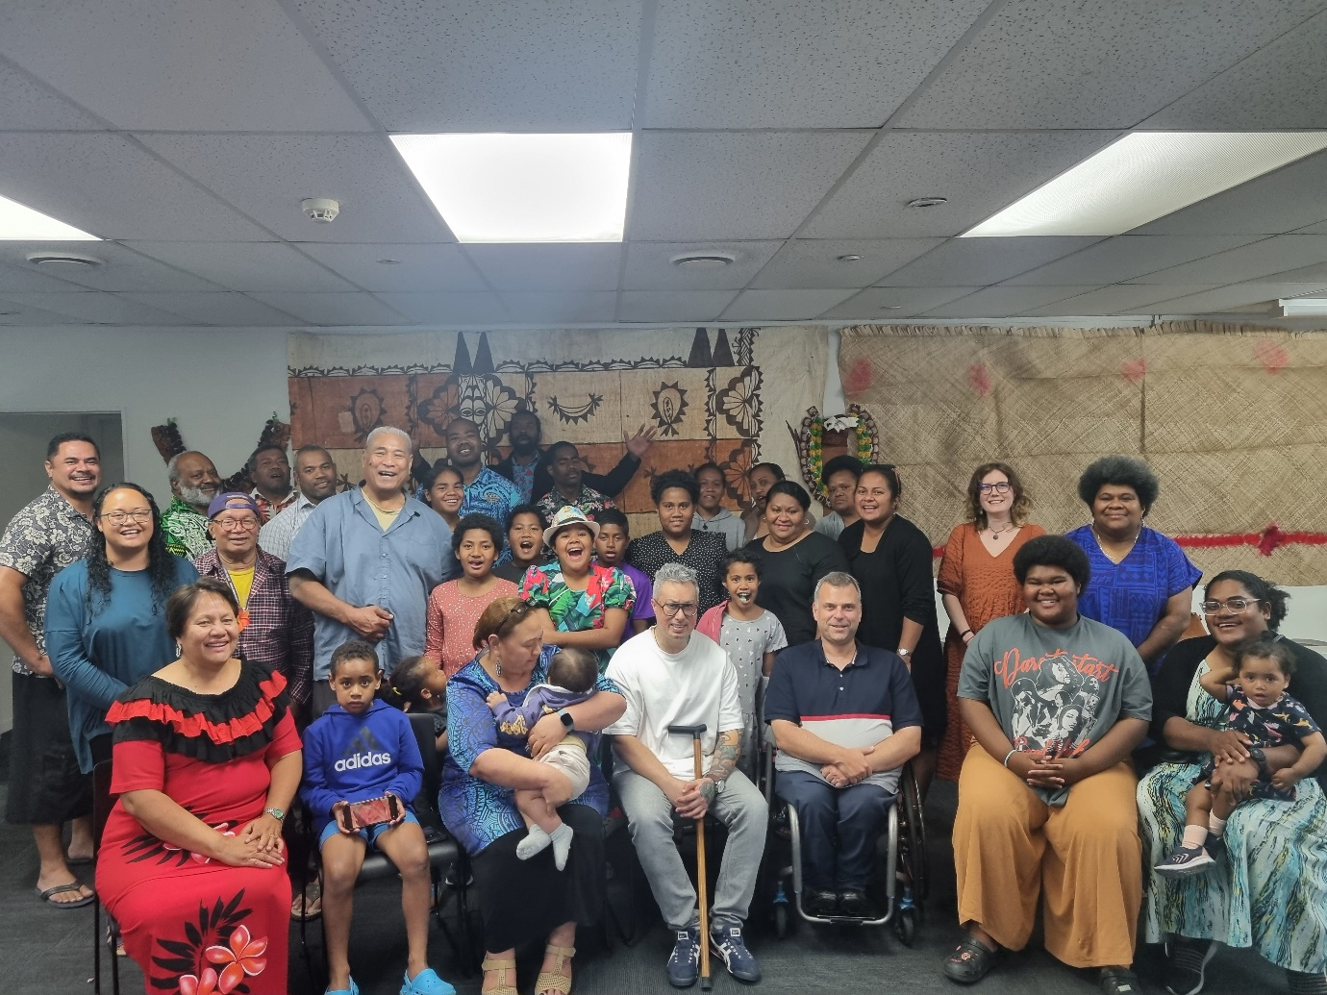

## **Regional Feedback**

### Invercargill – Pan Pacific Languages

|  |  |
| --- | --- |
| **Strengths** | **Challenges** |
| * Connection between and within communities is strong given the isolation * Thank you for coming to Invercargill, “NZ doesn't end in Dunedin” * Service providers strive to share information, but infrequent updates can delay timely communication of system changes * Establish a Pacific ‘information hub’ to serve as a resource for families seeking information about disability services and support options | * Lack of access to information * Accessing services in smaller and more rural regions is difficult * Challenges faced by those living in rural to semi-rural settings * Ensuring the voices of Pacific disabled people are included in development and policies that has meaningful benefit to them * ACC funding model can create inequities due to its stringent criteria, limiting access for some individuals * Shortage of Pacific professionals in social service agencies limits culturally appropriate support and exacerbates language barriers |

### Dunedin – Pan Pacific Languages

|  |  |
| --- | --- |
| **Strengths** | **Challenges** |
| * Connections within their community * Changing of attitudes to disability is slow but encouraging * Pacific organisations connecting Pacific disabled community to each other, and to information * Focus on improving social and health outcomes for disabled children, youth and their families | * Would like to see opportunities for elders, pastors to learn about disability as the next group to advocate on behalf of PDP * Low expectation of community on what disabled people can do and able to do with proper support that is provided without questions * Access to specialist services * Language and cultural barriers of health and disability workforce * Access to information on housing, health, education, and outdoor spaces * Attitudes towards the disabled person * Work and Income present challenges, highlighting the need for intentional and effective cross-agency collaboration for disabled people, such as requiring annual form completion for my severely disabled daughter. |

### Timaru – Pan Pacific Languages

|  |  |
| --- | --- |
| **Strengths** | **Challenges** |
| * Awareness of disability in their community is increasing * Increase actions to advocate for women and youth with disability in the wider community * Establish a disability group within local Pacific churches to promote awareness and dialogue around disability issues | * Awareness of disability and having strength-based words in their language for it * Access to specialist services * Transport access * Language barriers in accessing disability support services * The reach of information on Pacific disability is difficult given the lack of Pacific services in the region * Funding should always follow the service user |

### Christchurch – Pan Pacific Languages

|  |  |
| --- | --- |
| **Strengths** | **Challenges** |
| * Strong community identity within island groups * Collective values * Interested in promoting disability * Pacific organisations connecting Pacific disabled community to each other, and to information * The priority outcomes, including accessibility and workforce development, must be central to this plan, as many of our families face challenges in these areas | * Want to grow Pacific disabled people in the disability workforce and in ministries * Health and disability workforce not culturally competent * Having resources translated in Pacific languages * Having more financial support for disability initiatives * Raising awareness of disability in churches and organisations that aren’t health related * Lack of cultural competency in health and social sector * Capturing accurate data on Pacific communities is important because it directly impacts the services provided to us. |

### Wellington, Aka Ora – Pasifika and Māori Blind Low Vision NZ members – Pan Pacific Languages

|  |  |
| --- | --- |
| **Strengths** | **Challenges** |
| * To serve the needs of our pacific people, we need to have small local region-based services provided by Pacific for Pacific * How are we monitoring agencies efforts on Pacific disability? We would like this to be forefront of the next Pacific disability Action Plan as part of overall pro equity approach. We know we can do better! | * Judgement – being seen as disability, the limitations society puts on them, and decisions about their well-being made by other people. * Misunderstanding – public perceptions and not understanding that they cannot see, lack of accessible and culturally competent avenues of contributing to their wider communities * Lack of cultural competency in health and social sector * Lack of access to Pacific services for after care after hospital * Health, Education, MSD information often communicated too quickly and with lack of cultural care |

### Porirua – Pan Pacific Languages

|  |  |
| --- | --- |
| **Strengths** | **Challenges** |
| * Appreciate commitment of Whaikaha to *‘****nothing about us without us’*** concept, our involvement as a community group from the outset of the Talanoa process has seen so many Pacific disabled people and their families here today to participate and share their views * It is important to set up a ‘Pasefika information hub’ where families can access information for services etc. * Pacific support groups are working for getting disabled people together to socialise and share information | * Want to grow Pacific disabled people in the disability and health workforce and in Government agencies * Access to information * Transport * Culturally competent workforce and having safe spaces to talanoa and process information * NASC’s provider that speaks up for and does Pacific things for pacific disabled people * Lack of Pacific providers in the Wellington region given its large Pacific population * The system struggles to connect with Pacific peoples, resulting in delays in the treatment they can receive * Faiva Ora Leadership Group must have wider representation from around the country not just Auckland, otherwise our collective disability issues become Auckland issues, which is not the same |

### Hutt Valley – Samoan, Youth Focus

|  |  |
| --- | --- |
| **Strengths** | **Challenges** |
| * Parents focus on teenager takes away the ability to earn to support the family; * College does their best to support but only limit to what they are funded for; * Need to gather and form support groups within churches and places where pacific youth are * The Education system plays a key role in ensuring they have the information to prepare families as their young person transitions out of the system into the adulthood system | * Poverty both economically and in terms of opportunity for youth * Lack of services for young people post-secondary schools, real difficulty to seek out where to next * Sense of frustration and hopelessness as navigating the system adds to stress and financial burden * Not a same size fits all scenario most of the time * Pacific growth for carers and a pipeline and career pathway for youth * Have flexibility, accessible and reciprocal approach when working with our families * Access to part time work |

### Wairarapa – Pan Pacific Languages

|  |  |
| --- | --- |
| **Strengths** | **Challenges** |
| * Drive to be champions within their own communities * Encourage those with lived experience to share the challenges of living with a disabled family member * Involvement of churches in supporting families with disability | * Difficult to access services in more rural areas * Awareness of disability and disability services * Want more Pacific disability providers and workers * Our pride often hinders us from seeking help and support |

### Horowhenua – Pan Pacific Languages

|  |  |
| --- | --- |
| **Strengths** | **Challenges** |
| * Planning takes a holistic approach to the person and their family’s (whole-of-life) * Community hub set up (pacific provider) where families can get support with information * Family values important in support of our disabled people * Keen to set up more workshops so community are informed of disability * Having a connector is helpful in accessing services | * We have a long way to go in the Pacific community to accept Disability exists and families are silent and non-existent about their daily struggles; * Ways to support families /parents to learn NZSL –lack of resources i.e. Alphabet * Mainstream services to have a workforce that is diverse that can support us * Look to set up a one-stop shop makes it easier for disabled people to go to one location for all their needs and information, as well as its accessibility to such place * Education to do more to support families with more teacher aide time etc |

### Hawkes Bay – Pan Pacific Languages

|  |  |
| --- | --- |
| **Strengths** | **Challenges** |
| * Starting to gather families with common disability needs to set up groups across the Hawkes Bay region * No clear sense that system transformation has or will help Pacific – need a system within so that concerns can be listened to appropriately and families can engage and start trusting | * Not all service providers share information readily and not all information is given when needed; * Processes to ensure fair allocations across population * Funding support to meet needs that unpaid natural supports can’t. * Minimal transport options in rural areas * There are day programmes – NASC Training of Assessors is insufficient, they should use Workforce that is fully trained and understand Pacific cultural norms |

### Waikato – Pan Pacific Languages

|  |  |
| --- | --- |
| **Strengths** | **Challenges** |
| * Develop a pipeline for Pacific disabled people to gain higher quals by offering scholarships to further their careers; * Enhance the Pacific leadership to engage their communities, that will help engage the support needed for families, * Connect to churches and community, important the visibility of providers in places where pacific gathers; | * Culturally appropriate and early response can support families in need; * We should look to create a model of NASC that is Pacific, that will also build the Pacific workforce; * Assessments should not be done on one visit, should be more time allocated so all the information received are accurate; * Include us in decision making; * Digital platform can assist families – build knowledge around financial literacy; * The constant form filling from one agency to another is not fair to families as the same information is provided often results to waiting and no better outcomes; |

### Online webinar – English

|  |  |
| --- | --- |
| **Strengths** | **Challenges** |
| * Acknowledgement from Whaikaha of the community’s contribution to all the talanoa; * Comprehensive cover of the Pacific disabled community to have a say on what the focus of the plan should be; | * Have we covered those who are in residential – a focus group to be arranged given the small number and wide spread of locations * Limited reach due to IT capacity and access to data * The system is not equitable – it falls short of meeting our needs * Support systems and ties need to be strengthened as pacific people don’t know where to go for assistance |

### **Auckland (**Youth, Providers, Lived experience, Aiga, Elderly) **– Pan Pacific Languages**

|  |  |
| --- | --- |
| **Strengths** | **Challenges** |
| * The strong value of family and faith. * Family provides a support system and companionship in overcoming challenges faced. Including families in decision making is the collective's best interest. * Faith plays a big part in our lives * Collective values underpin Pacific cultures * Shared beliefs and Values * Resilient community identity within Island groups * Community connections * Having younger employees who can relate to and empathize with youth issues * A sense of humour, you don’t need to be serious all the time! * Receiving services in our homes, rather than needing to travel to their offices constantly. | * The lack of resources in Pacific languages. * Limited employment programs that are specifically set up to support disabled people into work. * The lack of available tools, information, and resources to help disabled people to achieve their goals, whether through education, career guidance, or other support. * Tagata Sa’ilimalo (TSM) are vulnerable to enduring financial abuse – It would be great to have access to budgeting services to increase our knowledge of how to protect ourselves so that we are not taken advantage of. * Culturally aware when they are engaging with our language, cultural values, and protocols. * Providing safe spaces where we feel comfortable sharing our concerns and asking for help. * Limited Pacific speaking staff that can engage with our people would go a long way to building a trustworthy relationship. * Continuous training for staff: Ensure staff members are trained in disability awareness, sensitivity, and up to date on best practices to provide effective and respectful support. * Need for increasing carer services, as family members stay home to look after TSM instead of working. * Need to involve families in the planning and support process, recognising their crucial role and insights in understanding the needs of the individual. * Need to empower the wider family supports to enable them to provide better care and support for the disabled person. * Prioritising the wellbeing of carers, the quality of care for those they support is significantly enhanced. * Need help with the excessive cost of living, housing is expensive, not enough money in the household. |

### National, Youth and Autism focus – Pan Pacific Languages

|  |  |
| --- | --- |
| **Strengths** | **Challenges** |
| * Safe spaces for youth to fully participate as representative of their voice in key decision-making areas. * Develop a pipeline for Pacific disabled people to gain higher quals by offering scholarships to further their careers; * Enhance the Pacific leadership to engage their communities, that will help engage the support needed for families, * Connect to churches and community, important the visibility of providers in places where pacific gathers * Accessible education through   Safe spaces in schools, workplaces, places of worship and other community centers   * Providing funding and scholarships opportunities for Pacific disabled children. * An intergenerational approach for youth emphasises their strengths, encouraging growth through shared experiences and support across generations | * Often feel left out, not seen or heard in decision making processes that affect them. * Participants highlighted the need for services that are accessible, user-friendly, and responsive to the diverse needs of Pacific disabled individuals and their family. * Need for accessible information and communication to empower Pacific disabled individuals and their families to make informed decisions * Employment and training opportunities for Pacific disabled individuals to enhance their independence and economic participation. Many Pacific people with disabilities aspire to have meaningful employment and contribute to society through their work. * Improvement, including early diagnosis and interventions, support for families and partners, accessibility in education, employment, financial support, cultural competency, funding allocation, inclusion, mental health support, education and training, and respite care. * Accessibility to services in rural communities. * Limited awareness and understanding for Pacific families around disability. * Service providers need to have a deep understanding of Pacific cultures, values, and practices to ensure effective support. * Having a balanced workforce with specific ethnic providers, such as Māori for Māori and Samoan for Samoan, can improve cultural competency * Advocate for the rights and inclusion of Pacific disabled individuals at a policy level to address systemic barriers and inequalities * Financial burden on families should be reduced through the provision of scholarships specifically for individuals with disabilities * The transition process in the current system is not working well, causing difficulties for families and caregivers * Individuals with disabilities should have more control and autonomy over funds allocated for their support and services. * More opportunities for Pacific disabled people to develop leadership skills and have self-autonomy in making decisions about their lives. * For families with a PLWD[4] (specifically autism), a critical concern was ‘safe’ spaces and zones for the PLWD to (a) function within their daily lives in school, work, place of worship * Need for Pacific advisory and governance group to ensure ongoing community involvement and leadership in developing and implementing the Action Plan. * Collaborate with Pacific community organisations to leverage their expertise and resources in supporting Pacific disabled people and their families * Empowering Pacific disabled people and their families to advocate for their rights and needs, ensuring their representation in decision making processes and policy development |

### Online Survey

|  |  |
| --- | --- |
| **Strengths** | **Challenges** |
| * Family as a source of support for disabled people * Pacific disability support groups * Pacific disability providers | * Support for carers is inadequate * Language – need more resources in Pacific languages and NZSL, as well as more interpreters. * Access to transport, housing, disability, health and specialist services, and employment * Promoting awareness and visibility of disability is crucial for Pacific communities' healthcare providers, educators, employers, social service professionals, and the broader New Zealand community. * Mental health and access to mental health support * Lack of cultural competency of workforce * Data collection * Access to earlier intervention * I would like to access Pacific disability and legal advocates to help navigate the system and services. |

## **Next Steps**

#### **Feedback by community**

We will now seek additional input from our regional leadership groups for this report to ensure all relevant areas have been addressed comprehensively and are included when the first draft of the Action Plan is developed.

Our goal is to gain a clear understanding of the community's priorities, to ensure the Action Plan reflects a comprehensive and aligned approach. The feedback received from the community will be integrated into the initial draft of the Action Plan.

Through this process, we will explore the identified priority areas, setting clear goals, defining potential impacts, outlining achievable timelines, and establishing measurable milestones. These steps are designed to ensure that the Action Plan aligns closely with Whaikaha core values and mission, while effectively meeting the community's needs and aspirations.

#### **First draft for the Action Plan**

We aim to complete the first draft for the Action Plan by late September to early October, with these timelines subject to potential adjustments.

This draft will then be shared with our regional leadership groups for their input. Feedback from these groups will inform the final draft of the Action Plan, which will subsequently be submitted for Ministerial feedback.

## **Reflections: Opportunities for Improvement**

While we aimed to engage as many Pacific disabled people and their families as possible during our community consultations, we acknowledge pre-existing challenges faced by Pacific disabled people in attending these consultations and we made efforts to ensure these logistical issues were accommodated. In hindsight, we recognise that there were areas where we could have improved on, that in future, could enhance community talanoa of this nature for Whaikaha.

On a positive note, the community had expressed their appreciation for the face-to-face talanoa and their importance as the preferred method for all agencies to listen and gather their voices but also to connect with community members.

1. Online survey
   * The survey platform operated by Survey Monkey lacked the capability for participants to save and resume surveys once they started. This made it challenging for participants to complete the entire survey. This feature could potentially have increased our survey completion rate.
2. Zoom (online) talanoa
   * The timing of the Zoom talanoa was done during working hours and had limited the opportunity for family members to partake in this. We also had participants joining for the Pacific regions who weren’t fully informed of the background to the Action Plan.
3. Timing of our community talanoa

* We scheduled sessions at different times to accommodate various regional needs. In some villages, morning sessions brought adults only and providers. In contrast, evening sessions brought the whole family. Despite our efforts, there were families who expressed interest but were unable to attend due to various reasons, the timing of the talanoa being a factor.

1. The value of social media
   * The value of social media became evident as we utilised our Whaikaha webpage, Facebook and LinkedIn channels. This proved highly effective in sharing information about our talanoa sessions and online surveys. Each time a post was made, we experienced a noticeable increase in emails and inquiries regarding our sessions or surveys.
   * While there was an increase in engagement after using social media, we also reflect that the reach to our Pacific communities through Whaikaha social media was limited as some Pacific communities were not yet aware of Whaikaha as a new Ministry.

## **Appendix One: Background to the Action Plan**

1. In October 2010, The Ministry of Health released its first Faiva Ora Pasifika National Disability Plan 2010-2013 to:
2. Improve the lives of Pacific disabled people. Its focus was supporting people to live in their own homes, participate in their own communities, and removing barriers to their participation.
3. Draw on improved data and evidence that indicated the Pacific population was living with significant disability-supported needs and high socio-economic disadvantage.
4. The guiding principles of the Faiva Ora Plan reflected the values that Pacific people said were important, ‘if health and social services connected culture and care for Pasifika people, we would see better access rates, earlier intervention from services, more satisfaction with the quality of services, and better social and health outcomes. (Le Va, Engaging Pasifika).
5. The Faiva Ora Leadership Group (community mandated) was set up to guide the work of Pacific Disability and to support the Faiva Ora Plan. The Group has provided the Ministry of Health and now Whaikaha with guidance and advice on issues relating to Pacific disabled people, their family members and Aiga.

## **Appendix Two: Whaikaha establishment**

Whaikaha - Ministry of Disabled People was created in response to the disability community asking for a Ministry which focuses on improving the lives of disabled people. The establishment was to work in partnership with the disability community, Māori and Government for a better, more independent future for disabled people and whānau in Aotearoa New Zealand.

In October 2021, Cabinet agreed to establish Whaikaha as a departmental agency, hosted by MSD, to support the shift of DSS towards a Social Model of Disability. This meant administration of a range of DSS functions and responsibility for the three Enabling Good Lives initiatives[5] would sit outside the health system. In addition, these were to be delivered by an agency with a focus on driving improved outcomes for disabled people.

The establishment of Whaikaha sees Aotearoa New Zealand as an international leader in promoting the rights of disabled people, tāngata whaikaha Māori and their whānau.

## **Appendix Three: Online Survey Questions**

1. How old are you?

0-18  18-24  25-34  35-44  45-54  55-64  65+

1. What is your ethnicity?

Samoan Tongan  Cook Island  Fijian  Kiribati  Niuean  Tokelauan

Tuvaluan  Māori  Rotuman  Other (please specify below)

1. What is your gender?

Prefer not to say  Female  Male  Another gender (Please specify below)

1. What type of services do you access?

Disability services  Health services  MSD  ACC  Informal Supports  Other (please specify below)

1. What are some things that make you feel good and confident as a Pacific Disabled person / Pacific Person with a Disability?
2. What are your goals for the future?
3. How can communities and organisations better support you in achieving your goals?
4. What are some of the difficulties you experience in accessing disability, health or social services?
5. How can disability & health services be improved to support you and your family’s wellbeing?
6. What other support would improve your quality of life?
7. How can disability support and services for Pacific disabled people / Pacific people with disabilities be more welcoming to include pacific cultural values and traditions?
8. How can disability support and services for Pacific disabled people incorporate cultural values while also reducing bias?
9. How can support services better address the unique needs and concerns of MVPFAFF+[6], rainbow, or takatāpui within the Pacific disabled community in Aotearoa New Zealand?
10. What difficulties do you face while participating in daily activities / community and how would you change them?

Transport  Public spaces  Healthcare Education

Employment  Housing  Sports  Social events  Public spaces

Other (Please specify below)

1. How can we grow Pacific disabled leadership within communities?
2. Do you feel that your voice and needs are well represented in decisions made by local and national decision-makers and why?
3. If you are a Carer, what do you want to share about supporting (the client/participant) and help to make your work manageable.
4. If you are a Carer: What is your relationship to the person you care for? (e.g. Mother, brother, paid carer for the client etc.)
5. Do you have a back-up for the person(s) you look after if you weren’t able?
6. Is there anything else you would like to share about your experience?
7. What is your email or contact number?
8. What type of disability(ies), impairment(s), or health condition(s) or injury(ies) do you have?
9. What region, town, or city do you live in?

End of National Pacific Disability Action Plan Survey

## **Appendix Four: Talanoa engagement questions**

(The below set of questions were used to aid our talanoa sessions)

1. How do you define disability in your own language?
2. In what ways can the National Pacific Disability Action Plan better reflect and address your community's priorities?
3. What are the main challenges you face in your daily life as a Pacific disabled person or a family supporting someone with a disability?
4. Are there specific barriers you encounter in accessing services, education, employment, or healthcare?
5. Can you share some positive experiences or successes that you have had in navigating the system as a Pacific disabled person or family member?
6. What support systems or services have worked well for you? E.g. domains of church, school, work, neighborhood etc
7. In your opinion, what changes or improvements could be made to the current system to better support Pacific disabled people and their families?
8. How can the sector be more inclusive and responsive to the needs of the Pacific disabled community?
9. How can disability & health services be improved to support you and your family’s wellbeing?
10. What other support would improve your quality of life?
11. How can disability support and services for Pacific disabled people / Pacific people with disabilities be more welcoming to include pacific cultural values and traditions?
12. How can disability support and services for Pacific disabled people incorporate cultural values while also reducing bias?

## **Appendix Five: Pacific disability dashboard**

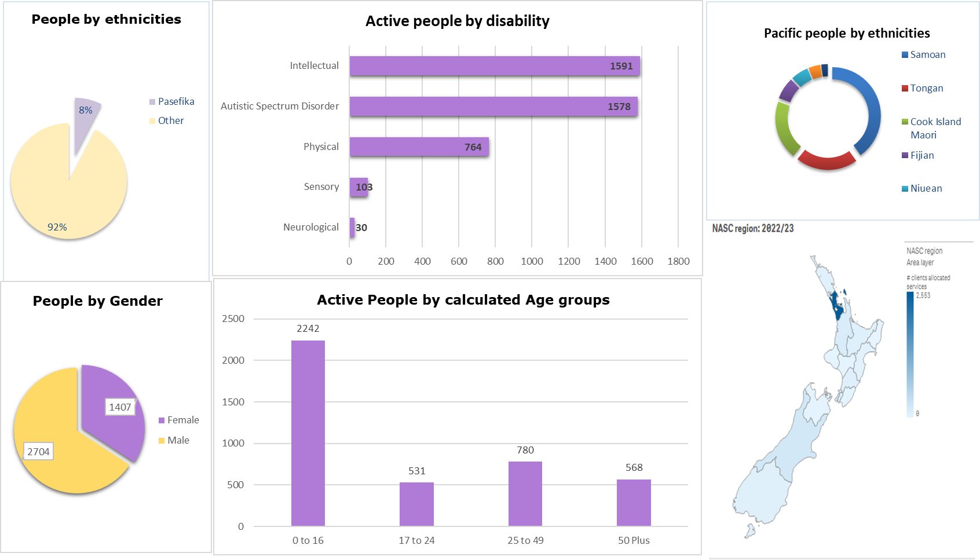

### **Description of Appendix Five**

There are six tables included in the Dashboard. **Table one** is a pie graph titled “Active people by gender”. There are a total 2704 females to 1407 males receiving Disability support services. **Table two** is a pie graph titled “People by ethnicities”. Pacific disabled people account for eight percent of the population in receipt of disability support services.

**Table three** is a column graph titled “Active people by Disability” with five columns, Intellectual disability - 11591, Autism Spectrum Disorder - 1578, Physical -768, Sensory - 103 and Neurological - 30.

**Table four** is a column graph titled “Active people by calculated age groups”. Age group 0 to 16 - 2242, 17 to 24 - 531, 25 to 49 - 780 and 50 plus - 568.

**Table five** is a pie graph titled “Pacific people by ethnicities”, illustrating the 3 leading ethnicities receiving Disability support services being Samoan, Tongan and Cook Island.

**Table six** is the NASC (Needs assessment service coordination) for the year 2022/23. The image highlights New Zealand, depicted in shades in light blue to dark blue. The image illustrates that the Auckland region has the highest concentration of Pacific disabled people receiving disability support services.



1. Faiva Ora 2016–2021 National Pasifika Disability Plan | Ministry of Health NZ
2. In the documentation, "villages" refers to the regions where Pacific disabled people and their families reside. This familiar terminology allows for connection to traditional and community living that embodies belonging and identity.
3. In the documentation, "villages" refers to the regions where Pacific disabled people and their families reside. This familiar terminology allows for connection to traditional and community living that embodies belonging and identity.
4. Person living with a disability
5. Enabling Good Lives initiatives are parts of DSS that operate in a manner more consistent with Enabling Good Lives. These sites are located in Christchurch, Waikato and Mid-central and have informed the development of and evidence base for ongoing transformation work.
6. Pasifika families have long included Mahu, Vakasalewalewa, Palopa, Fa’afafine, Akava’ine, Fakaleiti or Leiti, Fakafifine. The term MVPFAFF+ was coined by Phylesha Brown-Acton, to centre and bring forward discussions that include Pasifika Rainbow peoples and the terms they identify with. The “+” symbol acknowledges that there are other Pacific Island cultures who also have terms that describe gender identities, gender expressions and sexualities.