- Visit NAATI Learn | - learn.naati.com.au
- Scroll down  - Click: New Zealand Interpreters - Registration for MBIE funding | 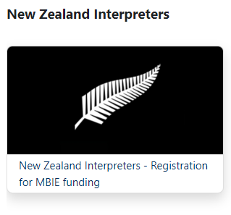
- Click: Self enrolment (Applicant) ‘continue’ | 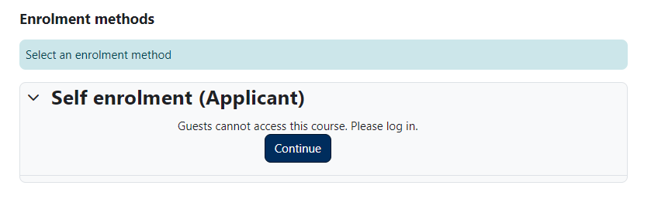
- Click: Create new account | 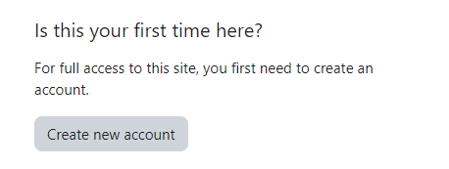
- Complete the ‘New Zealand Interpreters - Registration for MBIE funding’ application process | 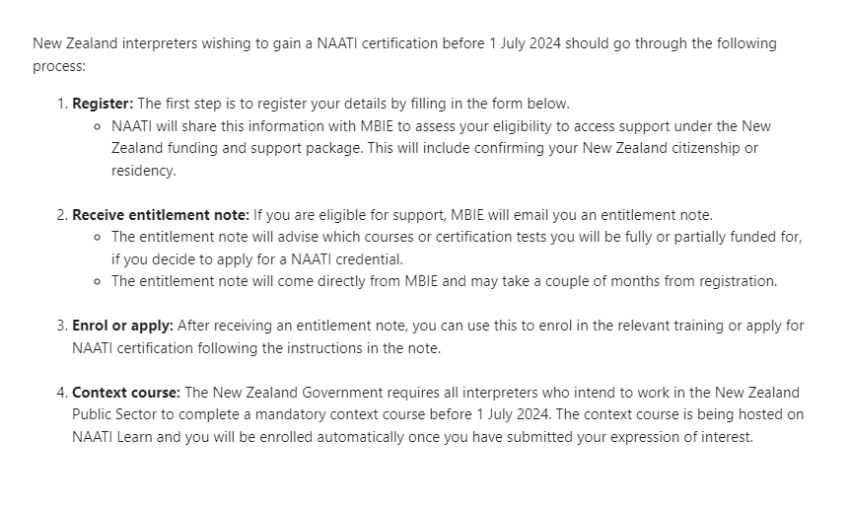
- Receive an email from MBIE with an Entitlement Note confirming your funding
- Complete the Interpreting in Aotearoa New Zealand: The Public Sector Context course

- Visit Home Page (naati.com.au) (my.naati.com.au) and register | 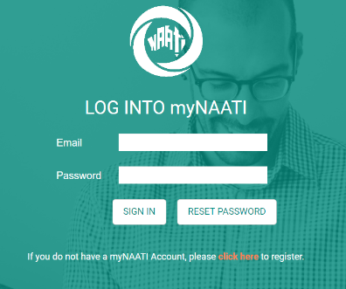
- To make the application for RPI, click the ‘submit an application’ icon on your home page. | 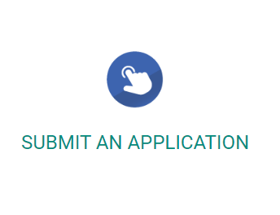
- Then ‘Certification & Recognised Practising’ where you can fill in all the relevant details and upload your documents | 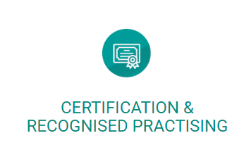  - You may need to upload your AUT qualification to several different sections, where an upload is required
- You will need scanned evidence of qualification, driver’s license, evidence of work and your AUT student id number | - You can contact AUT (or overseas education provider) for your student id number
- Register for the Ethical Competency Test | - The Ethical Competency test is now available regularly

Candidates will have access to NAATI’s Ethical Competency test preparation course on NAATI Learn. The course takes about 20 hours of study time | - The preparation course can be accessed at any time
A week prior to your test date, you will receive an email from ProctorExam with instructions on how to set up for your test | - You will not receive a link to sit the test until you have completed the system check
The Ethical Competency test consists of 45 questions:
- 10 Matching statements questions: each question asks you to match statements from the relevant code of ethics to individual principles
- 20 Multiple choice questions: each question relates to the application of one ethical principle
- 15 Multiple choice questions: scenario-type questions depicting an ethical dilemma – you must choose the best course of action based on the relevant ethical principle out of the options available
- You will be offered a resit of the whole test if you fail the test.
- You will need to pay the applicable fee for each additional test.
- You may have a maximum of two test resits. After the third failed attempt, your credential application will be deemed unsuccessful
- Apply for testing when the Certified Provisional Interpreter (CPI) and Certified Interpreter (CI) tests become available | The tests will be available after 1 July 2024

