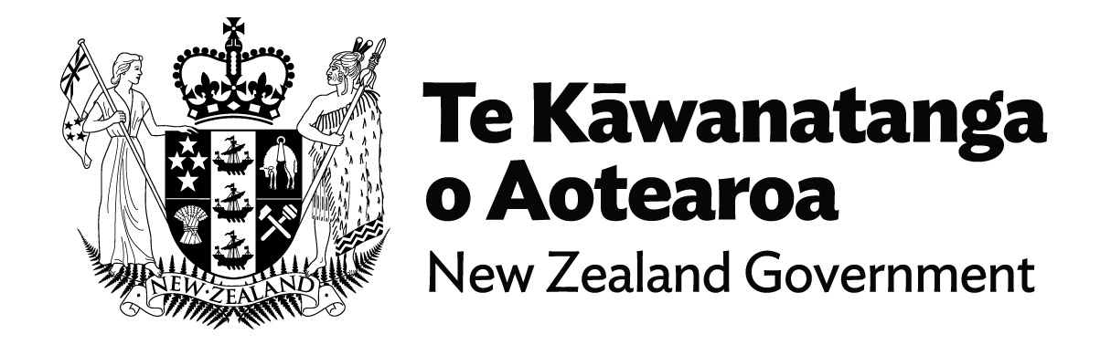

# Update on Disability Support Services by Minister for Disability Issues, Hon Louise Upston

Hello everyone,

I want to give you an update and reassurance about what’s happening with Disability Support Services.

If you are a disabled person, family member, or carer of a disabled person, there is no immediate change to the support you are receiving.

For now, you will continue to get the funding, equipment, care, and the other disability support you are eligible for.

Your point of contact will continue to be your providers – your NASC, host or Enabling Good Lives site.

I also want to reassure you that you will not need to come into MSD’s Work and Income offices to receive Disability Support Services.

When Disability Support Services move to MSD before October, they will be set up as a separate business unit within MSD, separate from Work and Income.

MSD already has many disabled Work and Income clients and will continue to work with them as usual every day through Work and Income channels, supporting them on matters such as income, employment and housing. That won’t change.

We've set up a special taskforce within the Ministry of Social Development to manage the transition and urgently address the recent review of Disability Support Services or DSS. This taskforce will make sure that the record $1.1 billion funding boost to Disability Support Services in Budget 2024 is used where it’s most needed.

MSD’s Chief Executive has appointed a senior public servant, Chris Bunny to lead this important work. Not only is Chris an experienced leader, but as a parent of a child with a disability he understands the challenges you face and the importance of support.

Your voice is crucial in this process, and I’ve asked that the taskforce actively engage with you, your families, and carers on any future changes to DSS.

I’ll be receiving updates by the end of the year and will make decisions early next year about any changes to Disability Support Services.

Lastly, I want to say that the Government is committed to building a fair, sustainable, high-quality disability support system that delivers better outcomes for disabled people based on their needs.

Thank you.

**End of information | Update on Disability Support Services by Minister for Disability Issues, Hon Louise Upston**

This Large Print document is adapted by Blind Citizens NZ from the standard document provided by the Ministry of Social Development (MSD)