Towards a non-disabling New Zealand
The annual report from the Minister for Disability Issues to the House of Representatives on implementation of the New Zealand Disability Strategy

December 2017

Author
Office for Disability Issues, Ministry of Social Development
Acknowledgements
This report was presented in December 2017 to the House of Representatives by the Minister for Disability Issues under Section 8 of the New Zealand Public Health and Disability Act 2000.
Published
This report is available online at: www.odi.govt.nz
ISSN: 2537-7701
Contents
Minister’s foreword 1
Introduction 3
Section one: Key achievements in 2017 5
Development of the New Zealand Disability Strategy 2016-2026 Outcomes Framework 5
Co-design of the new disability support system 8
Waikato demonstration of the Enabling Good Lives approach 11
Completion of the Disability Confident Campaign 14
New disability data from Statistics New Zealand’s household surveys 15
Development of the New Zealand Sign Language Board’s five-year Strategy 2018-2023 and the completion of the New Zealand Sign Language Fund’s third funding round 17
Development of a new service delivery model for learning support in schools 20
Creation of a positive school environment for learning 22
Section two: Progress against the Disability Action Plan 2014-2018 24
The implementation of the Disability Action Plan 2014-2018 25
Section three: Looking forward to 2018 and beyond 27
New Zealand Disability Strategy 2016-2026 28
Updating the Disability Action Plan 2014-2018 33
Second review of how New Zealand is implementing the CRPD 34
Improving the collection of disability data 35
Transforming the disability support system 36
Disabled people remain a disadvantaged minority 37
Appendix one: Cross-government leadership on disability issues 38
Appendix two: Relationship between the CRPD and the New Zealand Disability Strategy 39
Appendix three: Detailed report on the Implementation of the Disability Action Plan (2014-2018) 40
Appendix four: Likely timeline for CRPD second review 58

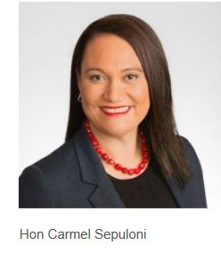
Minister’s foreword
It is a pleasure to release the annual report on implementation of the revised New Zealand Disability Strategy 2016-2026. This is my first report as Minister for Disability Issues.
I feel both honoured and privileged to be the Minister for Disability Issues. I have, for a long time, been committed to addressing the many barriers faced by disadvantaged minorities such as disabled people in New Zealand. Creating a more inclusive society in which disabled people can live fulfilling and meaningful lives, and fully participate in our diverse society is a priority for me and the Government.
It is clear from the evidence available that disabled people continue to experience poorer outcomes than non-disabled people in all those areas essential to living a good quality life, including: education, employment, health, transport and housing. As Minister for Disability Issues, I will be driving change to reduce those barriers preventing disabled people from having equal opportunities to make the most of their talents and skills.
The New Zealand Disability Strategy 2016-2026 and the on-going work to transform the disability support system represent positive steps forward. The Disability Strategy was developed in collaboration with disabled people. The use of co-design in the transformation of the disability support system reflects a fundamental change in the service provider-client relationship. A key principle of co-design is that users, as experts on their own lived experience, become central to the design of any service. In other words, the best way to understand disabled people’s issues is to listen to and learn from them. Disabled people should be involved in every aspect of decision-making impacting on their lives, with support from their families and whānau and others who care about them, when required.
We also need more data to fully understand how we can effectively meet the needs of disabled people. I am pleased to report that new sources of disability data are becoming available in some of Statistics New Zealand’s household surveys and in government surveys. However, there are gaps in the data that need attention. I will be doing whatever I can to ensure that valid and reliable data is collected to inform the development of robust disability policy, and the delivery of the best possible supports and services to our disabled citizens.
I am looking forward to working with my fellow Ministers in the year ahead to reduce the inequalities that disabled New Zealanders experience.

Hon Carmel Sepuloni
Minister for Disability Issues

Introduction
In New Zealand, there are several frameworks to address the barriers disabled people experience in living the best quality of life they can. These are:
- Convention on the Rights of Persons with Disabilities (CRPD) is a United Nations treaty that the Government ratified in 2008. The CRPD is the most comprehensive global tool that outlines the human rights of disabled people.
- New Zealand Disability Strategy 2016-2026 (the Strategy) was launched in November 2016. The Strategy represents New Zealand’s approach for implementing the CRPD in the New Zealand context.
- Disability Action Plan 2014-2018 (DAP 2014-2018) is the primary vehicle for implementing actions to realise the Strategy in New Zealand. The DAP 2014-2018 brings together key priorities and actions that require cross-agency collaboration.
These frameworks are supported by several governance, monitoring and coordination mechanisms, including:
- Cabinet Social Policy Committee (SOC)
- Chief Executives’ Group on Disability Issues
- Senior Officials’ Group on Disability Issues
- Independent Monitoring Mechanism
- Disabled People’s Organisations Coalition (DPO Coalition)
- DPO Coalition and members of the Senior Officials’ Group on Disability Issues meet every three months to oversee progress on the implementation of the DAP 2014-2018.
Every year, the Minister for Disability Issues reports to Parliament on progress with implementing the Strategy. Given that the DAP 2014-2018 is the primary vehicle for implementing actions to realise the Strategy, this report comments on progress in the implementation of the DAP 2014-2018. The report has three broad sections:
- key achievements in 2017
- progress against the DAP 2014-2018
- looking forward to 2018 and beyond.
It is important to understand that beyond the government actions and programmes addressing the barriers impeding disabled people from fully participating in society (outlined in this report), the achievement of a non-disabling New Zealand is equally dependent on the attitudes, actions and commitments of all New Zealanders.

Section one: Key achievements in 2017
Several initiatives in 2017 have continued work towards improving the identification and removal of barriers that disabled people experience, and ensuring they have the same opportunities and outcomes as other New Zealanders. These include:
- development of the New Zealand Disability Strategy 2016-2026 Outcomes Framework
- co-design of the new disability support system
- Waikato demonstration of the Enabling Good Lives approach
- completion of the Disability Confident Campaign
- new disability data from Statistics New Zealand’s household surveys
- development of the New Zealand Sign Language Board’s five-year Strategy 2018-2023 and the completion of the New Zealand Sign Language Fund’s third funding round
- development of a new service delivery model for learning support in schools
- creation of a positive school environment for learning.
This section outlines what has happened with each of these initiatives and what has been achieved in 2017.

Development of the New Zealand Disability Strategy 2016-2026 Outcomes Framework
The revised Strategy, launched in November 2016, is the primary vehicle for progressive realisation of the CRPD in New Zealand. The vision underpinning the Strategy is that: “New Zealand is a non-disabling society – a place where disabled people have an equal opportunity to achieve their goals and aspirations, and all of New Zealand works together to make this happen”. Implementation of the Strategy will be guided by:
- the principles of the Treaty of Waitangi
- the principles of the CRPD
- the principle of ensuring disabled people are involved in decision-making that impacts on them
- a long-term approach to investing in disabled people’s lives
- a twin-track approach comprising of:
- mainstream services, developed within an universal design framework, accessible to everyone
- specific services required by a disabled person for part or all of their lives.
The Strategy will provide the mandate for and guide the work of government agencies to identify and remove barriers faced by disabled people over the next ten years.
During the 2016 public consultation on the revision of the first Strategy (launched in 2001), the importance of monitoring and implementing the new Strategy was emphasised. There are strong expectations in the disability sector relating to measurement and accountability. Throughout 2017, the Office for Disability Issues (ODI) has been working with others on the development of an Outcomes Framework of indicators and measures which will provide accountability for the implementation of the Strategy.
Of paramount importance in the development of the Outcomes Framework is devising a set of population-level indicators that are well-defined and meaningful to disabled people, and can be tracked over time to demonstrate what change or progress is occurring against the Strategy’s eight broad outcome domains/priority areas. The eight key interconnected priority areas for targeted action in the Strategy are:
- education
- employment and economic security
- health and wellbeing
- rights protection and justice
- accessibility
- attitudes
- choice and control
- leadership.
Over the course of 2017, ODI has been working with the New Zealand Disability Strategy Revision Reference Group, relevant government agencies and the three Independent Monitoring Mechanism partners (DPO Coalition, Human Rights Commission and the Office of the Ombudsman) to develop and refine indicators. Twenty-nine draft indicators have, so far, been developed that align well with the eight priority areas in the Strategy. These indicators are reflective of what disabled people think will demonstrate progress in the implementation of the Strategy.
Robust data is required to measure these twenty-nine indicators. Some of the draft indicators are currently able to be measured through administrative data held by government agencies and some Statistics New Zealand surveys (for example, New Zealand General Social Survey and Household Labour Force Survey). Other draft indicators cannot currently be measured.
A data dictionary (to be incorporated into the Outcomes Framework) is in the process of being developed against which indicators will be measured. The dictionary will include:
- a narrative to more fully describe each indicator
- a description of the measures for each indicator, including the data source and limitations
- identification of who is responsible for collecting the data
- an outline of the frequency of reporting.
Where on-going work is required to develop measures for any of the final indicators, the Outcomes Framework could note that the measures are “under development”. This is consistent with the process used in some international Outcomes Frameworks, where data is emerging.

Co-design of the new disability support system
The current disability support system does not provide disabled people and their families and whānau with choice and control over their lives. Work is underway to change the system to ensure disabled people and their families and whānau have greater choice and control over the support they receive from government, including individualised funding. This work is aligned with Outcome Seven in the Strategy: Choice and control – “We have choice and control over our lives”.
In March 2017, a co-design process to transform the disability support system was announced. The co-design process is based on the eight Enabling Good Lives (EGL) principles underpinning the EGL demonstrations in Christchurch (completed in June 2016) and the Waikato. The principles include:
- self-determination
- beginning early
- mana enhancing
- person centred
- ordinary life outcomes
- mainstream first
- easy to use
- relationship building.
More than 70 people from the disability sector applied to be on the co-design group. Five disabled people, two people with disabled family and whānau members and three from disability service organisations were selected to join three government officials to make up the group.
The co-design group held workshops from April through to June 2017 to develop the high-level design. Collectively, they came up with what the different elements of the new system would look like. These include:
- a disability information hub and outreach
- capability funding for disabled people and whānau
- a new funding model which increases choice and control
- support to expand peer and whānau networks
- a personal information profile and tool tracks
- a personal information profile managed by disabled people and whānau
- streamline monitoring proportionate to the level of funding
- national/local governance groups with disabled people and whānau representatives
- seamless support across government.
Together these elements of the service design create the opportunity for disabled people to have greater agency in the services provided.
Disabled people involved in the group said they felt able to contribute in an equal way to the co-design process. One group member stated:
We really had a significant role and input. We felt like we broke new ground and created a solid foundation for change. It truly felt like the high-level design was something a high proportion of the community would feel ownership of.
Another member of the group commented they found the co-design process inspiring and challenging. This member stated:
It was mentally tough, the conversations were frequently crunchy, and for myself, it took a while to trust that everyone in the group genuinely wanted transformational change. The people in the co-design group were flexible, generous, honest and human. They brought different experiences, expertise, and perspectives to the conversations.
There are now more than 20 working groups developing the detailed design of the different aspects of the prototype which, if agreed by Cabinet, will be rolled out in MidCentral on 1 July 2018. Again, there was an overwhelming response from people in the disability sector wanting to be involved. Each working group is made up of least a third disabled people, no more than a third government officials and the rest is made up of people from the disability sector. As the working groups develop aspects of their designs, these will be tested by virtual testing groups.
There are monthly updates to the sector and constant feedback. Disabled people and their families and whānau are contributing to the transformation of disability support in meaningful ways and feel ownership of the new system. It also increases government awareness around what exactly is needed by disabled people and their families and whānau.

Waikato demonstration of the Enabling Good Lives approach
The EGL demonstration in the Waikato has successfully completed another year and has been extended until June 2019.
The key characteristics of the demonstration include:

- a vision and a set of principles to guide decision-making
- independent facilitation
- development of a personal plan
- making better use of mainstream services
- new assessment and funding processes
- capacity building for disabled people, families and whānau and providers
- pooled funding from the Ministries of Health (MOH), Education (MOE) and Social Development (MSD), which can be used by each individual to flexibly purchase supports and services.
There are currently 270 people engaged in the Waikato demonstration, with 82 disabled people and families and whānau on the waiting list. Of note, 33 percent of participants are Māori and 22 percent are aged under 10 years. Forty-eight percent of people participating in the demonstration live in the many towns and rural areas of the Greater Waikato, including: Tokoroa, Taumarunui, Huntly, Ngaruawahia, Te Kuiti, Thames and Paeroa.
By October 2017, 232 people were receiving a personal budget, with 85 percent receiving and managing this budget directly.
In February 2017, the Phase Two Evaluation of the Waikato demonstration was completed and released. Phase Two covered the first year of the demonstration’s implementation from July 2015 to July 2016. This Phase included interviews with 32 participants and six providers. Clear lessons were found to be emerging, including:
- Enabling Good Lives is creating opportunities that were not always possible in the previous system.
- The demonstration is fostering relationships across the sector to ensure there is a continuum of support for participants.
All of the 32 participants interviewed felt that, prior to joining the demonstration, participating in EGL Waikato would be positive; they would have more choice and control and the flexibility to determine what was possible. Thirty participants felt that the demonstration is making a difference, given that they are experiencing positive change across a number of outcome domains, with 31 feeling that their achievements would not have been possible without EGL Waikato.
Twenty-six people described the planning process as positive and 30 have experienced a positive working relationship with their Tūhono/Connector.
Five of the six providers interviewed identified that they are working positively and flexibly with people participating in EGL Waikato in ways that reflect the EGL approach. The Community of Practice, a provider network, coordinated by the providers on the Waikato Leadership Group, was identified as a valued mechanism to share and build principles-based practice across the sector.
The third phase of the evaluation is in the planning stages. The intention is to interview 60 disabled people and families and whānau participating in the demonstration. This report will be completed by mid-2018.

Completion of the Disability Confident Campaign
The Disability Confident Campaign (the Campaign), led by MSD, was launched in November 2016 at an event hosted by BusinessNZ and PricewaterhouseCoopers. It built on employer forums held around the country to promote the benefits of employing disabled people. It was recognised that disabled people represent an untapped pool of employees that can have a positive impact on various aspects of a business, including: culture, employee and customer relations and performance.
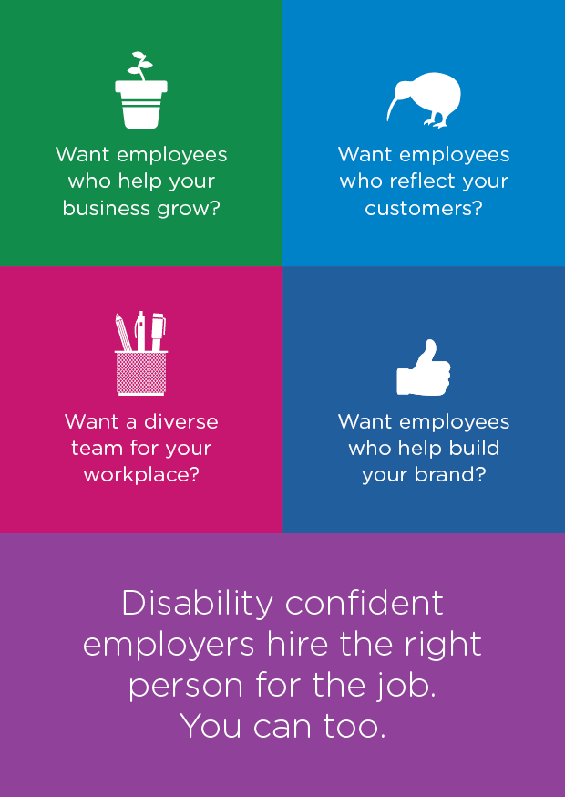
The Campaign is aligned with Outcome Two in the Strategy: Employment and economic security – “We have security in our economic situation and can achieve our potential”.
The Campaign was used as a platform to promote existing services and resources for employing disabled people and to support broader attitudinal change among employers. MSD developed a webpage and collateral material for the Campaign, with input from employer and disability representatives.
Since it was launched, 6,416 people have visited the webpage and the material has been distributed to all Work and Income regional offices. The Campaign was also promoted:
- at a number of events hosted by employer groups (eg, regional Chambers of Commerce)
- through external partners (eg, Wellplace.nz and business.govt.nz)
- on social media.
The Campaign itself came to a close in July 2017, and the tools have now been embedded into business as usual. MSD will continue to work with employers and disability representatives to build and support disability confident employers.

New disability data from Statistics New Zealand’s household surveys
The importance of decision-making relating to each of the Strategy’s eight outcomes being “informed by robust data and evidence”, is emphasised throughout the Strategy document.
Existing and emerging data will provide measures for many of the indicators developed to show us whether the eight outcomes in the Strategy are being realised.
Statistics New Zealand has adopted a new set of survey questions for producing information about disabled people. So far, the questions have been included in two regular household surveys. The questions have also been approved for inclusion in the 2018 New Zealand Census of Population and Dwellings, which will take place in March 2018. Using these questions allows findings for disabled people to be compared with those for non-disabled people. The surveys in which the questions have been included are the New Zealand General Social Survey (NZGSS) and the Household Labour Force Survey (HLFS).
The NZGSS is a biennial survey that covers a wide range of social and economic topics. The HLFS produces timely, relevant and comprehensive statistics relating to employment and the labour market. Results for disabled people from these surveys were published for the first time in mid-2017. The consistent use of the new questions in future survey periods will make it possible to monitor changes or trends at a population level in disabled people’s lives, compared to non-disabled people, over time.
The specific question set adopted by Statistics New Zealand for inclusion in the regular household surveys is known as the Washington Group Short Set (WG-SS). The WG-SS is a set of six questions on functioning difficulties and activity limitations: seeing, hearing, walking, cognition, self-care and communication. Considerable work has been carried out in many countries around the world on the design and testing of the WG-SS, providing evidence that the data collected is valid and internationally comparable. The WG-SS is gaining increasing acceptance and being used more frequently worldwide.
Statistics New Zealand is continuing to work with agencies across government and organisations in the disability sector to promote the inclusion of a disability measure in data collection tools and, thereby, improve the availability of disability data to inform policy and practice, as well as monitor progress on the implementation of the Strategy.

Development of the New Zealand Sign Language Board’s five-year Strategy 2018-2023 and the completion of the New Zealand Sign Language Fund’s third funding round

Background
The New Zealand Sign Language Board (the Board) was established by Cabinet in May 2014 to progress priorities for New Zealand Sign Language (NZSL). The Board is unique, given its national role and singular focus on NZSL. The key functions of the Board are:
- It provides a critical point of reference and support for NZSL language planning efforts in New Zealand.
- Expert advice is provided to the Government and stakeholders on NZSL.
- It helps the Government meet its obligations under the NZSL Act 2006 and the CRPD.
NZSL is used by 20,000 NZSL users (Census 2013). Of the 20,000 users, 4,000 are Deaf people who use NZSL as their primary form of communication.
Research undertaken in 2015 on NZSL confirmed that the recognition and status of the language has improved. However, the apparent shrinkage in the acquisition and use of the language provides evidence that NZSL can be officially described as a threatened language in relation to both language endangerment and vitality frameworks. The research highlighted for the Board the critical and on-going need for effective NZSL planning.

The Board’s Action Plan 2016-2018 review
In 2017, the Board undertook a review of its Action Plan 2016-2018 to ensure that the Board’s planning processes support it as effectively as possible to promote and maintain NZSL. The review has resulted in the Board developing a draft five-year Strategy 2018-2023, in conjunction with a revised annual Action Plan.
The Board has also initiated work to develop an NZSL Outcomes Framework to support the Board to determine the impact of NZSL actions implemented by the Board and government agencies. Work will continue on the Outcomes Framework, with the aim of completing this work by the end of 2018.
The five-year Strategy 2018-2023 and Action Plan 2016-2018 will be submitted to the Minister for Disability Issues for approval before being publically released in early 2018.

NZSL Action Plan 2016-2018 - Achievements
While the Board undertook a review of the Action Plan 2016-2018, it continued to implement key activities in the Action Plan 2016-2018. This included commissioning reports on:
- NZSL Interpreter Standards
- NZSL Online Hub
- NZSL Tutoring.
These reports will inform the Board’s further planning relating to NZSL resources and services during 2018.

The NZSL Fund
The Board has an annual appropriation of $1.25 million to support NZSL initiatives.The primary purpose of the NZSL Fund is to fund activities which promote and maintain NZSL through an annual contestable grant process or “funding rounds”.
Three contestable rounds of the NZSL Fund have been carried out since the establishment of the Board. The funded initiatives during 2017 have included:
- NZSL Week
- NZSL camps for young people and/or families and whānau with Deaf children
- NZSL tutoring for parents and people working with the Deaf community
- development of NZSL resources and a national hui for Māori.
In addition to supporting local NZSL community initiatives, the NZSL Fund has provided funding to some key national initiatives, including:
- Development of the first standardised NZSL Assessment Tool for Deaf learners aged between 3-11 years, to be used by New Zealand deaf education professionals. The assessment tool was developed by the Combined Board of Kelston Deaf Education Centre and van Asch Deaf Education Centre.
- Provision of a training programme for ten people who are able to undertake NZSL assessments of adult NZSL users.
The NZSL Fund is under pressure due to consistently receiving more funding requests for NZSL initiatives, events, resources and services than the available funding can cover. This shows that there is a high demand for funds for NZSL initiatives and limited availability of alternative funding sources. The funding situation is an on-going concern for the Board. The Board is working to ensure that strategic priorities identified in the Board’s planning are given precedence.

Development of a new service delivery model for learning support in schools
New Zealand needs an inclusive education system where all children get the support they need to access the curriculum, participate fully and achieve in education.

Modernising learning support
In mid-2015, the Ministry of Education (MOE) consulted extensively with over 3,650 parents, families and whānau, schools and local communities to understand their frustrations in dealing with MOE’s Special Education provision.
MOE is now using this feedback to modernise the learning support system so that it is easier to access, child-focused and more efficient. Through the Learning Support Update, MOE has been testing a new service delivery model for learning support in the Bay of Plenty – Waiariki region since March 2017. The new model and implementation plan were co-designed with regional sector partners and key stakeholders from Whakatane, Ōtūmoetai and Taupō.
Key features of the new model include:
- providing a streamlined process for parents and schools/kura to access support
- using Communities of Learning | Kāhui Ako as the primary platform for delivering learning support
- using local learning support teams who will coordinate service providers and facilitate flexible, tailored, dedicated solutions for children and young people
- using a single Learning Support Plan to document actions, resources and goals
- collecting individual student data related to learning support and achievement.
Early indications from the Bay of Plenty – Waiariki test suggest that the new model is facilitating quicker and easier access to learning support, when needed.

Maintaining and improving learning support
During 2016/17, MOE provided or funded specialist services and support to over 36,000 children and young people with additional learning needs.
Over the last year, the average time children and young people have to wait for support to be provided, following a referral, has been reduced from 73 days in June 2016 to 60 days in June 2017.
Resource Teachers: Learning and Behaviour have continued to work with teachers, schools and kura to support over 17,000 Year 1 to 10 students with learning and behavioural difficulties.
The Intensive Wraparound Service: This Service supported over 320 children and young people who were struggling to stay at school and learn.
In-Class Support: With the additional funding for In-Class Support received through Budgets 2016 and 2017, around 3,375 students, who have on-going high learning needs, received up to five additional teacher aide hours per week from the start of Term 3, 2017.

Dispute Resolution Process
MOE worked with the New Zealand School Trustees Association to develop a Dispute Resolution Process for schools, families and whānau, where there are issues and concerns about students with learning support needs that cannot be resolved between the parties.
The new process will focus on early resolution of issues by:
- supporting facilitated conversations
- introducing a review process to consider all options
- providing a mediation service for complex issues.
There will be a phased implementation in three regions
(Auckland, Whanganui/Manawatu and Marlborough), which will be evaluated before being rolled out nationally.

Creation of a positive school environment for learning
Various initiatives are underway to create a more positive school environment to facilitate student learning.

Positive Behaviour for Learning
Positive Behaviour for Learning (PB4L) is a long term, systemic approach involving several initiatives. These initiatives include:
- whole school change initiatives
- targeted group programmes
- individual student support services.
The initiatives are designed to help parents, families and whānau, teachers, early childhood centres and schools address problem behaviour, improve children’s wellbeing and increase educational achievement.
As at 30 June 2017, 174 secondary schools are participating in PB4L Restorative Practice and 779 schools are implementing PB4L School-Wide. MOE’s goal is to significantly increase the number of schools accessing the School-Wide framework over the coming year.

Restraint and seclusion
In November 2016, the Secretary for Education wrote to all schools stating the expectation that they should cease the practice of seclusion. Schools were offered support to enable the change of this practice immediately.
During 2016/17, MOE worked with a sector-based advisory group to develop new rules and guidance on physical restraint. The new rules, which came into force in August 2017, require schools to notify, monitor and report on the use of physical restraint.

Preventing bullying
Rates of bullying in New Zealand schools are high compared with most other countries. The Secretary for Education established the Bullying Prevention Advisory Group in 2013 to begin cross-sector work to address bullying in New Zealand schools. The Advisory Group is a collaboration of 18 organisations, with representatives from across the education, health, justice and social sectors, as well as internet safety and human rights advocacy groups.
Bullying-Free New Zealand Week, which ran between 22 and 26 May 2017, provided schools with an opportunity to review their bullying prevention policies, run classroom activities, and get their students and community talking about bullying. This year’s theme was “New Zealand students with solutions – working together to end bullying”.
Prior to the Bullying-Free New Zealand Week, schools accessed more than 900 copies of MOE’s developed activity pack from the bullyingfree.nz website.
MOE is also developing a Bullying-Free New Zealand School Toolkit to provide practical resources for schools to use.

Section two: Progress against the Disability Action Plan 2014-2018
The Disability Action Plan is the agreed actions to progress the New Zealand Disability Strategy. The Action Plan was updated in 2014 to cover the period from 2014 to 2018 (DAP 2014-2018), and was based on the first New Zealand Disability Strategy (2001), and the Concluding Observations from the United Nations Committee on the Rights of Persons with Disabilities’ review of New Zealand’s implementation of the Convention on the Rights of Persons with Disabilities (CRPD) in 2014.
The actions in the DAP 2014-2018 are those actions that have been agreed between the DPOs and relevant Government Agencies.
Governance for the DAP 2014-2018 is provided by joint meetings of the Senior Officials’ Group on Disability Issues and the Disabled People’s Organisations Coalition (DPO Coalition), which are held quarterly. Given that the DAP 2014-2018 is developed within the context of a government strategy, final decisions about the Plan are made by Cabinet.

The implementation of the Disability Action Plan 2014-2018
Ensuring disabled people are involved in decision-making that concerns them is very important. This is because disabled people themselves are experts on their own lives and are best-placed to advise on issues and solutions to barriers they experience in their everyday lives.
The principle of involving disabled people in decision-making that concerns them is also included in CRPD Article 4(3) as a specific obligation for Governments:
In the development and implementation of legislation and policies … and in other decision-making processes concerning issues relating to persons with disabilities, States Parties shall closely consult with and actively involve persons with disabilities, including children with disabilities, through their representative organisations.
The updated DAP 2014-2018, approved by the Ministerial Committee on Disability Issues and, later by Cabinet in mid-2014, was co-designed by government agencies working together with disabled people through their representatives in the DPO Coalition. The refresh of the DAP 2014-2018 in 2015 was also a joint effort between government agencies and the DPO Coalition. This collaborative way of working is an example of putting Article 4(3) of the CRPD into practice.
The DAP 2014-2018 prioritises actions that require more than one government agency to work together. It also ensures that the DPO Coalition and other organisations with relevant expertise in the area are involved. Given that many of the barriers disabled people confront span different government agencies’ and disability organisations’ responsibilities, this collaborative approach is vital.
The shared vision of DAP 2014-2018 is that “All New Zealanders experience equal rights of citizenship”. Supporting this vision are five person-directed outcomes that focus activity on making a positive difference in disabled people’s daily lives:
- Safety and autonomy: “I am safe in my home, community, and work environment. I feel safe to speak up or complain, and I am heard. Those assisting me (professionals and others) have high awareness, and I do not experience abuse.”
- Wellbeing: “I feel dignity and cultural identity through a balance of family/community, mental, physical and spiritual wellbeing. I can earn and grow my wealth on an equal basis with others.”
- Self-determination: “I make my decisions myself based on my aspirations. I have access to information and support so that my decisions are informed.”
- Community: “I feel welcomed by my community. I feel respected for my views and my contribution is received on an equal basis with others.”
- Representation: “Disabled People’s Organisations (DPOs) represent collective issues that have meaning for me (based on lived experience) in a way that has influence and impact. DPOs are sustainable with the capacity to deliver their role and evolve over time.”
Actions in the DAP 2014-2018 are grouped into four shared result areas:
- increasing employment and economic opportunities
- ensuring personal safety
- transforming the disability support system
- promoting access in the community.
There are currently 28 actions across all four shared result areas. Appendix three a detailed report on progress in implementing the Disability Action Plan (2014-2018).

Section three: Looking forward to 2018 and beyond
What is important looking forward to 2018 and beyond is prioritising those strategic opportunities that will promote positive change for disabled New Zealanders, and empower them to live the best quality of life they can. These strategic opportunities include:
- ensuring the New Zealand Disability Strategy 2016-2026 (the Strategy) makes a positive difference in disabled people’s daily lives
- updating the Disability Action Plan 2014-2018
- learning from the United Nations Committee on the Rights of Persons with Disabilities’ second review of how New Zealand is implementing the Convention on the Rights of Persons with Disabilities (CRPD).
- improving the collection of disability data
- transforming the disability support system.

New Zealand Disability Strategy 2016-2026
The Strategy is the fundamental mechanism to establish priorities for working towards a non-disabling New Zealand by guiding the work of government agencies to identify and remove barriers that prevent people with impairments from participating fully in society. The Strategy can also be used as a tool to inform other organisations, including regional councils, non-government organisations and so on, that make decisions which impact on disabled people.
A key message that came through from disabled New Zealanders during the public consultation in 2016 on the revision of the 2001 Strategy - was the need to ensure the revised Strategy is supported by action that will make a meaningful difference in their daily lives.
The Office for Disability Issues (ODI) is currently leading the development of the Strategy’s Outcomes Framework which will provide the tool to measure whether progress is being made on implementing the Strategy. This will include targets and indicators to measure whether there has been an improvement in life outcomes for disabled people. Measures for the indicators are in the process of being established and data gaps have been identified. Once the Outcomes Framework has been approved by Cabinet, a public engagement will take place in early 2018 to inform and explain the indicators.
Bearing in mind the Strategy’s eight outcome domains/priority areas (education, employment and economic security, health and wellbeing, rights protection and justice, accessibility, attitudes, choice and control and leadership), there are three priority areas that underpin the achievement of the other outcomes. Positive movement on these three priorities will benefit all the Strategy’s outcomes. Conversely, poor performance will limit or prevent success on the others.
There is an opportunity to put in place a sustained programme of action over the next few years to increase understanding and boost action relating to these three priority areas: improving accessibility, changing attitudes and leadership development.

Improving accessibility
Accessibility impacts on every aspect of a person’s daily life. If something is described as accessible, it is possible to be:
- reached, entered or used
- easy to obtain or use
- easily understood or appreciated.
For example, it is easy to get to a bus stop and onto the bus independently.
Given that accessibility is used to describe a feature or quality, it can include many things such as:
- the built environment (buildings, housing, public spaces)
- transport
- information
- communication
- services.
Accessibility is particularly important for disabled people, given that they are likely to be most affected by a lack of accessibility (along with other groups like older people). While there has been some progress in improving accessibility for disabled people, it has been slow and fragmented. There is no one government agency that could be expected to take the lead in this priority area. What is required is a long-term, coordinated and multi-agency approach to improving accessibility.
Leverage points for improving access for disabled people include:
- working on housing, particularly promoting an increase in the supply of accessible state/social housing
- working to improve the design of and access requirements for buildings
- supporting the transport sector to improve access to land transport for disabled people
- ensuring government information is available in New Zealand Sign Language
- supporting local authorities to improve access for disabled people.

Changing attitudes
Attitudes towards a person impact on every aspect of their everyday life. An attitude is a relatively stable organisation of beliefs, feelings and patterns of behaviour. People’s attitudes are a product of life experience, including our social relationships.
There is an increasing body of evidence to indicate that disabled people are more likely than non-disabled people to experience the negative attitudes of others as a barrier to participating in education and employment, accessing public services and so on. Of importance also is that disabled people who perceive themselves as stigmatised may internalise the negative attitudes they experience in a disabling society.
The first step to take is to develop an understanding of the reasons for the prevalence of negative public attitudes towards disabled people. Principal factors include:
- lack of good information about impairments/disabilities
- intolerance of difference
- fear of impairments/disabilities
- lack of opportunities for daily interactions with disabled people.
Any initiatives to promote positive attitudes towards disabled people need to:
- build up disability awareness and responsiveness
- increase knowledge
- activate behaviour change.
There may be an opportunity to partner with the disability sector on common messages and other communication tools to promote positive public attitude change towards disabled people. Promoting positive messages about disabled could be articulated in terms of a rights-based approach to disability as espoused in the CRPD and the Strategy. Disabled people have the human right to be valued and recognised.
Previous public awareness campaigns such as the Like Minds, Like Mine project (to counter the stigma and discrimination associated with mental health issues) and the 2016-2017 Disability Confident Campaign targeting employers, could inform the development of future initiatives to promote positive attitudes towards disabled people.

Leadership development
Disabled people can be empowered to be influential leaders who bring authenticity, uniqueness and added value to families and whānau, communities, workplaces and wider society. Disabled people in leadership positions are not only more likely to have an insightful understanding of the impact of prejudice, discrimination and exclusion, but are also able to practically relate to these challenges of daily living in a disabling society.
Various initiatives are underway in the non-government sector to build leadership capability. There is an emphasis on workforce development in disability support services and mental health and addiction services. Stronger leadership across the disability sector will benefit government agencies, leading to more effective engagement, particularly in government policy formulation and service development.
Disabled People’s Organisations (DPOs) can be supported to promote the leadership of disabled people in both the community and government sectors through investment in capability development for disabled people. It is also important to build leadership capability across various groups within the disabled population, especially amongst those that have not been as visible, including:
- Māori
- Pasifika
- Asian
- women
- youth.
Different approaches, including cultural competency skills, will be needed to reach and develop the leadership capability of these diverse groups.
The Public Service can work as allies alongside DPOs in promoting leadership of disabled people. There may be opportunities to increase the number of disabled people employed in the public service, in addition to building their leadership capability.
Finally, it is important to facilitate the leadership development of disabled people to help build resilient families and whānau. Substantial numbers of disabled people, including non-verbal disabled people, are dependent on their families and whānau for support. Hence, these families and whānau need to have the resources and skills to speak up and advocate on behalf of their disabled family members.

Updating the Disability Action Plan 2014-2018
The Disability Action Plan 2014-2018 (DAP 2014-2018) sets out actions that contribute to realising the eight outcomes in the Strategy. The Strategy requires all disability action plans to cover four-year periods, and be refreshed at the mid-point (that is, two years after each update of a disability action plan) to ensure priorities remain relevant. The current DAP 2014-2018 finishes in 2018.
A public consultation will take place in 2018 to seek input from disabled people on priorities for action in the update of the DAP 2014-2018. The next disability action plan will cover 2019-2022. This collaborative way of engaging with disabled people is in line with the principle of involving disabled people in decision-making that concerns them, specified in CRPD Article 4 (3).

Second review of how New Zealand is implementing the CRPD
As a State Party to the CRPD, the Government is committed to participating in a review every four years on their progress with implementation. The review is led by the United Nations Committee on the Rights of Persons with Disabilities (UN Committee). It is focused on disabled people’s experience of human rights. As a consequence, the review raises problems and deficits needing attention rather than focusing on overall achievements impacting on disabled people.
New Zealand’s second review is due to start in 2018, when the UN Committee releases the List of Issues (expected around mid-March) which it wishes to discuss with the Government. New Zealand’s State Party report, in response to the List of Issues, is due to be submitted to the UN Committee by October 2018. The report will be mandated by Cabinet.
Following a Government delegation’s examination in front of the UN Committee in Geneva (expected in February/March 2019), the Committee will release its Concluding Observations. These are a series of recommendations for action by the Government.
It will be important for government agencies to learn from and take on board the issues raised in the UN Committee’s Concluding Observations to bring about the progressive realisation of the CRPD in New Zealand.
ODI will also use the Concluding Observations to inform the refresh of the DAP 2019-2022, currently intended for 2020.

Improving the collection of disability data
Collecting more valid and reliable data on disabled people is important to:
- inform policy development, service planning and practice
- monitor and evaluate effectively New Zealand’s progress in implementing the CRPD
- track progress in the implementation of the Strategy.
New sources of data on disabled people are becoming available as a result of the inclusion of the Washington Group Short Set (WG-SS) of questions on disability in Statistics New Zealand household surveys such as the General Social Survey and the Household Labour Force Survey, and in the forthcoming 2018 Census.
The Ministry of Justice has included the WG-SS in the 2017 pilot of the Crime and Victims Survey, and is likely to keep this set of disability questions in the survey to be run annually from 2018. The WG-SS is also being included in the 2018-2019 New Zealand Health Survey.
Although new sources of disability data are emerging, it is important to emphasise that there are substantial gaps in the data available. For example, some of the 29 draft indicators in the Strategy Outcomes Framework cannot currently be measured.
The inclusion of the WG-SS in more government agency surveys would enhance survey comparability. The inclusion of more disability datasets (both surveys and administrative data) in Statistics New Zealand’s Integrated Data Infrastructure will also be important to build up a more holistic understanding of disabled New Zealanders’ lives.
The running of the national dedicated Disability Survey on a more regular basis would provide the most comprehensive data on all domains of disabled people’s lives. In addition, only a disability-specific survey can produce robust estimates of the size of the disabled population.

Transforming the disability support system
A significant amount of public funding is directed to support services specifically for disabled people. However, the current disability support system does not provide disabled people and their families and whānau with choice and control over their lives.
The transformation of the disability support system is being co-designed with disabled people. The prototype for the MidCentral District Health Board region will, with Cabinet approval, be rolled out in July 2018. Once in place, the design will be refined over the first year through learning and adjusting the prototype. Over time and with further refinement, and subject to Cabinet approval, the transformed disability support system will be rolled out in other regions across New Zealand. The transformed disability support system will:
- be proactive and responsive, welcoming people needing support
- offer access to independent facilitation (to assist people to plan for the kind of life they want)
- provide a personal budget (comprised of funding from multiple government agencies)
- target services more effectively to help disabled people and their families and whānau achieve better outcomes and reduce long-term disability costs
- refer people to other agencies for additional services
- use data analytics and system insights to monitor outcomes and continually improve the system.

Disabled people remain a disadvantaged minority
The Government’s prioritisation of the strategic priorities outlined in this section will contribute towards improving equal opportunities for disabled New Zealanders in society. However, as the 2013 Disability Survey shows, disabled people on average continue to experience poorer economic and social outcomes than non-disabled people.
The disabled people-led monitoring reports on disabled people’s lived experience of disability substantiate most of the findings derived from the 2013 Disability Survey. Disabled people, who took part in the 2016 public consultation on the revision of the Strategy, expressed the view that the pace of progress in bringing about a non-disabling society in which they can fully participate is too slow. We need to do better in removing the barriers preventing disabled people from fulfilling their potential. There is much more to do.

Appendix one: Cross-government leadership on disability issues
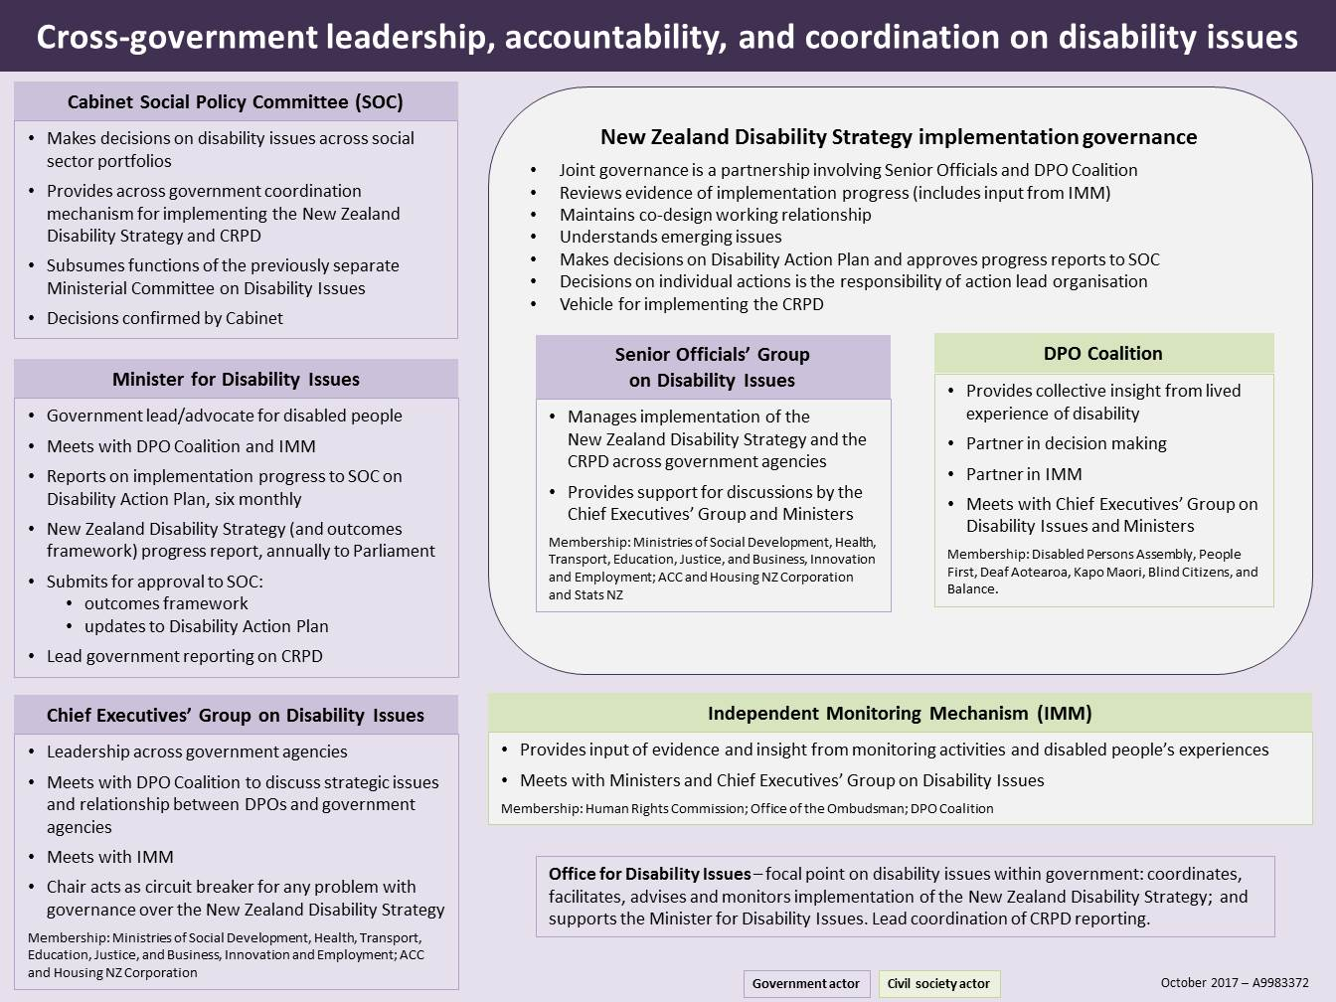

Appendix two: Relationship between the CRPD and the New Zealand Disability Strategy
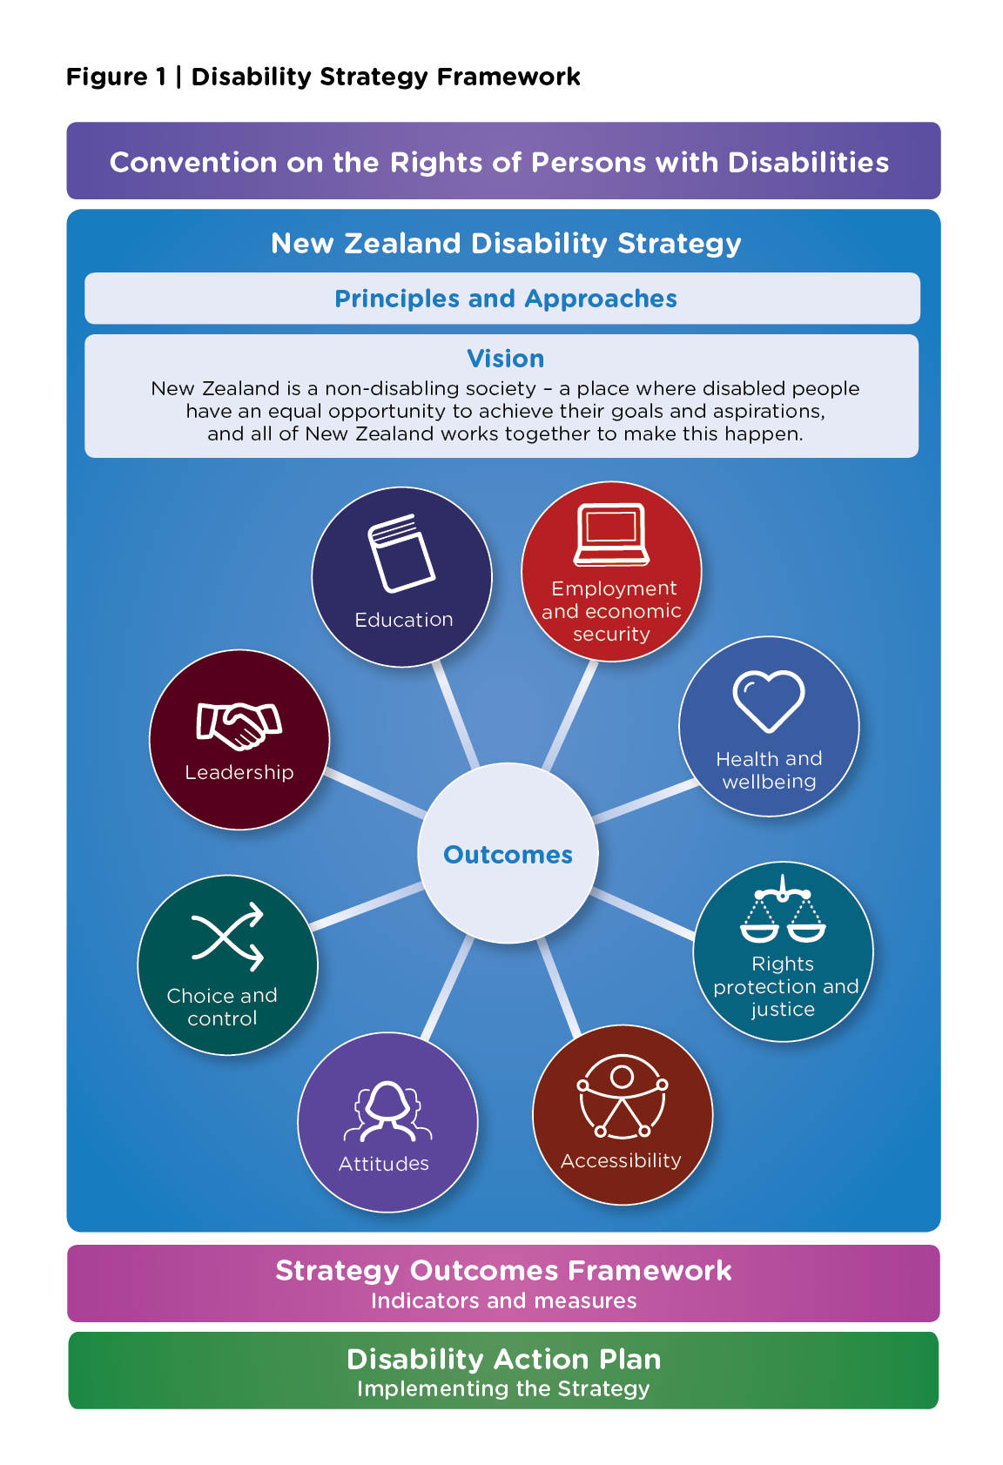

Appendix three: Detailed report on the Implementation of the Disability Action Plan (2014-2018)
The current status of actions (as at November 2017) is as follows:
- seven actions completed (2a, 4a, 6a, 8a, 9d, 11a, 12a)
- eight actions on track (3a, 3b, 4b, 7a, 9a, 9f, 9g, 10a)
- five actions with minor risks to achieving milestones (1a, 2b, 5a/b, 9c, 9e)
- seven actions with major risks to achieving milestones (7b, 8b, 9b, 9h, 9i, 10b, 10c)
- one action reinstated and being reassessed (6b)
- one action that was previously completed (4a) is now being re-started with further work.

Increase employment and economic opportunities
This shared result area focuses on building employers’ confidence to:
- employ disabled people
- provide accessible workplaces
- provide opportunities for work experience
- contribute to educational and skill development
- encourage entrepreneurship.
The five actions being progressed under this shared result area are guided by the Strategy’s Outcome Two: Employment and economic security – “We have security in our economic situation and can achieve our potential”.
- Action 1 (a), led by Ministry of Education (MOE), is about increasing the number of disabled people who transition from school and tertiary education into employment.
Phase Two of the project has commenced. In October 2017, MOE officials met with the DPO Coalition to discuss DPO representation on the Transitions Project Working Group, and the establishment of a Transitions Project Steering Group.
- Action 2 (a), led by Ministry of Social Development (MSD), was completed with the release of a progress report in August 2016. This action was focused on the implementation of the Health and Disability Long Term Work Programme to improve employment outcomes for disabled people, including the development of reasonable accommodation guidelines.
The Work Programme approach is based on the health benefits of work and the principle of self-management. The focus of the Programme includes:
- improving employment supports and services for disabled people (eg, a policy framework has been developed for specialist employment services)
- implementing an individualised approach to involve the client identifying their aspirations, skills and strengths to work, and the support they need to find and stay in work (eg, Self-Assessment and Work Ability Assessment tools)
- increasing the capability of Work and Income staff to work with disabled people and people with health conditions (eg, Work Focused Case Management).
- Action 2 (b) builds on work completed in Action 2 (a). It is focused on identifying better and more equitable ways to support disabled people who are working and receiving minimum wage exemptions, so that the Minimum Wage Exemption process can be removed. It is led by MSD and the Ministry of Business, Innovation and Employment (MBIE).
A report is due to be submitted to the Minister for Disability Issues in December 2017 setting out the options, considered to date.
- Action 3 (a), led by MSD, relates to the Government taking a lead in employing disabled people and providing paid internships. The focus is on the 29 Government Departments generally referred to as the public service. This includes increasing the number of disabled people employed in the public service, and providing work experience through paid internships.
The Lead Toolkit for Employing Disabled People in the State Sector, launched in March 2016, was revised and published in October 2017. The Toolkit is hosted on the State Services Commission (SSC) website. It contains a range of information and resources for leadership teams, managers and human resources teams to help them employ disabled people within their organisations.
Material on Interviewing Disabled People and Summer Internships has been published. Reasonable accommodation resources are now also available.
A Master Class with Chief Executives has been scheduled for February 2018.
SSC is leading the work around improving data, monitoring and reporting on disabled people in the public sector. To assist with this, MSD is in the process of repeating the 2015 internal survey of staff to identify the number of disabled employees.
MSD has agreed to sponsor the Institute of Public Administration Award on Diversity and Inclusion for 2018.
- Action 3 (b), led by MSD, has a focus on working with the private sector to progress employment of disabled people. The scope of this action is to identify changes to policy and services for businesses and workplaces to support them to build disability confidence.
Research on effective methods to increase disability confidence in employers has been completed. The research findings have been used to draft a consistent set of messages to employers to distribute across employer networks.
A White Paper is in the process of being developed by the Disability Employment Forum and Business NZ which highlights the current issues facing employers in increasing the employment of disabled people, and the necessity to develop a co-designed mechanism based on an Employment Strategy for all New Zealanders, including disabled people.

Transform the disability support system
This shared result focuses on ensuring effective engagement with disabled people and coordination across sectors and agencies to focus on outcomes and maximum progress from available resources.
Six actions are being progressed under this shared result area:
Actions 4 (a) and 4 (b) fall under the Strategy’s Outcome Seven: Choice and control – “We have choice and control over our lives”.
- Action 4 (a), led by the Ministry of Health (MOH), has to do with promoting disabled people to have more choice and control over their supports/services, and making more efficient use of disability support funding.
This action that was previously completed is now being re-started with further work.
DPOs will advise and work with government agencies and the National Enabling Good Lives Leadership Group to support co-design processes with the disability sector to begin a nationwide transformation of the disability support system, starting with people receiving Disability Support Services in the MidCentral region. This will include learning from the Enabling Good Lives (EGL) approach (particularly, the demonstrations in Christchurch and the Waikato). Key principles of this work are:
- choice and control
- being culturally responsive
- strengths based
- holistic
- an integrated approach.
- Action 4 (b), led by MOE, is about developing policy options to improve government supports for parents, families and whānau of disabled children aged 0-6 years. A progress report and initial advice to government, due in the first quarter of 2018, is to be confirmed with incoming ministers.
There are also a number of initiatives currently occurring across government in the 0-6 space that are relevant to this action, including the co-design of the disability support system, and the MOH review of Child Development Services.
Actions 5 (a) and 5 (b) which are now combined come under the Strategy’s Outcome Eight: Leadership – “We have great opportunities to demonstrate our leadership”.
- Action 5 (a), led by the Office for Disability Issues (ODI) and the DPO Coalition, is concerned with progressing the partnership between DPOs and the Government to meet New Zealand’s obligations under the CRPD, specifically Article 4.3, pertaining to the inclusion of DPOs in decisions that affect disabled people.
- Action 5 (b), led by ODI and the DPO Coalition, relates to improving DPOs’ capability (individually and collectively) to engage with government agencies and their wider community, and considering representation of different population groups in DPOs.
In March 2017, Guidelines for DPO meetings: Costs and fees, was completed. The Guidelines document highlights reasonable accommodations for DPOs engaging with government agencies. This document will inform a wider discussion about government agencies developing a consistent approach, when working with DPOs on the DAP 2014-2018.
ODI is waiting on the DPOs to complete their MSD-funded capability work and Te Pou-funded governance training and other capability building, before exploring further any additional areas for capability strengthening.
Actions 6 (a) and 6 (b) are guided by the Strategy’s Outcome Six: Choice and control – “We have choice and control over our lives”.
- Action 6 (a), led by MOH, was completed in October 2016. It was focused on developing and implementing effective ways for disabled people and DPOs to:
- provide feedback (both qualitative and quantitative) safely about the quality of services and support
- monitor, evaluate, scrutinise and make providers accountable to funders for achieving outcomes.
Malatest International has also completed a survey, based on the Schalock Quality of Life Framework, on people living in MOH funded community residential services. The final results were presented to the Disability Consumer Consortium and the five Disability Support Services provider forums between October and November 2016.
- Action 6 (b), led by MOH, has a focus on ensuring providers are responsive to disabled people and provide choice and tailoring of services. This action also relates to exploring how provider performance should be assessed.
This action has been reinstated in the DAP 2014-2018. ODI will meet with officials from MOH in November 2017 to discuss the status of this action.

Ensure personal safety
This result area focuses on three key priorities. These are:
- reducing barriers to disabled people making decisions to determine their own lives
- reducing the number of disabled people who are victims of violence, abuse and neglect
- ensuring that civil defence and emergency management respond appropriately to disabled people.
Four actions are being progressed under this shared result area.
Actions 7 (a) and 7 (b) fall under the Strategy’s Outcome Seven: Choice and control – “We have choice and control over our lives”.
- Action 7 (a), led by ODI, is focused on ensuring disabled people can exercise their legal capacity, including through recognition of supported decision making.
In August 2017, a report undertaken by ODI was presented to the Minister for Disability Issues on promoting a shared understanding of support for the exercise of legal capacity, and considering the people most likely to be directly affected by it. ODI will be further exploring options to improve support for the exercise of legal capacity, with an update due to the Minister in February 2018.
- Action 7 (b), led by MOH, has to do with exploring the framework that protects the bodily integrity of disabled children and disabled adults against non-therapeutic medical procedures, including the issue of consent. This action will focus, initially, on options to protect against non-therapeutic sterilisation without the fully informed consent of the individual.
This action is currently being re-scoped alongside discussions with the new Government on their policy priorities. A revised scope and schedule will be developed, once the scope review has been completed.
Action 8 (a), led by MSD, has been completed. This action is consistent with the Strategy’s Outcome Three: Health and wellbeing – “We have the highest attainable standards of health and wellbeing”.
- Action 8 (a) involved reviewing the care and support arrangements for disabled children who are (or are likely to be) subject to care under the then Children, Young Persons and their Families Act 1989 (now the Oranga Tamariki Act 1989) (the Act) - to establish whether they were being treated equitably and fairly, and in their best interests and, if not, provide advice on changes needed to legislation, operational policy, operational delivery and/or monitoring and enforcement.
The Disabled Children Project (led by MSD and MOH) organised a public consultation as part of the Disabled Children: Voluntary Out-of-home Placement Review in 2015 to consider these issues.
For severely disabled children and young people, whose parents are unable to continue to provide care for their child at home because they are no longer able to meet their needs within the family and whānau (but for whom there are no concerns relating to abuse or neglect), the provisions in sections 141 and 142 of the Act provided a process for arranging out-of-home placements.
Government subsequently agreed to repeal sections 141 and 142 of the Act. The intent of repealing these sections was to ensure that severely disabled children who cannot be cared for at home by their parents, guardians or caregivers are afforded the same safeguards as other children requiring out-of home care under the Act.
Further, repealing sections 141 and 142:
- responds to a recommendation by the United Nations Committee on the Rights of Persons with Disabilities in its 2014 Concluding Observations
- is consistent with the findings of the previous public consultation carried out as part of the 2011 Green Paper for Vulnerable Children and the Vulnerable Children Bill 2013
- was recommended in the 2015 Expert Panel Final Report: Investing in New Zealand’s Children and Their Families.
Repealing sections 141 and 142 of the Act means that severely disabled children requiring Government funded out-of-home placements will be taken into statutory care through the care and protection pathway of the Act (for example under a section 101 custody order or a section 110 sole guardianship order). They will be subject to the same care mechanisms, protections and safeguards as other children in the statutory care system.
In addition to repealing sections 141 and 142, the rights of disabled children to have their views considered in decisions affecting them have been added to the Act.
The Children, Young Persons, and Their Families (Oranga Tamariki) Legislation Bill came into force on 13 July 2017. The repeal of sections 141 and 142 of the Act will come into effect on 1 July 2019, or earlier by Order of Council.
Action 8 (b), aligns with the Strategy’s Outcome 4: Rights protection and justice – “Our rights are protected; we feel safe, understood and are treated fairly and equitably by the justice system”.
- This action, led by MSD, is focused on exploring options to reduce violence, all types of abuse (including bullying) and neglect of disabled people, and understanding the impact of different cultural contexts.
Identification of resource and re-scoping has been delayed because of recent changes proposed to the Family and Whānau Violence Legislation Bill currently before Parliament. These proposed changes would make explicit reference to disabled people in the Principles section, and have an impact on what might be the intended outcome of this action.

Promote access in the community
This shared result area focuses on promoting access for disabled people in the community, by increasing:
- levels of accessible buildings and spaces, transport and urban design
- accessible information and communications
- access to health and justice services
- political and civic participation.
Promoting disabled people’s access in the community is underpinned by three key priorities:
- increasing government services’ responsiveness to disabled people
- increasing the accessibility for disabled people of the built environment and transport services
- promoting disabled people participating in political and civic processes.
These priorities are supported by 13 actions that are being progressed.
Actions 9 (a) and 9 (b) are aligned with the Strategy’s Outcome Five: Accessibility – “We access all places, services and information with ease and dignity”.
- Action 9 (a), led by MSD and the DPO Coalition, relates to improving disabled people’s access to information provided by government agencies. It also aims to provide disabled people with a consistent experience when accessing information.
An Accessibility Statement has been agreed with the DPO Working Group. In June 2017, the Chief Executives’ Group on Disability Issues signed off the Accessibility Statement. A workshop with stakeholders was held on 14 November 2017. The next steps are currently being worked through with the DPO partners.
- Action 9 (b) (led by the Ministry of Justice [MOJ]), is concerned with understanding the journey through the justice sector for disabled adults, disabled children and their families and whānau.
ODI is still discussing opportunities to progress this action with MOJ:
- MOJ has included the Washington Group Short Set (WG-SS) of questions on disability in the 2017 pilot of the Crime and Victims Survey, and plans to include the WG-SS in the Survey to be run annually from 2018.
- MOJ and the DPO Coalition will set up a meeting between DPOs and justice sector representatives on issues regarding disabled people in the justice system.
Actions 9 (c) and 9 (d) are aligned with the Strategy’s Outcome 3: Health and wellbeing: “We have the highest attainable standards of health and wellbeing”.
- Action 9 (c), led by MOH, has to do with increasing access to health services and improving health outcomes for disabled people, with a specific focus on people with learning/intellectual disabilities.
The project had moderate risks due to staffing changes. However, an appointment has now been made. The project is being re-scoped in line with discussions with the new government on their policy priorities and work associated with the Disability Support Services System Transformation project.
- Action 9 (d), led by the MOH, was focused on exploring how the Mental Health (Compulsory Assessment and Treatment) Act 1992 relates to the New Zealand Bill of Rights Act 1990 and the CRPD. This action was completed with the release of a progress report in July 2017. Cabinet accepted the report on 11 July 2017.
Action 9 (e) is aligned with the Strategy’s Outcome Eight: Leadership – We have great opportunities to demonstrate our leadership”.
- Action 9 (e), led by ODI and Statistics New Zealand, involves the implementation of the Disability Data and Evidence Working Group’s (DDEWG) work programme, including a focus on Māori and Pasifika.
When the DDEWG’s work programme was planned in 2015, there was a focus on the development of a Disability Data and Evidence Plan. A couple of steps in the Plan were undertaken in 2016:
- stocktake of disability data held by government agencies and organisations outside of government
- consultation and prioritisation of a list of enduring questions focused on identifying long-term disability data needs.
When the DDEWG’s work programme was, initially, planned, there was no indication that indicators would be required to monitor progress in the implementation of the Strategy 2016-2026. The need for an Outcomes Framework means that data needs are now being framed by the development of indicators for the eight outcome domains in the Strategy.
Action 9 (f) is guided by the Strategy’s Outcome Four: Rights protection and justice – “Our rights are protected; we feel safe, understood and treated fairly and equitably by the justice system”.
- This action, led by ODI and the DPO Coalition, relates to carrying out a stocktake to identify any legislation that is not consistent with the CRPD and exploring options to improve consistency.
The final scope for this action was approved in October 2017. Work has begun to draw up a list of legislation to analyse by:
- consulting with the DPO Coalition, relevant disability sector organisations and government agencies to identify legislation that, in their experience, contradicts the CRPD
- conducting a word search for phrases concerning disability in current legislation on the legislation.govt.nz website
- including legislation identified by the United Nations Committee on the Rights of Persons with Disabilities in New Zealand’s 2014 review
- consulting prior work done by ODI to identify legislation with references to disability.
Actions 9 (g) and 9 (h) align with the Strategy’s Outcome Five: Accessibility – “We access all places, services and information with ease and dignity”.
- The focus of Action 9 (g), led by Accident Compensation Corporation (ACC) and the DPO Coalition, is investigating opportunities for technology to increase disabled people’s participation in work, community and political life, including through both assistive technology and access to mainstream technology.
ACC is working with the DPO Coalition, an external research provider and partner agencies to develop a survey. The purpose of the survey is to understand the types of technology disabled people use and their views on funding frameworks and access pathways. Once the survey questionnaire has been finalised (in consultation with the DPO Coalition), the survey will be carried out in November/December 2017. A final report is due to be completed by February 2018.
- Action 9 (h) relates to developing a framework for understanding the costs of disability and mechanisms for meeting these. ODI will pursue discussions with government agencies and DPOs on opportunities to progress this action.
Action 9 (i) is guided by the Strategy’s Outcome Seven: Choice and Control – “We have choice and control over our lives”.
- This action is concerned with investigating how Government can utilise a whānau ora approach for disabled people who prefer a whānau and community inclusive approach to government services. Options are being explored between MOH and the DPOs to look at what can be gained from Māori focused work in the transformation of the disability support system.
Actions 10 (a), 10 (b) and 10 (c) are aligned with the Strategy’s Outcome Five: Accessibility – “We access all places, services and information with ease and dignity”.
- Action 10 (a), led by the Ministry of Transport and the New Zealand Transport Agency (NZTA), has a focus on implementing the five recommendations which were identified through the stocktake on the accessibility of public transport, and agreed by the Chief Executives’ Group on Disability Issues. The five recommendations include:
- Consider issues of access to public transport, including for disabled people, when developing the Government Policy Statement on Land Transport.
- Develop further NZTA’s Guidelines for public transport infrastructure and facilities to provide best practice guidance on the provision of information and signage for public transport.
- Investigate how the training of bus drivers can better guide them in interacting and assisting passengers, including how the guidance specifically relating to disabled people can be further developed.
- Investigate how many councils have formally adopted and incorporated NZTA’s Pedestrian Planning and Design Guide and Road and Traffic Standards for Facilities for Blind and Vision Impaired Pedestrians into their codes of practice.
- Investigate what data is already available regarding trips made by disabled people on public transport, and consider how this data can be used more effectively to measure disabled people’s accessibility.
Progress has been made across three of the five recommendations, with others on track to meet milestones and timeframes.
- Action 10 (b), led by MBIE, concerns the implementation of the Accessibility Plan: Public Buildings. The purpose of this action is to provide building owners, designers, consenting authorities and managers with the knowledge and skills to fully comply with the requirements of the Building Act, and achieve equitable access to and use of publicly accessible buildings by all New Zealanders.
Milestones dates need to be updated and agreed with DPOs. This will occur after internal MBIE discussions on milestones have taken place in November 2017. A new management team came on board in October 2017. The team will have a formal briefing and discussion during the week of 20 November 2017. MBIE will report the results of this to ODI and Blind Citizens soon after.
- Action 10 (c), led by ODI and MSD, has to do with understanding the impact of disability on housing needs, and influencing the social housing reform programme to meet the needs of disabled people.
ODI is exploring opportunities for scoping this action with MSD Social Housing.
Action 11 (a) is aligned with the Strategy’s Outcome Eight: Leadership – “We have great opportunities to demonstrate our leadership”.
- Action 11 (a), led by DPOs, was completed in August 2016. This action involved DPOs completing a stocktake of what are the areas needing the most attention, and which will make the biggest difference to promote disabled people’s participation in political and civic processes. The priorities identified in the stocktake include:
- There is a lack of accessible information on candidates in general and local elections.
- A fully confidential vote for both general and local elections, including an online voting option, is needed.
- Disabled people should be elected not only to Parliament, but to governing roles on local authorities, District Health Boards, schools and so on.
- Disabled people need to be able to form organisations, with the capacity to effectively represent the voice of disabled people at the local, national and international level.
- More training of polling officials on the rights and needs of disabled people is required.
- Strategies are required to ensure that consultation processes such as the recent flag referendum include disabled people.
Action 12 (a) is guided by the Strategy’s Outcome Three: Health and wellbeing – “We have the highest attainable standards of health and wellbeing”.
- Action 12 (a), led by Ministry for Culture and Heritage (MCH), was completed with Final Advice provided to Ministers in October 2016. This action focused on investigating the feasibility of introducing a companion card programme in New Zealand.

Appendix four: Likely timeline for CRPD second review
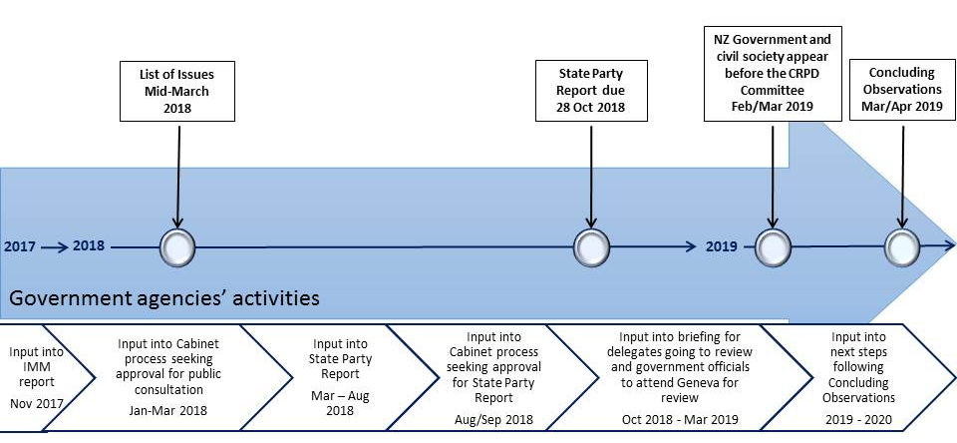

The relationship between these mechanisms is illustrated in Appendix one.
Reference will continue to be made to the previous Government’s Cabinet Social Policy Committee, covering social policy issues, until any change is made.
The DPO Coalition is a collection of six DPOs. Members include: Disabled Persons Assembly (New Zealand) Incorporated, People First New Zealand Incorporated, Kāpō Māori Aorearoa/New Zealand Incorporated, Association of Blind Citizens of New Zealand Incorporated, Deaf Aotearoa New Zealand Incorporated and Balance Whanganui (Balance Aotearoa).
The relationship between the CRPD, the Strategy and the DAP 2014-2018 is illustrated in Appendix two.
The New Zealand Disability Strategy Revision Reference Group members bring expertise and leadership in working with the disability sector, providing strategic advice, building connections between the government and the community sector and skill in collaborative approaches. The Group includes members who bring the perspectives of Māori, Pasifika, older people, young people, families and service providers.
The Independent Monitoring Mechanism is Domestic accountability is formally provided through the Independent Monitoring Mechanism (IMM), designated by Cabinet in 2010. The Independent Monitoring Mechanism (IMM)is a three-way partnership between the Human Rights Commission, the Office of the Ombudsman, and the DPO Coalition and is designated by Cabinet to provide independent monitoring of New Zealand’s implementation of the UNCRPD.
The Phase One Evaluation, made public in September 2016, focused on the co-design of the demonstration and the implementation plan.
Further information on the Waikato demonstration is available at: http://www.enablinggoodlives.co.nz/current-demonstrations/enabling-good-lives-waikato/.
More information can be found at: www.msd.govt.nz/DisabilityConfidentnz.
The Board is also allocated a further $0.25m per annum to support the annual operational management of the Board, and to progress approved activities the Board is undertaking under its current Action Plan, such as commissioning reports on NZSL services and resources.
No national system currently exists in New Zealand to assess the NZSL proficiency of adults. The implementation of such a system is dependent on funding.
The DAP 2014-2018 is available on the ODI website: http://www.odi.govt.nz/nz-disability-strategy/disability-action-plan/disability-action-plan-2014-2018-update-2015/.
Action 5 (b) in the DAP 2014-2018 relates to improving DPOs’ capability (individually and collectively) to engage with government agencies and their wider community.
Action 3 (a) in the DAP 2014-2018 relates to the Government taking a lead in employing disabled people and promoting paid internships.
The timeline for New Zealand’s review by the UN Committee is illustrated in Appendix four.
The most recent Disability Survey was undertaken in 2013 and the next Survey is scheduled for 2023. The 2023 Survey will have limited utility in monitoring change/progress over the course of the New Zealand Disability Strategy 2016-2026.
See https://www.stats.govt.nz/information-releases/disability-survey-2013.
See http://www.dpa.org.nz/resources/sector-resources/the-convention-disability-rights-in-aotearoa-new-zealand.
The Toolkit can be accessed at: http://www.ssc.govt.nz/lead.
More information can be found at: http://www.odi.govt.nz/what-we-do/making-it-easier-to-employ-disabled-people/index.html.
Malatest International are New Zealand evaluation and research specialists.
A summary report is available at: http://www.odi.govt.nz/summary-of-progress-on-improving-disabled-peoples-exercise-of-legal-capacity/.
The Summary Consultation Findings report is available at: https://www.msd.govt.nz/about-msd-and-our-work/work-programmes/policy-development/disabled-children-project/in-home-support-and-voluntary-out-of-home-placement-review.html.

